Reading Lesson Plan

Dolphins' Social Behavior
Teacher | Student Level& Age | No of Students | Length
Rosa Rhiy | Intermediate & 17 | 19 | 50 mins

Materials:
White board, markers
Computer and projector (to show video clip or pictures)
22 copies of the worksheets( Topic, 'Guessing New Words', 'Reading Comprehension Activity', 'Discussing with questions')

Aims: At the end of the class, students will have practiced
- how to connect their schema and text(context) by doing 'Guessing New Words' activity.
- reading by doing reading comprehension activities with a true story.
- how to skim and scan the text by doing some time-limited activities.

Language Skills:
Reading: Doing reading comprehension activities
Writing: Doing 'Guessing New Words',
Listening: Teacher Talk, Ss conversation(Discussing)
Speaking: Discussion, Asking to T

Language Systems:
Phonology: Sounding new words with Ss.
Lexis: Learning new words from the text (creature, pod, abundance, merge, exceed, vocalization, rigid, establish, bond, altruism, shallow, stranded, charge, snout, sponge, forage)
Grammar: Making structures while writing activity.
Functions: Questioning, Maintaining, Hypothesizing,
Discourse: Asking and answering to solve problems and to discuss in groups about a topic and words.

Assumptions:
Ss learned and practiced the words besides words from 'Guessing New Words'

Anticipated Errors and Solutions:
Ss may not remember some words so they can't understand context easily and accurately.
- Let them to have time for searching the meaning in a dictionary or show them a demo and give them CCQ and ICQ to make sure they understand the whole context.

References:
- http://www.myenglishpages.com/site_php_files/reading-dolphin-social-behavior.php
- http://www.youtube.com/watch?v=xZv03LdgRfs

Notes:

Pre Task
Title:  Introducing a Topic |  | Aims:  To introduce today's topic to Ss by showing them a dolphin's picture and eliciting their schema. | Materials:  White board & markers  Computer and projector.
Time | Set Up | Students | Teacher
10mins | Whole class | Get to know a topic  Guess and predict today's topic while seeing the video.  Try to know today's topic.  Respond to the T's eliciting. | Introducing a topic  Show the class a video clip of some dolphins' social behaviour. (while seeing it, get them to guess a topic)  Write their prediction on the board.  Introduce a topic "Dolphin's Social Behavior"  Elicit what Ss already know about the topic.

Notes: If a video is not working, show them photos.

Task Preparation
Title:  Previewing New Words |  | Aims:  To preview new words from the text by doing 'Guessing New Words' activity. | Materials:  Topic sheets(text)  Worksheets of (1)Guessing New Words  While board and markers.
Time | Set Up | Students | Teacher
10mins | Group work.  Whole class | Pairs.  Discuss/Guess the meaning of new words together while reading a text.  Write them on the 'Guessing New words' worksheets.  If done, tell what they thought as answers to T  Answer to CCQ | (1) Guessing New Words  Make pairs  Give out topic texts and 'Guessing New Words' worksheets and make Ss guess the meaning of the new words from the text and write them on the worksheets. (3~4mins)  If Ss done, let Ss say what they guessed and write down the right or close meanings on the board. (3~4mins)  CCQ (to make them understand meanings)

Notes: For this activity, Ss should try to draw out their schema. And, at the end of this activity, don't tell the exact answers to Ss. T will give the words answer sheets in post task.

Task Realization
Title:  Reading Comprehension Activities. |  | Aims:  To make Ss understand context by doing reading comprehension activities. | Materials:  Worksheets of (2)Reading Comprehension Activity
Time | Set Up | Students | Teacher
20mins | Individually  Whole class  Individually  Whole class  Individually  Whole class  Group work  Whole class | (2)-1. True or False  If they think it's true, circle T, if not, circle F reading the text 'Dolphins' Social Behaviours'  Check their answers by telling them to T.  Answer to CCQ  (2)-2. Writing answers for questions.  Part.1)  Write the answers for questions reading the text carefully. (Scanning)  Check their answers by talking to T about them.  Answer to CCQ  Part.2)  Write their own answers for questions reading the text carefully.  Check their answers by talking to T about them.  Answer to CCQ  (2)-3. Ordering sentences of the text  In a group, discuss the first and last sentences of the text and order them in a sequence together.  If done, tell the answers to T and compare with classmates.  Answer to CCQ | (2)-1. True or False  Give them worksheets  Get them to read the text and choose T or F (4mins)  Check the answers.  CCQ  (2)-2. Writing answers for questions.  Part.1)  Get them to write answers for literal questions. (4mins)  Check the answers  CCQ  Part2.)  Get them to write their own answers for Interpretive questions.(4mins)  Check the answers  CCQ  (2)-3. Ordering sentences of the text  Make groups of 4~5 members.  Give them 4mins to write proper alphabets on the boxes in the right order.  Check the answers. (D-H-E-K-C-G-I-A-L-F-B-N-M-J)  CCQ

Notes:

Post Task
Title:  Discussing applied questions |  | Aims:  To make Ss share opinions related to the topic by discussing some applied questions with classmates. | Materials:  Worksheets of (3)Discussing with questions
Time | Set Up | Students | Teacher
10mins | Group work | (3)Discussing with questions  In a group, discuss applied questions on the worksheet by asking and answering each other.  Present shortly their answers to the class.  Check their opinion with others  Answer to CCQ  (4) Bonus activity with today's work(At home)  Get the words answer sheet.  If they don't know some words' meanings, ask it to T.  Ss think and write answers for questions. | (3)Discussing with questions  Make groups  Give Ss 4mins to discuss with applied questions on the worksheet.  Check their answers by letting them present.  CCQ  (4) Bonus activity with today's work(warp up)  Give them answer sheets for 'Guessing New Words'.  Ask them to think and write answers for questions. (Demonstrate with examples.)

Notes: Before wrap-up, ask Ss to think about next topic's story or words to prepare for next class.

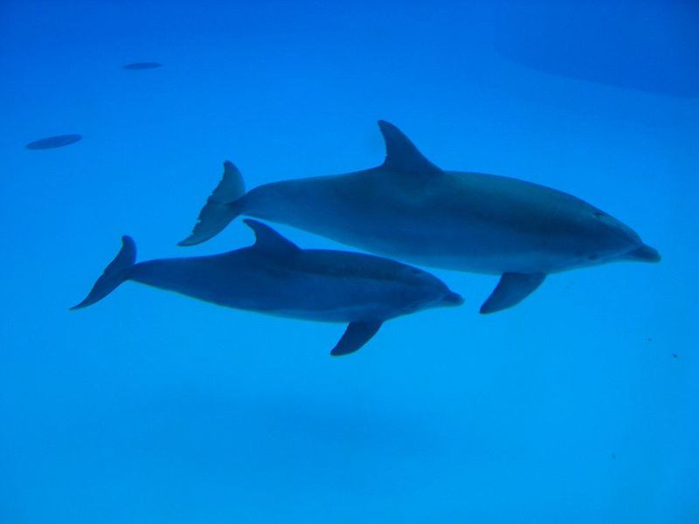
Dolphins' Social Behavior
Dolphins are often regarded as one of Earth's most intelligent animals. They are social creatures, living in pods of up to a dozen individuals. In places with a high abundance of food, pods can merge temporarily, forming a superpod; such groupings may exceed 1,000 dolphins. They communicate using a variety of clicks, whistle-like sounds and other vocalizations.

Membership in pods is not rigid; interchange is common. Dolphins can, however, establish strong social bonds; they will stay with injured or ill individuals, even helping them to breathe by bringing them to the surface if needed. This altruism does not appear to be limited to their own species. The dolphin Moko in New Zealand has been observed guiding a female Pygmy Sperm Whale together with her calf out of shallow water where they had stranded several times. They have also been seen protecting swimmers from sharks by swimming circles around the swimmers or charging the sharks to make them go away.

Dolphins also display culture, something long believed to be unique to humans. In May 2005, a discovery in Australia found Indo-Pacific bottlenose dolphins (Tursiops aduncus) teaching their young to use tools. They cover their snouts with sponges to protect them while foraging (looking or searching for food or provisions.) Using sponges as mouth protection as well as other transmitted behavior proves dolphins' intelligence. This knowledge is mostly transferred by mothers to daughters.

(1) 'Guessing New Words'
Guess these words' meanings while reading the text and write it down.

Creature | -Any living thing that is not a plant
Pod
Abundance
Merge
Exceed
Vocalization
rigid
Establish
Bond
Altruism
Shallow
stranded
charge
Snout
Sponge
Forage

(1) 'Guessing New Words' (Answers)

Creature | -Any living thing that is not a plant especially when it is of an unknown or unfamiliar kind.
Pod | -A group of aquatic mammals
Abundance | -To be more than average amount
Merge | -To become one, join.
Exceed | -Be greater in size than normal.
Vocalization | - the sound made by the vibration of vocal folds modified by the resonance of the vocal tract
rigid | -Not flexible or not easy to change.
Establish | -To set up or found
Bond | -A connection based on friendship.
Altruism | -The quality of unselfish concern for the welfare of others. Thinking not only my welfare but also other's
Shallow | -Not deep
stranded | -Left behind
charge | -To make a rush at or sudden attack upon, as in battle.
Snout | -A long projecting nose of mammal's head.
Sponge | -Primitive marine animal whose body has lots of tiny holes.
Forage | -To search for food and provisions

(2) Reading Comprehension Activity
(2)-1. True or False(Individually)
T | F
T | F
T | F
T | F
T | F
T | F
1. Dolphins live individually.
2. A pod of dolphins can exceed the number of 1,000.
3. Dolphins only help their own species.
4. They have been observed to save a swimmer from a shark.
5. They don't know how to use a tool.
6. There are several transmitted behaviors of dolphins.

(2)-2. Write the your answers for each question(Individually)
Part.1
1. How do dolphins communicate?

2. What kinds of social behaviour did they show in this text? (write 2 answers)

3. How did they use a tool, sponge?

Part.2
1. Why do you think dolphin are regarded as intelligent animals?

2. What do you think they will do if they see a injured swimmer?
(2)-3. Ordering sentences of the text (Group work)

A. The dolphin Moko in New Zealand has been observed guiding a female Pygmy Sperm Whale together with her calf out of shallow water where they had stranded several times.
B. In May 2005, a discovery in Australia found Indo-Pacific bottlenose dolphins (Tursiops aduncus) teaching their young to use tools.
C. Membership in pods is not rigid; interchange is common.
D. Dolphins are often regarded as one of Earth's most intelligent animals.
E. In places with a high abundance of food, pods can merge temporarily, forming a superpod; such groupings may exceed 1,000 dolphins.
F. Dolphins also display culture, something long believed to be unique to humans.
G. Dolphins can, however, establish strong social bonds; they will stay with injured or ill individuals, even helping them to breathe by bringing them to the surface if needed.
H. They are social creatures, living in pods of up to a dozen individuals.
I. This altruism does not appear to be limited to their own species.
J. This knowledge is mostly transferred by mothers to daughters.
K. They communicate using a variety of clicks, whistle-like sounds and other vocalizations.
L. They have also been seen protecting swimmers from sharks by swimming circles around the swimmers or charging the sharks to make them go away.
M. Using sponges as mouth protection as well as other transmitted behavior proves dolphins' intelligence.
N. They cover their snouts with sponges to protect them while foraging (looking or searching for food or provisions.)

D |  |  |  |  |  | I |  |  |  |  |  |  | J
(3) Discussing with the questions(Group Work)
1. Can you think of other things dolphins use as tools besides of sponges?

2. Have you seen other species having social behaviors like a dolphin?

3. If you were a dolphin Moko, what would you do to get a Pygmy Sperm Whale and her calf out of the shore and guide to a sea?

4. Are you altruistic or selfish person? Why do you think so?

(4) Bonus activity with today's topic. (Individually)
1. Make 3 sentences with random words we learned today in 'Guessing New Words'.
-
-
-

2. Research one other animal that shows social behaviors and write the animal's name and its social characters.

- animal :
- social behaviour :

