The Beauty Makes a Chance?

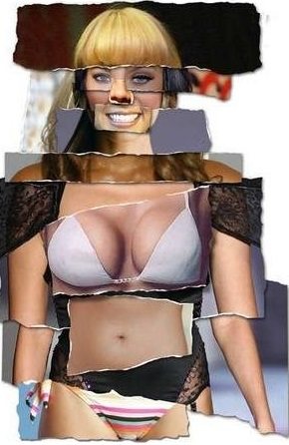
The growing popularity of cosmetic procedures, both surgical and nonsurgical, has given Korea the dubious title of “plastic surgery republic.”
Fueled by the highly competitive nature of Korean society, aesthetic procedures have become so common that it is not unheard of for students to receive them as “graduation gifts.”
“I think it’s a positive thing to be able to address the complexes you might have about your appearance,” said Yoo Hye-rin, a second-year high school student. She added that the common opinion among her peers is that eyelid surgeries aren’t a big deal, as they are so common.
For Korean society in general, however, plastic surgery is more popular than ever and has even come to be a normal means of improving one’s “spec.” Spec, short for specifications, is used in Korea to refer to an individual’s qualifications, which are now considered to include physical attractiveness.
“I think getting cosmetic surgery helped a lot in finding a job,” a 29-year-old female accountant said, declining to be named. Although she graduated from a university ranked among the global top 10, she says that she never felt fully confident before she had a number of procedures done. Since graduating from university in 2007, she has had surgery on her eyelids and nose. She has also had braces and had two embedded wisdom teeth removed. She believes that these procedures have made the shape of her face more attractive.
According to a recent survey conducted by a Web-based recruitment service provider, as many as 30 percent of university students would consider getting cosmetic surgery to increase their chance of finding employment.
Like any other industry, the plastic surgery industry has seen a number of trends come and go, and a recent one is “Gwansang” surgery. Gwansang, or face-reader, is a field of fortune-telling where an individual’s facial features are used to tell her or his fate.
Some clinics and even practitioners of traditional Korean medicine offer face-reading services for those hoping that making specific alterations will positively influence their lives.
Even experts in face-reading, however, say the effects of such plastic surgery are questionable.
“The focus of Gwansang is the face, and that is based on the philosophy that the face is the reflection of one’s inner self. So if the heart doesn’t change, then you can’t fundamentally alter your Gwansang,” said Jo Kyu-mun, professor of East Asian philosophy at Kyonggi University. “At the same time, it can’t be said that minor changes to Gwansang cannot be made through plastic surgery. So, small changes are possible but plastic surgery really isn’t a tool for changing Gwansang.”

The Beauty Makes a Chance Question Sheet

Q1. If you were a chairman in the huge company, would you hire a beautiful applicant or chose other criterion?

Q2. Do you think beauty quite guarantees the social success for both men and women?

Q3. What is the meaning “looking good” to you personally?

