Grammar Lesson Plan
96WD _Rosa

Past simple - regular verbs
Teacher | Student Level& Age | No of Students | Length
Rosa Rhiy | high beginner & 15 | 19 | 50 mins

Materials:
Computer, projector
4 sets of flashcards ( "The last time I ...." activity )
22 copies of worksheets.
Chocolates.

Aims: At the end of the class, students will have practiced
- how to make past simple regular verbs by doing "The last time I .. ", substitution drills, exercises and also "Past tense slap" activities.

Language Skills:
Reading: Reading exercises.
Writing: Doing exercises.
Listening: Teacher talk, conversation with peers
Speaking: Answering to T's questions, conversation with peers

Language Systems:
Grammar: Past simple regular verbs
Phonology: Practicing sound -ed with verbs. .
Lexis: Verbs with -ed, -d, -ied.
Functions: Questioning, answering, presenting, making a sentence
Discourse: Asking to T or other Ss to make full sentences

Assumptions:
Ss have learned present tense in the last lesson.
Ss know what the 'past' means.

Anticipated Errors and Solutions:
While they do "The last time I ____ " activity, they can say wrong sentence.
- T does not correct them all but encourage them to speak and be active.

References:
- http://www.eslkidstuff.com/esl-kids-games/past-tense-games.htm
- http://www.youtube.com/watch?v=YF2jRfFe82Y
- http://www.slideshare.net/logosacademyeduec/regular-past-tense-for-kids
- EnglishForEveryone.Org

Notes:

Pre Task
Title:  " The last time I ___" |  | Aims:  To get Ss attention before starting a lesson by doing a simple activity. | Materials:  Computer and projector.  Sheet 1 (manual for two activities)  Flashcards(4 sets)  Chocolates.
Time | Set Up | Students | Teacher
10mins | Group work | See how to do the activity by T's demo.  In a group, make a sentence with the structure "The last time I ....was (time expression) " one by one.  If S could answer in 10seconds, they keep the card, but if they cannot, they return the card back to the pile. (They don't need to tell grammatically correct answer. ) | Turn on the ppt with first page(The last time I ....)  Make 4 or 5 groups  Give flashcards for each group.  Get them to make a sentence with the structure "The last time I ....was(time expression)" in 10 seconds. The one with more cards than others becomes a winner in the team.  CCQ to check they know the rules.  Give them 5 minutes to do it.  After finish, ask who's the winner.  Give them chocolates.

Notes: T should monitor whether they do correctly or not.

Task Preparation
Title:  Substitution drills |  | Aims:  To get them to practice pronouncing past simple and to know the difference between present and past tense by doing substitution drills. | Materials:  Computer and projector  Pointer.
Time | Set Up | Students | Teacher
15mins | Whole class | Read what T points out.  If they think it's wrong, they can express it.  Guess what we are talking about in this substitution table.  By responding to T's eliciting, Ss get to know our topic today.  Answering to T's talk while T explains about past simple. | Show them a second page of ppt(substitution table)  Let them to read the point where T points out.  Get them to feel the difference between present and past tense by doing this activity. (when they say wrong words, use mouthing to correct it.)  Question what we did with this table.  Elicit until they know our topic 'past simple' or 'past tense' and write it on the board.  Instruct when to use it and the time markers.  (while teaching it, get Ss attention as much as possible by letting them join the class.)  CCQ

Notes: Ss might not know what consonant and vowel means. Tell them simply to move on.

Task Realization
Title:  Worksheets for past simple forms. |  | Aims:  To get Ss to understand many forms of past simple by solving some problems in worksheets. | Materials:  exercise worksheets.  White board, markers.
Time | Set Up | Students | Teacher
15mins | Whole class  In pairs  Whole class | Ss listen to T's explanation about how to do worksheet.  Guess how to solve number 1 of exercise 1 by talking to T.  Respond to CCQ  One S writes the his/her own answer in the board.  Other Ss say it's correct or not.  Move on to next exercises like this sequence. | Give them a worksheets with past simple forms.(exercise 1~3)  Elicit how to solve the problems in exercise 1 by doing number 1of it with Ss.  CCQ  From number 2 to 7, pick a student randomly and let them write the full answer in the white board.  If a S wrote it, ask other Ss whether they agree with the answer or not to activate them more.  Keep doing other number like that.  And move on to exercise 2 and 3 by the process above.

Notes:

Post Task
Title:  "Past Simple Slap" |  | Aims:  To get Ss to review what they learned today by doing "past simple slap". | Materials:  chocolates
Time | Set Up | Students | Teacher
10mins | Group work | Answer to the T's CCQ  If they know the correct past simple form, slap the table and say the answer. ( Their team gets one point.)  The winner team get chocolates. | Make 4 groups  Explain how to do this activity.(There is a manual below)  CCQ  Start the activity by saying regular infinitive verbs.  Give chocolates to a winner team.

Notes:

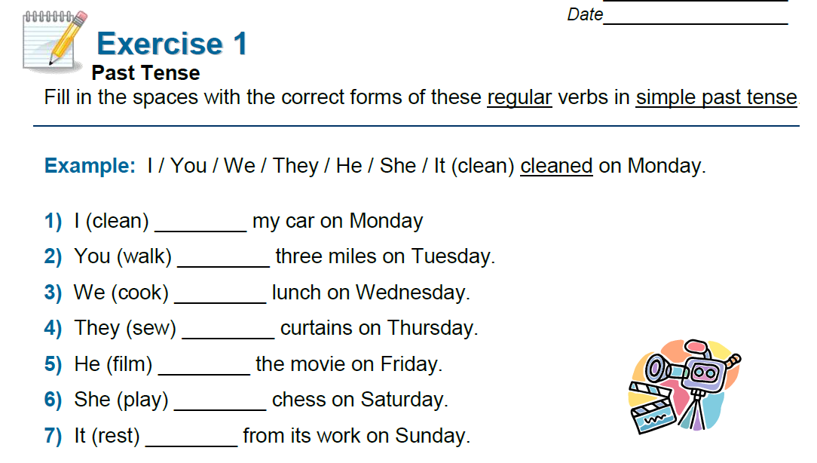

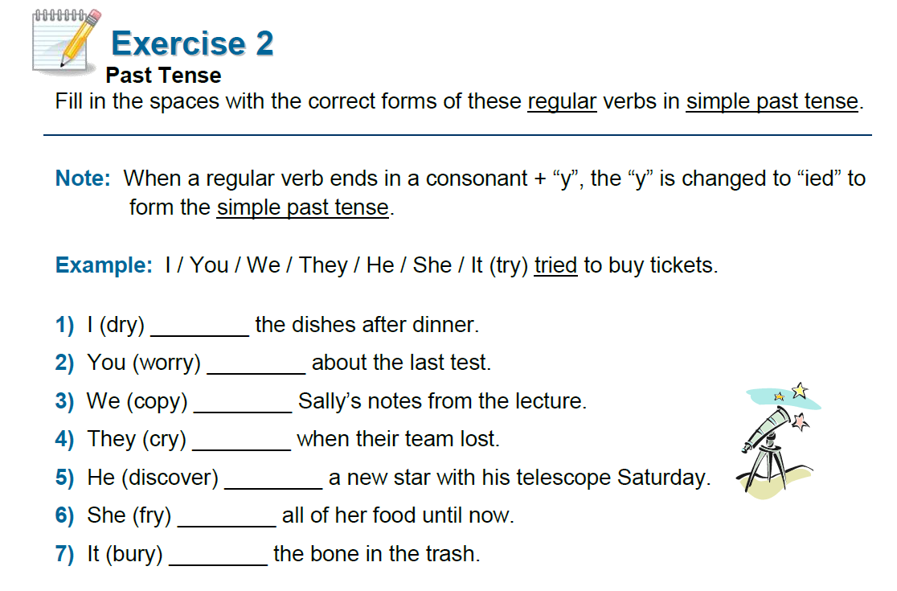

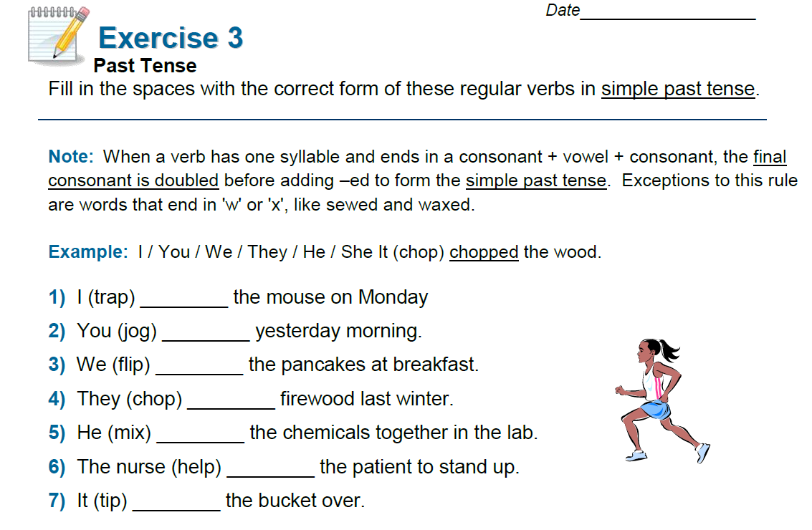

The last time I ...
You sit in a group with flashcards, face down, in the middle. One person picks up a card and makes a sentence using the structure, "The last time I ___ was (time expression)" For example, the last time I played tennis was last summer. The last time I watched TV was yesterday evening. The last time I cooked was 4 days ago, etc. If he/she makes a sentence in 10 seconds, the person keeps the card and scores 1 point. If not, the card is returned to the pile.

Past simple slap
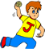A very simple activity. You are put into teams. When the teacher says a verb in the infinitive, you have to slap the table if you know the past tense version (e.g. T: "work", S: "worked"). The teacher will ask someone who slapped the table first to give his or her answer to win a point for their team.

cooked | helped someone
used a machine | played the piano
called my mother | changed my hair style
planned a trip | studied history
played badminton | asked direction
cleaned my room | waited my friend

