Grammar Lesson Plan
96wd JANICE

Title: COUNTABLE OR UNCOUNTABLE NOUNS
Teacher | Student Level & Age | No of Students | Length
96wd JANICE | INTERMEDIATE LOW &11~ | 20 | 50 mins

Materials:
Whiteboard &markers, projector, paper, pictures,

Aims:
To help Ss differing between countable and uncountable nouns and to use correctly

Language Skills:
Listening: teacher’s instruction and explanations, team or individual opinion
Speaking: presentation , demonstration, discussion with groups and the whole class
Reading: reading Ss sentences, teacher’s explanations
Writing: making sentences with countable and un countable nouns

Language Systems:
Phonology: new vocabulary and proper intonation and stress
Lexis: nouns of countable and uncountable, daily words.
Grammar: countable and uncountable, there is or are , many and much
Discourse: group discussion, conversation, presentation

Functions: Questioning, answering, and explaining

Assumptions:
N/A

Anticipated Errors and Solutions:
N/A

References:
http://www.myenglishpages.com/site_php_files/grammar-lesson-countable-uncountable-nouns.php#.UwNk92J_uSo

http://esl.about.com/library/beginner/blmuchmany.htm

http://www.pinterest.com/search/pins/?q=countable%20and%20uncountable

Notes:
N/A

Pre Task
Title: can you count it~? Or not? |  | Aims:  To help Ss to motivate themselves and preparing idea for the next task  To give Ss an idea about the task. | Materials:  White borad
Time | Set Up | Students | Teacher
5 mins | Teacher  With whole class | -answering to the teacher’s Questions | -give a CCQ to the Ss for schema of countable and uncountable nouns.  -ex) can you touch a banana?  Can you touch air?  Can you see air?  Can you count air?

Notes: vocabulary (money, air, rice, bread/banana, friend, pen, cup)

Task Preparation
Title: How many?  Or much?  Give more info to understand by using Question |  | Aims:  To help Ss to Define the difference of countable and uncountable nouns with in new vocabulary.  To help Ss to prepare of using countable and uncountable nouns | Materials:  Whiteboard & markers  Projector(pictures),paper, pen
Time | Set Up | Students | Teacher
15 mins | Teacher  Whole class | -discuss about the words about what is the difference  -guess the idea of the vocabulary and follow teacher’s instructions.  -answering to the teacher’s question. | -write new vocabulary on the board what you have asked before At the pre-task.  -give instruction to Ss to discuss in groups  -divide words with countable and uncountable with whole class.  -give the Ss a pictures  -give Ss questions by using How many or much ~?

Notes:N/A

Task Realization
Title: draw and describe |  | Aims:  To provide Ss an opportunity to use C & U.C nouns  To help Ss expending ideas and comprehend with the others by discussing. | Materials:  Papers, markers,
Time | Set Up | Students | Teacher
20mins | Teacher  In groups | -make in groups and discuss  -Ss have to draw a picture about using countable or uncountable nouns  -Ss have to describe the picture by 2~3 sentences  -Ss have to prepare presentation. | -give Ss instruction  -monitor Ss

Notes:
Ss have to make sentences with “there is~ or are~”
If necessary Teacher can provide to Ss

Post Task
Title: sum up |  | Aims:  To help Ss practicing presentation to the class  To provide opportunity to review what they have comprehended | Materials:  Hand outs of task sum up  White board
Time | Set Up | Students | Teacher
10 mins | In groups  Whole class  teacher | -presentation to the class per each group.  -listen to teacher’s explanation | -give time to Ss presenting themselves  -after presentation give a short  Sum up and hand outs  -finish the class

Notes:
If there is more time T can give the whole class of CCQ about countable and uncountable

Worksheets, handouts and lesson materials
Task –prep example
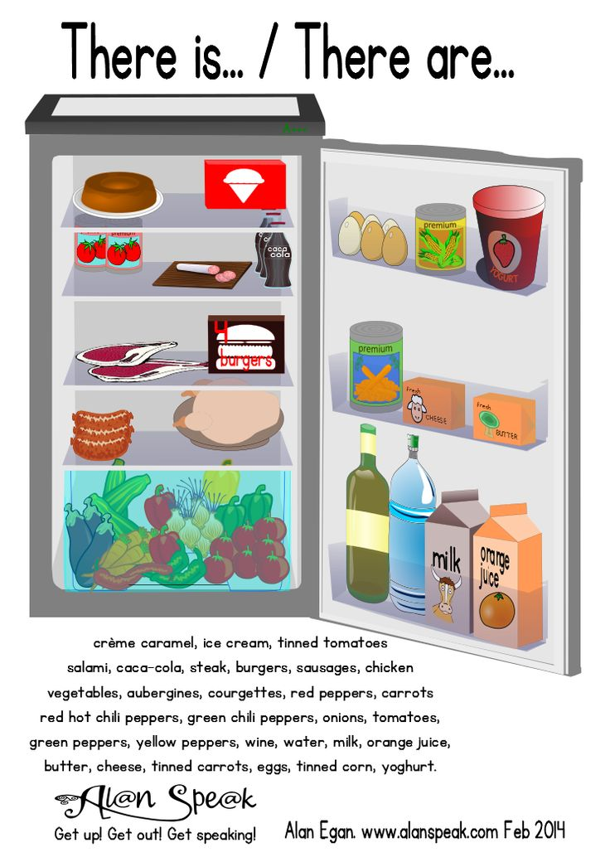
Sum up hand out
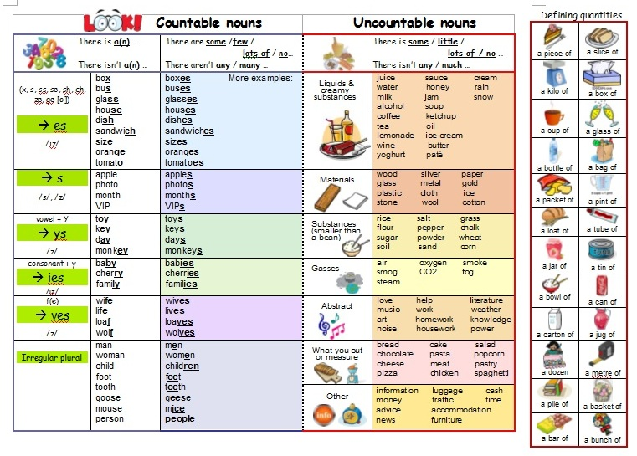

Helps for task-realization
