Listening Lesson Plan
How to make tomato spaghetti (cooking)

Level:
Intermediate
Students:
10
Length:
50 minutes
Instructor:
Chloe, Joy, Jane
Materials:
- picture of spaghetti (1-4)
- Word flash cards (2-4)
- Pictures of food ingredients for two groups (3-4)
- Recipe worksheet (fill-in-the-blanks) (4-4)
- Listening CD and CD player (track 1)
Aims:
- Students will learn and understand various cooking vocabularies through listening and demonstration of a recipe.
- Students will practice listening skills focusing on how to read and pronounce cooking action verbs through listening and dictation of a recipe.
Language Skills:
- Reading: Reading the recipe worksheet (fill-in-the-blank)
- Listening: Listening to the recipe
- Speaking: Group discussion and presentation
- Writing: Dictation (fill-in-the-blank)
Language Systems:
- Phonology: /ee/ sound, and reading the vocabularies from the recipe
- Lexis: Words used in the recipe describing cooking method
- Grammar: N/A
- Function: Instruction and ordering the steps
- Discourse: Recipe style
Assumptions:
- Students already covered words related to food.
- Students are elementary students (Age 11)
Anticipated Errors and Solutions:
- Students may not be able to remember words by just doing TPR few times during pre-activity.
-> Do not force students to remember at first, wait and give more time to practice the words through activities. They will know at the end of the by repeating the words over and over again.

-If DVD player or projector does not work
-> Teacher can read the script rather than spend too much time figuring out technical problems.

-When groups of students are present their work, try to play the recipe chunk by chunk
-> They are going to listen and demonstrate the recipe at the same time. Try to play the recipe chunk by chunk so that they have enough time to prepare for the food.
References: Jamie Oliver’s cooking recipe (Tuna spaghetti)

Lead-In
Materials: a picture of spaghetti
Time  3 min | Set Up  Whole Class | Procedure:  (Divide into two groups of five)  (Show a picture of a spaghetti)  Hello everyone, do you know what is this? Have you ever eaten this food? What ingredients can you see here? Does it look yummy? We will make this food together in this class. Can you believe it? (Eliciting)  First, we will learn some cooking vocabularies to read our recipe.

Pre-activity
Materials: flash card
Time  10 min | Set Up  Whole Class  Individually | Procedure:  Instruction  Teacher will show the flash cards and read the words with actions one time and students will repeat and follow after the teacher. After going over each word, teacher will randomly pick a flash card and ask students what this picture represents and students will answer with the action.  I.C.Q.  - How many times teacher will read and act the flash  card?  - Are you going to repeat the word and action  together?  - When teacher randomly pick a flash card, what are  you going to do?  - Use Total Physical Response (TPR) method to  explain the flash cards.  - Go over the vocabularies slowly with the action.

Main-activity
Materials: DVD, DVD Player(or we can use Youtube), listening worksheet
Time  20 min | Set Up  Whole Class | Procedure:  Instruction  Listen without worksheet: Put your pens down. Close your eyes.  Turn on the DVD: How much do you understand the way of recipe?  Give work sheets to the students and turn on the DVD with 3 times: Please listen carefully and fill in the blanks.  I.C.Q.  - Can you fill in all?  - Do you want to listen again?  - Yes -> Have them one more time. (try it 1~2 times repeat)  - No-> Have them share their own answers.  Read together all sentences including answers in the blanks.  : 1) How does the garlic do?  (peel and finely slice)  2) What is ‘chop’? (c)  a. to change from a liquid to a gaseous state  b. to rub harshly  c. to cut in pieces  3) How to do the lemon on the spaghetti?  (squeeze)  4) What does ‘stir’ mean? (b)  a. to pour water  b. to move briskly  c. compress between the finger and thumb  5) Which word can you change in the box of the  below sentence? (a)  Drop the spaghetti in the water.  a. Bring down  b. go up  c. turn left  Turn on DVD and let them listen and watch it for the better understanding.

Post-activity
Materials: DVD, DVD Player(or we can use Youtube), listening worksheet
Time  15 min | Set Up  Whole Class | Procedure:  Students can learn exact meaning of the vocabulary while demonstrating their own recipe in front of others.  Teacher Talk  OK, everybody! Finally it's time to cook!  Have you guys all filled in the blanks now?  Then let's make Tomato Spagetti following each team's recipe.  First, to help you guys a little, I will show you how to demonstrate with step 1 in the recipe as a sample for you.  ("Peel and finely slice the garlic and cut the cherry tomatoes in half" / with gesture try to demonstrate the action with the paper ingredients : Garlic, Cherry Tomatoes )  I.C.Q  - What do we really use on demonstration?  (Paper ingredients!)  -----------------------------------------------------------------  Ok, now team A will come out and show us how to cook! Because I did step 1 already, you guys can show us and explain next 2-5steps in our recipe. And then, team B will come out and demonstrate last of 4 steps in the recipe.  Each team will use their own team's recipe that you've filled in listeing to the audio clip, and if the team's demonstration and the explanation of the vocabularies are different from yours, you can compare your answers on the spot and I will check which is correct!  I.C.Q  - How many steps each team explain?  (4 steps per each team!)  - If there's a difference between your recipe,  what do you do?  (Compare with our recipe and teacher will answer  the right thing!)

Wrap-up
Materials: N/A
Time  2 min | Set Up  Whole Class | Give some feed back after group work (demonstration) using CCQ

Material 1-4
A picture of spaghetti

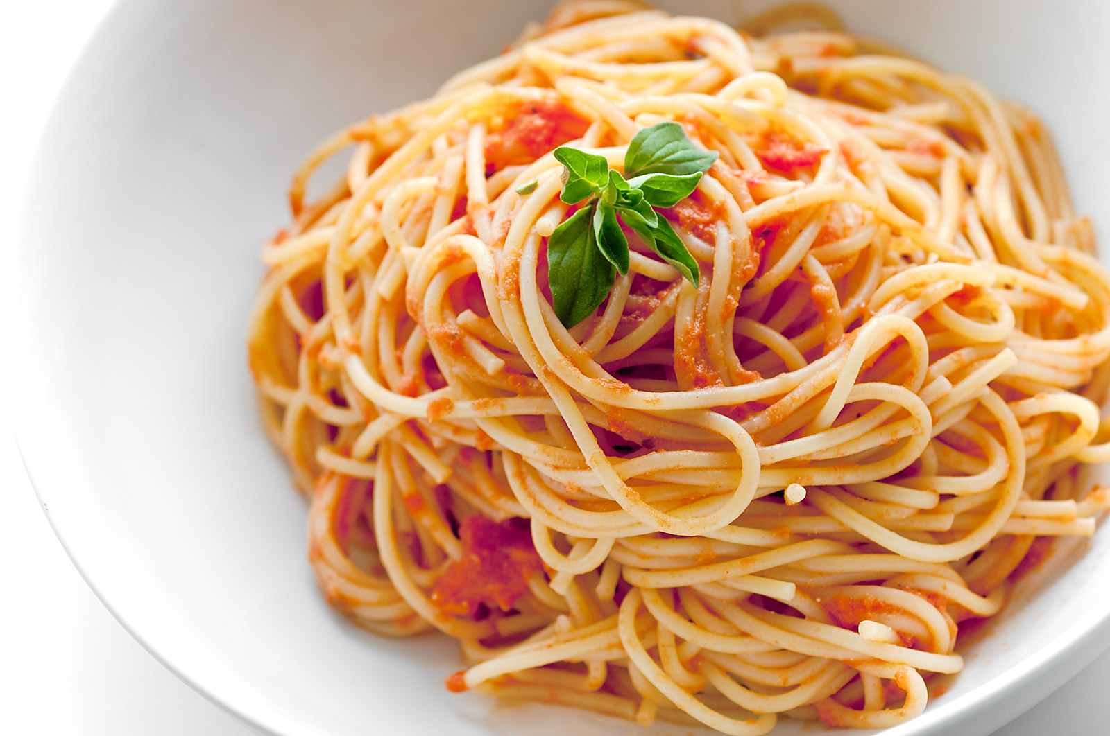

Material 2-4
Word flash cards

1. chop
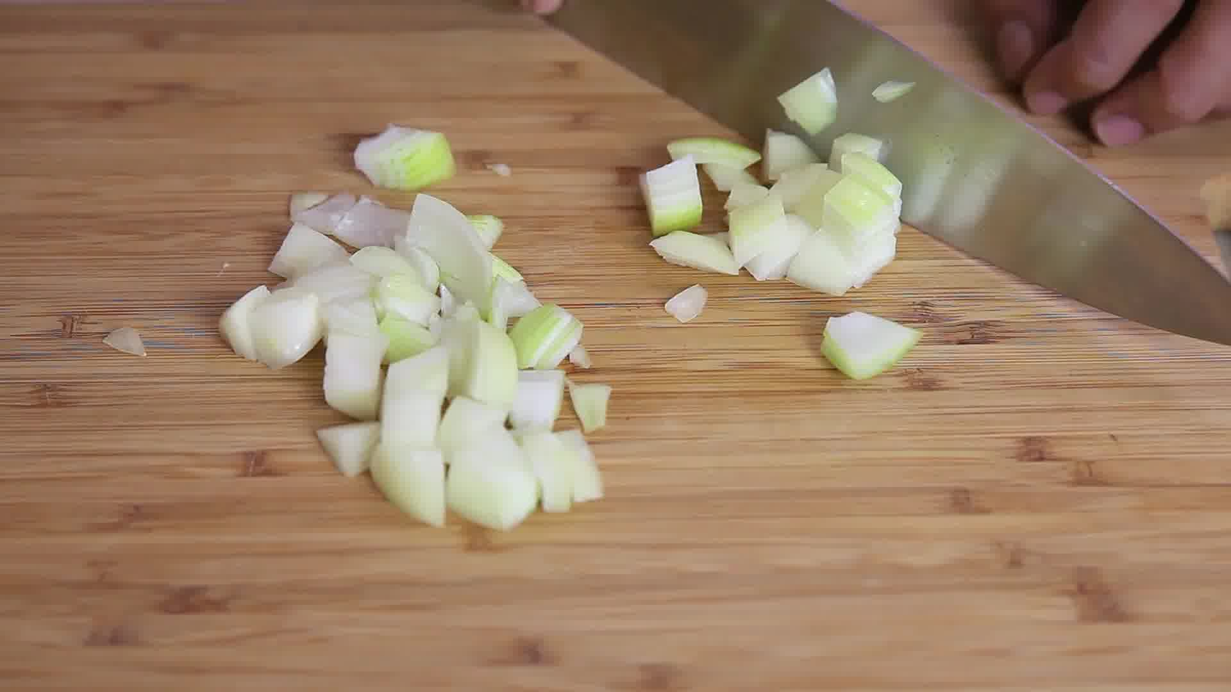

2. in half
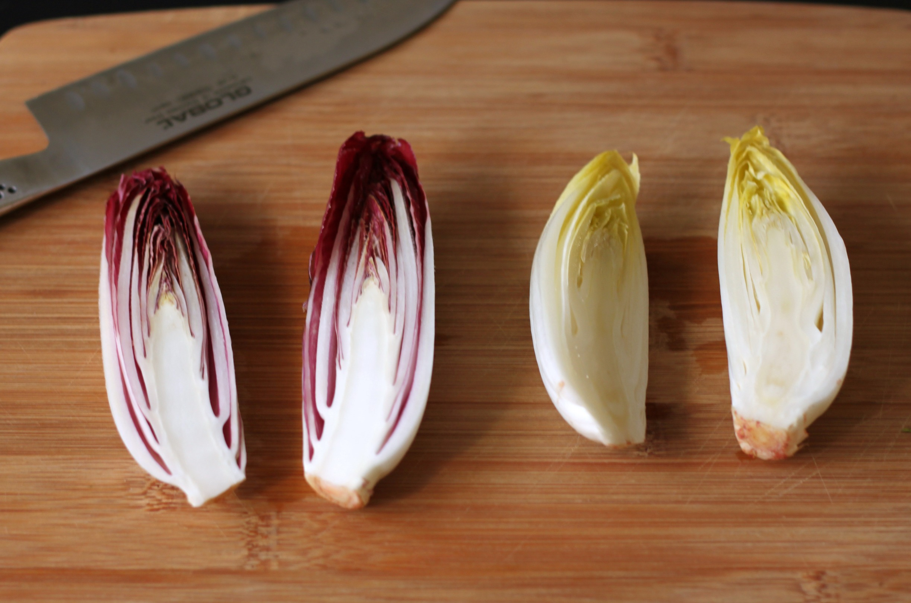

3. slice
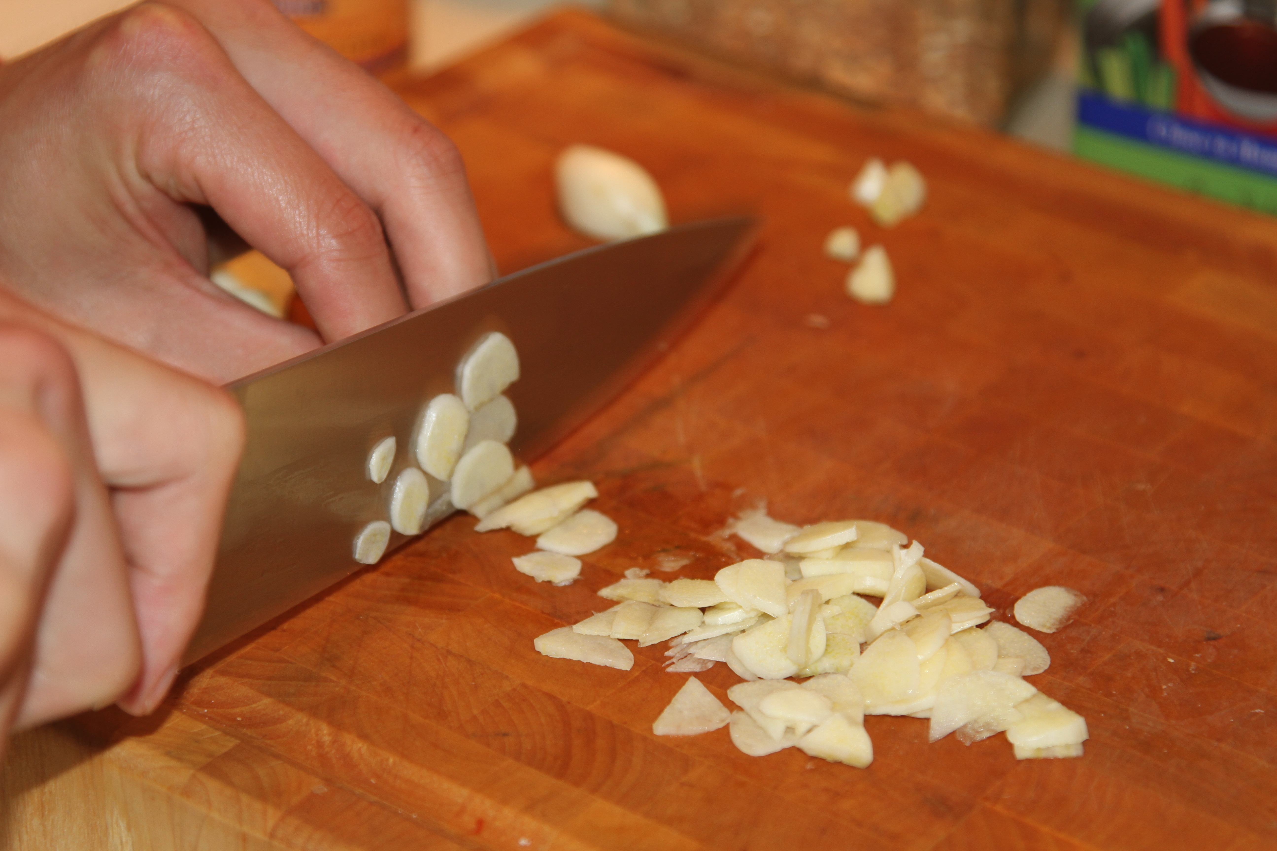

4. peel

5. pinches of
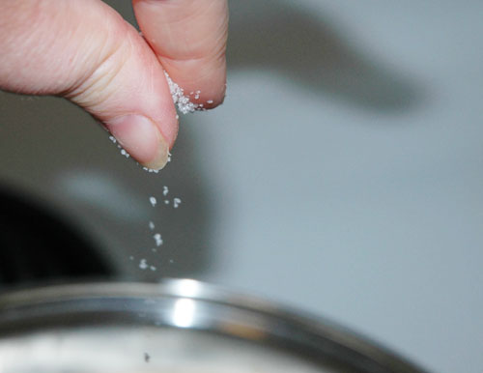

5. stir
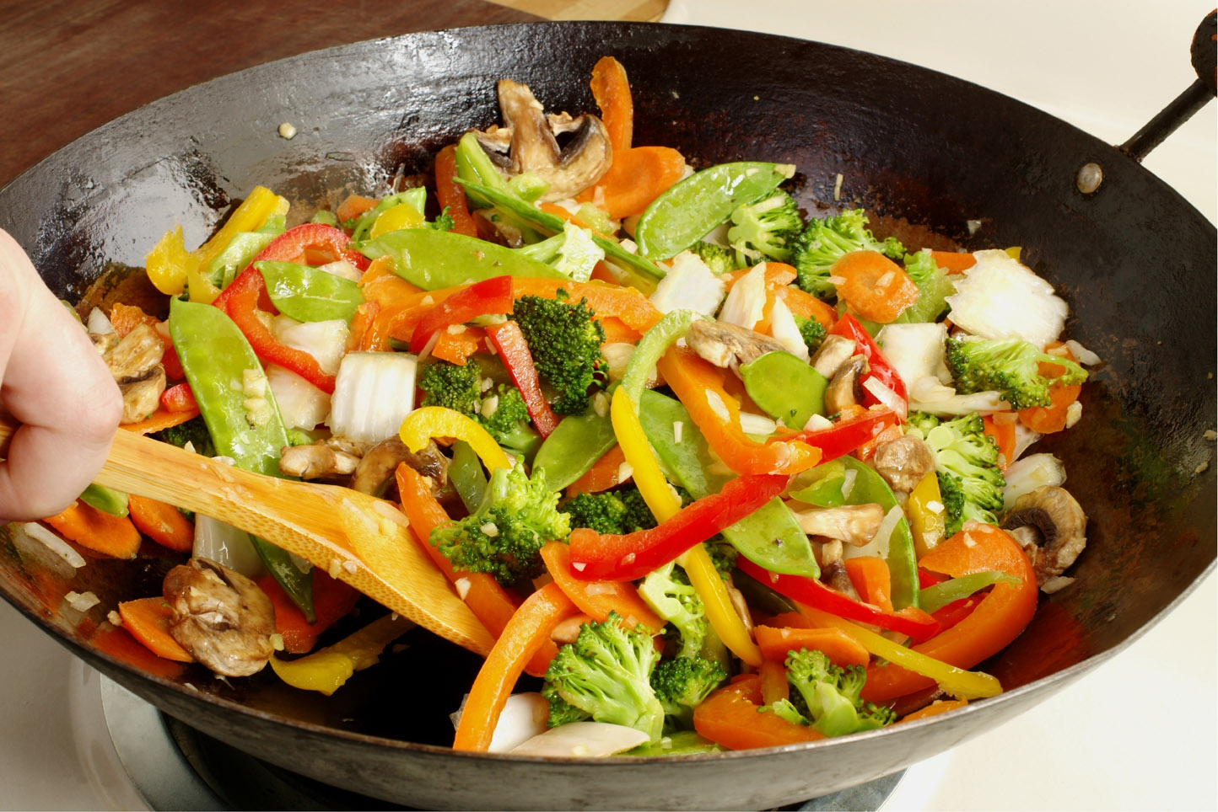

6. drain
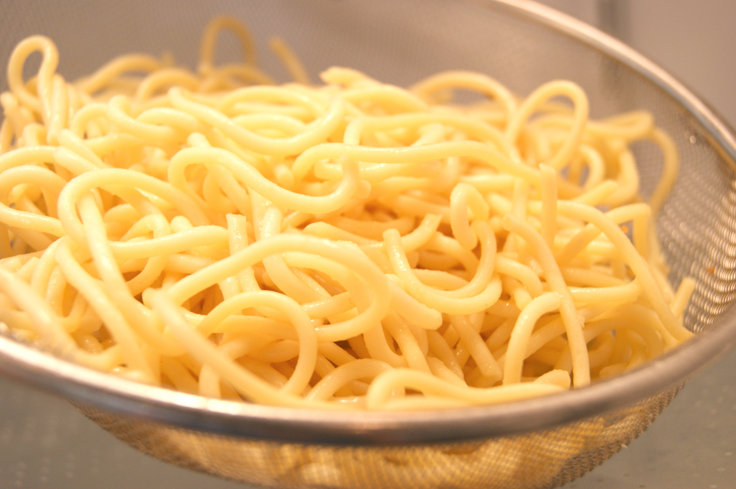

7. squeeze
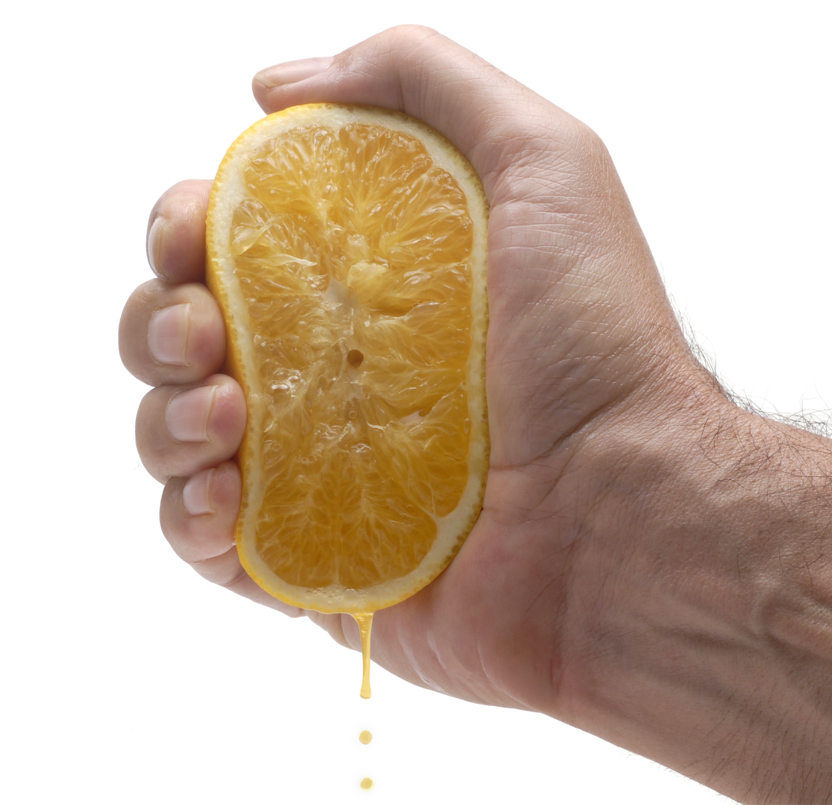

8. tip
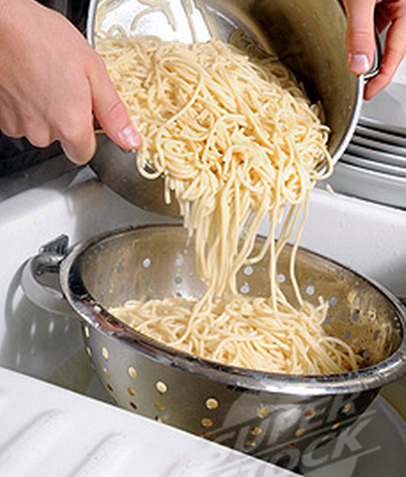

Material 3-4
Pictures of food ingredients
