□ Listening ■ Speaking □ Reading □ Grammar □ Writing

Topic: Facebook and twitter – Social networking

Instructor:  Jung, Dasom(Som), Penny Yun | Level:  Intermediate(Adults) | Students:  12 students | Length:  30 minutes

Materials:
- Realia - some pictures of social networking
- White board and board markers
- Meaning match worksheet (12 copies)
- Fill in the blanks worksheet (12 copies)
- A piece of paper and a pen, poster(for each group and pairs)
- Computer for watching video(about 2minutes)

Aims:
- Main aim: Ss will be able to improve their language skills by speaking and
understanding topic at the same time.
- Secondary aim: Ss will be able to learn vocabulary by doing activities.
(Meaning match, discussion, fill in the blanks)
- Personal aim: I want them to be more confident in using the English language
and be able to speak fluently.

Language Skills:
- Reading: Ss will read worksheets.
- Listening: Ss will listen to the video about social networking.
- Speaking: Ss will discuss and present about the advantages and disadvantages of using social networking sites.
- Writing: Ss will write their comments on the topic.

Language Systems:
- Phonology: /r/, /l/ and /f/, /p/
- Lexis: New vocabulary used in the dialogue:
(acronym, threaten, juvenile, bully, detective)
- Function: Presenting the topic
- Grammar: Preposition + noun
- Discourse: Discussion

Assumptions:
Students already know:
- They know how many classmates they have in the class.
- All students know some examples of social networking sites.
- They have an opinion about the advantages and disadvantages of using social networking sites.

Anticipated Errors and Solutions:
- If students don’t understand the meaning of the vocabulary such as acronym, juvenile, bully etc.
→ Students will learn new vocabulary before activity.
- If students can’t complete the matching activity at the first time.
→ Teacher will guide and give some tips to the students.
- If students discuss loudly.
→ Ask them to keep their voice down.

References:
- Visual aid - pictures of social networking site(https://www.google.co.kr)
- Video file - http://youtu.be/7zp0MQiknxg
- Vocabulary definition – http://endic.naver.com

Lead-In
Materials: None
Time | Set Up | Student Activity | Teacher Talk
1min | Whole  class | Answering teacher’s questions | Hello everyone!  How was your weekend?  What is something that we do every day?  What are the most creative things these modern days?  Do you like sharing your photos and thoughts with your friends?

Pre-Activity
Materials: Board, board markers, visual aid, worksheet #1, poster
Time | Set Up | Student Activity | Teacher Talk
3min  3min  2min | Whole  class  Pairs  Whole  class | Answers elicited questions  Students check answers and learn the vocabulary | Procedure :  1. Brainstorming  Elicit  (Show the students visual aid-picture from google without telling the name.)  What do you see?  Have you ever joined this before?  Model  Write the name “Social networking” on the board.  CCQ  Is it time-consuming?  Is there any chance to get addicted of it?  Do we social network in person?  2. Idioms  Instruction  “I’ll give a worksheet of acronym.  By the way, what is acronym? Firstly, read the meaning of the words and match the meaning on the worksheet. Work in pairs. I’ll give you 3minutes to finish.”  (Distribute the worksheet #1)  “Guys, please don’t start yet.”  Demonstration  Look at #1… “Yes, that's right, it means… ”  ICQ  Do you work alone or in pairs?  How much time do you need?  “Let’s begin.”  Monitoring  Monitor discreetly. Answers students if they ask questions.  Give time warning :  2minutes; 1minute left.  (Be flexible with time. Give 1 more minute if they need it.)  “Time is up.”  Check answers  Let’s check the answers together.  (Call out two teams write their answer on the poster.) Go through the sentences one by one.  Explain the meaning and teach pronunciation if necessary.  “All right, well done, guys.”

Main Activity
Materials: Board, board marker, a piece of paper, a pen, poster
Time | Set Up | Student Activity | Teacher Talk
2min  6min  4min | Group  Group  Whole  class | Students start discussing about the advantages and disadvantages of using social networking sites  Students think about their opinion | 1. Prediction  Today’s topic is social networking.  (Write the topic on the board.)  Instruction  “We’re going to have a discussion in two groups. Group A and B will discuss about the advantages and disadvantages of using social networking sites and then decide group’s conclusion. After the discussion, in each group, one person will report to the class. I will give you 6minutes to discuss.”  ICQ  Do you need to write about your  group’s opinion on the poster?  Do you choose one person to report to  the class?  Do your group need to decide a  conclusion?  “Let’s discuss.  Monitoring  Monitor discreetly. Answers students if they ask questions.  Give time warning :  2minutes; 1minute left.  (Be flexible with time. Give 1 more minute if they need it.)  “Time is over.”  Feedback  “It’s time to listen to each group’s  conclusion. Please come to the front  and report your results. Speak loudly  and clearly. Other students must pay  attention to the reporter.”

Post Activity
Materials: Computer for watching video, a piece of paper, a pen
Time | Set Up | Student Activity | Teacher Talk
3min  4min  2min | Individually  Individually  Whole  class | Writing  Answers elicited questions of today’s lesson | 1. Free production  (Watching video and writing comments)  Instruction  “As you watch the video, pay close attention to the speaker. After watching the video, you will write comments. “  (Distribute a piece of paper)  (Watching video for about 2minutes)  “Let’s make a comment together.  This is my comment about the video. (Read the comment to the students) You make your own comment for 2minute.”  ICQ  Are you working in group?  How many minutes do you have?  “Let’s start.”  Monitoring  Monitor discreetly. Answers students if they ask questions.  Feedback  “Let’s talk about your comments.”  (Call out the two students)  2. Conclude Lesson  Elicit today’s vocabulary for  students and make corrections  about mispronounced words such as  ‘juvenile, bully’ and incorrect  grammar that students often make.  Also, review about the pros and cons  of using social networking quickly.  “We talked about social networking,  Sometimes it is useful for people ,  but it can be very harmful. Please try  to remember what we have learned  today. Using it wisely. Thank you for  your attention. You guys did a great  job today. See you tomorrow.”

SOS Activity
Materials: Worksheet #2
Time | Set Up | Student Activity | Teacher Talk
3min  2min | Pairs  Whole  class | Watching and fill in the blanks  Students check answers read each sentences | 1. Fill in the blanks  Instruction  “Now, we’re going to watch the video  one more time. You have to complete  the worksheet with the correct words  while watching. Please work in pairs.  ”  (Distribute the worksheet #3)  ICQ  Do you work alone or in group?  Do you complete the worksheet while you’re watching or after watching?  (Teacher plays the video file. Let students complete the worksheet as they listen.)  “Do you need to listen again?”  If yes, play it once again.  Check answers  “Let’s check the answers together.  Please read aloud each sentences  slowly and correctly.”  Teacher tells students the correct  answer as soon as they answer.

Visual aid



Worksheet #1
◈ Read the meaning of the words and match the correct acronym.
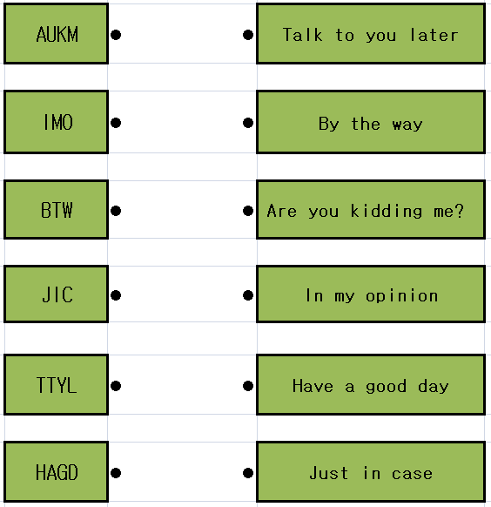

Worksheet #2
◈ Read the meaning of the words and complete these sentences using the correct form of words from the box.
threaten / juvenile / memorial / bully / detective

1. A ________ is a child or young person who is not yet old enough to be regarded as an adult.
Ex) There is a growing second conviction rate for ________ offenders.

2. A _________ is someone who uses their strength or power to hurt or frighten other people.
Ex) He’s a _________ and he’s been bothering me.

3. A _________ is someone whose job is to discover what has happened in a crime or other situation and to find the people involved.
Ex) They hired a private _________ to find their missing child.

4. If a person _________ to do something unpleasant to you, or if they _________ you, they say or imply that they will do something unpleasant to you, especially if you do not do what they want.
Ex) He had something on me and used it to _________ me.

5. A _________ event, object, or prize is in honor of someone who has died, so that they will be remembered.
Ex) The man is kneeling in front of the _________.

