XListening/Speaking Reading Grammar Writing
Topic: For The Birds
Instructor:  Roxanne | Level:  Pre-Intermediate | Students:  9 | Length:  50 Minutes
Materials:
- White Board And Markers
- “For The Birds” Video Clip
- Laptop
- Animal Cards
Horse
Tiger
Pig
Bird
Rabbit
Dog
Cow
Hen
Bear
- “For The Birds” Work Sheet
Aims: (What students will be able to achieve by participating in the activities of the lesson.)
- Ss are interested in lesson by observing teacher and listening to teacher’s story and students’ ideas.
- Ss learn new vocabularies by doing activity and describing.
- Ss practice speaking by discussing their opinion which is related to the activity.
- Ss get the information about animals idiom.
Language Skills: (Lists what language skills students will be using by participating in the activities of the lesson.)
- Speaking: describing, presentation, answering teacher.
- Listening: teacher talk, during the describing and presentation, discussion.
- Reading: vocabulary.
- Writing: taking dictation.
Language Systems: (Lists what language systems students will be using by participating in the activities of the lesson.)
- Phonology: presentation, discussion, teacher talk.
- Function: prediction. discussion
- Lexis: vocabulary, adjective.
- Grammar: using completed sentences on the presentation.
- Discourse: group discussion, responding the teacher.
Assumptions: (What students must already be able to do and what concepts must already be mastered before the lesson in order to achieve the aims of the lesson.)
- Ss know teacher’s style of teaching.
- Ss will be able to predict the story.
- Ss will be able to express their ideas and opinions in English.
- Ss wonder what the origin of words.
Anticipated Errors and Solutions: (What things might go wrong in the lesson and what the solution will be)
- If Ss may not be able to express. ☞ Solution: T gives them little examples.
- If Ss may not be able to catch details from the video clip ☞ Solution: Let Ss share their ideas.
Play the video clip one more time.
-If Ss can’t finish the task in time ☞ Solution: Give them extra time to finish the task.
- If Ss do their works earlier than planed ☞ Solution: Let them share ideas.
References:http://blog.naver.com/angelpyj2/120189455625

Lead-In(Warm-Up Part to activate and create interest in the lesson) 10 minutes
Materials:
- Animal Cards
Horse
Tiger
Pig
Bird
Rabbit
Dog
Cow
Hen
Bear
Time | Set Up | Student Activity& Goals | Teacher Procedures and Instructions actions
1min  3min  5min  1min | Whole  Whole  Ss  Ss | Ss greet the teacher.  Ss listen to teacher.  Ss talk their ideas.  Ss become interested in the  Activity. | Greeting.  Tell T’s stories related to picture cards.  Elicit the ideas from Ss.  T mentions a possible activity about “For The Birds”

Pre-Activity(Presentation Part Presenting the language structure to be covered in the lesson) 10 minutes
Materials:- “For The Birds” Work Sheet
Time | Set Up | Student Activity& Goals | Teacher Procedures and Instructions
3min  2min  3min  2min | Whole  Group  Group  Whole | Ss listen what T says.  Ss move into group and make turns.  Ss predict what will happen  In the picture.  Ss discuss the story. | Introduce the activity and describe setting.  Divide Ss into group and hand out the work sheet.  T encourages Ss to predict what the story will be.  T mentions next activity.

Main Activity(Practice to Production Part Teacher lead practice of the language presented) 20 minutes
Materials:
- “For The Birds” Video Clip
- Laptop
- “For The Birds” Work Sheet
Time | Set Up | Student Activity& Goals | Teacher Procedures and Instructions
1min  5min  6min  3min  5min | Whole  Group  Whole  Group  Whole | Ss listen and get ready for activity.  Ss do activity; 2 Ss watch the video clip and describe the scene, 1S just listen and summarize the story.  Ss present the summarized story and watch the video clip all together.  Ss discuss what will happen next.  Ss share their ending story and watch the ending scene all together. | T gives instruction to start the activity.  T turns on the video clip.  T monitors and gives encouragement.  T gives encouragement to presentation.  T turns on the video clip.  T monitors and gives encouragement.  Congratulate and thank Ss; give Ss positive feedback.

Post Activity(Wrap-Up Part Close the Lesson on a high note to consolidate language learned)10 minute
Materials:- White Board and Markers.
Time | Set Up | Student Activity | Teacher Procedures and Instructions
3min  6min  1 min | Whole  Whole  Whole | Ss discuss the title of the video clip.  Ss listen and give ideas.  Ss listen and say bye to T. | T gives example to Ss.  T explains the origin of the “For the birds” and apply the words in situation.  Close by giving Ss feedback about their ideas and improvement and thanking Ss.

Picture Cards

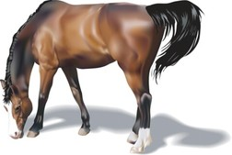

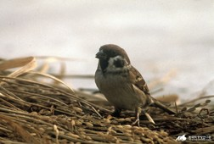
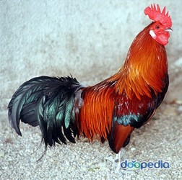

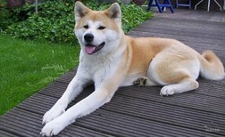

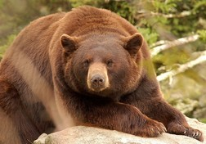

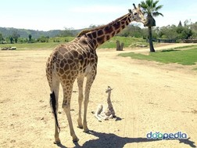
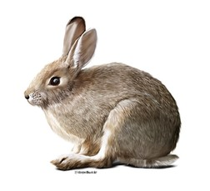
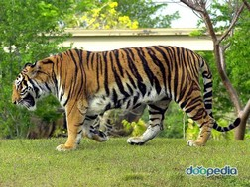

“For The Birds” Work Sheet

- Watch the video clip and Summarize the story. What is in the clip? What happens?

- Discuss what will happen next?

?

