Listening/Speaking X Reading Grammar Writing
Topic: The Loyal Friend
Instructor:  Roxanne | Level:  Intermediate | Students:  8 | Length:  50 Minutes
Materials:
- White Board and Markers
- Key Word Train
- Key Word Pocket
- “Hachico: The Loyal Friend” Text Sheet
- “My Loyal Friend” Pictures
- Laptop
- “Hachico: The Loyal Friend” Video Clip
Aims: (What students will be able to achieve by participating in the activities of the lesson.)
- Improve reading skills by reading text sheet.
- Improve listening and speaking ability by listening to T and discussing with Ss.
- Discuss each other through the activity.
Language Skills: (Lists what language skills students will be using by participating in the activities of the lesson.)
- Speaking: Sharing Ss’ ideas, answering T, Ss presentations.
- Listening: T talk, Ss talk, Ss presentations.
- Reading: Text sheet
- Writing: Writing end of the story.
Language Systems: (Lists what language systems students will be using by participating in the activities of the lesson.)
- Phonology: Discussion, T talk and Ss talk, discussion
- Function:
- Lexis: Vocabulary
- Discourse: Group discussion, responding the T, activity.
Assumptions: (What students must already be able to do and what concepts must already be mastered before the lesson in order to achieve the aims of the lesson.)
- Ss know teacher’s style of teaching.
- Ss know the meaning of the loyal friend and have experiences with loyal friend.
- Ss will be able to express their ideas and opinions in English.
Anticipated Errors and Solutions: (What things might go wrong in the lesson and what the solution will be)
- If Ss may not be able to express. ☞ Solution: T gives them little examples.
- If Ss can’t finish the task in time ☞ Solution: Give them extra time to finish the task.
- If Ss do their works earlier than planed ☞ Solution: Let them share ideas.
References: App - The Little Fox

Lead-In(Warm-Up Part to activate and create interest in the lesson) 10 minutes
Materials:
- “My Loyal Friend” Pictures
- Key Word Train
- Key Word Pocket
Time | Set Up | Student Activity& Goals | Teacher Procedures and Instructions actions
2min  5min  3min | Whole  Whole  Ss | Ss greet the teacher.  Ss listen to teacher.  Ss share Ss thinking. | Greeting.  T asks Ss to predict T’s story through the Key Word  Train and tells the story about “My Loyal Friend”.  T asks Ss to share their thinking about loyal friend.

Pre-Activity(Presentation Part Presenting the language structure to be covered in the lesson) 13 minutes
Materials:
- White Board And Marker
Time | Set Up | Student Activity& Goals | Teacher Procedures and Instructions
7min  3min | Whole  Whole | Ss tell their story about loyal friend.  Ss listen to what T says. | T asks to share Sss’ loyal friend story.  T gives another example about loyal friend stories.

Main Activity(Practice to Production Part Teacher lead practice of the language presented) 24 minutes
Materials:
- “Hachico: The Loyal Friend” Text Sheet
Time | Set Up | Student Activity& Goals | Teacher Procedures and Instructions
1min  3min  10min  4min  3min  3min | Whole  Group  Group  Whole  Group  Whole | Ss listen and get ready for activity.  Ss move into 2groups and make turns.  Ss do activity; read the text for each S and make one story by uniting the each text.  Ss present their story.  Ss predict and discuss the end of the story.  Ss present their ending story. | T gives instruction to start the activity.  T divides Ss 2groups and gives information about the activity.  T hands out “Hachico: The Loyal Friend” Text Sheet.  T monitors each Sss’ part of the text sheet.  T gives encouragement to present.  T gives example and encouragement.  Congratulate and thank Ss; give Ss positive feedback.

Post Activity(Wrap-Up Part Close the Lesson on a high note to consolidate language learned)10 minute
Materials:
- Laptop
- “Hachico: The Loyal Friend” Video Clip

Time | Set Up | Student Activity | Teacher Procedures and Instructions
2min  4min  5min  1 min | Group  Whole  Whole  Whole | Ss listen and say bye to T.  Ss predict and discuss the end of the story.  Ss present their ending story.  Ss watch the video clip and check the real story.  Ss listen to T. | T gives example and encouragement.  T encourages Ss ideas.  T turns on the video clip and tell about the real story.  Close by giving Ss feedback about their ideas and improvement and thanking Ss.

“Hachico: The Loyal Friend” Text Sheet

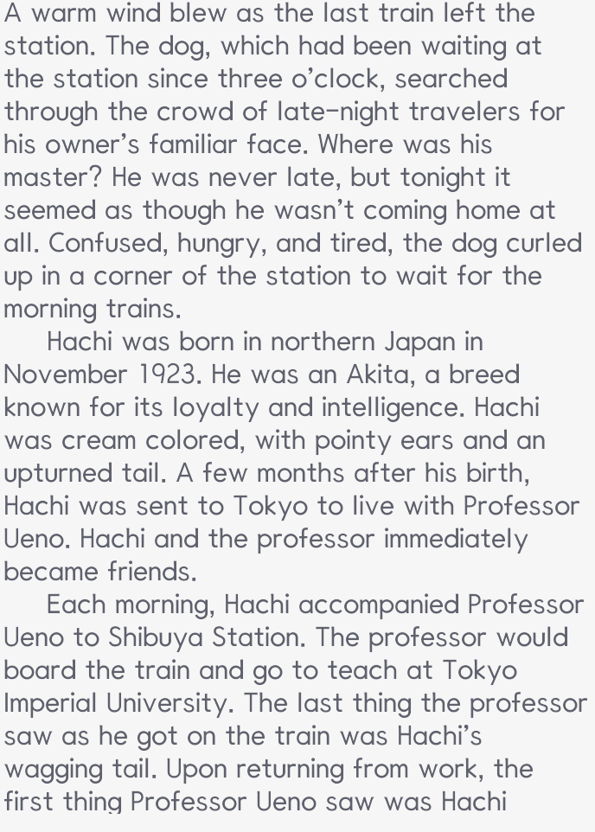
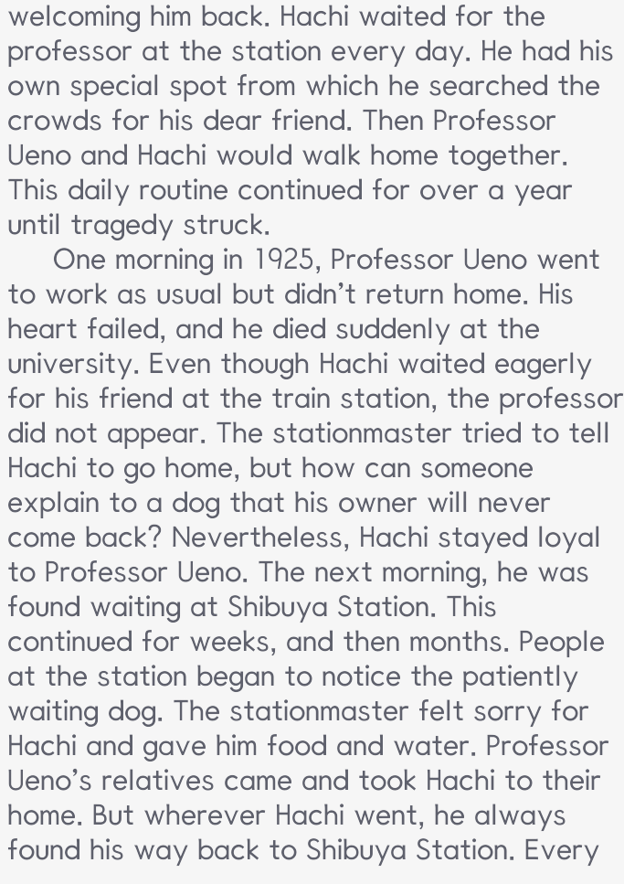
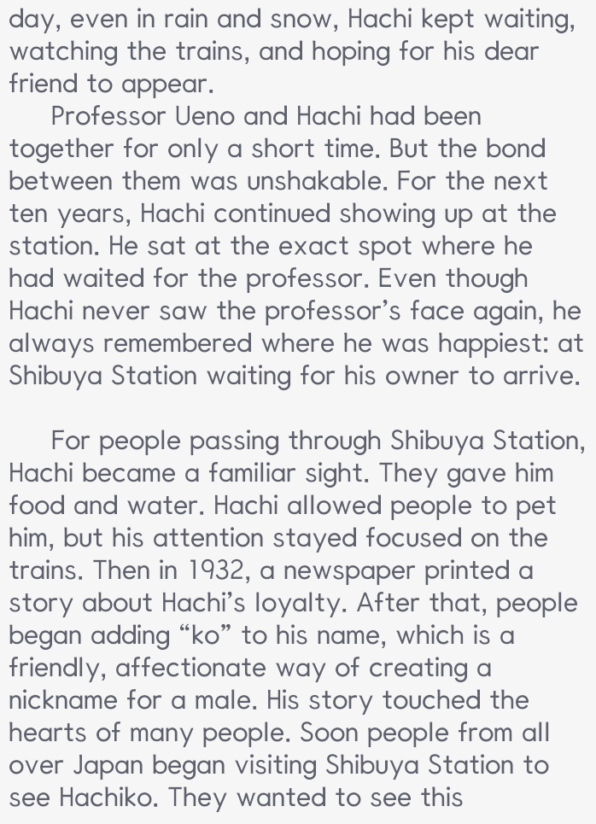

“My Loyal Friend” Pictures

Key Word Train & Key Word Pocket

