Worksheet #1 Name:

"Stronger” by Kanye West
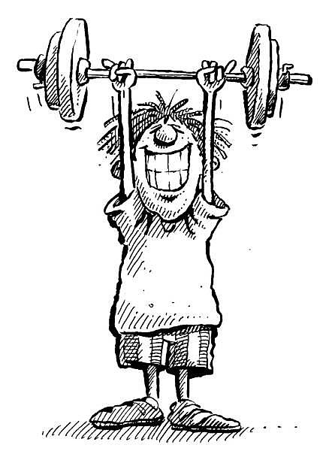

Work it, make it, do it,
Makes us _______, ________,
_______, ________!
Na-na-na that that don't kill me
Can only make me ________
I need you to hurry up now
'Cause I can't wait much ________
I know I got to be right now
'Cause I can't get much ________
Man I've been waiting all night now
That's how long I've been on ya.

I need you right now
I need you right now
Let's get lost tonight
You could be my black Kate Moss tonight
Play secretary, I'm the boss tonight
And you don't give a fxxx what they all say right?
Awesome, the Christian and Christian Dior
Damn, they don't make 'em like this anymore
I ask 'cause I'm not sure
Do anybody make real shxx anymore?
Bow in the presence of greatness
'cause right now thou hast forsaken us
You should be honored by my lateness
That I would even show up to this fake sh**
So go ahead go nuts go ape shit
Especially in my pastel on my bape sh**
Act like you can't tell who made this
New gospel homie, take six, and take this, haters
Na-na-na that that don't kill me
Can only make me ________
I need you to hurry up now
'Cause I can't wait much ________
I know I got to be right now
'Cause I can't get much ________
Man I've been waiting all night now
That's how long I've been on ya.
I need you right now
I need you right now
Me likey

Worksheet #2 Name:

Business Comparisons

Can you guess the missing comparatives?

1. Writing an email is ________________than writing a letter.

2. Using emoticons is __________________ than using abbreviations and acronyms.

3. Writing an SMS with your thumb is ___________________ than writing an email on a computer keyboard.

4. Cancelling a meeting by texting someone is ___________________ than cancelling a meeting by leaving an answer on their answer machine.

5. A polite email to a client is usually __________________ than an informal email to a colleague.

6. An SMS is usually __________________ than an email.

7. A memo is __________________ than a company newsletter.

8. BCCing someone is __________________ than CCing someone.

9. Sending a signed contract by a courier is __________________ than faxing a signed contract.

10. Speaking to someone directly is __________________ than speaking to someone on the phone.
Worksheet #3 Name:

Practice activity for comparing
Please choose one topic that you’d like to share with the class. Incorporate the comparative adjectives in your sentences.
Discuss with your partner.

- The past and present
- The past and future
- Things (transport, infrastructure, lifestyles, etc) in two places
- Jobs
- Genders
- Generations
- Famous people
- Weeks or weekends
- Routines
- Products
- Holidays
- Ways of learning language

