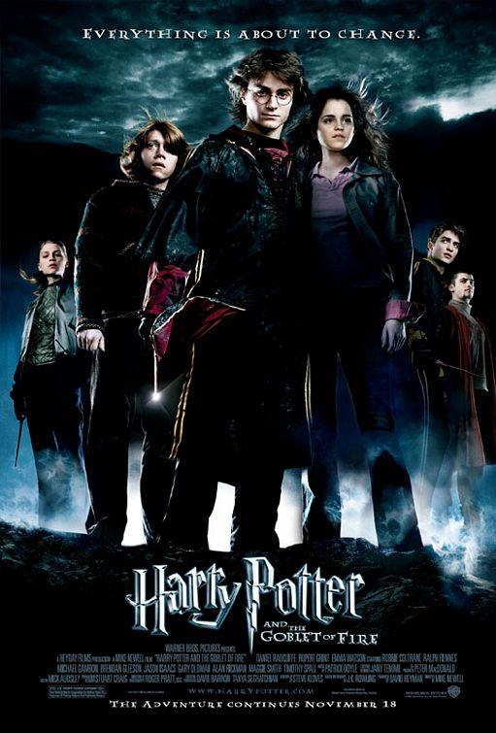
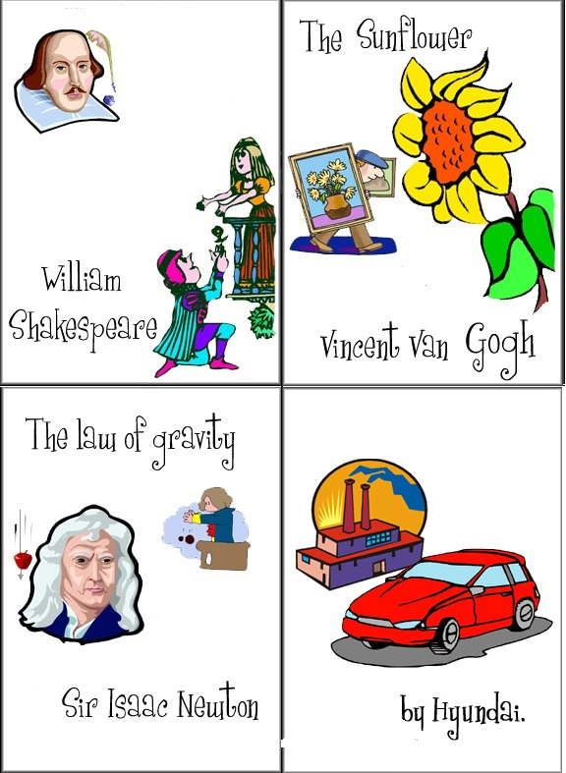
Word order
NAME
1) were the thieves caught
?
2) always the tests in the language lab are written
?
3) my apology accepted be will
?
4) are found eagles in Alaska
?
5) for the World Exhibition was built the Eiffel Tower in 1889
?
6) will be replaced the workers by computers
?
7) be cooked beans and carrots together can
?
8) the accident was yesterday by the police seen
?
9) opened the first underground railway was where
?
10) the books going to returned be to the school are
?

Answer sheet
NAME

1) Were the thieves caught?

2) Are the tests always written in the language lab?

3) Will my apology be accepted?

4) Are eagles found in Alaska?

5) Was the Eiffel Tower built for the World Exhibition in 1889?

6) Will the workers be replaced by computers?

7) Can beans and carrots be cooked together?

8) Was the accident seen by the police yesterday?

9) Where was the first underground railway opened?

10) Are the books going to be returned to the school?

