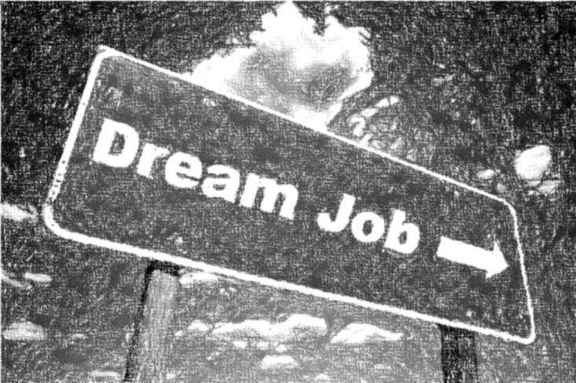  MY … | NAME | JOB INFORMATION
- JOB
- INCOME
- ADVANTAGE

- DISADVANTAGE

- HOW CAN YOU BECOME

- Why?

