Worksheet # 2
** AT / IT / ON Table

5 o’clock
6

Monday, New Year’s Day
Dec 31st
My birthday
6

2 weeks
1987
1980’s

** Exceptions: ( ) the morning, ( ) the evening, ( ) night, ( ) 5 minutes

** Think about the moment that you want to time travel.
Worksheet # 1
Q. What time was it?
: ( ) ( ) PM/AM
Q. What date was it?
: ( ) ( ) ( )
나 갈래~!!
I want to go ~~!!
Q. What day was it?
: ( )( )
Q. What year is it?
: ( )( )
Q. When is it?
:
** Draw about your time travelling moment~!
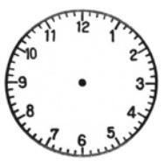

** Let’s interview friends what moment they want to go back and why they want to go.
Worksheet # 3
“Memorable moments of your friends”
Name of Friends | Moment | Reason | Time  (at) | Date  (on) | Year  (in)
Tim’s happiest moment was
at 6PM
on Sunday evening of Dec 31st
in 1996.
Because…
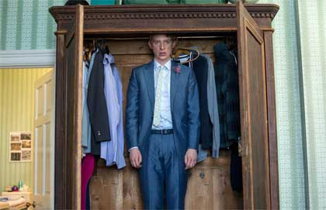
When is the moment that Tim wants to go back?

** Fill in the black !
Worksheet #4
{AT , ON , IN }
"What do you usually do ( ) weekend?"
"My grandfather is coming to Germany ( ) March."
School starts ( ) 8.40.
"The next party is ( ) Friday 17 December."
"I don't like working ( ) the morning."
"She was born ( ) 1981."
"My birthday is ( ) August!"
"When do you get up ( ) Christmas?"
"I often go to bed late ( ) night."
"She's living in a hotel ( ) the moment."

