Listening Lesson Plan
Title: El Dorado

Instructor:  Torah | Level:  intermediate | Students:  9 | Length:  40minutes

Materials:
-1 mp3 file (‘El Dorado’ by Goombay Dance Band)
-Laptop computer and screen
-6 pictures (p1~p6)
-9 copies of listening comprehension for a main idea worksheet
-9 copies of listening comprehension for details worksheet
-9 copies of the pieces of paper for post-activity
-a white board and a marker
-a cell phone

Aims:
∙Students will learn key words and figure out them by playing a game in pre-activity.
∙Students will comprehend the main idea by listening to music and solving worksheets for themselves.
∙Students will create their own lyrics by referring to original lyrics.
∙Students will discuss their own main idea by the course of writing lyrics in post-activity

Language Skills:
1) Listening: Listening to music and teacher’s explanation of key vocabularies.
2) Speaking: Explaining key vocabularies during pre-activity
3) Reading: Reading to complete the worksheet
4) Writing: Writing the lyrics again during post-activity
Language Systems:
1) Grammar : How to use ‘have + p.p’
2) Function : The proper use of key words in particular lyrics
3) Discourse : Interaction with their own group through post-activity.

Assumptions about Students:
1) Students can communicate with other classmates
2) Students are not used to their teacher’s teaching method
3) Students are good at listening basically
4) Most of students are good, but don’t respond immediately

Possible Problems and Solutions:
1) Unless students know the background of the lyrics, I will explain it as long as it doesn’t disturb the class.
2) If time is not enough, I’ll make just one group presenting their work during post-activity.
3) If it is finished earlier, I’ll divide students into three groups during post-activity.
4) If some students have already known this song and they feel bored, I’ll give them a chance to talk about it for a moment.

References:
∙http://blog.naver.com/PostView.nhn?blogId=bluefishtank&logNo=140157271936&redirect=Dlog&widgetTypeCall=true#
∙http://www.eldorado29.com/m/post/429
∙http://www.altzar.org/2011/Images/conquistador-on-horse-fighting-two-incas.jpg
∙http://socobroker.com/post/3350287/watching-an-agent-drown-in-a-glass-of-water
∙http://omsine.com.ne.kr/history/pyramid.htm

Lead-in:
Materials: Laptop and screen, a white board and marker
Time | Set Up | Procedure
2 min | Whole Class | ∙Greeting  Good morning, everyone. How are you today? (students answer) Good. Thanks.  ∙Lead-in  Let me show one picture before class. Look at this picture. (show p1 on the screen)What do you think? It looks very splendid, isn’t it? But is that all? Here is the song related to this picture. Today, I would like you to learn new fact as listening to the song.

Pre-activity:
Materials: Laptop and Screen
Time | Set Up | Procedure
4 min  5 min | Whole Class  Group Work | ∙Pre-teaching  Before listening, let’s check 5 key words. I will show 5 pictures to you.  (p2) Look at the first picture of them. This is a city of gold in legend. Also, it is the title of the song we are going to listen soon. It is called El dorado. After looking at this picture, you can guess the topic of the song listening to music.  But the origin of El dorado means the chief who was painted with gold power. (show p3)  (p3) It is said that they had something to yearn. ‘yearn’ is to last for something, or to want to something really. They yearned that something would come true sincerely through their chief. It is immortal life. (show p4)  (p4) They yearned immortal life which never dies such as Egyptian did. ‘Immortal’ is to live forever.’  (p5) Let’s look at the next picture. Yes, I know. You feel kind of cruel. Look at him especially. He is a conquistador. Conquistadors mean Spanish who invaded El dorado which was in Columbia. The citizen of El dorado suffered from everything cruel like …’drowning’ (show p3)  (p4) Anyone who drowns into the water must be painful. Look at this picture. If you drown into the water like this picture, you can have difficulty in breathing! Of course, ‘drowning’ is very brutal scene. So I pick up a little cuter picture. Haha…  ∙Pre-Activity  Well, We know these 5 key words now. So let me give you time to make sure them.  Instruction  From now, we can play a game! How about dividing two groups? (students can make two groups) Today we can do ‘speed quiz’. I want you choose one explainer of the words. If you are chosen as the explainer of each group, you will come here and turn the roulette on the screen. And then the explainer should explain the one word to the members of the group. Then, members can answer! But be careful! It is “Speed Quiz” So the group which can answer faster than the other group is the winning team. But I want you not to exceed 1 minute one group. I will give you 5 minutes for this game.  Demonstration  Look at this. You can see the roulette on the screen. So each explainer can turn it touching the laptop monitor like this. (show them to touch the laptop) Can you?  CCQ  1. What are you going to do?(Speed Quiz)  2. How much time do you have? (3 minutes) and how much time does each explainer explain one word? (1 minute)  3. Are you working individually or group? (Group)  Ok, now, begin!  Feedback  Good Job! Was it fun? I hope so.

Main Activity:
Material: Laptop, an Mp3 file for listening, worksheets for a main idea and details.
Time | Set Up | Procedure
3 min  8 min  2 min  4 min | Whole Class  individually  Whole Class  individually | Listening for the Main Idea  Now we are going to listen to music. It is ‘El dorado’ as I told you. It was in fashion for past 1980. I think some students are unfamiliar with it. But it is a kind of Disco so it’s very joyful. But Don’t be fooled by the rhythm. Please think the lyrics over and over listening to music.  Instruction  We are going to listen. Can you listen to the topic? Yeah, I think some student can, or the others can’t. Ok, now let me give you a worksheet. And then, you can listen to the song once. After or while listening, I am sure you can fill with the answers about the questions by yourself. You will have 5 minutes including the time to listening to music.  Demonstration  Look at number 1. 1. How do you feel while listening to music? Do you know what the answer is? There is no correct answer. See? In this worksheet, I want you to feel and think about this song freely and honestly.  CCQ  1. What are you going to do? (Answer in the worksheet)  2. How much time do you have? (5 minutes)  3. Are you working individually or in group? (individually)  Hand out worksheet  Ok, let’s listen carefully.  Monitor  (While listening, monitor students. After listening, walk around and monitor)  30 seconds left. You don’t have to write too long sentences.  Checking answers  Are you done? Ok, let’s check. First, No.1. AAA, What is your answer of no 1? (answer) Do you agree with her? Good. Next, BBB, What is your answer of no 2? (answer) Do you agree with her, guys? Good. Last, CCC, what is yours of no 3? (answer) Do you agree with him? Good.  Feedback  Wow, you all have creative and unique idea.  Listening for the details  Instruction  Now, I am going to give another worksheet. From now, you can listen to music one more time, and you can fill in the blanks by yourself. You are going to do just first verse of lyrics. You have about 3 minutes.  Demonstration  Look at this first blank. You can write one word you can listen while listening.  CCQ  1. What are you going to do? (Fill in the blanks)  2. How much time do you have? (3 minutes)  3. Are you working individually or in group? (individually)  Hand out worksheet  Ok, let’s begin.  Monitor  (While listening, monitor students. After listening, walk around and monitor)  Checking answers  You are done. Let’s check. DDD, What is fist blank? (answer) Do you agree everyone? (get one student to answer one blank over and over)  Feedback  You are great!

Post-activity:
Materials: two pieces of paper, several pens, cell-phone
Time | Set Up | Procedure
2 min  6 min  4 min | Whole Class  Group Work  Whole Class | Production : Discussion and Trying writing lyrics  Instruction  El dorado is an exciting song definitely. But ironically, the lyrics include one of the saddest things in history. I am sure that you have many sad stories of your life. At school, at work, and so on..Well, you can divide two teams. I will give you one piece of paper one team. Please share your idea and decide one topic that everyone can sympathize. You can have 6 minutes you can be lyricist.  Demonstration  For example, your boyfriend has put you to any trouble recently. You can change lyrics from ‘they came 500 years ago, they stole the gold of Mexico’ to ‘Tom came just 1 year ago. He stole my heart from me’. It is just an example.  CCQ  1. What are you going to do? (write lyrics again with our own experiences)  2. How much time do you have? (6 minutes)  3. Are you working individually or in group? (group)  Hand out the piece of paper  Let’s begin!  Monitor  (Walking around students and taking notes for errors)  30 seconds left.  Feedback  (correct errors)  You are much better that I thought!  ∙Giving Homework  Instruction  Today you can be a lyricist. I think you felt funny. So today as your homework, write lyrics your own life by yourself, not in group. And record your reading or singing of your lyrics and send this recording to me through your cell phone. It is due to next Tuesday.  Demonstration  Let me tell you how to send your homework. Look at this. Here is my cell phone. You can find something to record on the wallpaper of your cell phone like this. If you find it, you enter it, and press a button to record like this. (show how to record)  CCQ  1. What are you going to do? (write lyrics and send recording)  2. When is it due? (next Tuesday)  3. With whom are you working? (individually)  Closing  Today we listen to El dorado and think of the lyrics. It is important to figure out the topic of the song. But it is worth to create something by yourselves above everything else.  Thank you for your participation.  Bye

Appendix

Script
They came 500 years ago
They stole the gold of Mexico
Killing people one by one
Only talking with their guns
Brave men locked on iron chains
All young mothers sold as slaves
Babies crying through the night
Will they ever see the light
Golden dreams of Eldorado
all have drowned in
seas of pain and blood
Golden dreams of Eldorado
May come true but only in your heart
Reach out your hands and you’ll be free
And we shall live in liberty
Oh will mankind ever learn
Shall the whole world die and burn
Golden dreams of Eldorado
all have drowned in
seas of pain and blood
Golden dreams of Eldorado
May come true but only in your heart
Within the memory of man
The search for happiness
has never ended
But the gates of Eden
will ever be closed
for those conquistadors
who are only hungry for power and might
Because the real Eldorado
isn't made out of diamond or gold
it's the immortal yearning for peace
love and understanding
in the hearts of everyone
Golden dreams of Eldorado
all have drowned in
seas of pain and blood
Golden dreams of Eldorado
May come true but
only in your heart

Picture 1
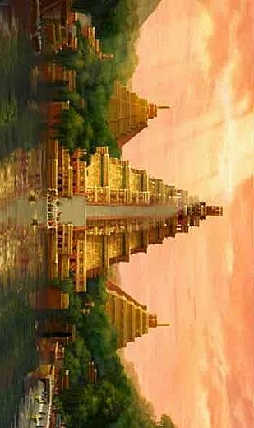
Picture 2
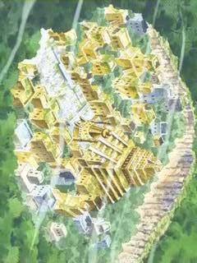

Picture 3
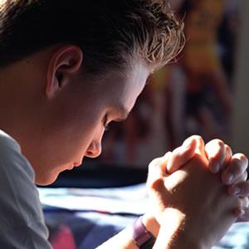

Picture 4
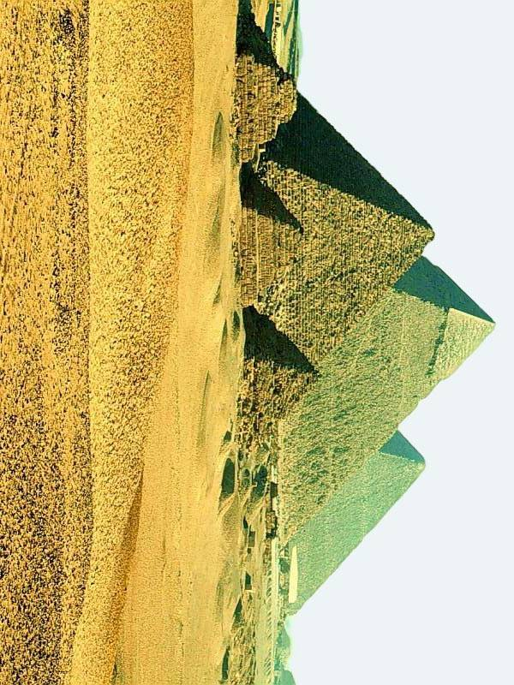

Picture 5
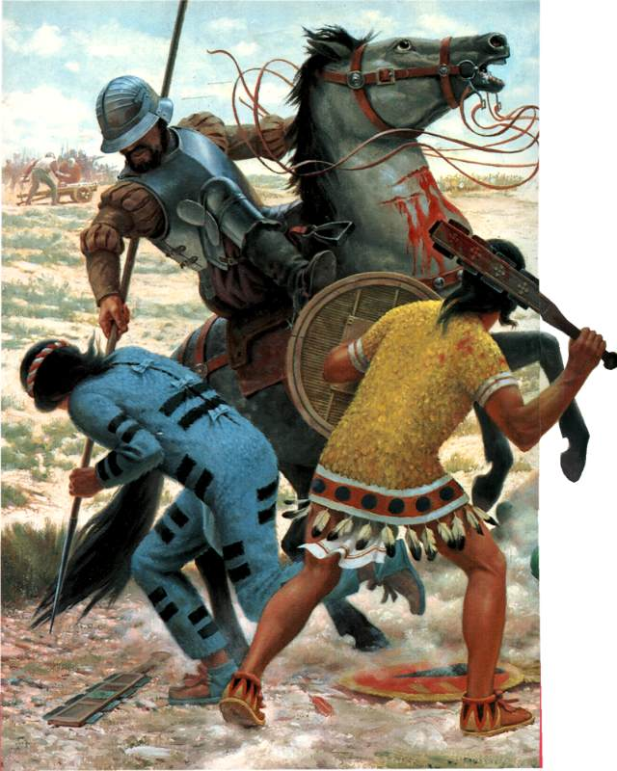

Picture 6
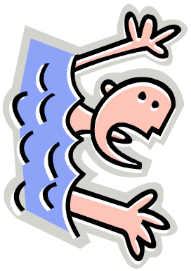

Comprehension Questions (Main Idea)

1. How do you feel while listening to music?

2. Why do you feel like that?

3. What do you think this topic is?

Comprehension Questions (Details)

★Fill in the blanks.

They came 500 years ago
They ( ) the gold of Mexico
Killing people ( ) ( ) ( )
Only talking with their guns
Brave men locked on ( ) chains
All young mothers sold as slaves
Babies crying ( )the night
Will they ever see the light
( ) dreams of Eldorado
all have ( ) in
seas of pain and blood
( ) dreams of Eldorado
May come true but only in your heart

Post-Activity
Original Lyrics | Yours
They came 500 years ago
They stole the gold of Mexico
Killing people one by one
Only talking with their guns
Brave men locked on iron chains
All young mothers sold as slaves
Babies crying through the night
Will they ever see the light
Golden dreams of Eldorado
all have drowned in
seas of pain and blood
Golden dreams of Eldorado
May come true but only in your heart

