Reading Lesson Plan
Title: Within an inch of my life

Instructor:  Iksoo | Level:  Intermediate | Students:  8 students | Length:  40 minutes

Materials:
• 5 pictures of vocabulary
• 9 card words for vocabulary game
• 9 copies of reading comprehension for a main idea worksheets
• 9 copies of reading comprehension for details worksheet
• a white board and markers

Aims:
• Students will be familiar with vocabularies used in the reading text by matching the words to their meanings.
• Students will be able to find the main idea by answering guiding questions and skimming the reading text.
• Students will be able to get details by scanning the reading text and answering the short answer questions.
• Students will be able to enhance speaking and listening skills by participating in the group discussion
Language Skills:
• Listening: teacher’s instructions and doing activities
• Reading: reading worksheets
• Speaking: answering teacher’s questions and doing activities
• Writing: answering questions on worksheets
Language Systems:
• Lexis: new words (ravine, cavern, dislodge, blunt knife, amputate)
• Function : use right words when predicting, sharing opinions
• Discourse: speak coherently with appropriate cohesive features when expressing opinion

Assumptions about Students:
• Students are adults at an intermediate level and are able to express their ideas in English.
• Students know how to skim and scan.
• Students are used to working individually, in groups or pairs.
• Students are good at finding out the main idea of the story.

Possible Problems and Solutions:
• Students may not easily understand the meanings of new vocabularies.
-> Teacher will explain with simple and easy words and give examples if necessary.
• Time may be short.
-> Teacher will reduce the number of students sharing their opinions. -
• Students may finish their tasks earlier than expected
-> Teacher will give more time and give all students chances to express their opinion.
References:
http://www.telegraph.co.uk/culture/film/8223925/127-Hours-Aron-Ralstons-story-of-survival.html
http://snapguide.com/guides/make-my-favourite-quinoa-salad/
http://www.aceros-de-hispania.com/battle-ready-sword/1417-raw-knife.asp?product=time-seller-pef1417
http://commons.wikimedia.org/wiki/File:Reflecting_cavern_lake.jpg

Presentation
Materials: 8 words card, makers
Time | Set Up | Procedure
2 min | Whole class | • Greeting  Hi everyone, how are you today?  Good~!? really?  most of you guys have dark circles under your eyes. what did you do last night?!  Cheer up okay?  Good!  • Lead-in  Do you know what "within an inch of one's life" means?  Let me explain this.  When I was a kid, one time, I was nearly drowned.  In a very short time, I saw the angel of the death. I thought I am gonna die. but I didn't want to die.  so I tried to swim really hard and reach to the waterside.  And I survived!  I believe everyone here ,at least once, have a experience within an inch of your life before.  Guess what today’s topic?  " within an inch of my life ".  . (write "near - death experience" on a board)  , so today, we are going to talk about "between life and death", but before that, we will learn some useful vocabulary which you will come across today in reading worksheets.

Pre-activity: pre-teaching new vocabulary
Materials: 5 vocabulary pictures. vocabulary game cards, markers.
Time | Set Up | Procedure
3 min  7 min | Whole class  Whole class | • Pre-teaching vocabulary  (show picture of amputate) can you guess what word will be?  Gross? disgusting? Cutting? right  Cutting something.  That is amputate  (show picture of cavern) can you guess what word will be?  cave?  Yes. and no  This is cavern  Cavern is much huge than cave  (show picture of dislodge) can you guess what word will be?  Remove.  Remove a seed from a avocado  Yes.  The word is Dislodge  Dislodge a seed from a avocado  That means Getting something out  (show picture of blunt knife) can you guess what word will be?  Knife, right but It's not a just knife,  Look more carefully  a blunt knife.  Because of this dull knife, it is very difficult to cut something hard.  (show picture of ravine) can you guess what word will be?  Canyon. right!  That is ravine.  Good job guys~!  • Pre-activity (vocabulary game)  Now, we’re going to play a ladder game with the words just we learned.  Instruction  I believe you already know how to play a ladder game.  Which is really popular in Korea, right?  I’m going to draw a ladder on a board.  Then, each of you, pick a number out of 8.  From number one, explain the word you get.  Demonstration  But, There is three trap out of 8  If you get trapped, you have to make adorable face and say , "save me!"  It have to be really cute. if you are cute. we will save you from the trap.  if you couldn't explain the word you get.  it would be also "adorable face".  And say, "save me" then your partner is going to help you to explain the word.  Got it?  CCQ  1. What do you have to do? (pick a number and explain the word I get)  2. If you are wrong what do you have to do? (make adorable face and say save me~!)  3. If you get trapped what do you have to do?  (make adorable face)  Feedback  Did you enjoy the game? Good job everyone!

Practice: main activity
Materials: worksheets for a main idea and details. article
Time | Set Up | Procedure
7min  7 min | Whole class  Whole class | • Skimming for a main idea  Instruction  Now, we’re going to read the story to find out main idea.  While you read the article, write the answers.  Read the all the words as quickly as possible in individually.  I will give you 3 minutes to read.  Demonstration  This is the worksheet. let's take a look at the number one question together. It says ' If you were a Aron Ralston, what is your choice, between life and death. write the reason.' you skim the article and write the answer. the answer could be,  Life. Losing one arm is better than lose life.?  Like this. Okay?  CCQ  1. What are you supposed to do?  2. Are you working in groups or individually?  3. How much time do you have?  (Pass out the worksheet)  you can start right away!  Monitor  Give time warning: 1minute left.  Okay. Times up. Check the answers!  what is your answer?......  do you guys agree?  Feedback  You did good job!  *Scanning for detail idea  Instruction  Now, we’re going to read the story again to answer detail question. In this time you have to scan the article to look for certain words and certain information.  You have 3 minutes and you must work in pairs. Work with the person next you..  Demonstration  This is the worksheet. let's take a look at the number one question together. It says ' What is the main character's name ?' you skim the article and find the answer .  The answer is  ‘Aron Ralston'  Okay?  CCQ  1. What are you supposed to do?  2. Are you working in pairs or individually?  3. How much time do you have?  (Pass out the worksheet)  you can start right away!  Monitor  Give time warning: 1minute left.  Okay. Times up. let's check the answers!  what is your answer?......  do you guys agree?  Feedback  You did good job!

Post-activity: production
Materials: a white board and a marker
Time | Set Up | Procedure
8 min  5 min  2 min | Pair work  Pair work  Whole class | •Production activity (post activity)  Instruction  Now, you’re going to have a conversation with your partners..  Imagine, that you were Aron Ralston fell into the ravine.  What were you going to say last words.  Discuss with your partners.  When you are done, come out here and say what you would do.  I’ll give you 3 minutes for making a conversation.  Demonstration  Actually, Aron Ralston had a camera when he fell into a ravine. He took a selfie. and left his last words. which was "Mom and dad, I love you."  We have a camera over there, say your last words okay?  You got it?  CCQ  1. What are you supposed to do? (making a conversation with your partners about what my last words would be)  2. Are you working individually or with partner?(partner)  3. How much time do you have? (3 minutes)  Monitor  Writing homework  TIME CHECK  OK. Let’s act it out.  (let students act it out)  Feedback  Was it fun? You did a great job!  • Giving Homework  Instruction  Please research someone who had faced with crisis and overcamet.  At least three people and in detail. okay?  The due is next class.  Demonstration  You can use Google search engine and write down them.  CCQ  1. What is your homework?  2. When is it due?  3. How many people do you have to write?  Closing  Ok, that’s all for today.  No matter which situation you are at,  Never give up. okay? Thank you. see you on next class. bye.

Script

Just cut off your damned Arm already!
When the sun starts to go down on the canyonlands of south-eastern Utah in the American west, it bathes the vast rock formations and caverns in a deep red glow. It’s beautiful.
But at night, if you’re alone, it can be a cold and frightening place. Particularly if you find yourself trapped in one of the deep ravines that split the sandstone monoliths in two. It would be difficult for anyone to hear you during the day – but in the dark, a cry for help would be met with only silence.
No one knows that more than 35-year-old Aron Ralston. In 2003, he had gone hiking, alone, near Robbers Roost – an old outlaw hideout used in the dying days of the wild west by Butch Cassidy. But while Ralston was climbing down a narrow slot in Bluejohn Canyon, a boulder became dislodged, crushing Ralston’s right forearm and pinning it against the wall.
For five and a half days, he struggled to get free until he was forced to do the unthinkable. Using a blunt knife from his multi-tool, he began amputating his arm. This month Ralston’s incredible tale of survival comes to the big screen courtesy of film-maker Danny Boyle, in his new movie, 127 Hours.

Since the accident, Ralston has been back to Bluejohn Canyon 10 times – with friends, news crews and with the producers of 127 Hours. They even shot some of the film there.
Understandably, the road to recovery hasn’t been easy. At first, Ralston was determined to carry on challenging himself.
At the end of the film, you see the real Aron Ralston together with Jessica and Leo, sitting on a sofa, with the canyon behind them.
Ralston says it’s funny, but even though he didn’t know them at the time, they’re the reason he was able to get out of that canyon alive. 'We have these very fundamental desires for freedom, for love and for connection. And that’s what got me out.’

Comprehension Questions (Main Idea)
※ Answer the questions

Ex. If you were a Aron Ralston, what is your choice, between life and death. write the reason.
Life.
Losing one arm is better than lose life.

1. If you were Aron Ralston, you would go to the canyon again?

2. If you survive from the accident, what you would do first?

3. What would you bring if you go to the canyon?

4. If you were Aron Ralston, What is your reason for survive?

5. If you were die 127 hours later, do you regret looking back on your life?

Comprehension Questions for details

※ Answer the questions

Ex. What is the main character's name ?
‘Aron Ralston'

1. How old is he?

2. What was he doing?

3. What year did he fall into?

4. Which part of body was caught in the wall.

5. How many times he has been back to Bluejohn Canyon, since the accident?

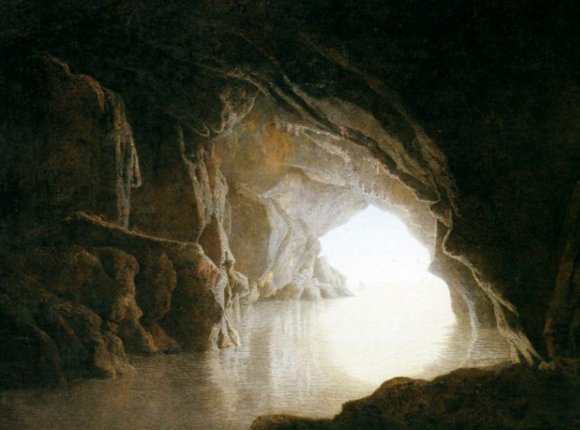

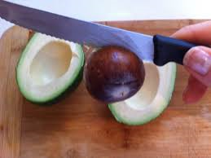

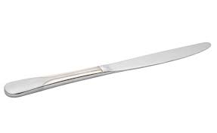
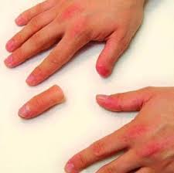

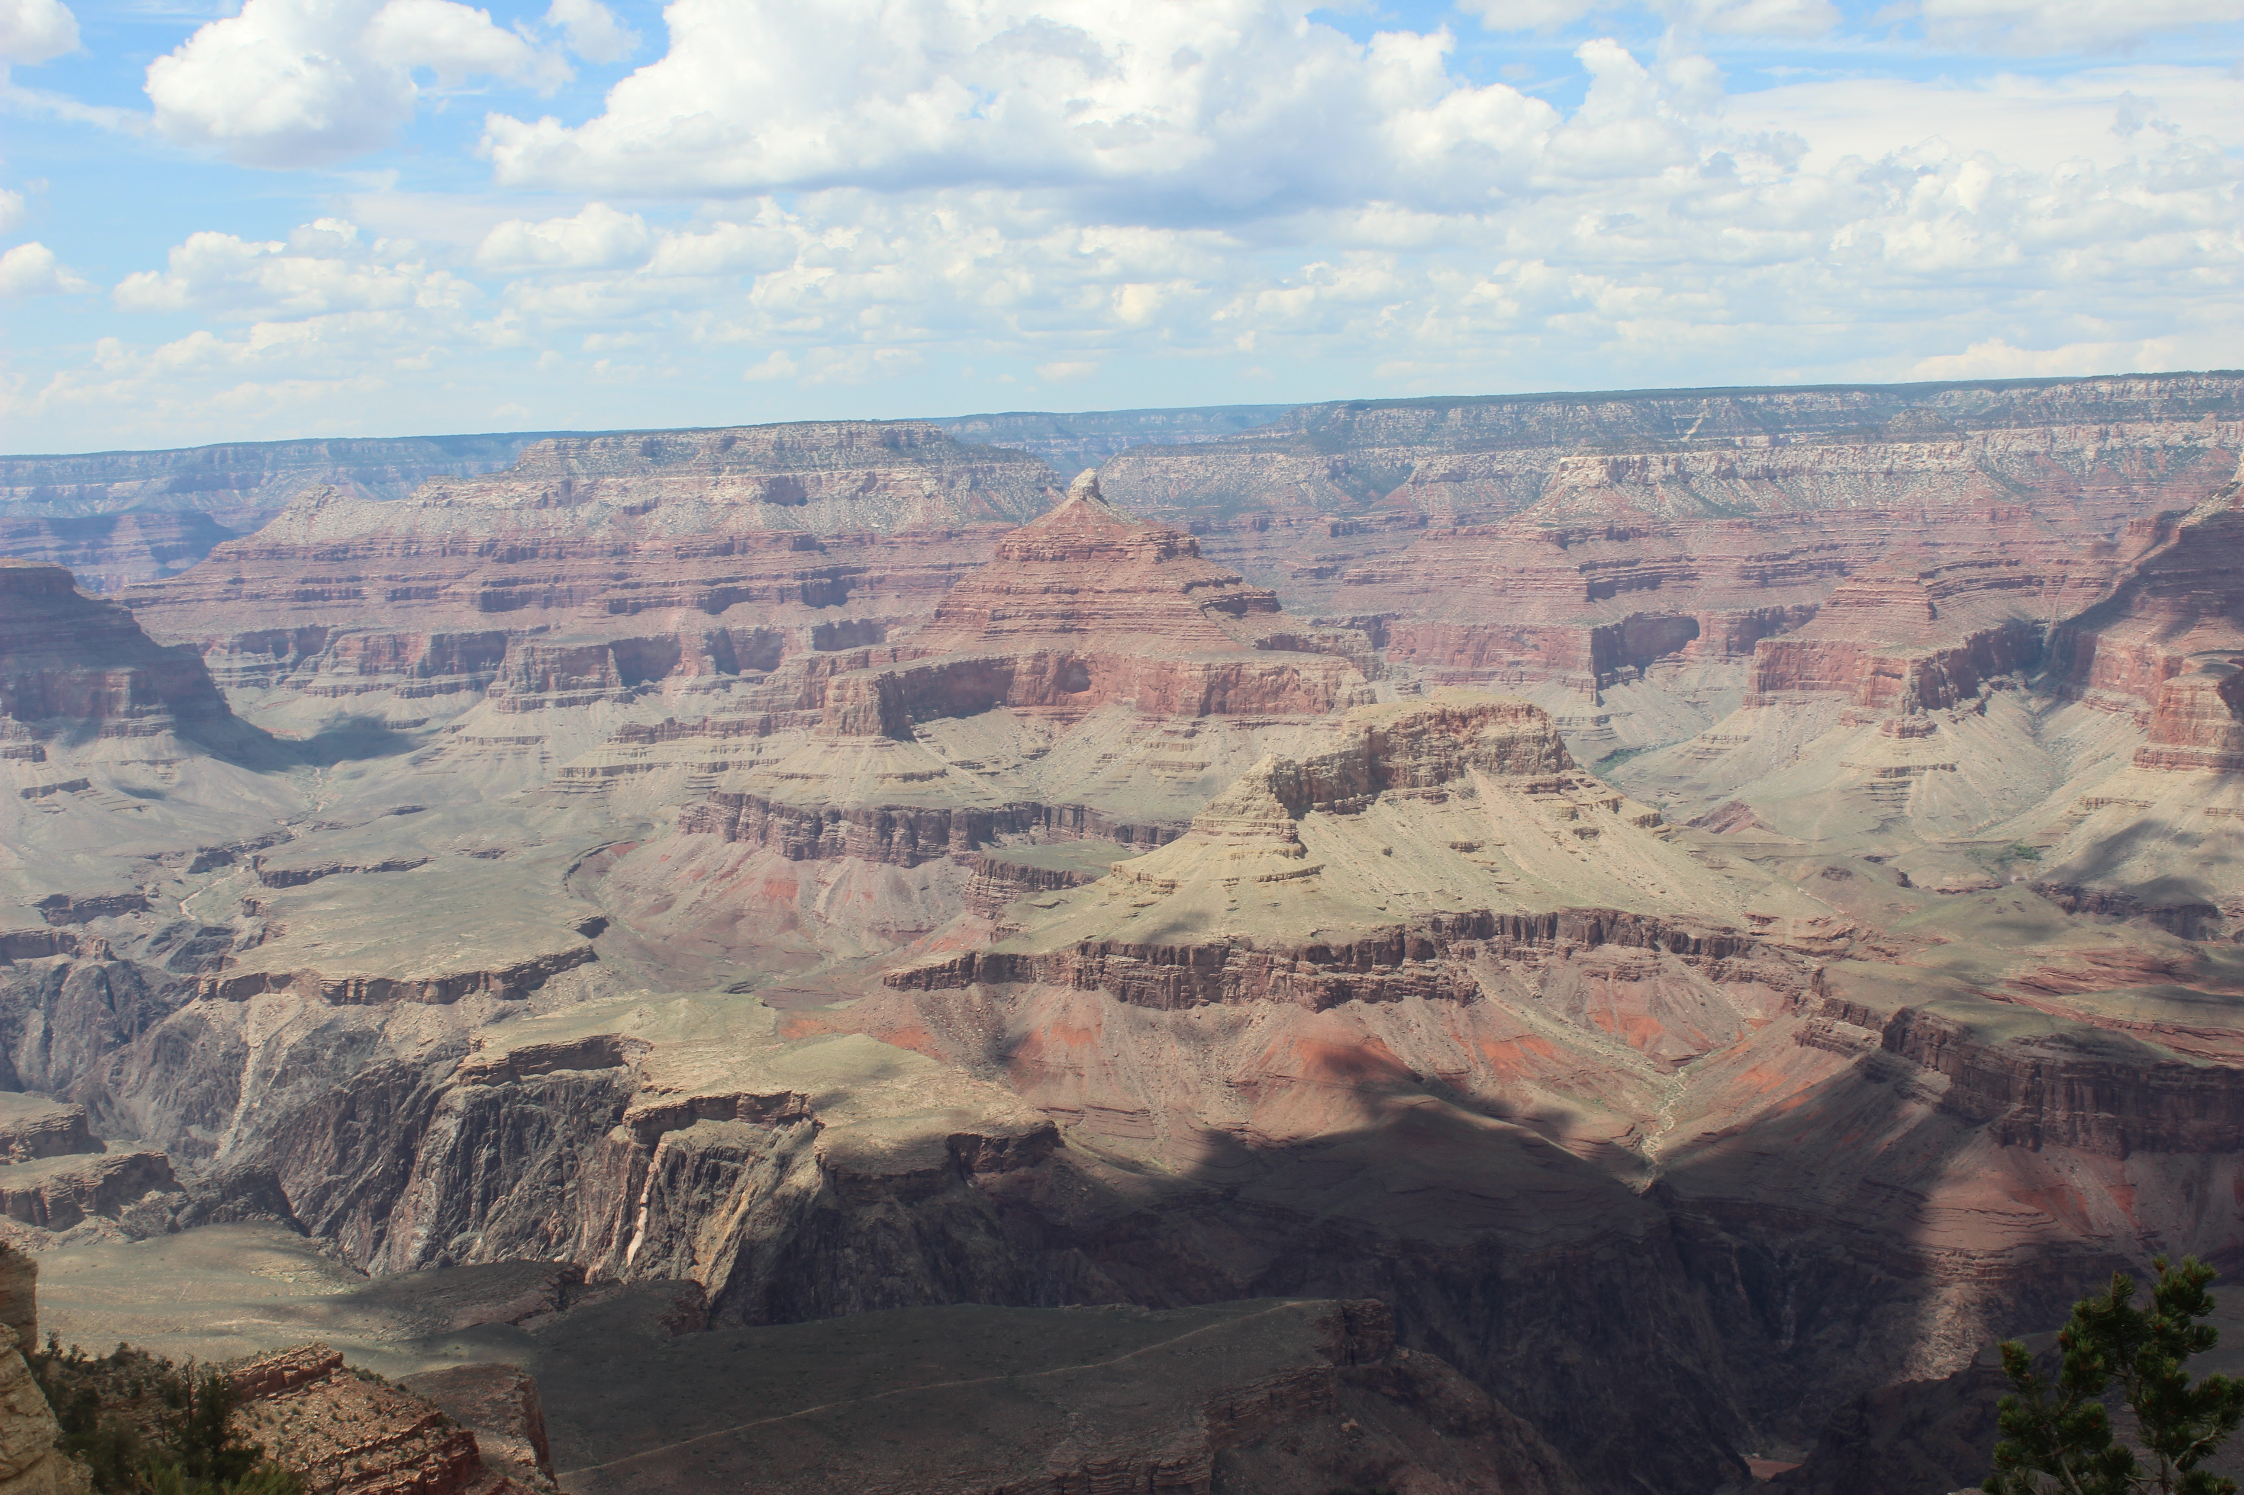Homework June.14, 2014
Due date: Next class
Student name:

※ Please research someone who had faced with crisis and overcame.
(at least 3 people, in detail).

