Listening

Topic:

Personality traits- What sleeping positions say about you

Instructor:  Sue & Rosie | Level:  Upper Intermediate | Students:  11 students | Length:  50 Minutes

Materials:

- Computer (with the internet) hooked up to a projector
- Visuals of key vocabularies PPT slide to be hooked up to a projector (see attached)
- Worksheet #1 Personality trait chart (see attached)
- Visual aids for a character used for demonstration of post-activity
- Worksheet #2 (see attached)
- Worksheet #3 Cloze exercise (see attached)
- A paper for the post activity (see attached)
- Drawing Analysis (for the Teacher’s reference) (see attached)

Aims:

Main Aims:
- Students will be able to improve in describing personality traits using various vocabularies through their worksheet (personality trait chart).
- Students will be able to distinguish in describing appearances (objects) with personalities (feelings) while describing each sleeping position’s traits.
- Students will understand people talking about personality traits by picking up various vocabularies learned from their worksheet.

Secondary Aims:
- Students will be able to get clear definition on synonyms and antonyms while finding out different traits of the classmate’s personality traits.
- Students will be able to improve their inference skill by predicting each sleeping position’s traits.

Personal Aim:
- I want to improve my instructions by implementing various activities while I deliver them
- I will be able to find out students personality traits through the activities for the reference of my teaching methodology.

Language Skills:

- Listening: Students should practice bottom up listening skills when they complete the cloze worksheet. Students should practice top down listening skills when they listen to their personality analysis results.
- Speaking: Students should work in pairs or groups and discuss while completing their worksheets.
- Reading: Students should read the cloze worksheet.
- Writing: Students should predict and describe each sleeping position’s traits.

Language Systems:

- Phonology: sounding out the keywords in proper pronunciation
- Lexis: Fetus, Starfish, Soldier, Yearner, Freefaller, Log
- Grammar: The simple present used throughout the video clip. Students will use simple present tense to describe general facts.
- Function: describing the personality traits
- Discourse: discussing words in groups. finding out classmates personality traits

Assumptions:

- The students are at a high enough level to listen and understand the passage.
- The students are old enough not to take this material too seriously.
- The students are all teachers or are planning to teach in the future.

Anticipated Errors and Solutions:

- Students might not have seen the movie Frozen and not be able to guess the character’s personality traits while demonstration. Show them various pictures from the movies that show the character’s personality.
- Students might not know their partner’s personality well. Let the students think of a famous person or a character who can be shared in class.
- Students may have difficulty guessing each sleeping position’s personality traits. Let students use some words from the personality chart given.
- The projector may malfunction. Read the script yourself.
- Some students might have difficulties drawing a dog. Show them some easy sample drawings or demonstrate using a whiteboard so that they can get ideas.

References:

Video clip of What sleeping positions say about you http://www.youtube.com/watch?v=XjoqsIgJTk0

Picture of Keywords
Fetus: http://www.ladycarehealth.com/short-and-long-term-effects-of-smoking-on-a-fetus/
Starfish: https://drupal.org/node/2064089
Soldier: https://www.google.co.kr/url?sa=i&rct=j&q=&esrc=s&source=images&cd=&docid=1CRoM6p9R6ZQzM&tbnid=zxCejL8S06w8IM:&ved=0CAEQjxw&url=http%3A%2F%2Fpeosoldier.armylive.dodlive.mil%2F2010%2F08%2F30%2Foefiotv%2F&ei=7m6dU8GTAor98QW_yILoCQ&bvm=bv.68911936,d.dGc&psig=AFQjCNEdDKFT7Hvm8y6jQEjLc0mhwClE9Q&ust=1402911162500538
Yearner: http://www.dailymail.co.uk/femail/article-2427732/BEL-MOONEY-I-yearn-fairytale-love-just-escape-painful-past.html
Freefaller: http://www.mercurynews.com/travel/ci_24506163/top-10-bungee-jumps-world
Log: http://youlearnsomethingeveryday.com/logarithms/

Anna: https://www.google.com/search?tbm=isch&q=Frozen&gws_rd=ssl

Lead-In
Materials:

- Visual aids of each keywords (Fetus, Starfish, Soldier, Yearner, Freefaller, Log);
Ppt slides hooked up to a projector

Time | Set Up | Procedure
5 min | Whole  class | Lead in by eliciting what kinds of shapes or outlines each keyword has. See Ss’ level of describing an object. Make sure students can pronounce each word correctly.  Guiding Questions/Elicit  What shapes do these words have?  Can a human make a similar shape with their body?  Do you think people make these gestures often?  When do we make these gestures?  Motivate  Today we are going to take a look at what your sleeping position says about you and some different ways to see your personality.  CCQ  Can you tell your sleeping positions that you keep when you sleep?  Do you know anyone who sleeps in a very rare pose?  Transition  Let’s go over some different words that can describe our personality.

Pre-Activity
Materials:

- Visuals of a famous animation character hooked up to a projector
- Worksheet #1 (a copy of personality trait chart for each student)

Time | Set Up | Procedure
5 min  10min | Whole Class  Pair work | Warm-up: Finding out your partner’s personality traits  Hand out Worksheet #1 (Personality trait chart)  Elicit  What kinds of words are they?  When can you use these words?  Instructions: Now on your worksheet, you will see the chart divided into 4 groups. We are going to choose and circle some adjectives from the chart that best describe your partner’s characteristics. Then afterwards we will find out each names of the group that they are in.  Before starting our activity, let’s look at this character.  [Display the visual aids hooked up to a projector]  Demonstration  Elicit  Have you seen this character?  Do you know who she is?  Have you seen this movie?  What are some words that best describe this character?  Let students call out some words from their worksheet and circle those words on the chart.  Elicit:  What words best describe this character?  Did Elsa socialize well with other characters?  Who did she mostly stay with?  Did she easily give up on making a snow-man with her sister?  Did Anna do things mostly on her own?  Talk about the results.  We circled the most words from the B section (from the personality trait chart)  We can say that Anna’s personality trait is close to emotional & outgoing.  Run the Activity: Now let’s find out more about our classmates. In pairs, circle 5 words from the given list that best describes your partner. You will have 3 minutes for choosing the words.  ICQ  How many minutes do you have for choosing the words?  How many words do you circle?  Finding out the results  [personality trait chart hooked up to a projector]  Let’s find out the personality traits of our classmates.  On the chart here, you will see 4 blanks for each section.  Elicit  What would be the right personality trait for each section?  How would we describe a moody and touchy person?  That’s right, Emotional  Which word would go into the opposite section?  Yes, it would be ‘Rational’  Which word would go into active and sociable section?  Yes, that’s right. ‘Extrovert’ and the opposite side is ‘Introvert’  Pick a student and ask the words he/she have circled.  Share other students’ results.  If I divide this chart into A B C and D from the top left,  How many of you are in A section?  How many of you are in B section?  How many of you are in C section?  How many of you are in D section?  Students raise their hands and by marking them on the board, students see the traits of the classmates.

Main Activity
Materials:

- Computer and projector for the video clip
- Worksheet #2 Personality trait chart (see attached)-already given while pre-activity
- Worksheet #3 Cloze exercise (see attached)

Time | Set Up | Procedure
5 min  10min  7min  3min | Pair work  Group work  Individ/ work  Whole class | - Predicting Task  Instructions: We talked about the 6 keywords of sleeping positions in the beginning of the class.  Now we’re going to guess what kind of personality traits each positions would have. Work in pairs to discuss the answers and you can use the vocabularies we learned at the personality trait chart. You will have 5 minutes to discuss with your partner.  Place the keyword visual aids on the board.  Students will each have a copy of the personality trait chart for the reference of various adjectives.  ICQ: What are you going to write?  How long do you have?  - Matching Task (Students listen and match the right sleeping positions)  Elicit  What kind of a personality trait would a person have who sleeps in a starfish position?  What do you think is the most common sleeping position?  Which sleeping position would cause pain in your body?  Now let’s check our ideas by listening to the passage.  Play the listening passage-play the sound clip and make sure that the video is projected onto the screen.  Now in groups, let’s check our ideas. You will have 5 minutes for the discussion.  Do you all have similar answers?  Re-play the video clip  CCQ  Why did you think the fetus position is the most common sleeping position?  Do you agree that people who sleep in soldier position is strong?  Among these sleeping positions, which one was the closest with you?  - Cloze exercise  Now, let’s get into details and check if we are aware of all the vocabularies in the passage. I will play the passage once again. Listen and write the correct words in the blanks.  Play the listening passage as many times needed.  Did you all have your answers?  Check your answers with your partners for 2 minutes.  - Comprehension check  Literal:  What kind of personality traits did a soldier type have?  What was the most common sleeping type?  I am very indecisive but when I make a decision I usually stick to my decision. What kind of sleeping position would I have?  Interpretive (Implied):  Why do you think a starfish position would lead to snoring?  Why would a log type suffer from back pain?  Why would a freefaller type suffer from digestion?  Applied:  Which type of sleeping positions would you want your spouse to have?  How many sleeping positions does a person keep (in average) while sleeping?

Post Activity
Materials:

- A paper for each students for the post activity
- Drawing Analysis (for the Teacher’s reference)

Time | Set Up | Procedure
5min  5min | Individ/  work  pair  work | 1. Try personality test  Build Motivation:  Imagine drawing a house on your own. Is it possible for us to  draw the same houses? As you well know, our personalities are all different so the answer is no. No one can draw out a same one.  Now, on your paper, draw a dog on your own style and let’s take a look at what the drawing says about you.  Instructions:  You will have 2 minutes to draw a picture of a dog. There’s nothing to worry about your drawing, just a simple sketch is fine.  Demonstration:  I will draw a dog on the board. (drawing)  Focus on the body parts such as ears or legs.  ICQs: How many dogs should you draw?  Are you working alone or in groups?  Run the Activity: Students will draw a dog. If there are some students who have difficulty in drawing, encourage them to draw.  Teacher keeps monitoring and managing time.  Finding out the results  Now, let’s switch your drawing with your partner and we are going to  analyze your partner’s picture of a dog.  Teacher reads out the analyze results. (see attached)  Using the words we already learned, share your partner’s  personality traits  Ask for volunteers to share their results  CCQ  What did your drawing tell you?  Has anyone draw long ears?  Did most your dog’s legs show?  Close: Congratulate the students on a job well done.  SOS: Give the class another personality test using the number  from 1 to 6.

Visual Aids of Key words





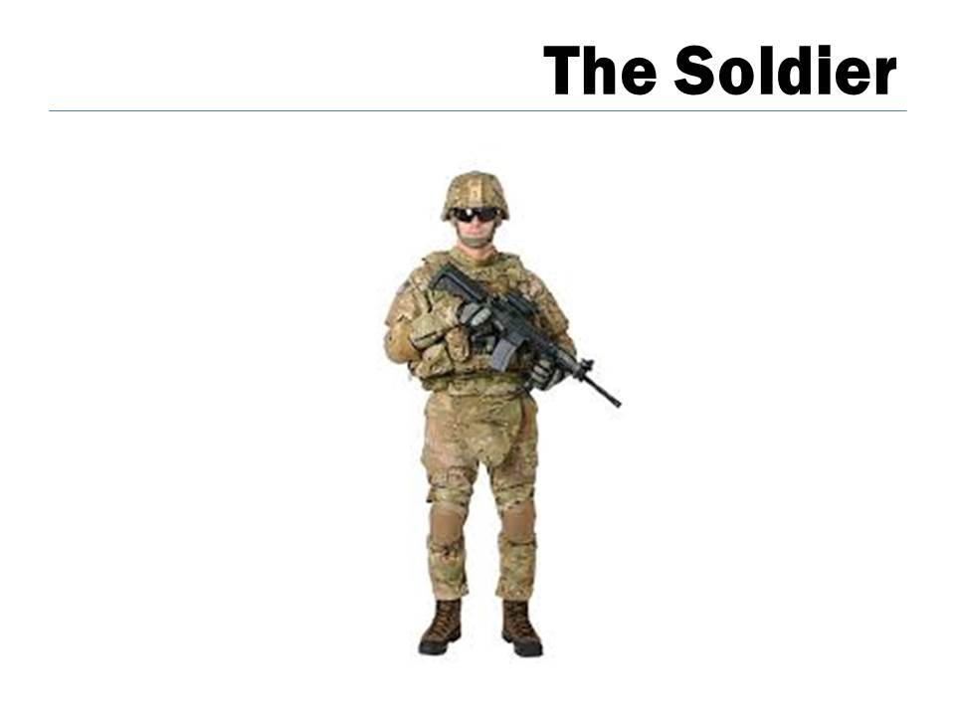

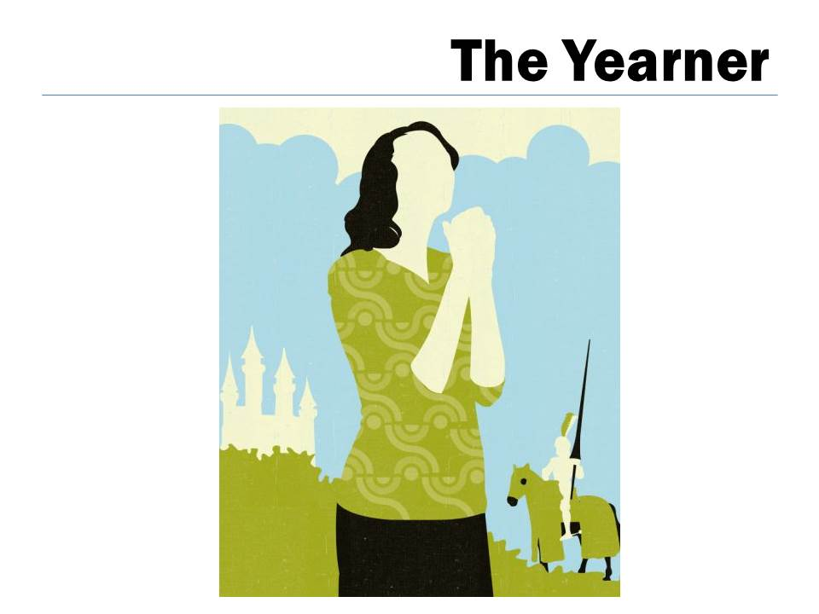



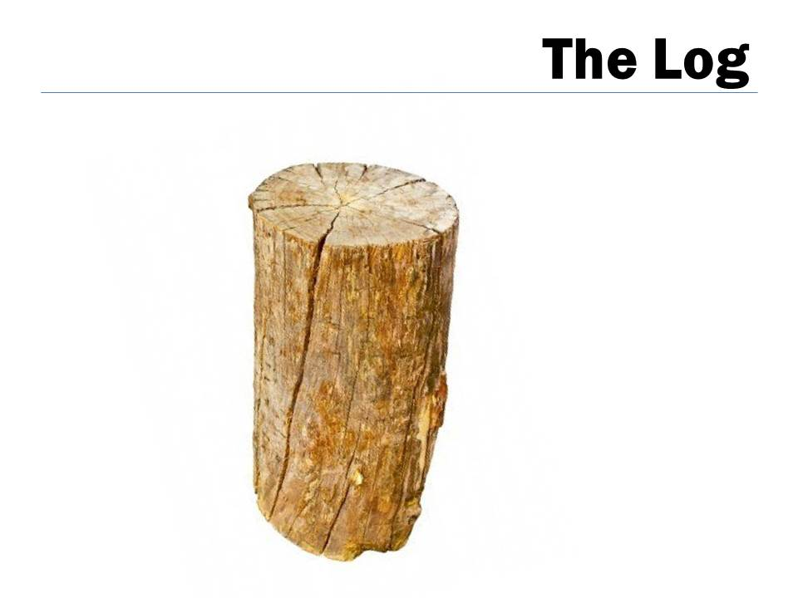

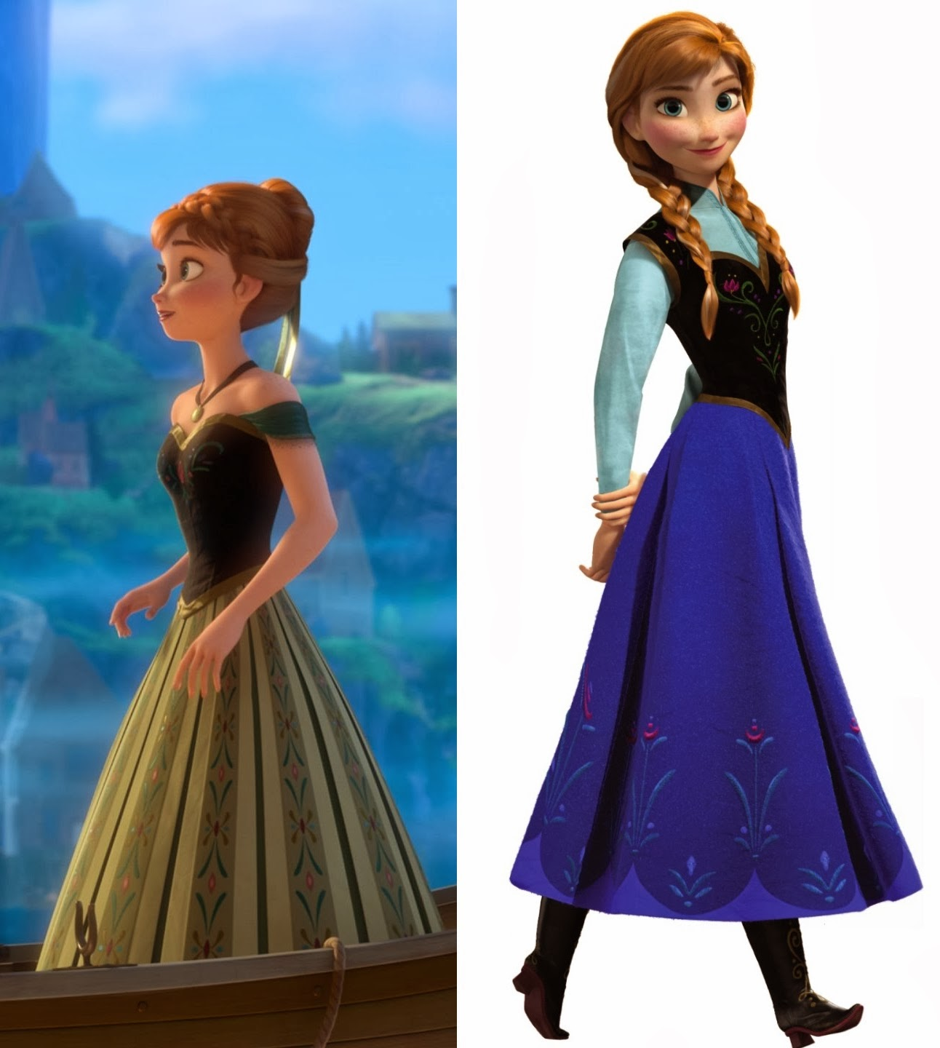
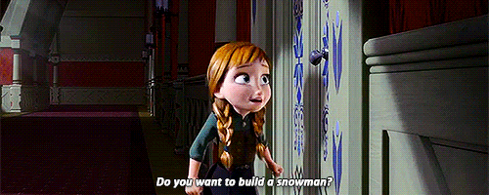



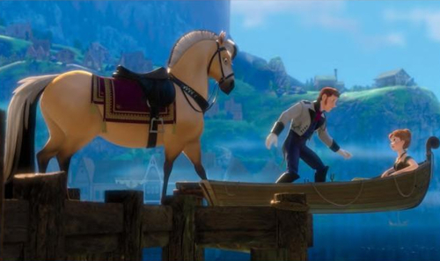


Worksheet #1

Personality trait chart

Choose 5 words that best describe your partner.

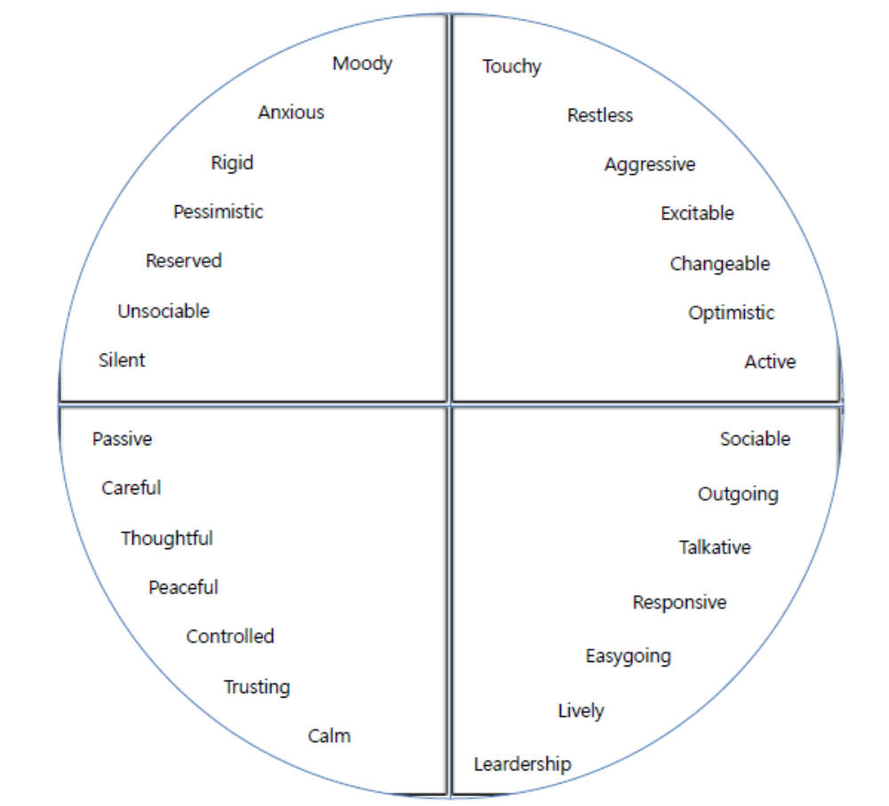

The Fetus | The Starfish | The Soldier
The Yearner | The Freefaller | The Log

Worksheet #2

Let’s make a guess of each sleeping position’s personality traits. Write down some words that you think it describes each personality.

Use the words from the personality trait chart for your ideas.

Worksheet #3 Cloze exercise

‘What your sleeping position says about you’

The Fetus
This is the most common position in the world. People who sleep in the field position tend towards worry and (1) _____ . It's not all bad though I mean what would this world be like without the shy (2) ____ types?

The Starfish
This position could lead to snoring and interrupt night's sleep. If you have a starfish sleeper as a best friend, you’re in luck. They’re great (3) ___ and the source of (4) ___ to others.

The Soldier
Sleeping like a soldier can lead to a bad night's sleep. Try using a pillow to support the (5)______ curve with your back.
Soldier sleepers do not like to make a big deal out of things.
They’re the strong silent type.

The Yearner
This is a good position to avoid snoring.
The yearner sleepers look like they're (6) for something. It's all part of their long periods of (7) but once they make a choice, they stick to it.

The Freefaller
This position can aid in digestion but their sleep is unsteady.
They like to be in control of everything around their life.
They’re (8) , (9) people but for them extreme situations, that's a no no.

The Log
For those who suffer from back pain, the log position could be helpful for you.
Log sleepers are very (10) . A little naive but are usually (11) and easy going individuals.

Personality Test
Draw a dog and find out your personality

Analysis of your drawing


If the dog is ...
at the bottom of the paper, you're usually nervous.
at the top of the paper, you're usually calm.
in the middle of the paper, you're sometimes nervous and sometimes calm.

If the dog is...
sitting, you're optimistic.
standing, you're confident.
The size of the ears shows how intelligent you are. The longer, the better.


If the dog is…
facing you, you’re talkative.
facing left, you have a good memory.
facing right, you’re creative.

If the dog has…
four legs showing, you can be stubborn.
fewer legs showing, you often change your mind.
The length of the tail shows how friendly you are. The longer, the better.

Transcript of the video clip.
‘What your sleeping position says about you’

The Fetus
This is the most common position in the world. People who sleep in the field position tend towards worry and anxiety. It's not all bad though I mean what would this world be like without the shy sensitive types?

The Starfish
This position could lead to snoring and interrupt night's sleep. If you have a starfish sleeper as a best friend, you’re in luck. They’re great listeners and the source of comfort to others.

The Soldier
Sleeping like a soldier can lead to a bad night's sleep. Try using a pillow to support the natural curve with your back.
Soldier sleepers do not like to make a big deal out of things.
They’re the strong silent type.

The Yearner
This is a good position to avoid snoring.
The yearner sleepers look like they're grasping for something. It's all part of their long periods of indecision but once they make a choice, they stick to it.

The Freefaller
This position can aid in digestion but their sleep is unsteady.
They like to be in control of everything around their life.
They’re outgoing, incompetent people but for them extreme situations, that's a no no.

The Log
For those who suffer from back pain, the log position could be helpful for you.
Log sleepers are very trusting. A little naive but are usually social and easy going individuals.

