Listening Speaking Reading Grammar Writing

Topic:
Rhetoric devices in a song from the musical “Les Miserables”

Instructor:  Kylie Lee  Karen Oh  Shawn Kim | Level:  Upper Intermediate | Students:  12 | Length:  50 Minutes

Materials:
- Computer connected to a projector and speakers
- A copy of video file and MP3 music file ("I Dreamed A Dream" from Les Miserables)
- Smartphone (or MP3 player) with portable speakers
- “Les Miserables” movie poster
- Relationship Diagram to explain relevant characters in the story.
- Crossword Puzzle exercise worksheet for each student
- Cloze worksheet with lyrics for each student

Aims:
Main Aims:
- Students will learn about rhetorical devices such as metaphor, simile, oxymoron, synecdoche, anaphora and hyperbole as they solve the crossword puzzle specifically designed for familiarizing students with the terms.
- Students will be able to apply rhetorical devices in everyday English as they work in pairs by creating their own sentences using the devices learned.
Secondary Aims:
- Students will be able to comprehend storyline through listening to the song and working on the cloze worksheet.
Personal Aims:
- I want to lead the class more confidently by speaking up.

Language Skills:
Listening
- Students will develop bottom-up listening skills as they focus on identifying as many rhetorical devices as possible in the song.
- Students will practice top-down listening skill to understand the overall storyline of the song.
Speaking
- Students will discuss in groups the use of rhetorical expressions/devices found in the song, and complete the cloze worksheet.
- Students will discuss with their partners to solve the crossword puzzle in pairs.
Reading
- Students will read the cloze worksheet with lyrics.
- Students will read the clues to solve the crossword puzzle.
Writing
- Students in groups will create and write their own sentences using different rhetorical expressions.

Language Systems:
Phonology
- Students will learn how to read the names of 6 rhetorical devices
Lexis
- Rhetoric, metaphor/simile, oxymoron, synecdoche, anaphora, hyperbole
Grammar
- Past tense, present tense used throughout the song "I Dreamed a Dream".
Function
- Self-narrating, wishing and regretting
Discourse
- Students will try to visualize flow of the story.
- Students will discuss figurative language in groups.

Assumptions:
- Students are able to fully understand the literal meaning of the song.
- Teacher fully understands the song and the rhetorical devices in it.

Anticipated Errors and Solutions:
- Students might have difficulty understanding the storyline within given time.
    - Discuss the storyline as a whole class based on the brief summary given in the lead-in
- Students may need extra time for creating their own sentences using rhetorical devices.
    - Try to come up with examples together as a whole class (ask for volunteers)
- Students might have confusion between simile and metaphor.
    - Provide comparative examples
- The projector or the computer may malfunction.
    - Play the song on iPhone (or MP3 Player) hooked up with portable speakers

References:

Les Miserables 25th Anniversary Live Concert Video File:
https://drive.google.com/file/d/0B1rHswpY8dYyZDU5YnFVT0V5Y0k/edit?usp=sharing

Les Miserables 25th Anniversary Live Concert MP3 File:
https://drive.google.com/file/d/0B1rHswpY8dYyTEtqSVhkYy0tbWs/edit?usp=sharing

Lead-In
Materials:
- An image of “Les Miserables” movie poster
- A diagram explaining the relationship between the singer (Fantine) and other characters.
Time | Set Up | Procedure
5 min | Whole Class | Lead in by presenting the poster of the movie.  See if they recognize the characters in the poster.  Guiding Questions  Do you know how Fantine, Jean Valjean and Cozette are related?  What happened to Fantine?  There is one person who is in the diagram but not in the poster. Who is he or she?  Motivate  What we are going to do today is... We are going to listen to Fantine’s song called “I dreamed a dream.” It's not from the movie, but from the Original London Cast Musical.  Elicit  Has anyone listened to the music before?  Has anyone seen the musical version (not the movie)?  Transition  Well, today, we will listen to that song, because there is a lot to learn from it! But before we listen to it, let's try a puzzle that will give us an idea on the specific kinds of expressions that we are going to learn from the song today.

Pre-Activity
Materials:
- Crossword puzzle worksheet for each student (See attached)
- 2 dictionaries for reference (1 per group)
Time | Set Up | Procedure
10 min | In Groups  (groups of 4) | Warm-up: Do The Crossword Puzzle  Instructions:  In the puzzle, 6 clues are provided for you. Each of them contains the definition and example of a specific type of rhetorical device, and your job is to figure out what each one is trying to represent. You can use the word bank for reference. Work in your groups to do some research on those rhetorical devices on the internet, and try to study their meanings and usages.  Then, discuss with your group to find the corresponding terms and clues.  ICQs:  How many of the rhetorical devices do you have to find?  Where can you find the information?  Run the Activity:  Monitor and get students engaged in active research and discussion to solve the puzzle.  Discuss and match the answers as a whole class.  CCQs  Read the sentences below to the students and induce them to talk about the rhetorical devices used.  - You have entered virtual reality. (Oxymoron)  - She is skinny as toothpick. (Hyperbole & Simile)  - Teaching is my bread and butter. (Synecdoche)  - I want it right here, right now! (Anaphora)  - He runs fast like a horse. (Simile)  - This place is heaven! (Metaphor)

Main Activity
Materials:
- Computer and projector
- Video file (“Les Miserables” 25th Anniversary Live Concert)
- Cloze worksheet for each student (See attached)
Time | Set Up | Procedure
5 min  5 min  5 min  5 min  10 min | Individual  Individual  Individual  Whole Class  In Groups  (groups of 4) | Task 1: Identifying Rhetorical Devices  Students take quick notes of rhetorical devices they will have to identify while listening to the song (video off for the first listen).  Instruction 1:  In the song, there are a number of rhetorical devices used.  You will find as many of them as possible as you listen to it.  For the first time you listen to the song, it will be without the video. So please focus on the song, and try to identify what devices are used.  You can still take a memo as you listen.  ICQs:  Could you find any rhetorical devices in the song?  How many rhetorical devices could you find?  Task 2: Working on Cloze Worksheet  Students are given the cloze worksheet with lyrics and they will be asked to fill in the blanks as they watch the video.  Instruction 2:  This time, you will watch a video clip for the song. Please try to fill in the blanks that you missed in the cloze worksheet as you watch.  ICQs:  Could you hear more rhetorical devices this time?  Task 3: Completing Cloze Worksheet  Students will watch the video for the last time and complete the cloze worksheet.  Instruction 3:  This will be the last time to watch the video. So watch and listen carefully and try to finish the worksheet.  Comprehension Check Questions  Literal  What happened to Fantine with her man?  When did he leave her? What season?  Interpretive  How has her life changed?  What is her life like now?  Applied:  Used in the Post Activity  Task 4: Group Discussion & Presentation  Students will discuss in groups what rhetorical devices were found in the song and the underlying meanings of them.  Each group will present their findings.  Instruction 4:  In your groups, discuss what rhetorical devices you have found based on the cloze worksheet and discuss what their underlying meanings are.  Each group presents.  ICQs/CCQs  Can you tell how the storyline of the song flows?

Post Activity
Materials:
- A piece of paper and pen/pencil
Time | Set Up | Procedure
5 min | In Groups  (groups of 4) | Instruction:  In groups, please come up with an example sentence for each rhetorical device to describe your experience or any circumstances you were in in the past.  Each group will present their sentences and the other groups will tell what rhetorical devices are used.  Run the Activity:  Make sure each group works on all 6 rhetorical devices to make example sentences.  Make each group present at least 3 examples and let the other groups interact.  Error Corrections:  Go over any errors that you heard throughout the lesson. Write them on the board and try to elicit corrections.  Close:  This is all for today.  All of you have done a great job.  See you all tomorrow.  SOS  Have students talk about their dreams or memories when they were little or younger by using the phrase from the song “There was a time when…….” And share them as a whole class.
Movie Poster

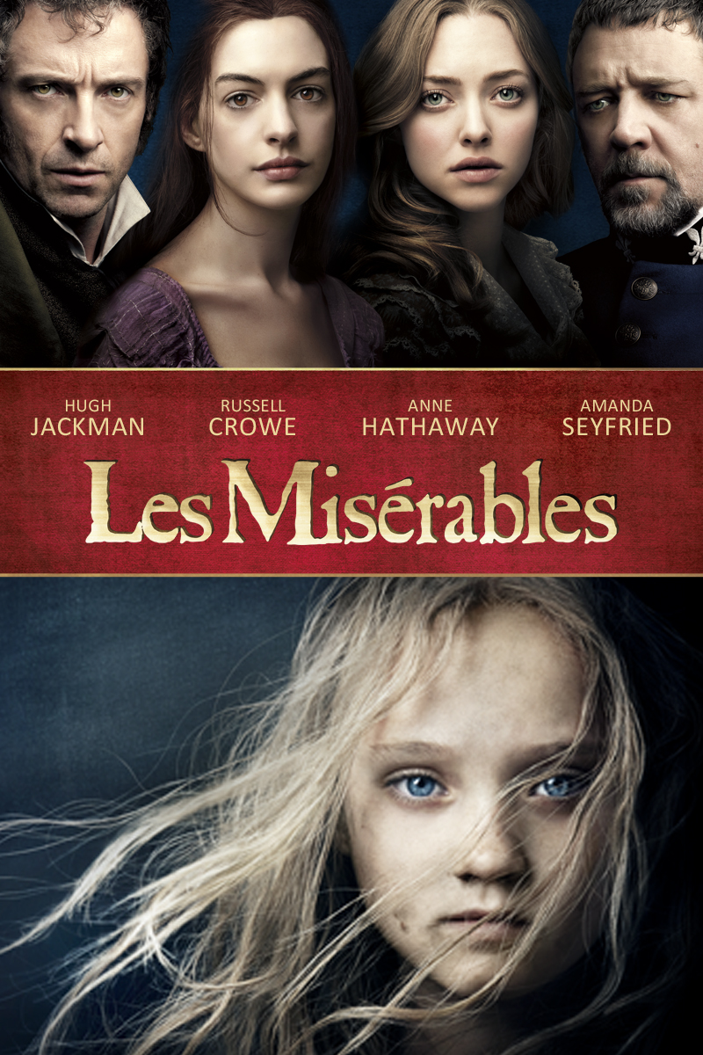

Relationship Diagram

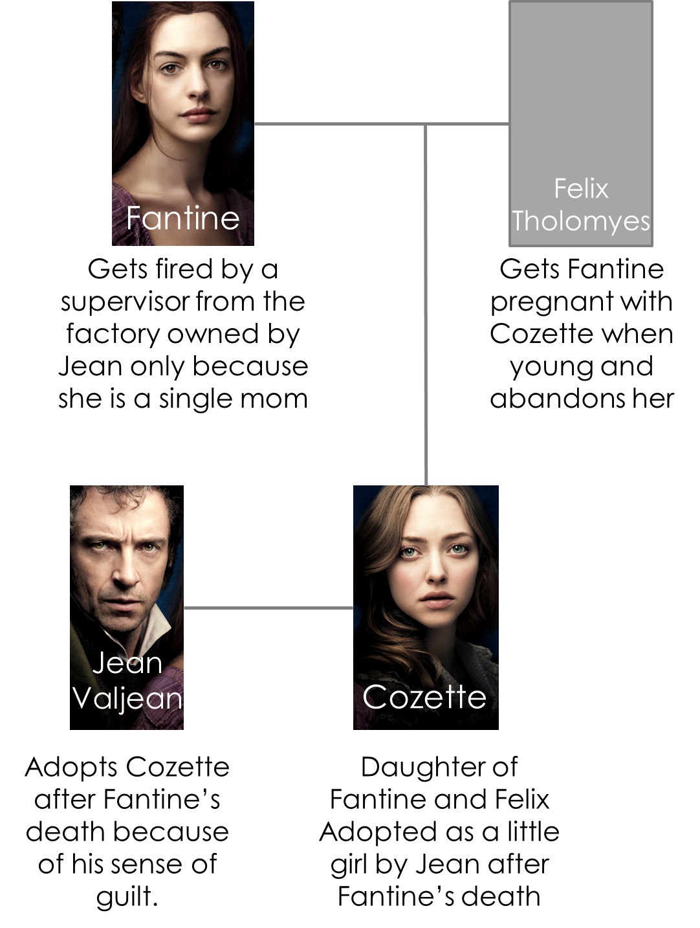
Script (Lyrics)
I Dreamed a Dream
From the musical “Les Miserables”

There was a time when men were kind
When their voices were soft
And their words inviting
There was a time when love was blind
And the world was a song
And the song was exciting
There was a time
Then it all went wrong
I dreamed a dream in time gone by
When hope was high
And life worth living
I dreamed that love would never die
I dreamed that God would be forgiving
Then I was young and unafraid
And dreams were made and used and wasted
There was no ransom to be paid
No song unsung, no wine untasted
But the tigers come at night
With their voices soft as thunder
As they tear your hope apart
As they turn your dream to shame
He slept a summer by my side
He filled my days with endless wonder
He took my childhood in his stride
But he was gone when autumn came
And still I dream he'll come to me
That we will live the years together
But there are dreams that cannot be
And there are storms we cannot weather
I had a dream my life would be
So different from this hell I'm living
So different now from what it seemed
Now life has killed the dream I dreamed.

Crossword Puzzle: Complete the crossword puzzle below. Use the word bank for reference.
WORD BANK
rhetorical devices / metaphor / simile / oxymoron / synecdoche / anaphora / hyperbole

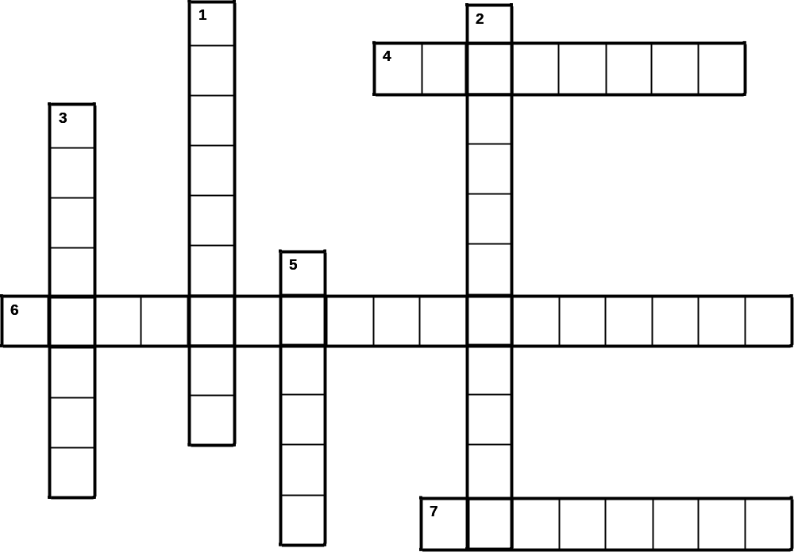
ACROSS
4. A figure of speech in which incongruous or seemingly contradictory terms appear side by side. (example: open secret, only choice, living dead, original copies…)

6. They go beyond meaning of words to create effects that are creative and imaginative, adding literary value to writing.

7. When subject ‘A’ is regarded as representative or symbolic of subject ‘B’ (example: time is money)
DOWN
1. a figure of speech (a form of irony) in which exaggeration is used for emphasis. (example: I told you a million times! / Her brain is the size of a pea / I had a ton of homework)

2. a figure of speech in which a part is used to represent the whole. (example: the word ‘bug’ used to represent any kind of insect)

3. the repetition of a word or phrase at the beginning of successive clauses or verses. (example: every day, every night, in every way, I am getting better and better)

5. A figure of speech where two unlike things are compared using the word “like” or “as” followed by a figurative example. (example: she sings like an angel)

Cloze Sheet with Lyrics

Cloze Worksheet: Fill in the blanks as you listen to the song
I Dreamed a Dream
From the musical “Les Miserables”

[ ] when men were kind
When their voices were soft
And their words inviting
There was a time when love was blind
And [ ]
And the song was exciting
There was a time
Then it all went wrong
I dreamed a dream in time gone by
When hope was high
And life worth living
I dreamed that love would never die
I dreamed that God would be forgiving
Then I was young and unafraid
And dreams were made and used and wasted
There was [ ] to be paid
No [ ] unsung, no [ ] untasted
But [ ]
With their voices [ ]
As they tear your hope apart
As they turn your dream to shame
He slept a summer by my side
He filled my days with [ ]
He took my childhood in his stride
But he was gone [ ]
And still I dream he'll come to me
That we will live the years together
But there are dreams that cannot be
And there are [ ] we cannot weather
I had a dream my life would be
So different from [ ] I'm living
[ ]now from what it seemed
Now life has killed the dream I dreamed.

