Listening

Topic:

Understanding news about disaster

Instructor:  Chloe Lee | Level:  Advanced | Students:  12 | Length:  60 Minutes

Materials:

- Computer with internet
- I pad with internet
- 6 cards with words related to disaster for warm up (see attached)
- A4 papers to take key notes
- Two Youtube videos (Tornado, Ice sheet melting)
- Two B4 paper
- Picture of places destroyed by disaster
- Color pencils, scissor, glue
- Tape

Aims:
Main Aims
- Students will get used to the words and phrased being used to explain disaster.
- Students will be confidence while they practice how to stand in front of class and have presentation.
- Students will improve their listening skill while they focus and take key notes about the given disaster video.
Secondary Aims :
- Students will get to know how much disaster can affect life and environment.
- Students will be able to learn how they should react to disaster.
Personal Aims :
- I want to improve my activity managing skill by controlling the level of tension of the class.
- I want to be more nice and clear when I give instruction or information to student by speaking slowly and clear.

Language Skills:
- Speaking : Students should have presentation about the disaster in the given video by summarizing the news and tell the class how they felt about the video.
- Listening : Students should focus on the video to understand what the video is talking about. Students should practice to find out the main sentence and important words by listening to the video.
- Writing : Students should take key notes on the given paper and write the summary of the video on the poster.
- Reading : Students should read the posters they made when they do presentation, and should read the substitutes of the video when they do not know some difficult word used in video.

Language Systems:
- Lexis : words on the warm up cards(Ice sheet melting, victim, earthquake, ambulance, tornado, casualty), some new words and phrases being used in the announcement
- Phonology :
- Grammar : the past simple used throughout the dialogue.
- Function :
- Discourse : Discussing about the video and the way they will present their opinion.

Assumptions:
- The students are at a high enough level to understand the news announcement.
- The students are able to express how they feel after watching video or looking at some pictures.
- The students are able to communicate each other.

Anticipated Errors and Solutions:
- Students might take too much time for discussing the way to make poster and practice presentation. In this case, I will roam around the class and ask students “Do you have any questions?” and try to help them to be on the right track by eliciting them.
- The projector may malfunction while T showing Ss the video for Lead-in. In this case T can skip video showing and show some extra pictures of disasters.

References:
Youtube video for Lead-in
- http://www.youtube.com/watch?v=Kg-6whkbZXs

Youtube video for main activity
- http://www.youtube.com/watch?v=s8xF_QSN15A&feature=player_detailpage
- http://www.youtube.com/watch?v=-weTx--ocDY&feature=player_detailpage

Images for Lead-in
- http://www.themobilityresource.com/wp-content/uploads/2014/01/disaster.jpg
- http://www.peakoilblues.org/blog/wp-content/uploads/2011/03/Desktop-Background.bmp

Extra images
- http://natgeotv.com.au/content/cache/600x600/gallery/iceland-volcano/photos1/Iceland%20Volcano%20%7B5887%7D.jpg http://www.legoengineering.com/wp-content/uploads/2013/06/earthquake.jpg

Lead-In
Materials:
White board & marker
Pictures of destroyed places

Time | Set Up | Procedure
3 min | Whole class | Show students the pictures of places destroyed by the disaster.  Guiding Questions  What do you think happened in this place?  How would people in this picture feel like?  Where do you think this place is?  What would you think if your house is also one of these destroyed structures?  Motivate  Let’s watch a short video about today’s topic.  (show the video for 1 min.)  Elicit  Does anyone have idea about topic for today?  (write down students’ answer on the board)  Ok nice try everyone.  After doing another activity, you will clearly know what the topic is!  Transition: Before we jump right into the class, Let’s have some fun first. We will play off a simple word game. We need two groups to compete with, so could you guys make two groups please?

Pre-Activity
Materials:
6 cards with words related to disaster

Time | Set Up | Procedure
7 min  4 min | Group of 6 people  Whole class | (Word Game)  Warm-up- Play a word game..  Instructions: Each team need one student giving question, and the other students will be answerers. Two questioners will have 3 cards each and the every other student can be the answerer. Any team correcting the answer first gets the point, and the winner team will have small benefit on the main activity.  Demonstration: Yuki, will you be a volunteer for me? I will give you 3 cards (give 3 cards), and you can explain the word to other students. For example, if the word on the card is ‘emergency’, you can give students siren sound or say “an unexpected and serious happening which calls for immediate and determined action”.  ICQs: What does the winner team has as a reward?  How many questions one questioner have?  Run the Activity: While two volunteers are giving explanation about the given word, T writes the score of teams. If the student doesn’t know or struggle with explaining, T can help. After playing activity, tell the winner team that the benefit is the right to choose the topic of the video first. (There are two videos – tornado, ice sheet melting).  Pre-teach by writing the 6 words on the board and following these steps.  Elicit: Does anyone have any idea about today’s topic?  Do you know any other kind of disasters?  (getting students’ opinion)  Before we jump into main listening activity, I will give the winner team benefit first. (see winner team side)Between two topic – ice sheet melting and Tornado, which one do you want to go with?  Transition : Now, let’s start with the main listening activity.

Main Activity
Materials:
Board to put poster on
Computer and I pad with internet
Scissors, glue, color pens, marker
A4 papers

Time | Set Up | Procedure
5 min  30 min | Whole class/ group  work  Group work | Now, let’s start with main activity. We have two video clips about tornado and ice sheet melting. After groups watching their given video, each team should make key notes and summarize the video. You have to make posters about the video and have a smaill presentation. It would be better if you write down how you felt throughout the video.  - Watching the video clip  Instructions: Work in groups, and focus watching the video clip. While listening to the announcement, if you hear 5-6 key words, take a note on the given paper. Forget about summarizing, as I will give you more time later on.  (each video is about 2:30 min long, so students will be able to listen to the task 1-2 times.)  ICQ: Do we have to take all the key words at once? (no)  DO we work individually? (no)  Give I pad and the computer to each group  - Make sure the speakers of each material are working well.  - Preparing the presentation  Instructions: Now, you should summarize what the video is talking about and make a poster for your presentation. The presentation will be 3-5 minutes long so don’t be too pressured. You can use scissors, glue, color pencils, whatever you want in classroom. I’ll give you B4 paper and show how you can use it.  Demonstrations: (Hold up the B4 paper) Please fold the paper into half size. Write the key words on the left side and summary in the right side. You can write your feelings about the video on the paper or just speak out not writing it on the paper. It’s your choice.  ICQ: Do we have to write down our feelings on the poster? (no)  How long will be the presentation? (3-5 minutes)  Can you use all the materials in the classroom? (yes)  Give students time to prepare  Ask Comprehension Check Questions (to each group):  Literal:  From where to where did the tornado move?  What is the name of smaller glacier which has experience some of the most dramatic changes the grounding line of Smith sure in 1996?  Applied:  (included in the question give as a task to complete in the presentation)  What would you feel like if you are damaged by this disaster?  What would you do if you noticed it way before?

Post Activity
Materials:
Tape to paste the posters on the board

Time | Set Up | Procedure
10 min | Group work | (Students’ presentation)  While Ss doing presentation  - T can check Ss’ comprehension by listening to their summary  - T can do post activity which is giving applied question  Build Motivation: if someone knows something but can’t explain it to others, it doesn’t mean that he/she really ‘knows’. When someone really ‘know’ about something, he/she should able to tell it to others. Now, we will have presentation time, feel free to tell classmates what you know and how you felt about it.  Instructions: Each group will come up to the board, and put the poster on the board. As I said, the presentation will take 3-5 minutes and at the last part of the presentation, please give us your opinion about ‘how you would felt if you are the one who experience this disaster’. You can give as many as you want to.  ICQs: Should each group say only one answer for the last applied question? (no)  Run the Activity Allow each team 3-5 minutes to give their presentation.  Error Correction: Go over any errors that you heard throughout the lesson. Write them on the board and try to elicit corrections.  Close: Congratulate the students on a job well done,  SOS: Have the students to tell about their accident experience, or have the students to tell about impressive disaster news they have ever seen or heard.

6 Cards for warm-up

Victim

Earthquake

Tornado

Casualty

Ice sheet
melting

Ambulance

The Script of given video – Ice sheet meting
We’re heading towards particular sector of West Antartica draining into the Emmett Cincy this sector is drained by six glaciers the biggest ones up Pine Island glacier and tweets glacier this P that the glaciers measured by satellite is shown it called a code read this past Brewers store and green is the slowest the glaciers flow into the sea and form floating extensions called ice shelves. Nine red are the areas where the flow speed is increasing almost every year to dock at the Red the more the glacier has been speeding up. You see that all the glaciers are speeding up now we focus our attention on the Smith pressure which is a smaller glacier but which has experience some of the most dramatic changes the grounding line of Smith sure in 1996. He’s at the transition battery between the blue collar the ice shelf and the white collar ice resting on the continent. Now we transition to 2011 the grounding line is 35 kilometers farther back the retreat up nearly two kilometers per year. If we could peel off the ice from the continent and see the bed this is what he would look like. The arrows indicate different direction that caller indicates the speed blue is slow read this past we see that the glaciers flow in top I’ve majors substantial valleys collared in brown the darker brown color. the deeper the valley’s as the glaciers retreats they will follow these deep valleys there is no mountain a big deal along the way that could act as a barrier to hold these measures back the glacial speed up the grounding on retreat deep valleys that a sloping lawn all reinforce each other to make the retreat device in this part of America.

Pictures of places destroyed by the disaster

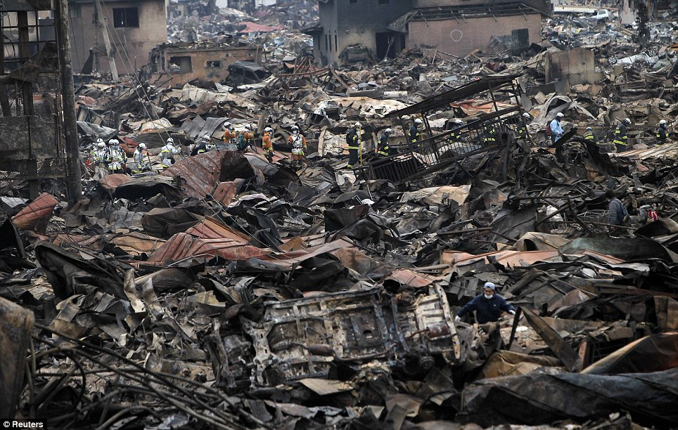
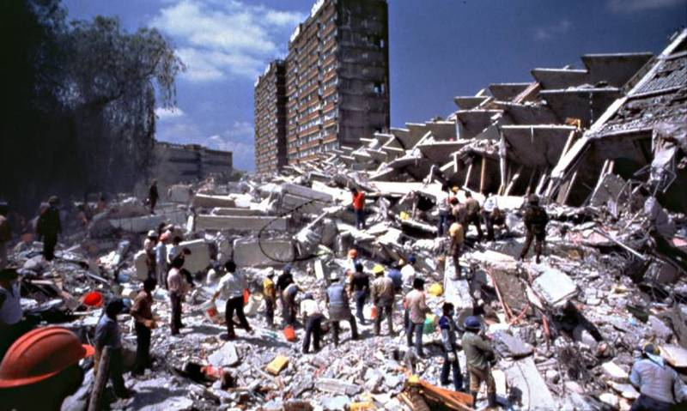
Extra pictures of disaster


