Reading

Topic:

Guinness world records

Instructor:  Chloe Lee | Level:  Intermediate | Students:  12 | Length:  50 Minutes

Materials:

- 3 pictures related Guinness world record for Lead-in (see attached)
- Hardcopies of reading materials
- White board & marker
- Youtube video for Lead-in
- 6 word cards for pre activity

Aims:
Main Aims
- Students will be able to understand the given materials by summarizing paragraphs.
- Students will be confidence while they practice how to stand in front of class and have presentation.
- Students will get used to the words and phrases being used for records by reading materials about Guinness world records.
Secondary Aims :
- Students will get to know how much variety the world is.
- Students will be able to imagine what kind of new record they can make.
Personal Aims :
- I want to improve my activity managing skill by controlling the level of tension of the class.
- I want to be more nice and clear when I give instruction or information to student by speaking slowly and clear.

Language Skills:
- Speaking : Students should have presentation about the given Guinness world records by summarizing the news and giving the audience some questions about the news.
- Listening: Students should listen to each other’s presentation to understand the news and they have the right answer for the questions.
- Writing: Students should write down what kind of new record they want to make.
- Reading: Students should read the given task about the Guinness world records.

Language Systems:
- Lexis : words on the warm up cards(largest, biggest, collection, first, most, tallest), some new words and phrases being used in the given task
- Phonology : How to pronounce the key words being used for explaining records, phonologic things used in presentation
- Grammar : the comparative and superlative used in Guinness world records reports
- Function : explaining, announcing, informing
- Discourse: Discussing about the reading material and the way they will present their opinion.

Assumptions:
- The students are at a high enough level to understand the reading material.
- The students are able to share their opinions about their ideal new records.
- The students are able to communicate with each other.

Anticipated Errors and Solutions:
- The S discussion (group work) may take too long. In this case, I will roam around the class and ask students “Do you have any questions?” and try to help them to be on the right track by eliciting them.
- The Ss may take too long to find examples for the word (pre-activity). T can help or give idea about the example.

References:

Reading material for main activity
- http://www.guinnessworldrecords.com/news/2014/7/uk-girl-sets-a-new-guinness-world-records-title-for-the-largest-collection-of-moshi-monsters-memorabilia-59010/
- http://www.guinnessworldrecords.com/news/2014/7/shakira-sets-new-facebook-world-record-after-reaching-100-million-likes-58881/
- http://www.guinnessworldrecords.com/news/2014/7/the-ice-cream-cone-turns-110-celebrate-with-these-five-record-scoops-58976/

Images for Lead-in
- http://www.guinnessworldrecords.com/media/6594397/Shakira-main.jpg
- http://www.guinnessworldrecords.com/media/6598340/Ashrita%20scoops.png
- http://www.guinnessworldrecords.com/media/6600263/Fan%20Choice%20sheep.jpg

Youtube video for Lead-in
- http://www.youtube.com/watch?feature=player_embedded&v=Jv8irsYb2I4

Lead-In
Materials:
White board & marker
Pictures related to Guinness world records

Time | Set Up | Procedure
3 min  1 min | Whole class  Whole class | Show students the pictures related to Guinness world records.  Guiding Questions  Do you think these pictures have same topic?  What do you think these pictures mean?  How do people here seem like?  Do you know who this woman is?  Does anyone have any idea about the topic?  Motivate  Let’s watch a short video about one of today’s topic.  (Show the video for 1 min.)  Elicit  Does anyone have idea about topic for today?  (write down students’ answer on the board)  Ok nice try everyone.  After doing another activity, you will clearly know what the topic is!  Transition: Before we jump right into the class, We will go for a small activity first. Let me make the class into three groups, (gesture drawing line in the middle of class to divide into two groups) here team A, here team B, and here team C.

Pre-Activity
Materials:
6 cards with words (superlative/ordinal number)

Time | Set Up | Procedure
7 min  4 min | Group of 6 people  Whole class | (Word Game)  Warm-up- Play a word game.  Instructions: Here are some word cards. Each team will choose two cards and I need one volunteer from each team who will find the example for the given words in 2 minutes. After that, volunteers will explain about the word by using every method; showing the other students the example they found, gesture, explaining verbally, etc. The winner team getting the highest point can choose reading material for the main activity first. Every word is superlative or an ordinal number.  Demonstration: I will show how. For example, if the word on the card is ‘youngest’, you can point the youngest student or say “opposite word to oldest”.  ICQs: What does the winner team has as a reward?  Can the questioner use verbal explanation?  CCQs: What is superlative/ ordinal number?  Run the Activity: While two volunteers are asking quiz to the other students about the given word, T writes the score of teams. If the student doesn’t know or struggle with explaining, T can help.  - Make sure not to give more than 2minutes for the volunteers finding examples.  Pre-teach by writing the 6 words on the board and following these steps.  Elicit: Does anyone have any idea about today’s topic?  Today’s topic is, ‘Guinness world records’. The video I showed you before was the fastest motorcycle hearse in the world. The words on the cards are superlative or ordinal number which commonly is being used in record report.  Transition: Now, let’s start with the main reading activity.

Main Activity
Materials:
Hardcopies of reading material

Time | Set Up | Procedure
5 min  10 min | Whole class/ group  work  Group work | Now, let’s start with main activity. We have three different kinds of Guinness world records. This activity will be run with the same team, and every team should read the task, summarize and prepare two questions. The questions will be asked after each presentation. The key words for each report are ice cream, facebook and collection. Team* (the winner team) can choose the topic first and then, first come first get.  - Rather than letting students to come up to the board and get the task, T goes to each group and give materials.  - Reading the given task  Instructions: Work in groups, and read the task first. If there is any word that you think it is important, highlighting may help you to understand the task effectively.  ICQs: Do we work individually? (no)  Should we highlight some important words? (no)  - Preparing the presentation  Instructions: Now, discuss your group how you will present your record and what question you will give. You have to prepare two questions for each reading task.  Demonstrations: For example, If the reading task says that Chloe has made up the biggest hamburger, than I can ask the audience “What kind of food did Chloe made up?” The questions can be just simple ones.  ICQ: Does the questions should be complicated and difficult? (no)  How many questions should you prepare? (two)  (Give students time to prepare)  Ask Comprehension Check Questions (to each group):  Literal:  When did Shakira upload the photo?  How many scoops of ice cream have been balanced on a cone?  How many years did she spend for collecting monsters?  Applied:  Why did Shakira upload the photo?  Why did he try to put on a cone as many scoops as he can?  How may her mom feel like?  Extended:  What kind of new record do you want to make?

Post Activity
Materials:
White board & marker

Time | Set Up | Procedure
15 min | Group work | (Students’ presentation)  While Ss doing presentation  - T can check Ss’ comprehension by listening to their summary  - T can do post activity which is giving applied question  Build Motivation: The record is not always something really big. Everyone here can have their own record. The longest hour S spent in studying, the biggest money S spent for parents’ present, etc. After tell the audience about the give task and asking two questions, let’s share your ideal new record.  Instructions: Each group will come up to the board, and have presentation 3-5 minutes long and give two questions. Then, at the end of presentation, please tell us what kind of new record you want to make!  ICQs: Should each group say only one answer for the last applied question? (no)  Runs the Activity Allow each team 3-5 minutes to give their presentation.  Error Correction: Go over any errors that you heard throughout the lesson. Write them on the board and try to elicit corrections.  Close: Congratulate the students on a job well done,  SOS: Have the students to tell about their accident experience, or have the students to tell about impressive disaster news they have ever seen or heard.

6 Cards for warm-up

Largest

Biggest

Smallest

First

Most

Tallest

Reading material

[1]

SHAKIRA SETS NEW FACEBOOK WORLD RECORD AFTER REACHING 100 MILLION LIKES


Guinness World Records can today confirm that pop star Shakira has set a new social media record after gaining the title for first person to reach 100 million likes on Facebook.
The Colombian singer-songwriter reached the benchmark figure after posting a photo of herself in the Maracanã Stadium in Rio, Brazil last Sunday, prior to her performance during the closing ceremony of the 2014 FIFA World Cup.
The image collected over 3.5 million likes in just four days, becoming the star’s most liked Facebook post to date.
The new milestone adds to Shakira’s existing record for most “liked” person on Facebook, a title she holds ahead of fellow pop stars Rihanna and Eminem.
[2] MOST ICE CREAM SCOOPS BALANCED ON A CONE
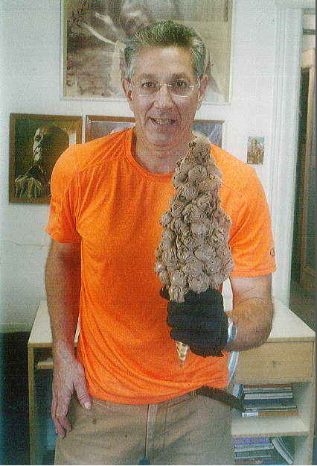
Way back in 2009, James Abram fit 11 scoops of ice cream on a single cone as the first-ever person to attempt this record. Impressive, right? Crossing the Atlantic by ship used to be impressive too. This record has been broken seven times since then, the latest coming from Mr. Records himself, Ashrita Furman (above). Last October, Ashrita crammed 100 (!) scoops of chocolate ice cream onto a single cone, his third time holding this mark.
TALLEST ICE CREAM CONE
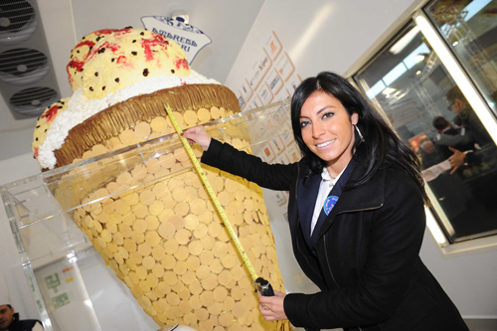
Have you ever dreamed of taking a literal bath in Rocky Road? This would be your chance to jump in. The tallest ice cream cone ever built measured 2.81 m (9 ft 2.63 in) tall by Mirco Della Vecchia and Andrea Andrighetti (both Italy) in Rimini, Italy, three years ago. The internal cone was made of wafer and covered with a 700 kg (1,543 lb) white chocolate cone. It took 30 hours alone to prepare all the gelato to go into the cone.
[3]

A NEW RECORD FOR THE LARGEST COLLECTION OF MOSHI MONSTERS MEMORABILIA
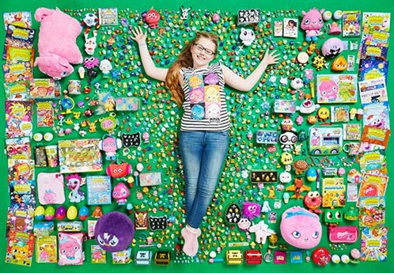
A Moshi Monsters enthusiast has set a brand new Guinness World Records Title for the Largest Collection of Moshi Monster Memorabilia.
Lucy Neath, aged 12, of Milton Keynes has collected 1,914 pieces of individual Moshi mementos to set the world record.
From Moshlings and mugs to Moshi Monsters cushions and cuddly toys, Lucy has been expanding her collection for the past three years.
Lucy’s monster-rific brand new Guinness World Records achievement coincides with the sale of Moshi Monsters’ one hundred millionth Moshling around the world. If Moshi Monsters were to line up one hundred million Moshlings, this would equate to 4,000 kilometres – that’s the same distance as Route 66 in the US and double the distance from London to Moscow. Lucy’s personal Moshling collection adds up to 400 and her favourite Moshling is ShiShi the Sneezing Panda.
Commenting on Lucy’s achievement, Founder of Mind Candy, Michael Acton Smith said: “At Mind Candy, we were very excited to learn that Lucy has set a new Moshi related world record and is a super fan! – We can’t wait to have her at Moshi HQ!”

Pictures of Guinness world records (Lead-in)




