Listening Lesson Plan

Title: Dream !!
INSTRUCTOR | LEVEL / AGE | STUDENTS | LENGTH
Stella (SeoYoung, Choi) | Intermediate | 12 | 50 mins

Materials:
- KungFu PanDa Video [00:02:25 ~ 00:5:12]
- Video script
- Visuals new of vocabulary cards (Key Voca)
- Worksheets: Fill in the blank / Discuses about dream
- Computer with project
- White board / Board Marker

Aims:
- Students will be able to learn and practice new vocabulary naturally through speed game.
- By using famous Film, students will be improved their listening skill and feel enjoying.
- Through the discuses about dreams, They will have brainstorming session “What’s difference thing Dream & Dream?”
- Following video and act play, Students will be able to train the pronunciation and can make approach English.
- [Personal Aim] I would like to enhance the teaching skill using eliciting and try to make more creative teaching material.

Language Skills:
- Listening: When students watch movie clip, they listen to movie clip and feel difference types of dreams.
- Speaking: Through the SPEED game, they need to explain about picture. Repeat after the movie clip’s line.
- Writing: Students participate in dictation activity like ‘Fill in the blank’ video’s each line to practice their grammar ability.
- Reading: Students will read movie script.

Language Systems:
- Phonology: Practice pronunciation of /L/ and /R/ through movie clip.
- Lexis: Ingredient / entrust / fulfill / sharp = New Vocabulary
- Grammar: Past continuous
- Discourse: Describing new vocabulary
- Functions: Discuses about ‘Dream’ / “What is your dream?” / “What is the best & worst dream you have ever had?”
“Pick an image or symbol from one of your dreams and explain what it means to you.”

Assumptions:
- Students have done their all of activities.
- Students are interested in listening material (Kong fu Panda).
- Students have knowledge about common English expressions and recognize their appearance in the dialogue.
- Students will be able to understand 'what are they going to do in the group work.
- Students can use learning expressions in similar situations.

Anticipated Errors and Solutions:
- Students might not understand the usage of the expressions in the worksheet.
- When they don’t catch about different type of dreams, at that time teacher need to ask a question to them. giving them idea.
(Never ever tell the answer directly)

References:
- www.google.com
- Book : Isaac’s Theme talk
- Kong Fu Panda Movie video

Notes:

Pre Task or Warmer
Title:  ‘Matching meaning’ |  | Aims:  To learn New Vocabulary | Materials:  Visual Picture Card
Time | Set Up | Students | Teacher
10  Mins | * Grouping  : 4 students in a group. | - See the picture and words cards, they have to answer what picture or word is.  - After Finish the speed game, Students make the sentence using new vocabulary. | - Through this game, students can learn New vocabulary.  - Give the Picture Card and explain the game Rule.  - Finish the game, teacher has to give the Question about each vocabulary whether they understand or not.

Notes:

Task Preparation or Presentation
Title:  Watching video |  | Aims:  To improve listening ability and expression | Materials:  Movie video and work sheet
Time | Set Up | Students | Teacher
15  mins | Whole student | - Watching video and they think about guiding Q  - Students are filling in the blanks and might ask the questions.  - They should read the complete sentence. | - Guiding Question.  “What are they talking each other? “  “What’s the main topic?  “what’s happened?”  - Motivate  Let’s watch a short movie clip. You’ll see why we asked the questions. (Watch a video clip for 3 mints.)  Giving work sheet is to help student making focus.  - Instruction  Work Individually. There are blanks in the paragraph. Fill in the blanks each the expressions above.  - Check the answer.  “Po and Father talk about different type of dream, what are those?

Notes:

Task Realization or Practice
Title:  Mimic and loud |  | Aims:  To practice and memorize new expression | Materials:  Playing video
Time | Set Up | Students | Teacher
10  mins | Two group of students | - Follow the video line and act kind of Roll play. | - Teacher gives the position ‘Po and Father’  - CCQ  Do you know what you have to focus on carefully during listening?  Why do we have to act Roll play?  - Instructions:  Students can practice about the expressions that are used in the role-play with their groups, let's talk together about what they might mean. (Listen to the students present and allow other students to supplement their responses. Also, elicit answers from the students.)

Notes:

Post Task or Production
Title:  Discussion |  | Aims:  To improve their speaking and sum up the class | Materials:  Blank Form (A4)
Time | Set Up | Students | Teacher
10  mins | * Grouping  : 4 students in a group. | - Discuses about each topic and drew the picture.  - Presentation about the drawing picture to the group menbers. | - Teacher’s role  Monitor the students discreetly and help them.  - Free production  “Please tell each other, How do you feel when you are having a dream? and what is your real dream? “  Discuses about ‘Dream’  “What is your dream?”  “What is the best & worst dream you have ever had?”  “Pick an image or symbol from one of your dreams and explain what it means to you.”  Drew the each concept picture.  - Close  Give feedback and encourage to all students.  Students for doing good work and for cooperating with each other.  - SOS  Have the students make up some new expressions.

Notes:
???

Worksheets, handouts and lesson materials
Speed Game’s Image Card

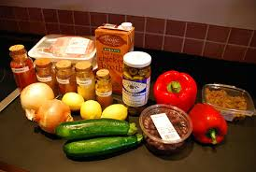
Ingredients are the things that are used to make something, especially all the different foods you use when you are cooking a particular dish.
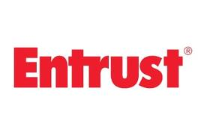
If you entrust something important to someone or entrust them with it, you make them responsible for looking after it or dealing with it.
If you fulfill something such as a promise, dream, or hope, you do what you said or hoped you would do.
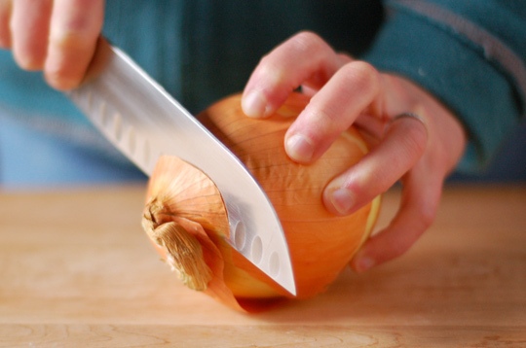
A sharp point or edge is very thin and can cut through things very easily. A sharp knife, tool, or other object has a point or edge of this kind.
Sharp is used after stating a particular time to show that something happens at exactly the time stated.
Worksheet “Fill in the Blank”
Father: Po! __________!
Hi~ Po, _______________ up there?
Po: Oh, Nothing!
Monkey! Mantis! Crane! Viper! Tigress! Wow!
Father: Po, let’s go! ______________________!
Po: Coming!
Sorry dad,
Father: Sorry ______________ the noodles,
And _________________up there? ______________
Po: Oh…Nothing, just ..________ crazy dream.
Father: ____________?
Po: Huh?
Father: What were you dreaming about?
Po: _______________, umm,
I was _______________..uh…noodles.
Father: Noodles? You ________________ about noodles?
Po: Oh yeah, ____________________ dreamin' about?
Oh, careful, that soup __________!
Father: Oh, happy day! My son ______________ the noodle dream!
You don’t know ____________________________ this moment!
________________, Po!
Po: Uh...a sign of what?
Father: You are almost _____________________ the secret ingredient of my secret ingredient soup,
And _______________ your destiny and take over the restaurant!
Father: Just ____________ over from my father,
Who___________ his father ____________________ friend _________________ mahjong.
Po: Dad,dad,dad! ______________ dream.
Father: No, it was 'the Dream.’
We are noodle folk, ________________ our veins!
Po: But, dad, ______________…want to do something else?
something besides noodles?
Father: Actually. ____________ young and crazy,
I thought about running away ___________________ make tofu.
Po: So why didn't you?
Father: Oh because ___________ stupid dream!
Father: Can you imagine me making tofu?
Father: Hahahaha……tofu……no!
We ______________ place in this world,
mine _______, and yours is…
Po: I know…is here.
Father: No…____________________ and _____!
Service ___________ smile

Movie Script

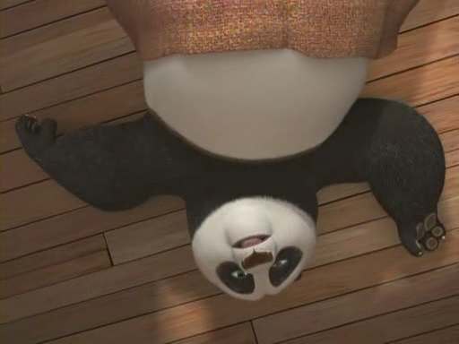
Father: Po! Get up!
Hi~ Po, what are you doing up there?
Po: Oh, Nothing!
Monkey! Mantis! Crane! Viper! Tigress! Wow!

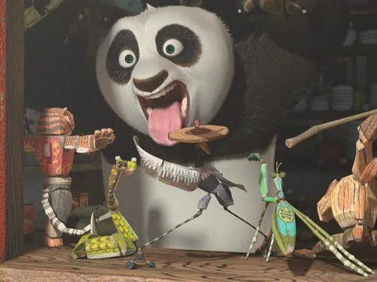
Father: Po, let’s go! You’re late for work!
Po: Coming!

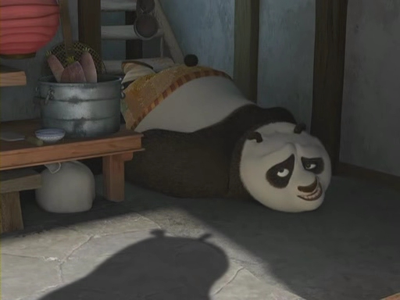
Sorry dad,
Father: Sorry doesn’t make the noodles,
And what were you doing up there? All that noise
Po: Oh…Nothing, just ..had a crazy dream.
Father: About what?
Po: Huh?
Father: What were you dreaming about?
Po: What was I, umm,
I was dreaming about..uh…noodles.
Father: Noodles? You were really dreaming about noodles?
Po: Oh yeah, what else would I be dreamin' about?
Oh, careful, that soup is sharp!
Father: Oh, happy day! My son finally having the noodle dream!

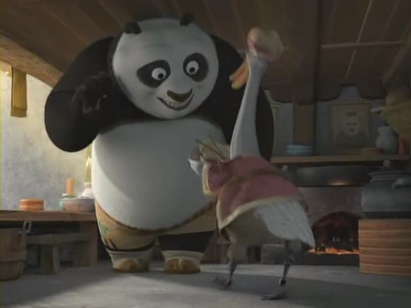

You don’t know how long I've been waiting for this moment!
This is a sign, Po!
Po: Uh...a sign of what?
Father: You are almost ready to be entrusted with the secret ingredient of my secret ingredient soup,
And then you will fulfill your destiny and take over the restaurant!

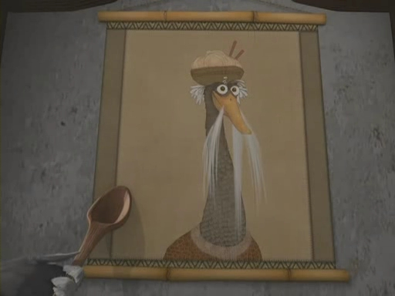
Father: Just as I took it over from my father,
who took it over from his father who won it from a friend in a game of mahjong.
Po: Dad,dad,dad! It was just a dream.
Father: No, it was 'the Dream.’
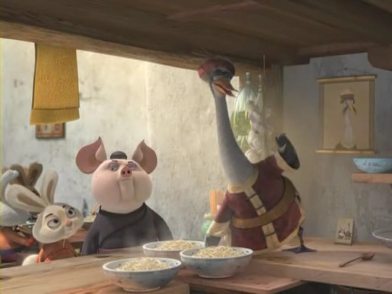We are noodle folk, broth runs though our veins!
Po: But, dad, didn’t you ever…want to do something else?
something besides noodles?
Father: Actually. when I was young and crazy,
I thought about running away and learning how to make tofu.
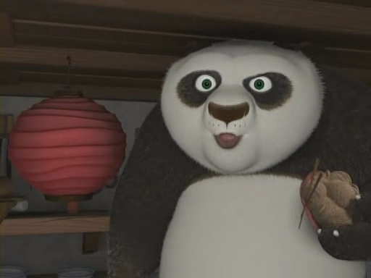Po: So why didn't you?
Father: Oh because it was a stupid dream!
Father: Can you imagine me making tofu?
Father: Hahahaha……tofu……no!
We all have our place in this world,
mine is here, and yours is…
Po: I know…is here.
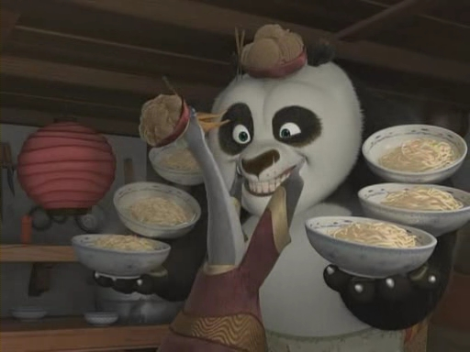
Father: No…it’s the table 2,5,7 and 12!
Service with this smile

