Grammar Lesson Plan
Topic: If you had $1,000,000, what would you do?

Instructor:  Carrie Choi | Level:  Pre-Intermediate | Students:  12 | Length:  25 Minutes

Materials : Computer with the Internet
Projector and Speaker
White board, Board Markers
Music video [starting from 00:20]
Phrase cards [20 pieces 3copies]
Picture cards[12 pieces 3copies]
Flash cards [15 pieces 3 copies]

Aims - Students will be able to imagine what they would do in some unreal situations by using the 2nd conditional.
- Students will be able to listen to Barenaked’s song, “If I had a million dollar”
- Students will be able to know the form of the second conditional by playing picture cards on which some specific situations are written.
- Students will be able to practice listening by playing phrase cards and also practice speaking by sharing their opinion by playing picture cards.

Personal Aims – I want to improve to explain the grammar form to students.

Language Skills:
- Reading : Students should read and understand phrase cards.
- Listening : Students should listen to the music, the teacher’s instructions and friends’ opinions.
- Speaking : Students should share their own opinions about some situations on the picture cards.
- Writing : Students should do their homework; find 5 problems they have now, and solve those by imagining.

Language Systems:
- Grammar : using the form of the 2nd conditional and getting used to it.
- Lexis: some words from the song by matching phrase cards with picture card. : remains, John Merrick, treefort, ottoman, Kraft Dinner
- Phonology : pronouncing new words by listening the video.
- Function : asking and answering the questions from flash cards.
- Discourse : sharing their imagination using the flash cards.

Assumptions:
- Students are at a pre-intermediate level, so they can listen, read and understand short sentences.
- Some of students already know the song and some of words from the song.
- Students already know the teacher’s teaching skill and type.
- Some of students may know the form of the 2nd conditional.
- Students know how to make a sentence by using a conjunction ‘if’.
- Students know seat arrangement and time dividing.

Anticipated Errors and Solutions:
- Internet may not be able to work for a while.
→ Save the music video clip in my USB drive in advance.
- Students may not know what to do while they are watching the music video.
→ Monitoring discreetly, if I feel something wrong with a group, I’ll remind them that they choose those phrases that they’ve listened from the song.
- Students may not be willing to discuss with their partner.
→ I will come closer and listen what they are sharing, and as if I am another partner in the group, I share my imaginations with them.
Encourage them to talk to each other.
- Students may have difficulty writing their own opinions for homework.
→ Tell them even short sentence is good to start, and show them some examples.

References:
Music video clip: http://busyteacher.org/3748-if-i-had-a-million-dollars-by-barenaked-ladies.html
Flash cards : http://busyteacher.org/10766-conditional-ii-flashcards.html
Picture cards : http://busyteacher.org/3748-if-i-had-a-million-dollars-by-barenaked-ladies.html

Lead-In
Materials: White board, Board Markers
Time | Set Up | Procedure
2 min | Whole Class | Hello, everyone. I’m a man, I’m not married, I’m taller than Scott, We are in France, I go to the gym at lunch break, I have a child, I run my business, It is sunny out there, We are all on the beach.  Are these are true? Are these are real? (elicit ‘no’ from students)  No, those are unreal or untrue. But we can imagine I were a man, I weren’t married, or we were all on the beach. Right?  Today, we are going to have some time to use our imagination.

Pre-Activity
Materials: : Computer with the Internet
Projector and Speaker
White board, Board Markers
The table for drilling
Music video [starting from 00:20]
Phrase cards [20 pieces 3copies]
Picture cards[12 pieces 3copies]
Time | Set Up | Procedure
2 min  5 min  3 min | Whole class  In Group  Whole class | Before we use our imagination, I will show a music video about some guy’s imaginations and wishes. Why don’t you enjoy the video and find out what they would do?  I will distribute some phrase cards and pictures. While you are watching it, you can choose every phrases and pictures you can hear and watch from the video. Some cards may be left. You will do this activity with your group. Each group has 4 members.  (Distribute phrase and photo cards to each group)  Demonstration:  - For example, if I heard ‘would buy you a house,’ you choose this card (saying ‘would buy you a house’) and choose this house picture (showing the house picture card).  ICQ  - Are you going to work alone or in a group?  - How many of you are working together?  - When do you choose the cards during the video? Or after the video?  - Are you choosing only phrase cards, picture cards, or both of them?  (Show the video clip)  (Monitor discreetly)  Did you choose every word you can listen? (elicit ‘yes’ from students / If they need more time, give them one more minute)  Are they actually millionaire? (elicit ‘no’ from students) Or, do they have a million dollar in real? So they just imagine they had a million dollar. What did they say for starting imagination of millionaire, “If I ~ ,” (elicit ‘had a million dollar’ from students) Good!  So, if they had a million dollar, what would they want to do? Shall we share two phrases and the matched pictures in each group?  Demonstration:  - For example, when I ask you to share what you got, you hold up your picture card (showing a house card) and read the phrase card (reading buy you a house).  This group, what do you have? Show us a right picture and read what you get.  (elicit to read some phrases on the cards and show pictures from students)

Main Activity
Materials: White board, Board Markers
Flash cards [15 pieces 3 copies]
Computer and Projector
Time | Set Up | Procedure
3 min  4 min | Whole Class  In Group | (Show the table)  So, when we imagine we were in unreal situation, we use a special form. Because we are saying unreal or untrue things now, we can’t use the present tense. So we changed the tense as we listened to the music.  Drilling  I don’t have a million dollar now, but I want to imagine I had one. That’s the time we use this tense-changed form : If I had a million dollar, ~ .  Now, we can fill the blank with you talking.  (Ask one student from each group to say and fill the blank)  CCQ:  - Can we use the form of present tense if you want to imagine that you were in untrue situation?  - If I want to imagine that I were in untrue situation now, what tense do you use, present tense or past tense?  We are going to imagine as if we were in some specific unreal or untrue situation now.  You will have 15 cards in each group. At first, pick two cards each person. Secondly, think about the situation on the cards and share what you would do or what you would want to do with your group. I will give you 3 minutes.  ICQ  - Are you going to work alone or in a group?  - How much time do you have?  - How many cards do you pick?  (Monitor discreetly)
  If I | had | a million dollar, | I | would | buy you a house.
  If I | had | a million dollar, | I | would | buy you a furniture.
  If I | were | on the beach, | I | would
  If I |  | , | I | could
  If I |  | , | I | could

Post Activity
Materials: White board, Board Markers
Flash cards [15 pieces 3 copies]
Time | Set Up | Procedure
4 min  2 min | Whole Class  Whole Class | Do you need more time? (if they say ‘yes’, give them one more minute)  How about sharing our own imagination? Let’s share two people in each group. Who wants to share from this group?  - If one student pick “If I were a girl, I …. ” , after sharing his/her answer, ask another group “Who has the same card?”  - Ask each group 6~8 their sentences in total.  Thank you for sharing. The form that we used through the cards is the 2nd conditional grammatically.  Now I want you to write 5 sentences by using your imaginary situations. Make an unreal or untrue situation, and write what you would do.  Hand in by tomorrow.  ICQ  - How many sentences do you make?  - Can you use the present tense?  - When do you bring it by~ ?  - Can you use real situation in the sentence?  Feedback  - Good job! So impressive of your participation.  - I believe you can do your homework as you’ve done in the class.

Phrase cards
I’d fly in the sky.
I’d buy a building.
I’d buy a helicopter.
I’d raise lots of dogs.
I’d hire Bill Gates as an engineer.
I’d run my business.
I'd buy you a house.
I'd buy you furniture for your house.
I'd buy your love.
I'd build a tree fort in our yard.
I'd buy you a fur.
I'd buy you an exotic pet.
I'd buy you John Merrick's remains.
We'd take a limousine.
We wouldn't have to eat Kraft Dinner.
I'd buy you a green dress.
I'd buy you some.
I'd buy you a monkey.
We could put a little tiny fridge in there somewhere.
We could buy a big table in the kitchen.


Picture cards


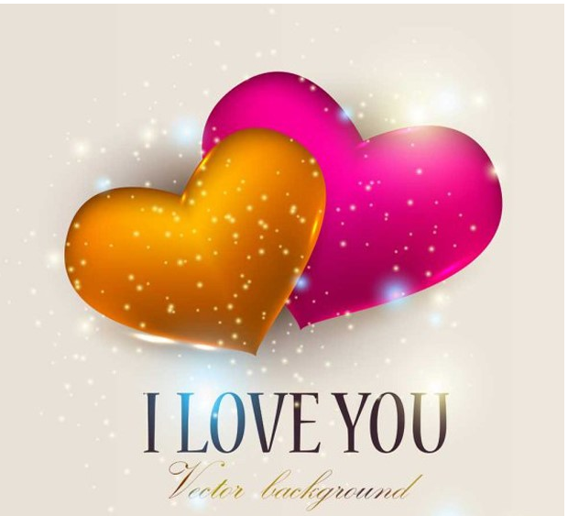

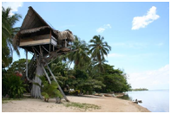


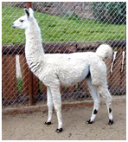


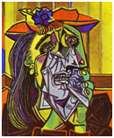
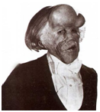

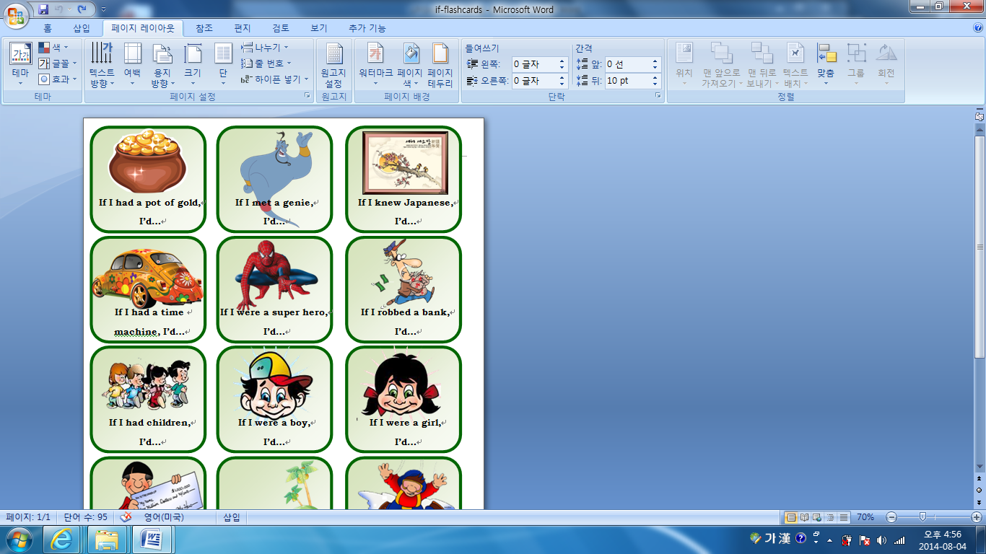
Flash cards


