Modal Verbs
Auxiliary Verbs
Yellow shades- Principal Modal Verbs
Be verb(is, are) | Do | Dare | Need to
Will | Would | Shall | Should
Ought to | Must | May | Might
Can | Could

An auxiliary verb is a verb that adds functional or grammatical meaning to the clause in which it appears—for example, to express tense, aspect, modality, voice, emphasis, etc. Auxiliary verbs usually accompany a main verb
The modal verbs of English are a small class of auxiliary verbs used mostly to express modality (properties such as possibility, obligation, intention, permission/approval, etc.). They can be distinguished from other verbs by their defectiveness (they do not have participle or infinitive forms) and by the fact that they do not take the ending -(e)s in the third-person singular.
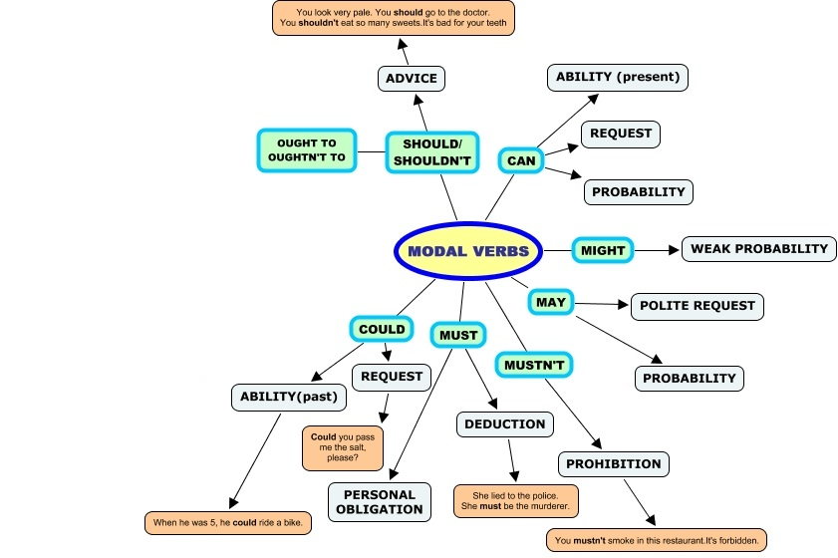
Modal Verbs Exercise /
choose the right answer according to the context
1. You can / should book the tickets for the play in advance - they sell out quickly.
2. Dave: Can / would you hold your breath for more than a minute?
Nathan: No, I can't.
3. He’s amazing, he _____ speak five languages.
a. will b. can c. shall d. may
4. That woman ______ be a doctor! She looks far too young.
a. can’t b. couldn’t c. should d. shouldn’t
5. Why are you still standing? You ____ have a seat here.
a. Will b. can c. shall d. must
6. I looked everywhere for my glasses but I _____ find them anywhere.
a. could b. can’t c. couldn’t d. shouldn’t
7. We have a lot of homework tomorrow. You _____ not be late!
a. must b. will c. may d. shouldn’t
8. Jesse: _____ I help you?
Peter: Yes, please. I’d like to know where I _____ find a grocery store
a. Can / should b. May / must c. May / can d. Can / will
9. Could / can you swim when you were 10?
10. You can borrow my new dress, but you ______ get it dirty
a. can b. cannot c. shouldn’t d. wouldn’t
11. Eric: Why is that man looking around like that?
Daniel: I don’t know. He _____ be lost
a. can b. might c. shall d. can’t
12. We shouldn’t / couldn’t get to the meeting on time yesterday, because the train was delayed by one hour.

