Listening Speaking Reading Grammar Writing

Topic: The Bucket list

Instructor:  Minji Jung | Level:  Pre-intermediate | Students:  12 | Length:  25 Minutes

Materials: White board and markers
Overhead projector and screen
Pictures for pre-activity
A Clip about bucket list
Bucket List worksheets
12 worksheets

- Main Aims
- Students will be able to improve their thinking and speaking skill by doing the task.
- Students will be able to develop their listening skill and the ability to describe their thoughts by speaking English.
- Secondary Aims
- Students will be able to share their opinions and experiences through conversation with each other.
- Personal Aims
- I want to be better at time management and demonstration of the activity.
- I want to have more confidence when I speak in front of students.

Language Skills
Reading: Students will read the worksheets and will discuss about their bucket list and life graph.
Listening: Listening teacher’s explanation and classmates’ answer.
Speaking: Students will discuss with each other
Writing: Students will write down their bucket list.

Language Systems
Phonology: Naturally get students to practice their pronunciation.
Lexis: Students using words to explain their worksheet and to give feedbacks.
Grammar: Rather than focusing on grammar this time, let students relax better so they can improve their fluency.
Function: Expressing their ideas and opinions, and showing sympathy and disagreement
Discourse: communication with other students

Assumptions
- Students are familiar with some vocabulary words about bucket list
- Students are basically able to say what they want to say
- Students can show their ideas and feelings with various expressions.
- Students enjoy sharing their thoughts.

Anticipated Errors and Solutions:
- Students may have difficulties speaking their opinions
Monitor, assist when necessary, and encourage them to come up with idea or words
- Students may not know some vocabulary in passage
Let students guess meaning in context
- Some students may not be active in the discussion
Encourage students by asking for their opinions

References:
http://www.youtube.com/watch?v=4XAeccQ1StE
http://personalexcellence.co/blog/bucket-list/
http://jo-jolovestuna.blogspot.kr/2008/09/my-life-graph.html

Pre-Task
Materials: Pictures and a clip for pre-activity

Time | Set Up | Student Activity | Teacher Talk
3 | Whole class | Guiding Questions  Good morning class.  How are you today?  Have you heard about a bucket list?  If you haven’t heard about the bucket list, it is a list of all the goals you want to achieve, dreams you want to fulfill and life experiences you desire to experience before you die.  I will show you some pictures.  These pictures are from list of the 101 things you want to do before you die.  And here is a short clip of movie called the bucket list. It is about a journey of two old men that accomplish their bucket list one by one before they die.  Did you enjoy the video?

Task Preparation
Materials: Bucket list worksheets

Time | Set Up | Student Activity | Teacher Talk
5 | Whole  class | Instructions  Now everyone make your own bucket list.  I will hand out worksheets.  I will give you 5 minutes.  Okay, everyone finished making lists?  Now, I want you to share your bucket list with your group.  Okay, I want you to tell one by one your bucket list and reason.  Make sure you tell your group the reasons behind your bucket list.  Demonstration  These questions are helping you to make bucket list.  Write down ten things you would like to do before you die and think about reasons why you want to do it.  ICQ  What are we doing?  Are we working in group?  How much time do we have?  How long do the reasons have to be  What kind of things can be on the bucket list  CCQ  Can I put unrealistic things on the bucket list?  Is the bucket list similar to a wish list? Or is it different?

Task Realization
Materials: 12 worksheets

Time | Set Up | Student Activity | Teacher Talk
10 | Whole  class | Instructions  Now we will draw a life graph and also a graph picturing the future.  Try and predict your future when you draw the graph.  For example, how old you think you will die and how many children you may have and what you will be when you are older. Write down things like this and after you are done share with your group. Since we do not have much time just one person from each group presents their future graph.  Who will like to present from this group?  Demonstration  The numbers on this graph represent age and the descending lines show depressing and hard times while the ascending lines show the good and happy times.  ICQ  What are we doing?  Are we working in group?  How much time do we have?  How many things have to be on the graph?  CCQ  Should students write all big events on each their life graph?

Post Task
Materials: No materials need

Time | Set Up | Student Activity | Teacher Talk
5 | Whole  class | Feedback  Was today’s class fun?  What did we talk about today?  Was it difficult to do activities?  Did you have fun talking about this topic?  Was it helpful for you to improve your thinking and speaking skill?  Error Correction  I did not hear any mistakes from everyone.  Closing  It was very entertaining and meaningful to hear about all of your plans for the future and bucket lists.
SOS Activities
Materials: No materials need

Time | Set Up | Student Activity | Teacher Talk
 | Whole  class | If some students have finished their worksheet earlier than they can share their big events on their life graph such as when was their turning point of life and what big happens they through.

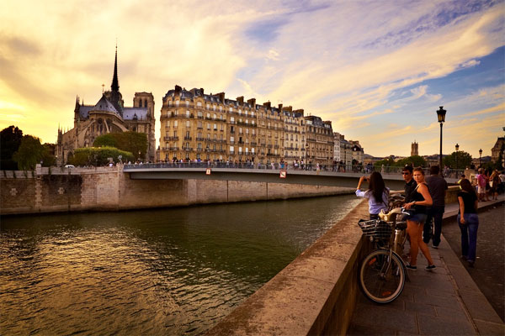 Travel all around the world
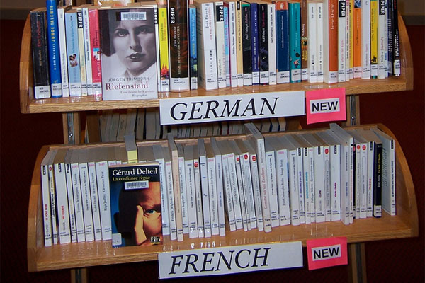 Learn a new language
 Achieve your ideal weight
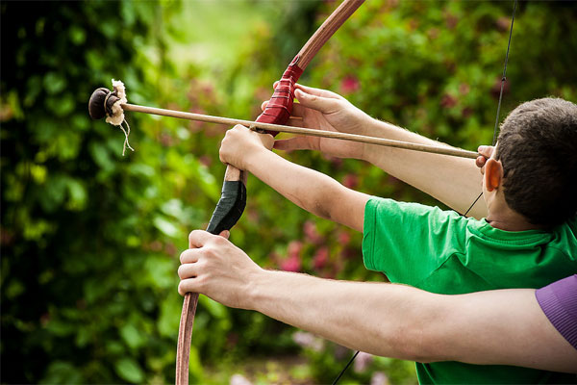 Take up a new sport

Let someone know how much he/she means to you
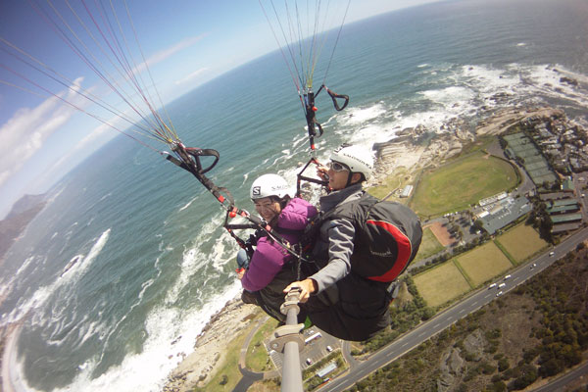 Do an extreme sport
 Give a heartfelt surprise to someone
 Perform a kind deed without expecting anything in return
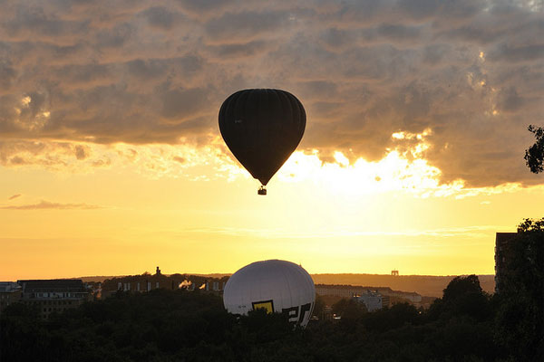 Fly in a hot-air balloon
Make your own bucket list

1.

2.

3.

4.

5.

6.

7.

8.

9.

10.

- What would you do if you had unlimited time, money and resources?
- What have you always wanted to do but have not done yet?
- Any countries, places or locations you want to visit?
- What are your biggest goals and dreams?
- What do you want to see in person?
- What achievements do you want to have?
- What experiences do you want to have / feel?
- Are there any special moments you want to witness?
- What activities or skills do you want to learn or try out?
- What are the most important things you can ever do?
- What would you like to say/do together with other people? People you love? Family? Friends?
- Are there any specific people you want to meet in person?
- What do you want to achieve in the different areas: Social, Love, Family, Career, Finance, Health (Your weight, Fitness level), and Spiritual?
- What do you need to do to lead a life of the greatest meaning?



