Speaking Lesson Plan

Title: My right to death with dignity at 29
INSTRUCTOR | LEVEL / AGE | STUDENTS | LENGTH
Yi Na Yoon | Intermediate / 21- 56 | 7 | 50 mins

Materials:
- 1 Board and 4 markers
- 10 copies of worksheet “What are useful expressions for group discussion?”
- 10 copies of worksheet “After watching the video clip about Brittany Mayard”
- Laptop for playing the video clips and showing power point slides
- Beam Projector

Aims:
- Students will practice summarizing by answering the questions in the worksheet “After watching the video clip about Brittany Mayard”.
- Students will study the useful expression of discussion by answering the questions in the worksheet “What are useful expressions for group discussion?”
- Students can practice speaking by group discussion.

Language Skills:
Listening: Watching the video clips, teacher’s instructions, group discussion
Speaking: Group discussion to answer the questions in worksheet.
Reading: The subtitles in the video script, Questions in the worksheet
Writing: Writing answers in the worksheets

Language Systems:
Phonology: Listening to the pronunciation of the words in the video clip (brain cancer, miracle, physician, suffer, comfort, dignity, hope)
Lexis: Brain cancer, miracle, physician, suffer, comfort, dignity, hope
Grammar: Future tense
Discourse: Talking about the past and the future of life
Functions: Planning and predicting

Assumptions:
Students will have some knowledge about the death with dignity and euthanasia.
Students will know the words related to the death with dignity, which is enough to discuss.

Anticipated Errors and Solutions:
- Error: Students may make some grammar mistakes when doing presentation
Solution: Making notes about errors during presentation and making comments on the errors after presentation.

References:
- http://www.youtube.com/watch?v=vDhurLK4Q8I
- http://www.wspa.com/story/26729736/woman-diagnosed-with-terminal-cancer-chooses-to-die-nov-1

Notes:
If students need more time to finish their activity, be flexible with the time.
SOS activities: Playing the video clip, where Robin Williams was the main character and discussing the video clip
http://www.youtube.com/watch?v=aM_KMfyqrzo

Pre Task
Title:  Death with dignity |  | Aims:  To make students ready and be interested in lesson  To practice speaking by answering the guiding questions | Materials:  Board and markers  Laptop for playing the video clip called ‘Death with dignity’  Beam Projector
Time | Set Up | Students | Teacher
4  mins | Whole class | · Giving answered to the below guided questions  - What is about?  - How do you feel about this video clip? | · Greeting  · Playing the below video clip:  death with dignity - YouTube  · Eliciting student’s response to the guided questions
Notes: While watching the video clip, laptop might not work properly. In this case, ask the students about the below questions instead of playing the video clip and asking the above guided questions.
- How are you supposed to respond to the person you love being in pain?
- How do you respond when you know they are dying?

Task Preparation
Title:  Discussion expression |  | Aims:  To study the useful expression of discussion | Materials:  One white board and 4 markers  10 copies of worksheet “What are useful expressions for group discussion?”
Time | Set Up | Students | Teacher
6  mins | Groups (3-4)  (3mins) | · Listing the expression for group discussion in the  worksheet | · Passing out copies of worksheet ‘useful expression  for group discussion’  · Helping students to make the list if needed
 | Whole class  (3mins) | · Writing down the discussed expression on the board | · Comparing the lists of two groups  · Adding more expressions if needed

Notes:

Task Realization
Title:  Woman diagnosed with terminal cancer chooses to die |  | Aims:  To practice summarizing by answering the questions in the worksheet “After watching the video clip about Brittany Mayard”  To practice speaking by group discussion | Materials:  1 Board and markers  10 copies of worksheet “After watching the video clip about Brittany Mayard”  Laptop for playing the video clips and showing power point slides  Beam Projector
Time | Set Up | Students | Teacher
31  mins | Whole class  (7mins) | · Watching the video clip about Brittany Mayard | · Passing out copies of worksheet “After watching the  video clip about Brittany Mayard”  · Playing the video clip about Brittany Mayard
 | Groups (3-4)  (8mins) | · Answering question I and II in the worksheet “After watching the video clip about Brittany Mayard” by discussion | · Giving instructions on how to complete the worksheet  “After watching the video clip about Brittany Mayard”  · Monitoring students discretely to check if students  need help
 | Groups (3-4)  (16mins) | · Discussing question III in the worksheet “After watching  the video clip about Brittany Mayard”  · Doing presentation after discussion about team’s opinion | · Giving instructions on the way of discussion  - Using the useful expression of discussion  · Monitoring to check if students have a clear  understanding about the topic  · Encouraging students to actively take part in  Discussion  · Monitoring to check if the presenter needs help

Notes:
While watching the video clip, laptop might not work properly. In this case, back up MP3 file in phone will be used.
If students do not have enough time to prepare for the presentation, ask the students to practice presentation and do it during the next class.

Post Task
Title:  Review |  | Aims:  To practice speaking through group discussion | Materials:  1 Board and markers
Time | Set Up | Students | Teacher
9  mins | Pairs | · Teaching each other what they learn during the class | · Giving the time to teach each other  · Giving them home work as below  - Preparing for 1 minute speech about the below question:  “Do you believe in euthanasia?”

Notes:

Worksheets, handouts and lesson materials
- Worksheet
Speaking: My right to death with dignity at 29

- What are useful expressions for group discussion?

Stating your own opinion | Interrupting
Agreeing with an opinion | Disagreeing with an opinion

After watching the video clip about Brittany Mayard
http://www.wspa.com/story/26729736/woman-diagnosed-with-terminal-cancer

I. Summarize Brittany Maynard in the below order of pictures.

1 | 2
3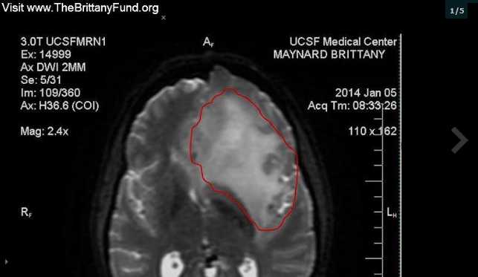 | 4
5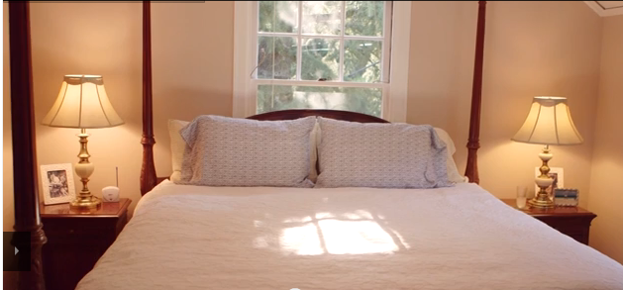

II. Concept questions

- What happened to Brittany Maynard?

- What was her and her family’s final decision about her life?

III. Discuss the below questions with your group members and do presentation about your
team’s opinion about them

- If you were Brittany Maynard, what would you do?

- What are the pros and cons of euthanasia (painlessly killing someone who wants to die but is physically unable to commit suicide)?

- In hospitals in England terminally ill patients may request not to be resuscitated if their heart stops beating. Medical staff must respect this Do Not Resuscitate (DNR) request and let the patient die. What is your opinion about this?

