Grammar Lesson Plan

Title: Comparative Adjectives
INSTRUCTOR | LEVEL / AGE | STUDENTS | LENGTH
Ms. Amy Oh | Elementary/13-15 | 17 | 50 mins

Materials:
White board, board markers, erasers, colored markers.
Adjective list (17 copies)
Few pictures of famous stars (saved in USB)
Computer & projector
Papers for “drawing your partner activity”
Extra papers

Aims:
- Students can improve speaking and listening skills by group activities and teacher’s eliciting
- Students can learn new vocabulary by describing and comparing people
- Students can improve reading and writing skills by doing group activity and racing game
- Students will be able to learn “Comparative adjective” naturally by participating in all activities

Language Skills:
Listening: listen to Class mates, teacher’s eliciting & instructions
Speaking: sharing ideas of topic in a group activities and drilling the new vocabulary with teacher
Reading: read a list of adjectives
Writing: students write answers in correct form of “Comparative adjective”

Language Systems:
Phonology: See Lexis
Lexis: learning new vocabulary (useful, curly, thin, gorgeous, nervous)
Grammar: Comparative adjectives ( -er, -ier, more adj + than )
Discourse: talking about differences between 2 people by using comparative adjectives
Function: describing, comparing

Assumptions:
All Students have been learning English for only 2~3 months
All students are able to find out the differences between two people and able to describe the differences in a short sentence
All students have a dictionary with them

Anticipated Errors and Solutions:
- Students may not know the meaning of new words exactly.
→ show students the meaning by gesture
- Some Students may have difficulty of remembering new vocabulary
→ keep repeat and use the new vocabulary during the class
- Some students may feel too shy to talk with other class mates and do not participate in group work
→ split the students into two teams and play games to motivate

References:
http://www.usingenglish.com/articles/fun-practice-for-comparative-adjectives.html
http://www.grammar-world.com/adjective/list_of_comparison_of_adjectives
http://www.k12reader.com/term/comparative-adjectives/

Notes:

Pre Task
Title:  Compare two pictures of famous stars |  | Aims:  To make students relax and get ready for the class  To introduce the topic in natural way | Materials:  Few pictures of famous stars (from my USB)  Board, markers
Time | Set Up | Students | Teacher
10mins | Whole class  + individual | - Greeting teacher  - Look at the famous star’s pictures  - Answers the guiding questions  -> Who do you like more? Why?  -> Who do you think is prettier/more handsome?  -> Can you find the differences between this two people? | - Greeting students (good morning everyone~)  - Show students the pictures of famous stars  - Give students Guiding questions

Notes

Task Preparation
Title: List of Comparative adjectives |  | Aims:  To help students to understand the meaning of vocabulary before we use them in the class  To improve student’s vocabulary and speaking by drilling with teacher | Materials:  White board, markers  Adjective list (17 copies)
Time | Set Up | Students | Teacher
6  mins | Whole class | - Drilling new vocabulary with the teacher  - Such as useful, curly, thin, gorgeous, nervous  - Improve pronunciation | - Hand out the list of adjective  - Pre-teach the new vocabulary related to topic  - Drilling with students

Notes:

Task Realization
Title:  Describing and Comparing the partner  & Group activity (Guess Who?) |  | Aims:  - Students can improve speaking and listening skills by group activities  - Students can develop writing skill by making sentences of comparison | Materials:  White board, board markers, erasers, colored markers.  Papers ( drawing your partner to compare the differences with myself)
Time | Set Up | Students | Teacher
24  mins | Pair work (7min)  Whole class (5min)  Group(9mins)  Whole class (3mins) | - Listen to the instructions and work in pairs  - Draw your partner to describe and write down the differences compared to myself  - Use comparative adjectives to make full sentences  - Random students will Present the previous pair work to the class  - Group up with 4~5 of other class mates  - Listen to the instructions of “Guess Who?” game  - Participating in group activity by guessing who is being compared  - listen to teacher’s description and guess who!! | - ask students to work in pairs  - hand out the papers for “describing partner” activity  - give students instructions  - walk around to observe the class  - Get few volunteers to present the pair work to the class  - Observe the class if any help needed  - Divide students into 3 groups  - Collect all the papers and switch them to new groups  - Give instructions of “Guess Who?”  - Walk around to observe the class  - I am going to pick a random student and describe and compare him/her to myself

Notes:

Post Task
Title:  Racing game |  | Aims:  Students can develop reading & writing skills by playing team game  - To make sure students know how to use comparative adjectives in correct form  - Students can develop cooperating skills by working as a team | Materials:  List of adjective  Whiteboard and markers  Prize for the winner (motivation)
Time | Set Up | Students | Teacher
10  mins | Group of 5-6 students | - Divided into 3 groups  - Listen to game instructions from teacher  - Encouraged to Play racing game by supporting team mates  - Write the correct form of “Comparative adjective” on the board  - Remember the comparative adjective by playing racing game | - Split the students into 3 groups and give instructions to play racing game  - Encourage students to participate by providing a prize for a winner  - Check the answers to make sure students know how to use comparative adjective properly  - Wrapping up the class

Notes

vs
Who are they?
Who do you like more?
Who do you think is more beautiful/prettier?
Can you find some differences between two of them?
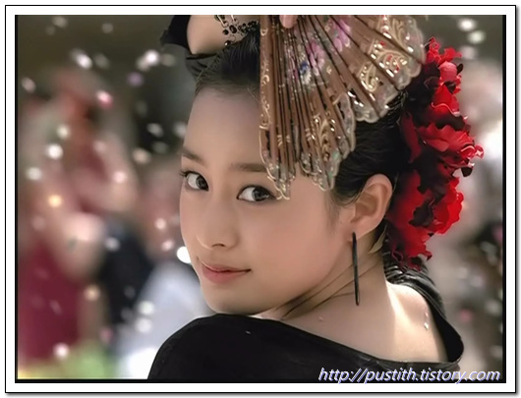 VS 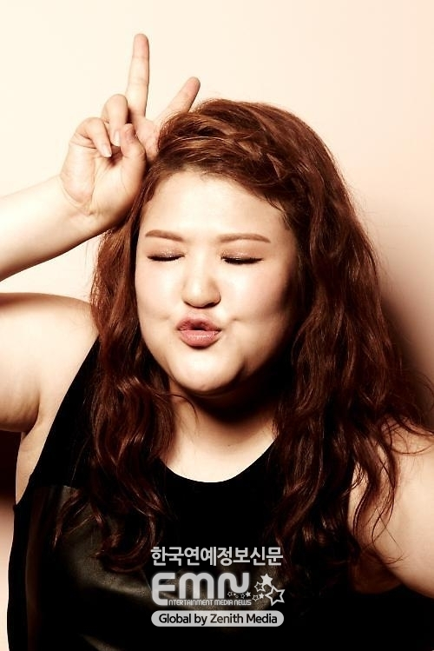
Who are they?
Who do you like more?
Who do you think is more handsome?
Who do you think is sexier?
