Grammar Lesson Plan

Title: What might have happened?
INSTRUCTOR | LEVEL / AGE | STUDENTS | LENGTH
Yi Na Yoon | Intermediate / 21- 56 | 7 | 50 mins

Materials:
- 1 Board and 4 markers
- 10 copies of worksheet “Criminal scene”
- 10 copies of worksheet “Clues”
- 10 copies of worksheet “The newspaper report”
- Laptop for playing the video clip
- Beam Projector

Aims:
- Students will study the new structures through controlled practice and less controlled practice in worksheet “Clues” and “The newspaper report”
- Students will study the meaning of new structures by answering the concept questions about “criminal scene” in the worksheet.
- Students can practice speaking through discussion and presentation.

Language Skills:
Reading: The subtitles in the video script, Text and Questions in the worksheet
Listening: Watching the video clip, teacher’s instructions, presentation
Speaking: Doing presentation and answering questions
Writing: Writing answers in the worksheets

Language Systems:
Phonology: Must have, May have, Might have, Can’t have
Lexis: Must have, May have, Might have, Can’t have
Grammar: Modals; Certainty about past time
Discourse: Talking about the possible happening in the past
Functions: Reporting and describing

Assumptions:
Students will be familiar with vocabulary about crime, which is enough to answer the questions in worksheet.
Some students will know how to talk about the certainty at present time.

Anticipated Errors and Solutions:
- Error: Students may make some grammar mistakes when doing presentation
Solution: Making notes about errors during presentation and making comments on the errors after it

References:
- http://www.youtube.com/watch?v=cnnmc9nBeOY
- https://www.paypal.com/kr/webapps/mpp/home

Notes:
If students need more time to finish their activity, be flexible with the time.
SOS activities: Playing the below video clip and discussing the topic related to the video clip
http://www.youtube.com/watch?v=FOocRwoc87w

Pre Task
Title:  The three little pigs |  | Aims:  To make students ready and get interested in topic  To practice speaking by answering the guiding questions | Materials:  One white board and markers  Laptop for playing the video clip  Beam Projector
Time | Set Up | Students | Teacher
6  mins | Whole class | · Answering the guiding questions  - What is it about?  - Why did people start to think that the little pigs were not the victims but the criminals? | · Greeting  · Playing the video clip called “The three little pigs”  http://www.youtube.com/watch?v=cnnmc9nBeOY  · Eliciting their ideas about the guiding questions
Notes: While watching the video clip, laptop might not work properly. In this case, explain the story of video clip instead of keeping trying to play the video clip.

Task Preparation
Title:  Vocabulary teaching |  | Aims:  To give chances for students to get familiar with the target structures  To study the meaning of the new structures | Materials:  One white board and markers  10 copies of worksheet “Criminal scene”
Time | Set Up | Students | Teacher
8  mins | Whole class  (8mins) | · Students read the text “Criminal scene” in the worksheet  aloud together  · Giving answers to the below concept questions  - Two police officers are talking about possible happening in the past?  - Two police officers are 100% sure about what they are talking about?  · Figuring out the target structures in the worksheet.  - Might have known  - Might have had  - Might have drunk  - Must have been | · Passing out copies of worksheet “Criminal scene”  · Eliciting student’s response to the concept questions  · Eliciting target structures with the sentences in the  worksheet

Notes:

Task Realization
Title:  The house husband |  | Aims:  To practice the new structures through controlled practice and less controlled practice  To practice speaking through discussion and presentation | Materials:  One white board and markers  10 copies of worksheet “Clues”  10 copies of worksheet “The newspaper report”
Time | Set Up | Students | Teacher
27  mins | Whole class  (7mins) | · Completing the worksheet according to teacher’s  instruction  · Giving answers to the below concept questions  - Did police officers believe it was true that the victim was having an affair?  - Did police officers believe that it was impossible for robber to break into the house?  - Did police officers think that the victim knew the murderer or not? | · Passing out copies of worksheet “Clues”  · Helping student to understand the new structures  with timetables if needed  · Eliciting student’s response to the concept questions
 | Pairs  (3mins) | · Answering the questions in worksheet “You read” by discussion | · Giving instructions on how to complete the number 3  question in the worksheet “Clues”  · Monitoring students discretely to check if students  need help
 | Groups (3-4)  (17mins) | · Preparation for doing presentation about “The newspaper  report” in the worksheet  · Doing presentation | · Passing out copies of worksheet “The newspaper  report”  · Giving instructions on how to presentation  - When doing presentation, students should use the new structures  · Encouraging students to actively take part in  preparation for presentation  · Monitoring the presentation to check if students need  help

Notes:
If students do not have enough time to prepare for role play, ask the students to practice it and do it during the next class.

Post Task
Title:  Review |  | Aims:  To practice speaking through group discussion | Materials:  One white board and markers
Time | Set Up | Students | Teacher
9  mins | Pairs | · Teaching each other what they learn during the class  · Submitting assignment to teacher by next class  - Watching the video clip called “The three little pigs” and writing the newspaper report  http://www.youtube.com/watch?v=cnnmc9nBeOY | · Giving the time to teach each other  · Giving instructions about the assignment

Notes:

Worksheets, handouts and lesson materials
- Worksheet

Grammar: What might have happened?

Criminal scene …

Scene: Two police officers are investigating the murder of Paul Roberts, a local businessman. They are at his house.

Inspector Black | Well, what do you think happened?
Sergeant Spacey | Hmm…the door isn’t broken. I think he might  have known the murderer.
Inspector Black | Yes. And look here. There are two empty wine  glasses. He might have had a drink with his killer.
Sergeant Spacey | Yes - there are some empty wine bottles in the  corner. They must have drunk quite a lot.
Inspector Black | Look at the glass! There’s lipstick on it. The killer  must have been a woman…
Sergeant Spacey | Interesting! Let’s see what else we can find…

Clues….

·1) Write the phrases in the correct position under the arrow.

May have | Must have
Can’t have |  | Might have

2) Rewrite these sentences
1) He was having an affair. (might)
2) A robber broke into his house. (must)
3) He knew the murderer. (may)
4) The murderer was a stranger. (can’t)
5) The murderer was a woman. (must)
6) He committed suicide. (can’t)

3) What might have happened? Look at the evidence below, and write some suggestions
There’s an empty picture frame on the wall.
Mr. Roberts’ glasses are on the floor, smashed.
There’s a gun lying near the body.
There’s a torn photograph on the kitchen floor.
Mr. Roberts’ car is missing.

The newspaper report…

· Look at the following newspaper report of the killing.

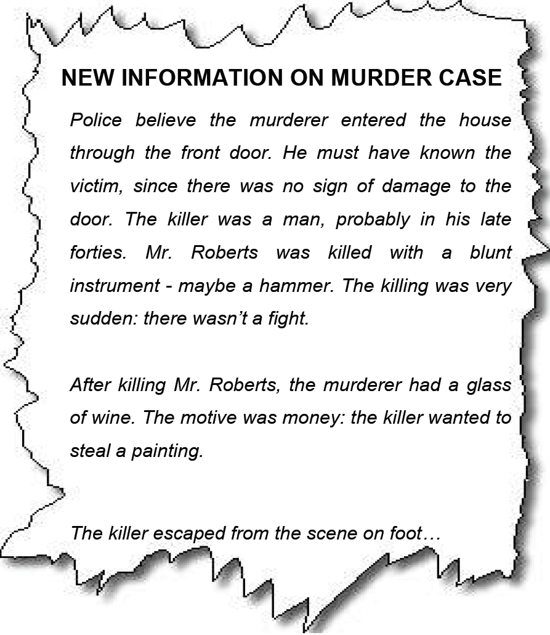

· Your task
- Is this newspaper report accurate?

- Discuss the report with a partner.

- Make notes about any errors you find.

- Why do you think the journalist is wrong?

