Listening Lesson Plan

Title: Facial Expressions
INSTRUCTOR | LEVEL / AGE | STUDENTS | LENGTH
Ellen Park | Intermediate (Adult) | 19 students | 50 mins

Materials:
-White board and markers
-Laptop to show a facial expressions video clip to the students
-Facial Expressions Worksheet
-Facial Expressions Vocabulary worksheet

Aims:
-To practice on the listening skills by watching a video clip on facial expressions.
-To study new vocabularies which are used to describe facial expressions and to make sentences by using the vocabularies we learned.
-To give them chances to work in groups and to develop the teamwork skills.

Language Skills:
Listening: Watching and listening to the Facial expressions video clip, listening to the other students’ opinions during the discussions, listening to the teacher’s questions and eliciting.
Reading: Facial expressions worksheet, vocabulary worksheet.
Writing: Facial expressions worksheet
Speaking: Group discussions, responding to the teacher’s questions and eliciting, making sentences using the words we learned today.

Language Systems:
Phonology: I read out various vocabularies that are used to express facial expressions: smirk, brooding, leer.
Lexis: smirk, brooding, leer.
Discourse: Discussion between students.
Functions: Requesting, questioning.
Grammar: We study several adjectives to describe facial expressions and try to make sentences using proper grammar structures.

Assumptions:
-Students should know simple vocabularies on facial expressions.
-Students are able to identify what causes which facial expressions to appear on the face.
-Students know the rules of using adjectives to describe certain things.

Anticipated Errors and Solutions:
-Students might not understand the definitions of the vocabularies –> Demonstrate.
-Students might find the video clip too difficult to follow –> Repeat it once or twice.

References:
Facial Expressions Worksheet Pictures: http://classroomclipart.com/clipart//Clipart/Facial_Expressions.htm
Facial Expressions Vocabulary: http://www.ethansenglishcafe.com/vocabulary-facial-expressions/
Facial Expressions Video Clip: first minute of http://www.youtube.com/watch?v=5G6ZR5lJgTI

Notes: Make sure that you have all materials ready.

Pre Task
Title:  Introduction on facial expressions. |  | Aims:  To introduce the idea of what we are going to learn today and to | Materials:  -Pictures of a dog and a baby  -White board and markers
Time | Set Up | Students | Teacher
8 mins | Whole Class | -“What are these pictures of?”  -“What do you think they are doing?”, “What kind of situation are they in?”, “How do they feel?”, “What can you tell me looking at these pictures?”  -Students answer the questions that I ask.  -CCQ questions:  “When do we have facial expressions?”  “Would your facial expressions change if you got in a sudden accident?”  “How would you feel if you lost your favorite stuffed animal? How would you react? What do you think your facial expression is going to be?” | -Greet the class.  -Show the pictures of a dog and a baby and ask the students what they are.  -Try to elicit by asking questions.  -Ask further questions depending on the answers that the students provide.  -Write the title “Facial Expressions” on the board.  -Ask CCQ questions.
Notes: By looking at people’s faces, students are able to identify many of the facial expressions, as they see them in everyday life.

Task Preparation
Title:  Facial Expressions Vocabularies |  | Aims:  To learn various types of vocabularies which are used to describe the facial expressions. | Materials:  -Vocabulary sheets  -White board and markers
Time | Set Up | Students | Teacher
1 min  -5 mins  -10 mins | Whole Class  -Individually  In groups | -Students receive the vocabulary sheets and are to work on them.  -ICQ questions:  “Do the students understand the instructions on how to do the vocabulary sheets?”  “Do they understand the definition?”  -Pick 2 groups to demonstrate in front of the class.  -Chosen groups are to come up front and demonstrate. | -Inform the students that I will hand out the Facial Expressions vocabulary sheets and they are to work on them. The students are to decide which definition best fits which picture of the facial expression (matching).  -Hand out vocabulary worksheets to the students.  -ICQ questions  -Ask the students to check the answers in groups and they are to come up with a scenario to explain when we use these types of expressions and also to demonstrate. Tell the students that you will give them 6 minutes to work on.

Notes: Make sure that everyone is on the same track. If I find anyone who is falling behind doing the worksheet, either one of the classmates or I could help he/she to find the answers.

Task Realization
Title:  Listening to the video clip. |  | Aims:  To watch the video clip and to recognize the ideas that they want to deliver to the viewers. | Materials:  -Laptop  -White board and markers
Time | Set Up | Students | Teacher
1 min  -1 min  -2 mins  -1 min  -5 mins  -7 mins | Whole Class | -Students watch the video clip and try to find the main idea on the clip.  -CCQ questions:  “Why are the facial expressions so important in communications?”, “What enables you to find out how the others feel?”, “Where does a facial expression come from? Is it a type of a communication, if so, what is it?”, “How does a facial expression affect in the comments?”, “Why do we use emoticons in emails?”  -Students carefully listen to the clip.  -Students discuss their answers in groups.  -Each group to present the outcomes. | -Notify the students that I am going to show them a short video clip on facial expressions.  -Play the video once and monitor the students to see whether they understand the clip.  -Ask CCQ questions.  -Ask the students to think about the questions presented and listen to the clip again.  -After the video clip has done playing, get the students to discuss on the questions in groups.  -Monitor discreetly.  -Get each group to present the outcomes. If they are having hard time coming up with the answers, try to elicit by asking further questions in regards to what the students came up with.  -Respond to the answers accordingly.

Notes:
Some students might find the video clip difficult to understand.

Post Task
Title:  Summarizing the lesson today. |  | Aims:  To go through the materials that we learned today. | Materials:  -White board and markers  -Pictures of a dog and a baby  -Facial Expressions worksheet
Time | Set Up | Students | Teacher
4 mins  1.5 mins  -2.5 mins | Whole Class  -Whole Class | -Students listen to the teacher and some might take notes.  -Students think about today’s lesson and try to think of questions that they could ask.  -Students look up to the teacher.  -Students listen to the teacher and take notes. | --Showing the picture of a dog and a baby from earlier, explain how the facial expressions play such an important role in every communication not only for humans but also for animals, and also it is beneficial for everyone to study the facial expressions to read the mind of the others.  -Check to see if the students understand the vocabularies we learned today  -Ask if anyone has any question and wait for 30 seconds so that the students have a moment to think back about today’s lesson.  -Get everyone’s attention. Distribute the Facial Expressions worksheets to the students. Tell them this sheet is to be done tonight as homework. Students need to make sentences according to the facial expressions that each person has. There are several examples provided underneath the pictures but students can use their own words or even the vocabularies we learned today.  -Write down homework on the right side of the board.  -Dismiss the class.

Notes:
Make sure that everyone knows about the homework.

Worksheets, handouts and lesson materials

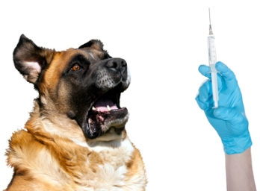
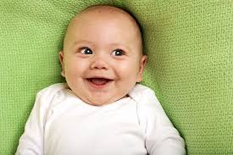

Vocabulary Worksheet

- Smirk –.
- Brooding –
- Leer -

- A face expression with a small smile while looking at someone using the side of your face. People often use this face expression with wide eyes and raised eyebrows like they are asking a question.
- A face expression when you are thinking deeply about something that makes you sad, worried or angry.
- A smile that only goes half way across your face

Facial Expressions Worksheet

- 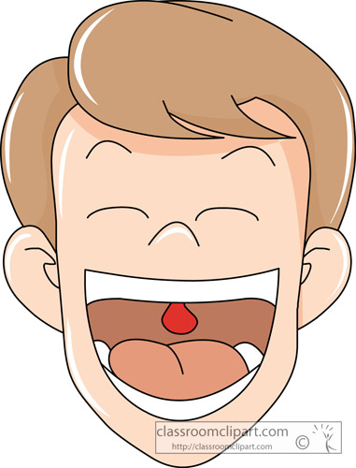Why?

- Why?

- 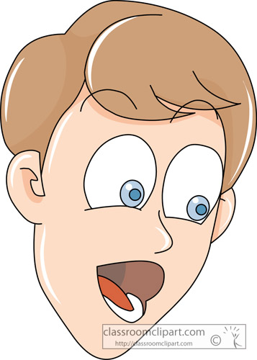Why?
- 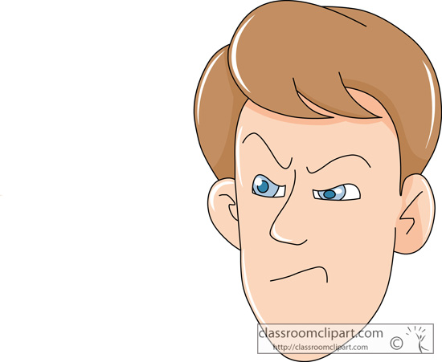Why?

Examples:
Happy | Sad | Excited | Disgust | Proud | Angry | Shy | Surprised

Transcript on “Facial Expressions” video clip.

We can tell how the others are feeling just by looking at them. When someone is happy, they smile. When they are sad, they frown. But where do these facial expressions come from? Are they learned or are they innate? David Matsumoto studied these questions for years at his culture and emotion research lab in San Francisco State. Facial expressions are so important because they are part of a non-verbal communication system that we all have and we use extensive to communicate with others. Facial expressions comment on the words in many different ways so that we know that the person maybe is joking or they are maybe very serious. I think that this is why we have emoticons in emails.

