Listening Lesson Plan

Title: We learn a song “Dancing Queen” (The movie Mamma Mia)
INSTRUCTOR | LEVEL / AGE | STUDENTS | LENGTH
Erica | Pre-intermediate / Adult | 7 | 50 mins

Materials:
- White board, markers, eraser, magnets, warmer pictures
- New vocabulary worksheets(7 copies / extra 3 copies)
- Listening worksheets(the song with fill in the blanks 7 copies / extra 3 copies)
- CD & CD player, extra MP3 file
- The movie Mamma Mia OST “Dancing Queen” from the video
- Computer with the internet and projector

Aims:
- Students will be able to improve their listening skills by song.
- Students will be able to acquire several idioms by pre-teaching.
- Students will be able to improve their language skills by sharing their idea.

Language Skills:
Listening: Students improve their listening skills while they listen to the song.
Speaking: Students speak their idea and sing along.
Reading: Students can read the lyric while they watch and listen.
Writing: students should fill in the blanks while listening.

Language Systems:
Phonology: The sound
Lexis: Vocabulary and idioms in the song
Grammar: Rule for of a direct object with two-word verbs
Discourse: Discussing by pairs
Functions: Asking and answering about their idea.

Assumptions:
- Students are at pre-intermediate level, so they can listen, read and understand lyric
- Students know the song “Dancing Queen”
- Some of students already know some of new idioms

Anticipated Errors and Solutions:
- Students may not be able to finish their task by the audio ends.
→ If they work hard even after the audio ends, give them more minutes.
- Internet may not be able to work for a while.
→ Save the music video clip in my flesh drive in advance.

References:
-http://www.youtube.com/watch?v=juTRRspWUqM

Notes:

Pre Task or Warmer
Title:  Share your idea. |  | Aims:  To be able to describe and explain the pictures. | Materials:  White board, magnets, warmer pictures
Time | Set Up | Students | Teacher
5  mins | Whole class | - Greeting to teacher and classmates.  - Think about the pictures.  (Listen carefully to other students' explanation.)  - Answering questions.  - Guiding questions.  Q: Can you guess what these pictures are saying about?  Q: Have you ever been that situation?  Q: What do you usually do on Friday nigh  - Elicit  Q: Do you like dance?  Q: Have you ever seen musicals?  Q: When you see the pictures which song flash upon your mind? | - Greeting students.  - show the pictures.  - Share with your idea.  - Introduce  Today we’re going to watch a video and learn a song.  The song is Dancing Queen.(The movie Mamma Mia)

Notes: Make sure all students can see the pictures.

Make sure all students understand the questions clearly.

Task Preparation or Presentation
Title:  Before listening |  | Aims:  To learn new vocabulary, idioms and grammar rule. | Materials:  White board, markers, worksheets (new vocabulary), eraser
Time | Set Up | Students | Teacher
3  Mins  12  Mins | pairs  Whole class | - Make the partner.  - Students guess the meaning on the worksheet with their partner.  - talk to each other  - Answering questions. | <Before we watch the video, we should check some new vocabulary and idioms.>  - Distributing vocabulary worksheets.  - Pre teaching new vocabulary: dig, teaser  Q: What’s the meaning of this word?  Q: let them guess what each vocabulary means.  - Teacher writes new idioms on the board.  - Pre teaching new idioms : look out for  Q: For example, a friend says “what are you doing these days?” I say “I’m between jobs. I’m looking out for a job.” Can you guess what I want to do?  - CCQ:  Q: Can you make your sentence by using look out for?  - Pre teaching new idioms: be in the mood for  Q: I’ll give you a situation. I’m so depressed to break up with my boyfriend, so I’m in the mood for sad melody. Can you guess what I want to do?  - CCQ  Q: Can you make what mood for you are in now?  - Pre teaching new idioms : turn somebody on  Q: For example, I’m very interested in jazz.  jazz really turn me on. Can you guess?  - CCQ  Q: Can you make your sentence by using turn somebody on?  - grammar rule: Direct object with two-word verbs  If the two-word verb is separable, the direct object may come between the verb and its particle.  However, separation is necessary when the direct object is a noun.

Notes: Make sure all students are following the class

Task Realization or Practice
Title:  Students try to write filling in the blanks. |  | Aims:  -To develop the listening skills by new vocabulary and idioms. | Materials:  CD & CD player, extra MP3 file, computer, listening worksheets
Time | Set Up | Students | Teacher
15  mins  5  mins | Individually  Whole class | - Listen to pronunciation carefully.  - Answering questions.  - Listen to the song  -Students listen carefully and fill in the blanks. | - Instruction:  Before listening to the song, teacher gives a worksheet to students.  First time, students listen to pronunciation carefully  Next time, students should listen carefully and fill in the blanks.  -Demonstration:  Work individually. Before the song start, you can’t see the worksheet you’ve got. At first just listen carefully.  And then you try to fill in the blanks while you listen to the song  I'll give you 2 times. Listen carefully.  -ICQ  Q: Are you going to work alone or in a group?  Q: Can you see the worksheet before the song starts?  Q: What do you do while you listen to the song?  -Play the song  - Monitor discreetly:  looking around to check whether they are doing right  -Play the song  - Check answers:  Play the listening again to check the correct answers.  -Feedback:  You all did great job. It’s so impressive.  Did you catch our new idioms in the lyric?

Notes: Make sure all students hear the sounds clearly.

Post Task or Production
Title:  Sing along |  | Aims:  To be able to understand and sing the song. | Materials:  Video clip, projector
Time | Set Up | Students | Teacher
10  mins | Whole class | - Decide Donna part, Tanya part, Rosie part by lots.  - Students sing the song.  - Answering questions. | - Instruction:  Before watching the video, we draw for roles.  Students sing the song 2 times.  - Demonstration:  Please remember your part.  Watching the video and the first time sing the song your part.  The second time we sing the song all together.  - Play the video.  - CCQ:  Q: How are actresses feeling?  Q: What situation are the actresses?  Q: Are the actresses happy now?  - Conclusion:  Elicit today’s idioms and a next lesson topic.

Notes:

Worksheets, handouts and lesson materials
<Warmer pictures>
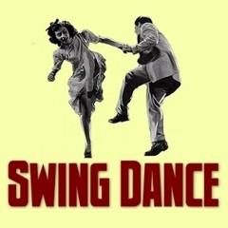
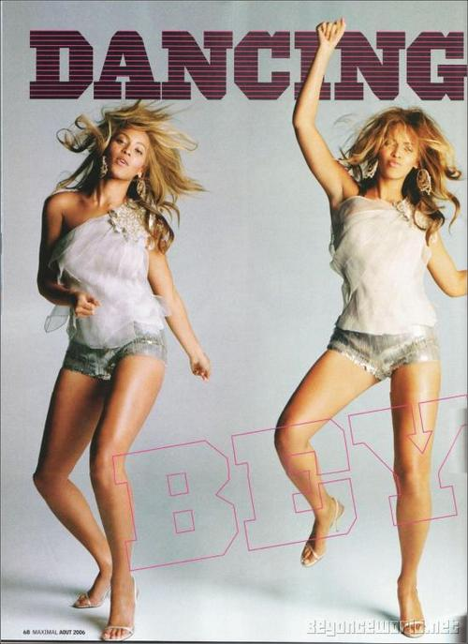

<worksheet>
1. What’s the meaning of this word?(Talk to your partner)
①Dig
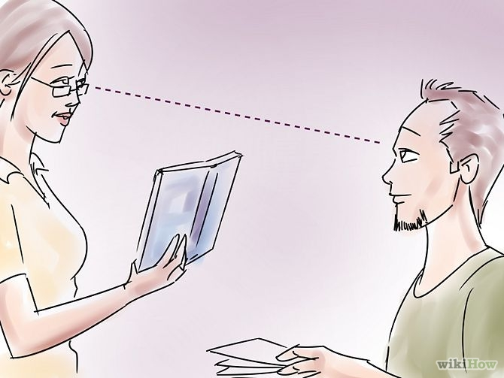

②teaser
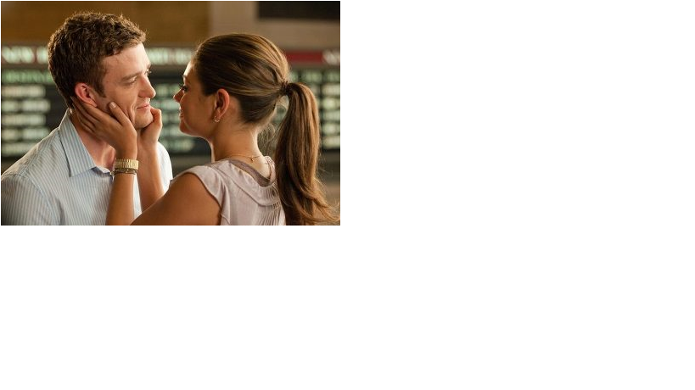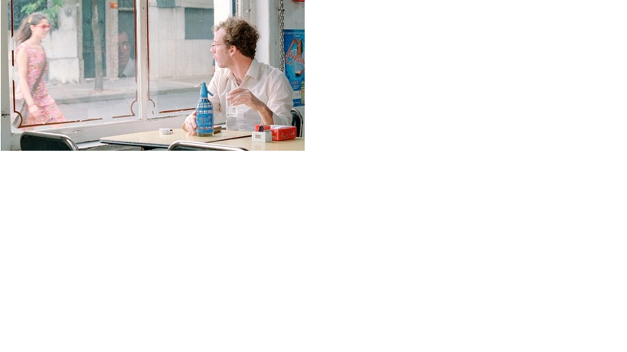

<Worksheet>
Dancing Queen (The movie Mamma Mia OST)
ROSIE & TANYA
You can dance, you can jive
Having the time of your life
See that girl, watch that scene
in the dancing queen
Friday night and the lights are low
a place to go
Where they play the right music
Getting in the swing
You’ve come to look for a king
TANYA
Anybody could be that guy
Night is young and the music's high
With a bit of rock music, everything is fine
a dance
And when you get the chance
DONNA / TANYA / ROSIE
You are the dancing queen
Young and sweet, only seventeen
Dancing queen, feel the beat from the tambourine
You can dance, you can jive
Having the time of your life
See that girl, watch that scene
in the dancing queen
DONNA
You're a , you turn 'em on
Leave them burning and then you're gone
another, anyone will do
You're in the mood for a dance
And when you get the chance
DONNA / TANYA / ROSIE
You are the dancing queen
Young and sweet, only seventeen
Dancing queen, feel the beat from the tambourine
You can dance, you can jive
Having the time of your life
See that girl, watch that scene
in the dancing queen in the dancing queen
You can dance, you can jive
Having the time of your life
See that girl Watch that scene
e

