The elephant can speak Korean

Title: The elephant can speak Korean
INSTRUCTOR | LEVEL / AGE | No of STUDENTS | Length
Solbi Lim (Solbi) | Intermediate /  10-11 | 18 students | 50 min
Materials:
- Video clip of Koshik speaks Korean
http://www.youtube.com/watch?v=jih5c-F7TBo
http://www.youtube.com/watch?v=vLUz7E5gU2c

- Two pictures of elephant, one picture of the elephant and the trainer
- Reading text
- Reading worksheet (Comprehension worksheet)
- Writing worksheet (‘Koshik Fact File’)
- White board& board marker

Aims:
- Able to get the main idea by skimming the reading text and answering a guiding question.
- To improve scanning skill by reading, underlining and answering the comprehension questions.
- To improve writing and speaking ability by making ‘Koshik Fact File’ and sharing idea. Also they will know what is different between the fact and the opinion.

Language Skills:
Reading: Reading text ‘The elephant that can speak Korean’
Listening: Listening a video clip, Instruction from a teacher.
Speaking: answering teacher’s questions, sharing ideas
Writing: Answering comprehension worksheet
Language Systems:
Phonology: Elephantese, how to pronounce suffix
Lexis: Suffix (Elephantese, Dolphinese..etc)

Grammar: Present Perfect Progressive (Koshik has been listening to human speech..)
Discourse: Comprehension scripts, Reading material
Functions: Communicating, Repetition
Assumptions:
- Students have their own experiences and knowledge about the elephants
- How to work alone, with pairs or group

Anticipated Errors and Solutions:
- Students may have different pace in reading text
ㄴTeacher reads the text with students and explains the sentences that students do not
understand.
- Some students will have difficulty in doing the comprehension question
ㄴHave students do themselves first and give some help. If they still don’t know, explain the
general story of text.
References: http://www.breakingnewsenglish.com/1211/121103-korean_language.html
http://www.huffingtonpost.com/2010/10/11/kosik-talking-elephant-at_n_758335.html
http://www.tving.com/vod/player/S001546281)
http://www.pandora.tv/video.ptv?c1=05&ch_userid=enghks3036&prgid=45649300&ref=na

Notes: SOS activity: To watch other animals speaking human languages.

Pre-Task
Title: Talking about elephant |  | Aims:  - To introduce topic  - To get used to an elephant | Materials:  - Board  - Marker  - Picture 1 & 2
Time | Set Up | Students | Teacher
5 min | Whole class | Greetings  Answering Questions  - Do you know elephants?  - Yes, you know elephants.  - How does it look like?  - Where do they live?  - What do they eat?  - Are they smart?  -Do you believe that they have emotion?  Introduction of Koshik | Greetings  Bring students’ schemata.  Showing the picture.  Introducing topic  Today, I want to tell you about the elephant called Koshik.

Task Preparation
Title: Understanding of  communication |  | Aims:  - To know how to put suffix(-ese) at the end of the animal name  - To understand of relationship through communication | Materials:  - White board  - Board marker
Time | Set Up | Students | Teacher
2 min  3 min | Whole class  5 Groups of  3 or 4  Whole class | Pre- vocabulary  Elicit  China-Chinese  Japan-Japanese  Elephant - ? (Elephantese)  Dolphin - ? ( Dolphinese )  Monkey - ? (Monkeynese)  Discussion  - Why do they use their own  language? Why do we need it?  - Why do you learn other languages?  - What can we get by learning  languages?  Elicit the word  ‘Communication & Relationship’  What is the relationship?  CCQ  What language do elephants speak?  Why do they speak to each other? | Give enough time to answer  Monitor students that they are following.  Asking CCQ
Notes: Give enough time to answer
Task Realization
Title: Amazing  elephant  Koshik |  | Aims:  - To learn skimming and scanning  - To learn ‘Present Perfect Progressive’ –When do we use it –What is the difference between present perfect |  | Materials:  - White board  - Board marker  - Reading Text  - Picture 3  - Comprehension worksheet
Time | Set Up | Students |  | Teacher
5 min  5 min  10 min  7 min  3 min  2 min | Pairs  Whole class  Whole class  Pairs | 1.Skimming the main idea  What makes Koshik special?  What can Koshik do?  Looking for answers  What can he talk  Reason he speaks Korean  How does he talk?  Sharing the answer with the class  How many words can he speak?  For example..?  Can you guess his favorite word to speak?  What kind of word he could speak well?  His favorite word is 좋아 because he has been listening that repeatedly from his trainer. By listening more he could speak well.  2.Scanning for details  See the picture  How do they look?  -Do you think they have a good relationship  -Why do you think Koshik can speak to the trainer?  Instruction  Underline  -2 possible reasons why koshick can talk  -How Koshik can talk?  Read out the answer together  -2 possible reasons why koshick can talk  One is…He had a very close relationship with his trainer…so copied what he heard.  Another is…He was so lonely, and wants to communicate.  -How Koshik can talk?  He puts his trunk in the mouth, and shakes it, similar to the way whistling with fingers.  This makes Koshik so special.  Grammar  5th row  ‘Koshik has been listening to human speech for many years and has slowly learned to copy it  ‘Present Perfect Progressive’  –When do we use it  –What is the difference between present perfect  Worksheet  - Answer the questions  -Try to use the Present perfect progressive or preset perfect form that we have used  Check the answers with other groups  Show the video Koshik speaks video  http://www.youtube.com/watch?v=jih5c-F7TBo  http://www.youtube.com/watch?v=vLUz7E5gU2c |  | Give students reading text  If they need more time give extra 30 seconds to get them ready to finish.  Show Students Picture of Koshik and the trainer  Give them simple situation to explain.  Give them handouts  ICQ  Remind them they have only 3 mins

Post Task
Title: Review |  | Aims:  - To know difference between the fact and the opinion  - To practice writing through filling the blank | Materials:  Worksheet
Time | Set Up | Students | Teacher
5 min  3 min | 5 Groups of  3 or 4  Whole class | Instruction  ‘Koshik Fact File’  You are going to write the facts.  What is fact? If I say Koshik wants to learn English, is it fact?  Think about all the facts in the text. Then choose 5 facts.  Share and confirm the answers with the class.  What do they feel after reading?  Homework Instruction  Think about you were in Koshik’s situation and write what would you do? Use the grammar we have learned today. At least 5 sentences. | Example about opnions.  Check Students understand the homework.  Write down homework on the board in red. Get the questions only if they have.
Notes: Give applause to student at the end of the class.

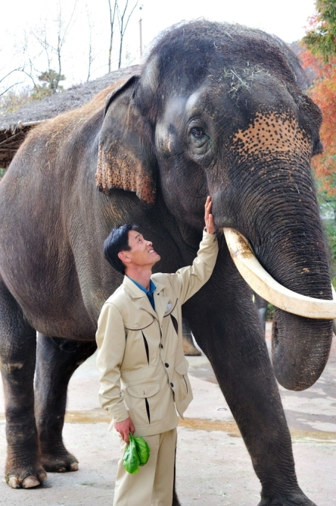

The elephant that can speak Korean

An elephant in Korea has become a language student. Koshik, a 22-year-old male elephant, is already fluent in speaking "elephantese," but he is now trying to learn the Korean language Hangul. A report about Koshik was printed in the online journal "Current Biology". The author of the report is Dr Angela Stoeger-Horwath, who works at the University of Vienna in Austria. Researchers said Koshik has been listening to human speech for many years and has slowly learned to copy it. He can now say the Korean for hello, sit down, no, lie down, good, not yet, and yes. Dr Stoeger-Horwath asked 16 Koreans to listen to 47 recordings of Koshik. They could all understand what he was saying.
The researchers gave a few reasons why they think Koshik can talk. One possibility is that he has a very close relationship with his trainer, Kim Jong-gab. Mr Kim often sleeps near Koshik to keep him company. The trainer talks to him every day, so Koshik copied what he heard. Another is that the elephant is lonely and wants to communicate with people and have friends. The research team said the way Koshik makes sounds is very unusual - he uses his trunk to reproduce human speech. They said he is much better at making vowel sounds than consonant sounds. Trainer Kim Jong-gab said he has one more phrase that he wants to teach Koshik - "Saranghae," or "I love you."

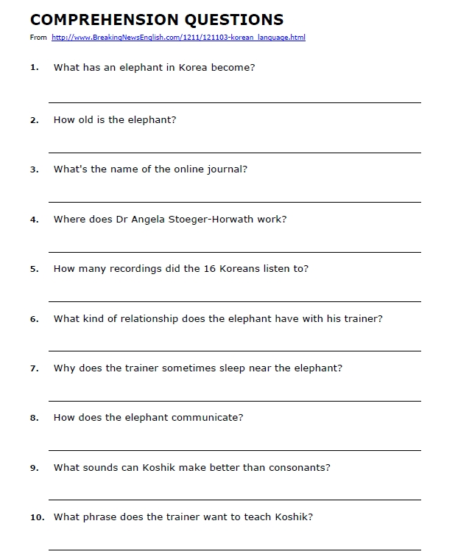

Koshik Fact File

1.

2.

3.

4.

5.

