Reading Lesson Plan
: Investigate the world with internet!
Title: Investigate the world with internet!
Instructor | Level/Age | Students | Length
Jeong KyoungSun | upper intermediate/18 | 18 | 50min.
Materials: cards with 18 different countries' name in 5 different continent, White Board, 5 kinds of handout for each group
1 sheet of paper for each group(For writing questions & answers), 18 sheets of handout for word-match
Aims:
Let Ss have a chance to read real English materials-out of textbook- and see interesting aspect of English by using text from Wikipedia.
Try to facilitate Ss' reading comprehension rate by letting Ss make questions based on given text.
Challenge Ss to read as fast as they can for solving other group's questions after reading the contents in limited time.
Language Skills
Reading: Contents from Wikipedia, Other group's questions, handout for word-match
Speaking: Discussion for making questions, Discussion for solving questions
Listening: T's instruction, Group members' speaking
Writing: Making questions
Language Systems
Discourse: Explanation of Specific country, Question & Answer
Functions: Explanation, Questioning, Solving, Discussing
Lexis: sovereign, alleged, archipelago, protectorate, pristine, cosmology, indigenous, animist, annexation, demarcated
Grammar: passive form, preposition
Phonology: archipelago [|ɑ:rkɪ|peləgoʊ] [|ɑ:kɪ|peləgəʊ] annexation [æ̀nikséiʃən,-nek-] indigenous [ɪn|dɪdƷənəs]
Assumptions: Ss are familiar with difficult texts for Scholastic Ability Test but not with real life texts.
Anticipated Errors and Solutions:
References:
www.eslcafe.com/idea/index.cgi?display:963859882-16354.txt
http://en.wikipedia.org/wiki/Brunei
http://en.wikipedia.org/wiki/Albania
http://en.wikipedia.org/wiki/Papua_New_Guinea
http://en.wikipedia.org/wiki/Paraguay
http://en.wikipedia.org/wiki/Eritrea
http://dictionary.reference.com/browse/sovereign?s=t
http://dictionary.reference.com/browse/alleged?s=t
http://dictionary.reference.com/browse/archipelago?s=t
http://dictionary.reference.com/browse/protectorate?s=t
http://dictionary.reference.com/browse/pristine?s=t
http://dictionary.reference.com/browse/cosmology?s=t
http://dictionary.reference.com/browse/indigenous?s=t
http://dictionary.reference.com/browse/animist?s=t
http://dictionary.reference.com/browse/annexation?s=t
http://dictionary.reference.com/browse/demarcated?s=t
Notes: There will be 5 groups with 3~4members.

Pre Task
Title:  Geographical  Group Formation |  | Aims:  mix Ss by giving them countries' name card and letting to find someone with same continent's countries' name. | Materials:  cards with 18 different countries' name  in 5 different continent.
Time | Set Up | Students do | Teacher does
1min | Whole class | get card(not open it until everyone gets the card)  go to wide side of the classroom and open the card | Give cards & instructions
4min | Whole class  By Group | find the person with same continent's countries' name and have a seat together.  first completed group will have advantage. | Give instructions &Monitor
Notes:

Task Preparation
Title: Research for practical use of English |  | Aims:  Help Ss to find practical use of English by Group discussion | Materials: White Board
Time | Set Up | Students do | Teacher does
3min | By Group | Brainstorm about real life English using  Make at least 3 kinds of uses per group | Give instructions & Monitor
3min | Whole class | Each group write their list on the board. | Give instructions & Monitor
Notes: If Ss have trouble to think, give some examples like Game manual, oversea purchasing, Internet Chatting, English Drama, etc.

Task Realization
Title:  Solve my Question! |  | Aims: Facilitate  1)Ss' reading comprehension rate by making questions from the text  2)Ss' reading speed by solving other group's questions in limited time. | Materials:  5 kinds of handout for each group.  1 sheet of paper for each group  (For writing questions & answers)
Time | Set Up | Students do | Teacher does
1min | By Group | Get Handouts  Be informed to make 8 T/F questions based on their handout. | Give Handouts & instructions
16min | By Group | Read the handout and make 8 T/F questions and answers. | Monitor
6min | By Group | Give handout in a clockwise direction & Read it carefully.  (Not giving the sheet of questions yet!) | Give instructions  Watch out for giving the question-sheet!
3min | By Group | Pass the question-sheet without answer part  in a clockwise direction and solve it! | Take all handouts from Ss  Give instructions  Watch out for giving the answer-sheet!
2min | By Group | Pass the answer-sheet and mark it | Give instructions
1min | Whole class | Figure out the winner group
Notes: inform the left time during main activity(-6min, -3min, -1min)
question-sheet & answer-sheet shoud be given at a proper moment!

Post Task
Title:  Grammar & word Check |  | Aims: review the words(sovereign, alleged, archipelago, protectorate, pristine, cosmology, indigenous, animist, annexation, demarcated) and grammar(passive, preposition) from the texts. | Materials:  18 sheets of handout for word-match
Time | Set Up | Students do | Teacher does
3min | Whole class | Talk their opinion about sentences with bold letter  (Passive form & preposition) | Elicit students to tell about passive form & preposition
4min | By Group | discuss & match words | Give Handout & instructions
1min | Whole class | Check the answers together | Guide students
1min | Whole class | Get homework about making 5sentences with 5 new words using passive form.  Winner group of the Pre-task can do only 4 sentences.  Winner group of the Task realization can do only 3 sentences. | Give Homeworks.
Notes: Skip checking the grammar part, if there is lack of time.

Worksheets, Handouts and Lesson Materials
Commonwealth of Australia | Republic of Fiji | New Zealand
Islamic Republic of Afghanistan | Kingdom of Bahrain | People's Republic of Bangladesh
State of Israel | Argentine Republic | Federative Republic of Brazil
Republic of Peru | Kingdom of Belgium | Bosnia and Herzegovina
Czech Republic | Federal Republic of Germany | People's Democratic Republic of Algeria
Arab Republic of Egypt | Republic of Ghana | Republic of South Africa
Brunei
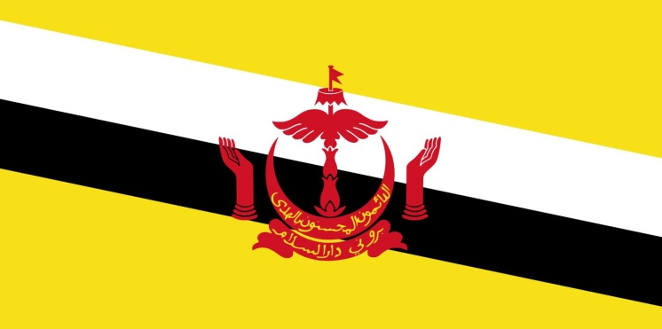 | Motto:  "Always in service with God's guidance"  Capital and largest city:  Bandar Seri Begawan  Official languages  Malay[a]  Recognised English[b]  Population: 415,717 (175th)  Currency: Brunei dollar (BND) | 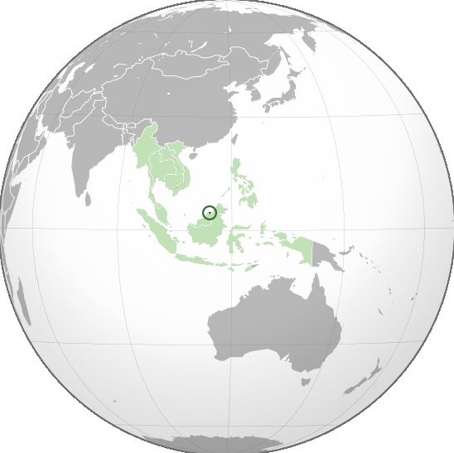
Brunei officially the Nation of Brunei, the Abode of Peace, is a sovereign state located on the north coast of the island of Borneo in Southeast Asia. Apart from its coastline with the South China Sea, it is completely surrounded by the state of Sarawak, Malaysia; and it is separated into two parts by the Sarawak district of Limbang. It is the only sovereign state completely on the island of Borneo; the remainder of the island's territory is divided between the nations of Malaysia and Indonesia.

At the peak of Bruneian Empire, Sultan Bolkiah (reigned 1485–1528) is alleged to have had control over most regions of Borneo, including modern-day Sarawak and Sabah, as well as the Sulu archipelago off the northeast tip of Borneo, Seludong (modern-day Manila), and the islands off the northwest tip of Borneo. The maritime state was visited by Spain's Magellan Expedition in 1521 and fought against Spain in 1578's Castille War.

Brunei regained its independence from the United Kingdom on 1 January 1984. Economic growth during the 1990s and 2000s, averaging 56% from 1999 to 2008, transformed Brunei into an industrialised country. It has developed wealth from extensive petroleum and natural gas fields. Brunei has the second-highest Human Development Index among the South East Asia nations, after Singapore, and is classified as a "developed country". According to the International Monetary Fund (IMF), Brunei is ranked fifth in the world by gross domestic product per capita at purchasing power parity. The IMF estimated, in 2011, that Brunei was one of two countries (the other being Libya) with a public debt at 0% of the national GDP. Forbes also ranks Brunei as the fifth-richest nation out of 182, based on its petroleum and natural gas fields.

Human rights
Children
Citizenship is derived through one's parents rather than through birth within the country's territory. Parents with stateless status are required to apply for a special pass for a child born in the country; failure to register a child may make it difficult to enroll the child in school. By law sexual intercourse with a female under 14 years of age constitutes rape and is punishable by imprisonment for not less than eight years and not more than thirty years and not less than twelve strokes of the cane. The intent of the law is to protect girls from exploitation through prostitution and "other immoral purposes" including pornography.
Homosexuality
Male and female homosexuality is illegal in Brunei. The country passed a law that came into force on 22 April 2014 allowing the death penalty to be administered by stoning for homosexual acts (sexual intercourse and etc. ) given there is enough evidence (with 4 most trusted witnesses that never lied when spoken, never repeating the acts of sins and the one who not taking sides[needs copy edit]) pointing to the action. It has been acknowledged as a crime in Brunei with the introduction of the Sharia law.

Albania
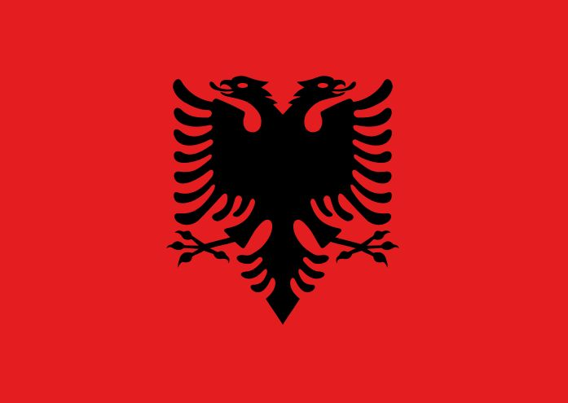 | Motto: (official)  "You Albania, give me honor, give me the name Albanian"  Capital and largest city: Tirana  Official languages: Albaniana  Population: 3,020,209  Currency: Lek (ALL) | 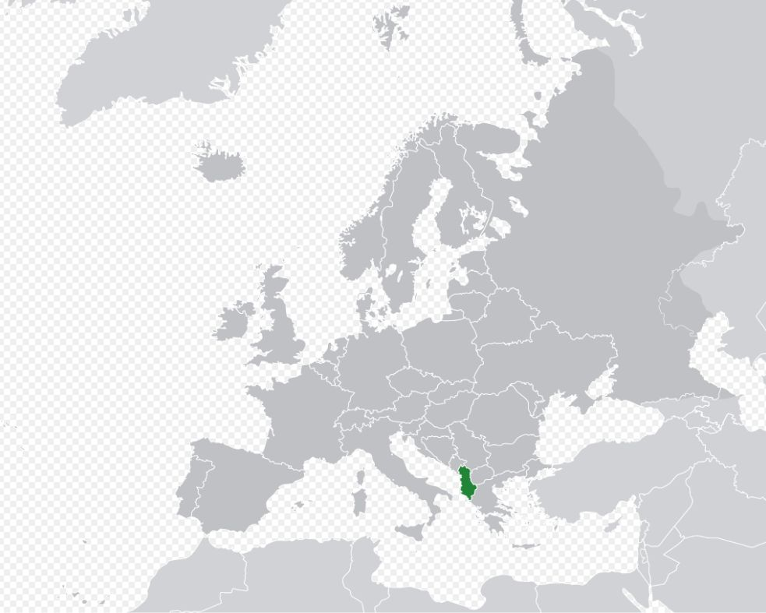
Albania, officially known as the Republic of Albania (Albanian: Republika e Shqipërisë; Albanian pronunciation: [ɾɛpuˈblika ɛ ʃcipəˈɾiːs]), is a country in Southeastern Europe. It is bordered by Montenegro to the northwest, Kosovo[a] to the northeast, Macedonia to the east, and Greece to the south and southeast. It has a coast on the Adriatic Sea to the west and on the Ionian Sea to the southwest. It is less than 72 km (45 mi) from Italy, across the Strait of Otranto which links the Adriatic Sea to the Ionian Sea.

The modern-day territory of Albania was at various points in history part of the Roman provinces of Dalmatia (southern Illyricum), Macedonia (particularly Epirus Nova), and Moesia Superior. The modern Republic became independent after the collapse of the Ottoman Empire in Europe following the Balkan Wars. Albania declared independence in 1912 (to be recognised in 1913), becoming a Principality, Republic, and Kingdom until being invaded by Italy in 1939, which formed Greater Albania, which in turn became a Nazi German protectorate in 1943. In 1944, a socialist People's Republic was established under the leadership of Enver Hoxha and the Party of Labour. In 1991, the Socialist Republic was dissolved and the Republic of Albania was established.

Tourism
A large part of Albania's national income comes from tourism. Tourism - as of 2013 - funds 10% of its gross domestical product, and this is expected to increase. Albania welcomed around 4.2 million visitors in 2012, mostly from neighbouring countries and the European Union. In 2011, Albania was recommended as a top travel destination, by Lonely Planet. In 2014 Albania was nominated number 4 global touristic destination by New York Times. The number of tourists has increased by 20% for 2014 as well .
The bulk of the tourist industry is concentrated along the Adriatic and the Ionian Sea coast. The latter has the most beautiful and pristine beaches, and is often called the Albanian Riviera. Albanian seaside has a considerable length of 450 km, including even the lagoon area which you find within. The seaside has a particular character because it is rich in varieties of sandy beaches, capes, coves, covered bays, lagoons, small gravel beaches, sea caves etc. Some parts of this seaside are very clean ecologically, which represent in this prospective unexplored areas, very rare in Mediterranean area.

The increase in foreign visitors is dramatic, Albania had only 500,000 visitors in 2005, while in 2012 had an estimated 4.2 million tourists. An increase of 840% in only 7 years. Several of the country’s main cities are situated along the pristine seashores of the Adriatic and Ionian Seas. An important gateway to the Balkan Peninsula, Albania’s ever-growing road network provides juncture to reach its neighbors in north south, east, and west. Albania is within close proximity to all the major European capitals with short two or three hour flights that are available daily. Tourists can see and experience Albania’s ancient past and traditional culture.
Seventy percent of Albania's terrain is mountainous and there are valleys that spread in a beautiful mosaic of forests, pastures, springs framed by high peaks capped by snow until late summer spreads across them. Albanian Alps, part of the Prokletije or Accursed Mountains range in Northern Albania bearing the highest mountain peak.

Papua New Guinea
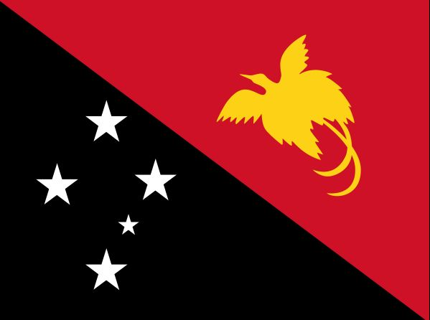 | Motto: "Unity in diversity"  Capital and largest city: Port Moresby  Official languages  Hiri Motu ·  Tok Pisin ·  English  Population: 7,059,653(102nd)  Currency: Papua New Guinean kina (PGK) | 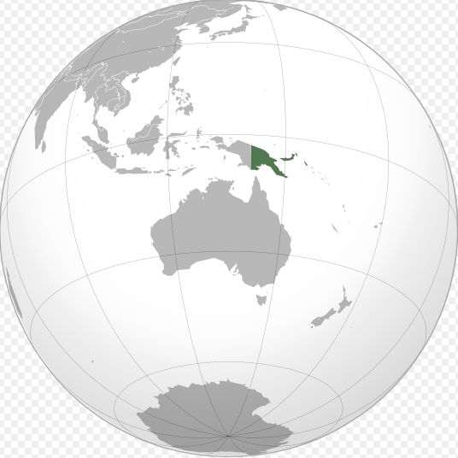
Papua New Guinea, officially the Independent State of Papua New Guinea, is an Oceanian country that occupies the eastern half of the island of New Guinea and its offshore islands in Melanesia, a region of the southwestern Pacific Ocean north of Australia. Its capital, located along its southeastern coast, is Port Moresby. The western half of New Guinea forms the Indonesian provinces of Papua and West Papua.

Papua New Guinea is one of the most culturally diverse countries in the world. 848 languages are listed for the country, of which 12 have no known living speakers. Most of the population of over 7 million people live in customary communities, which are as diverse as the languages. It is also one of the most rural, as only 18 per cent of its people live in urban centres. The country is one of the world's least explored, culturally and geographically, and many undiscovered species of plants and animals are thought to exist in the interior.

At the local level, the majority of the population still live in strong customary societies and - while social life is overlaid with traditional religious cosmologies and modern practices, including conventional primary education - customary subsistence-based agriculture remains fundamental. These societies and clans are explicitly acknowledged within the nation's constitutional framework. The Papua New Guinea Constitution expresses the wish for "traditional villages and communities to remain as viable units of Papua New Guinean society" and for active steps to be taken in their continuing importance to local and national community life.

Religion
The courts and government practice uphold the constitutional right to freedom of speech, thought, and belief, and no legislation to curb those rights has been adopted. The 2000 census found that 96% of citizens identified themselves as members of a Christian church; however, many citizens combine their Christian faith with some traditional indigenous religious practices. The census percentages were as follows:
Roman Catholic Church (27.0%)
Evangelical Lutheran Church of Papua New Guinea (19.5%)
United Church (11.5%)
Seventh-day Adventist Church (10.0%)
Pentecostal (8.6%)
Evangelical Alliance (5.2%)
Anglican Church of Papua New Guinea (3.2%)
Baptist (2.5%)
Church of Christ (0.4%)
Other Christian (8.9%)
Bahá'í Faith (0.3%)
Indigenous beliefs and other (3.3%)

There are also approximately 4,000 Muslims in the country. Non-traditional Christian churches and non-Christian religious groups are active throughout the country. The Papua New Guinea Council of Churches has stated that both Muslim and Confucian missionaries are active, and foreign missionary activity in general is high.

Traditional religions were often animist. Some also tended to have elements of ancestor worship, though generalisation is suspect given the extreme heterogeneity of Melanesian societies. Prevalent among traditional tribes is the belief in masalai, or evil spirits, which are blamed for "poisoning" people, causing calamity and death, and the practice of puripuri (sorcery).

Eritria
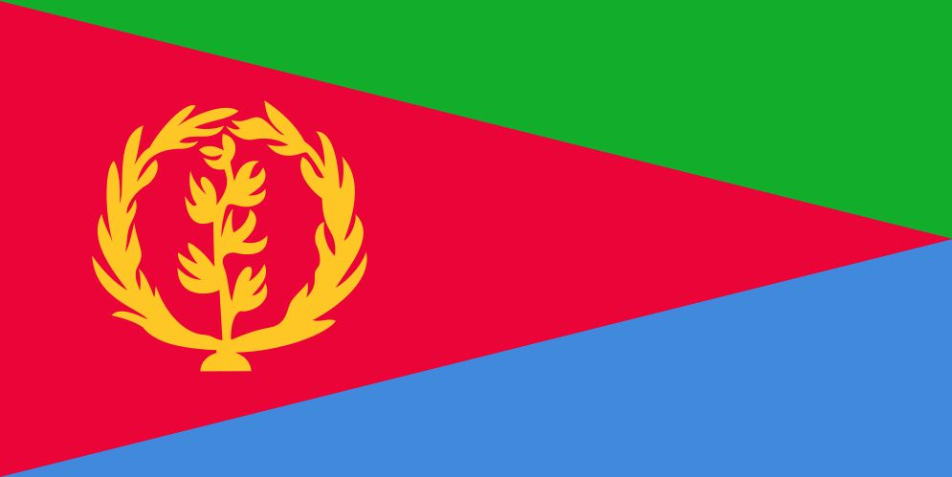 | Capital and largest city: Asmara  Official languages  Tigrinya  Arabic  English  Population: 6,536,000 (107th)  Currency: Nakfa (ERN) | 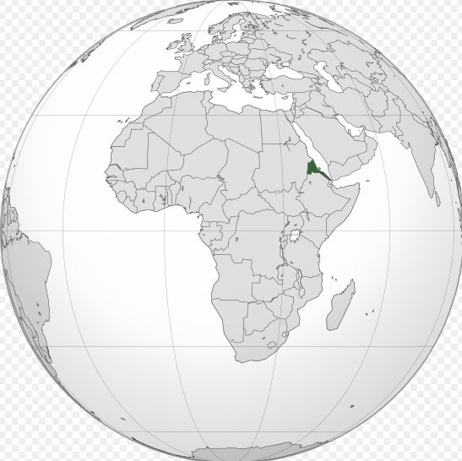
Eritrea, officially the State of Eritrea, is a country in the Horn of Africa. With its capital at Asmara, it is bordered by Sudan to the west, Ethiopia in the south, and Djibouti in the southeast. The northeastern and eastern parts of Eritrea have an extensive coastline along the Red Sea, across from Saudi Arabia and Yemen. The nation has a total area of approximately 117,600 km2, and includes the Dahlak Archipelago and several of the Hanish Islands. Its name Eritrea is based on the Ancient Greek name for the Red Sea, which was first adopted for Italian Eritrea in 1890.

Eritrea is a multi-ethnic country, with nine recognized ethnic groups. It has a population of around six million inhabitants. Most residents speak Afroasiatic languages, either of the Semitic or Cushitic branches. Among these communities, the Tigray-Tigrinya people make up about 55% of the population, with the Tigre people constituting around 30% of inhabitants. In addition, there are a number of Nilo-Saharan-speaking Nilotic ethnic minorities. Most people in the territory adhere to Christianity or Islam.
Eritrea is a member of the African Union, the United Nations and IGAD, and is an observer in the Arab League.
Foreign relations
Relations with the United States
Eritrea's relationship with the United States has a short yet complex history.

Relations with the European Union
Eritrea's relationship with the Italian Republic and the European Union are still both reasonably strong and do not seem to be as strained as is the country's relationship with the United States. On 27 January 2009, the Dutch Ambassador, Yoka Brandt, Director General of International Development Cooperation, paid an official visit to the country for bilateral talks with President Isaias' government, which were held in Massawa.

Relations with Israel
Eritrea and Israel have ambassadors in each other's countries. Israel maintains an embassy in Asmara and Eritrea has a presence in Ramat Gan. Avi Granot, head of the Africa division in the Israeli foreign ministry, has described Eritrea as a strategic ally, the one friendly port on the Red Sea. There are approximately 60,000 African refugees in Israel, mostly from Sudan and Eritrea.

Relations with neighbouring countries
Eritrea's relations with its neighbours have been strained due to a series of wars and disputes. These include a break of diplomatic relations with Sudan when Eritrea accused Sudan of hosting a network of terrorists in 1994, a war with Yemen over the Hanish Islands in 1996, and a border conflict with Ethiopia from 1998–2001. An international border commission, the Eritrea-Ethiopia Boundary Commission had delimited and demarcated the border, but Ethiopia has refused to implement it.

Paraguay
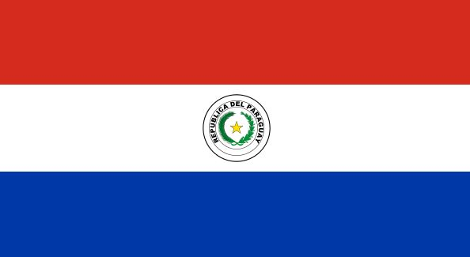 | Motto: "Peace and justice"  Capital and largest city: Asunción  Official languages  Spanish  Guaraní  Population: 6,800,284 (104th)  Currency: Guaraní (PYG) | 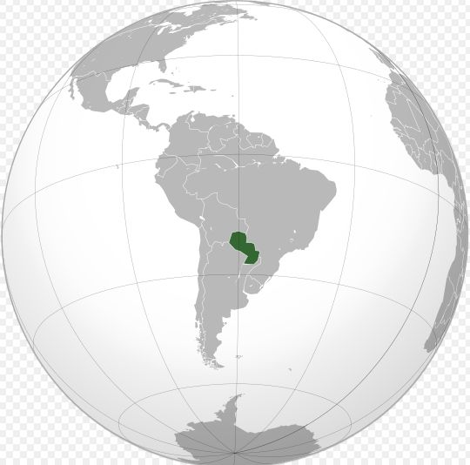
Paraguay, officially the Republic of Paraguay (Spanish: República del Paraguay [reˈpuβlika ðel paɾaˈɣwaj], Guaraní: Tetã Paraguái [teˈtã paɾaˈɣwaj]), is a landlocked country in central South America, bordered by Argentina to the south and southwest, Brazil to the east and northeast, and Bolivia to the northwest. Paraguay lies on both banks of the Paraguay River, which runs through the center of the country from north to south. Due to its central location in South America, it is sometimes referred to as Corazón de América ("Heart of America").
The indigenous Guaraní had been living in Paraguay for at least a millennium before the Spanish conquered the territory in the 16th century. Spanish settlers and Jesuit missions introduced Christianity and Spanish culture to the region. Paraguay was on the periphery of Spain's colonial empire, with few urban centers and a sparse population. Following independence from Spain in 1811, Paraguay was ruled by a series of dictators who implemented isolationist and protectionist policies.
As of 2009, Paraguay's population was estimated to be at around 6.5 million, most of whom are concentrated in the southeast region of the country. The capital and largest city is Asunción, of which the metropolitan area is home to nearly a third of Paraguay's population. In contrast to most Latin American nations, Paraguay's indigenous language and culture, Guaraní, remains highly influential. In each census, residents predominantly identify as mestizo, reflecting years of intermarriage among the different ethnic groups. Guaraní is recognized as an official language alongside Spanish, and both languages are widely spoken in the country, with around 92 percent of the general population speaking Spanish and 98 percent speaking Guaraní.

Sport in Paraguay
Soccer is by far the most popular sport in Paraguay to the point that it is part of the nation's culture. Soccer was first introduced in Paraguay by Dutchman William Paats, who moved from the Netherlands to Asunción in 1888. In 1900, small tournaments were held at the Plaza de Armas, a plaza located in downtown Asunción. By 1906 the number of football clubs in Paraguay had increased and the Paraguayan Football Association, the governing body of soccer in Paraguay, was founded. The Paraguayan Soccer Association joined CONMEBOL in 1921, and FIFA in 1925. Football has grown enormously since then, and there are over 1600 teams spread throughout Paraguay participating in multiple leagues. Each of those teams try to make their way to the first division by clearing the different levels of lower divisions. The growth and evolution of Paraguayan soccer can be seen in the achievements made in the club level and by the Paraguayan national soccer team. The national team has participated in eight World Cups, won two Copa América tournaments, and obtained a silver medal at the Olympic Games in 2004. All these accomplishments established Paraguay as the fourth most successful football nation in South America behind Argentina, Brazil and Uruguay. At the club level, Olimpia Asunción has won a total of eight international tournaments, including three Copa Libertadores and one Intercontinental Cup. Among the most important and successful football players in Paraguayan history are Arsenio Erico, Aurelio González, Romerito and José Luis Chilavert.

Question |  | Answer
 | T / F
 | T / F
 | T / F
 | T / F
 | T / F
 | T / F
 | T / F
 | T / F

Word matching
sovereign | a. the relation of a strong state toward a weaker state or territory  that it protects and partly controls
alleged | b. the branch of astronomy that deals with  the general structure and evolution of the universe
archipelago | c. having supreme rank, power, or authority
protectorate | d. having its original purity; uncorrupted or unsullied
pristine | e. the belief that natural objects, natural phenomena, and the universe itself  possess souls
cosmology | f. the act or an instance of attaching or adding, especially new territory
indigenous | g. declared or stated to be as described; asserted
animist | h. to determine or mark off the boundaries or limits of
annexation | I. a large group or chain of islands
demarcated | j. originating in and characteristic of a particular region or country; native

