Grammar Lesson Plan

Topic: Clothing
INSTRUCTOR | LEVEL / AGE | STUDENTS | LENGTH
MinHee Huh (Ellie) | False Beginner / 9-11 | 18 | 50 minutes

Materials:
White board and markers
Paper, pencil
Worksheets: Who’s this?
Color pencils, markers
Worksheets: T-shirt outline (18)
Flashcards: What is he/she wearing?

Aims:
To be able to identify and recognize different clothing and to be able to describe what someone is wearing using adjectives.

Language Skills:
Reading: Read short clothing description
Speaking: Answer the questions
Listening: Listen teacher’s instruction / Interact with group members
Writing: Write one cloth description for its character (Worksheets: who’s this?)

Language Systems:
Discourse: Discuss in a group who is who / Imagine what does he/she wear
Functions: Describing or explaining each items of clothing, color, pattern / Questioning and answering each questions
Phonology: Correct pronunciation of vocabulary words (architect, athlete, chef, doctor, solider)
Lexis: Vocabulary for items of clothing. (T-Shirt, Shirt, Jeans, Blouse, Jacket, Dress, Skirt, Shorts, Pants (Trousers), Suit, Tie, Shoes, Sandals, Sneakers, Hat, etc.), Adjectives (Striped, Colorful, Sleeveless, Short-Sleeved, Long-sleeved, Denim, Polka dots, etc.) Colors (Red, Blue, White, Yellow, Green, Black, Pink, Orange, Purple, Brown, etc.)
Grammar: Present Progressive tense (verb + -ing)

Assumptions:
Students already know the items of clothing, colors, patterns

Anticipated Errors and Solutions:
Students may not know many words of patterns.
- Show and describe the patterns, and then elicit the words

References:
http://eslvietnamzone.com/clothing-present-continuous-esl-lesson-plan/
http://www.teach-this.com/resources/present-continuous

Notes:
N/A

Pre Task
Title:  Who’s wearing? |  | Aims:  To learn to ask for and give descriptions of things using adjectives of color. | Materials:  White Board, Markers  Paper, pencil
Time | Set Up | Students | Teacher
1min.  4min.  6mins. | Whole class  Whole class  Whole class | Answer the question:  - What am I wearing today?  - What do you usually wear at the weekend?  - What do you usually wear for special day?  - Let’s tell about the items of clothing  - Who’s wearing jeans/blouse/jacket/skirt…?  - Who’s wearing red/blue/yellow..?  - Who’s wearing striped shirt/dotted shirt..? | Greeting  Ask questions  Write list items of clothing and write on the board.  Focus on the items of clothing.  Focus on colors.  Focus on patterns.

Notes:
N/A

Task Preparation
Title:  Who’s who? |  | Aims:  To check their understanding and knowledge of the vocabulary and grammar get them to describe. | Materials:  Worksheets: Who’s this?  Pencil, Color pencils, markers
Time | Set Up | Students | Teacher
2mins.  6mins.  3mins.  7mins | Whole class  Whole class  Group of 4or5  Individuals | Choose one classmate and describe him/her what he/she is wearing (at least 3 sentences).  Do not say his/her name. The other students in the class listen and try to guess who is being described.  Read descriptions and guess who this is.  Coloring what each student get. Add one description of its character. | Give an instruction (Guess game)  Give out Worksheets: Who’s this?  - Pirate  - Princess  - Magician  - Crown  - Witch

Notes:
N/A

Task Realization
Title:  Design t-shirt |  | Aims:  To realize the words of clothing/color/pattern | Materials:  Worksheets: T-shirt outline (18)
Time | Set Up | Students | Teacher
1mins  8mins  17mins | Whole class  Individual  Individual | Design your own t-shirt.  Describe their t-shirt.  - When do you want to wear it?  - Where do you go wearing this t-shirt? | Give an instruction  Give out Worksheets: T-shirt outline  Ask questions

Notes:

N/A

Post Task
Title:  What is he/she wearing? |  | Aims:  To review the use and structure of the present progressive tense through the flashcards | Materials:  Flashcards: What is he/she wearing?
Time | Set Up | Students | Teacher
3min  2mins | Whole class  Whole class | Describe the clothes what is he/she wearing. | Show Flashcards: What is he/she wearing?  Review what we learned today.

Notes:

N/A

Worksheets, handouts and lesson materials
- Worksheets: Who’s this?
1  He’s wearing black and white trousers.  He’s wearing a purple shirt.  He’s wearing brown boots.  He’s wearing a yellow crown.  He’s wearing eye patch.  Pirate | 2  She’s wearing a pink and white dress.  She’s wearing a yellow necklace.  She’s wearing pink shoes.  She’s wearing a black and white hat.  She’s wearing diamond tiara.  Princess
3  He’s wearing red shorts.  He’s wearing a black jacket.  He’s wearing a black and yellow hat.  He’s wearing black trousers.  He’s holding a wand.  Magician | 4  He’s wearing blue and yellow trousers.  He’s wearing a yellow and orange shirt.  He’s wearing a red nose.  He’s wearing a black and yellow hat.  He’s wearing spotted jumpsuit.  Clown
5

She’s wearing a purple skirt.
She’s wearing a brown T-shirt.
She’s wearing black and yellow shoes.
She’s wearing a red and green tie.
She’s riding a broom.

Witch

Worksheets: Who’s this?
1

He’s wearing black and white trousers.
He’s wearing a purple shirt.
He’s wearing brown boots.
He’s wearing a yellow crown.
He’s wearing eye patch.
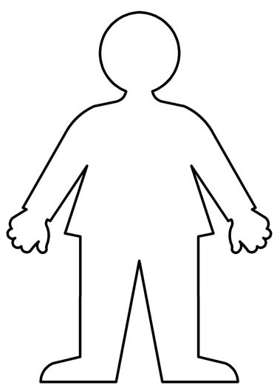

Worksheets: Who’s this?
2

She’s wearing a pink and white dress.
She’s wearing a yellow necklace.
She’s wearing pink shoes.
She’s wearing a black and white hat.
She’s wearing diamond tiara.

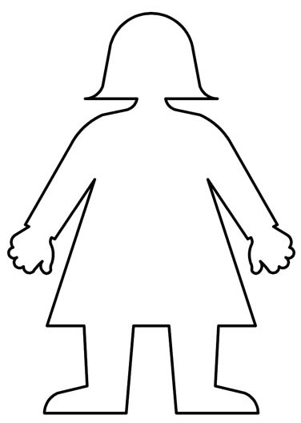
Worksheets: Who’s this?
3

He’s wearing red shorts.
He’s wearing a black jacket.
He’s wearing a black and yellow hat.
He’s wearing black trousers.
He’s holding a wand.

Worksheets: Who’s this?
4

He’s wearing blue and yellow trousers.
He’s wearing a yellow and orange shirt.
He’s wearing a red nose.
He’s wearing a black and yellow hat
He’s wearing spotted jumpsuit.

Worksheets: Who’s this?
5

She’s wearing a purple skirt.
She’s wearing a brown T-shirt.
She’s wearing black and yellow shoes.
She’s wearing a red and green tie.
She’s riding a broom.

- Worksheets: T-shirt outline
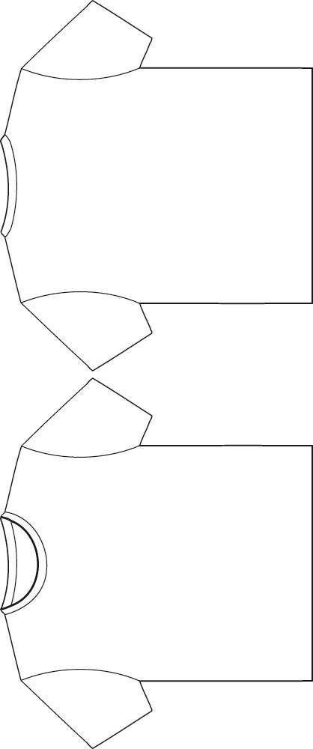

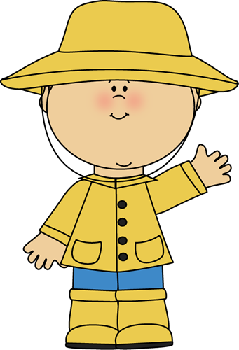
- Flashcards: What is he/she wearing? -1-
- Flashcards: What is he/she wearing? -2-
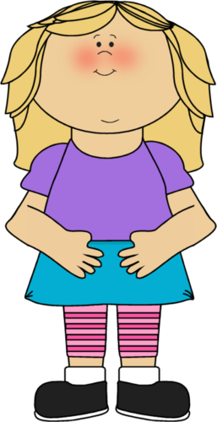

- Flashcards: What is he/she wearing? -3-
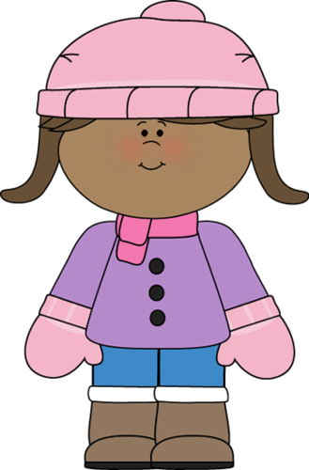

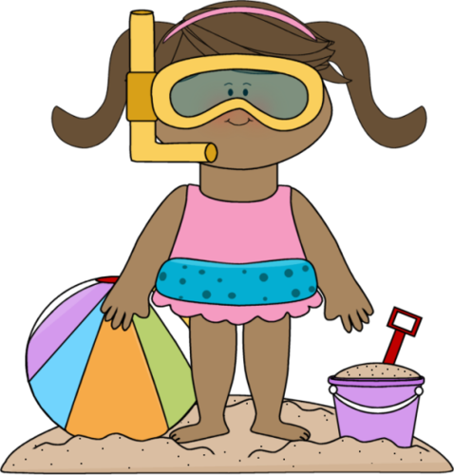
- Flashcards: What is he/she wearing? -4-

- Flashcards: What is he/she wearing? -5-

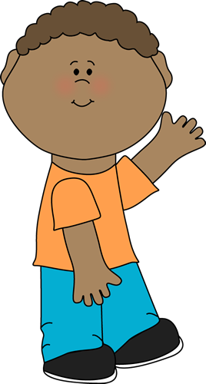

- Flashcards: What is he/she wearing? -6-

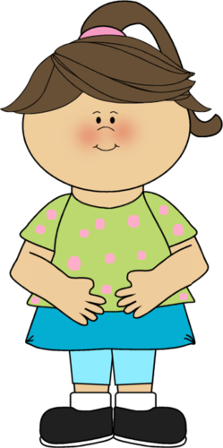

- Flashcards: What is he/she wearing? -7-
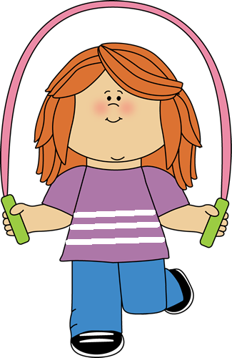

- Flashcards: What is he/she wearing? -8-

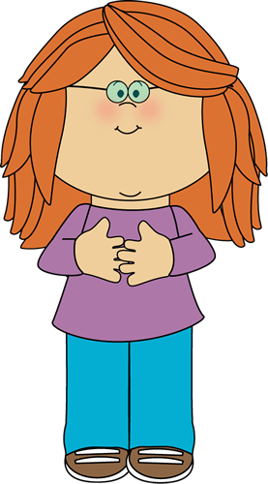

- Flashcards: What is he/she wearing? -9-

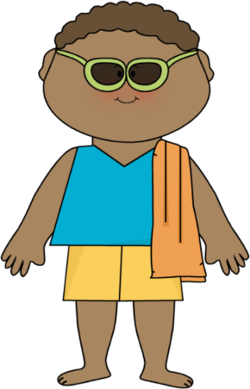

- Flashcards: What is he/she wearing? -10-



