Grammar Lesson Plan

Title: Excuses Excuses
INSTRUCTOR |  | LEVEL / AGE | No of STUDENTS |  | LENGTH
Kyungah Chang (Veronica) |  | Pre-Intermediate / 9 - 11 | 18 |  | 50 mins

Materials:
White board, Markers and Eraser
Worksheet, ‘How was your weekend?’
Handout ‘Excuses Excuses’ board game & dice, 5 each
Video clip, Max the Cat
Projector, Computer

Aims:
- To study the grammar ‘Past simple tense’ by grammar practice activities
- To build a knowledge of Irregular Verbs by grammar practice activities
- To practice speaking with ‘Excuses Excuses’ activity in inductive approach

Language Skills:
Speaking: Discussion of last weekend and ‘Excuses Excuses’ Board game
Listening: Other’s discussion and Video Clip
Reading; ‘How was your weekend’ worksheet and ‘Excuses Cards’
Writing: ‘How was your weekend’ worksheet

Language Systems:
Grammar: Past Simple Tense and Irregular Verbs
Phonology: Pronunciation of Irregular Verbs. See Lexis
Lexis: Wake, Lose, Fall, Forget, Get, Think, Win, Sleep and Break
Discourse: How was your weekend, Why you were late for the class
Functions: Explaining, Excusing, Apologizing

Assumptions:
- Ss already have a knowledge of Past simple tense and regular past tense verbs from the previous class
- Ss have a knowledge of Irregular verbs from the homework

Anticipated Errors and Solutions:
For students who didn’t do homework, whole class review together in the Task preparation section

References:
http://www.teach-this.com/images/resources/excuses-excuses-board-game.pdf
http://www.youtube.com/watch?v=18NlPMAiWXQ

Notes:

Pre Task
Title:  How was your weekend? |  | Aims:  To get Ss talking about what happened last weekend using past simple tense |  | Materials:  Worksheet
Time | Set Up | Students |  | Teacher
2 mins  5 mins  2 min | Whole class  Groups (2-3 Students in each group)  Whole class | Answer guiding questions  - How was your weekend?  - What did you do? Anything fun?  In groups Ss discuss and get answers for the worksheet  - Put the words in correct order  - Write the correct reply next to the questions  Share their answers |  | Greet students  Ask guiding questions  Give instruction  Monitor students

Notes: Monitor if they are using past tense

Task Preparation
Title:  Irregular Verbs |  | Aims:  Review irregular verbs homework from last week and practice pronunciation of each word | Materials:  White Board, Markers and Eraser
Time | Set Up | Students | Teacher
6  mins | Whole Class | Ss come up and write down the answers on the board  Review together (Recall)  Ss repeats together the Irregular verbs and practice pronunciation | Review Irregular verbs  T write down the present tense verbs on the board  Chose students or ask for the volunteer  T reads & tracks the words; whole class repeats together (Choral drill)

Notes: Wake, Lose, Fall, Forget, Get, Think, Win, Sleep and Break are the irregular verbs in Excuses cards for the board game

Task Realization
Title:  Excuses Excuses |  | Aims:  - To encourage speaking in groups  - To study Past simple tense | Materials:  White Board, Markers and Eraser  Copy of board game  Dice
Time | Set Up | Students | Teacher
2  mins  26  mins  2  mins | Whole Class  Groups (3-4 Students in each group)  Whole Class | Get instruction of the board game ‘Excuses Excuses’  Answer the ICQ  - Which tense to use when you make the excuses?  - The time limit for the board game?  Play the Board Game (Reflect)  The group has the most Ss have arrived at the class win | Hand out the copy of board game ‘Excuses Excuses’  Give instruction  Instruction checking questions  Monitor
Notes: Monitor discreetly if Ss are using past simple tense with correct verbs

Post Task
Title:  Max the Cat |  | Aims:  - To review the form of past simple tense and watch video of Irregular Verbs song | Materials:  Projector  Video clip from YouTube  White board, Markers and Eraser
Time | Set Up | Students | Teacher
5  Mins | Whole Class | Answer the past simple tense form (Conclude)  Watching Video Clip (1:36) of Max the Cat song  Ss answer the blanks in the song | Elicit the form of Past simple tense  Play the video clip  Close session

Notes: Elicit from Ss regarding two types of form for Past simple tense, Verb+ed and Irregular Verbs

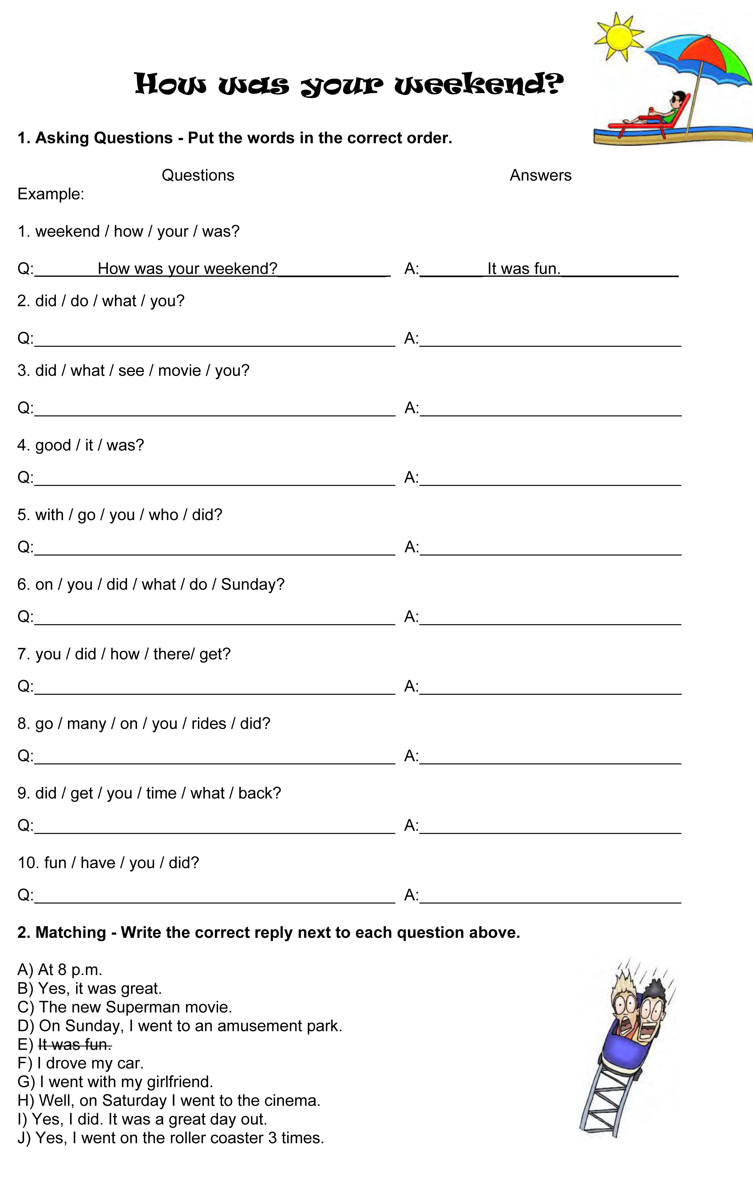
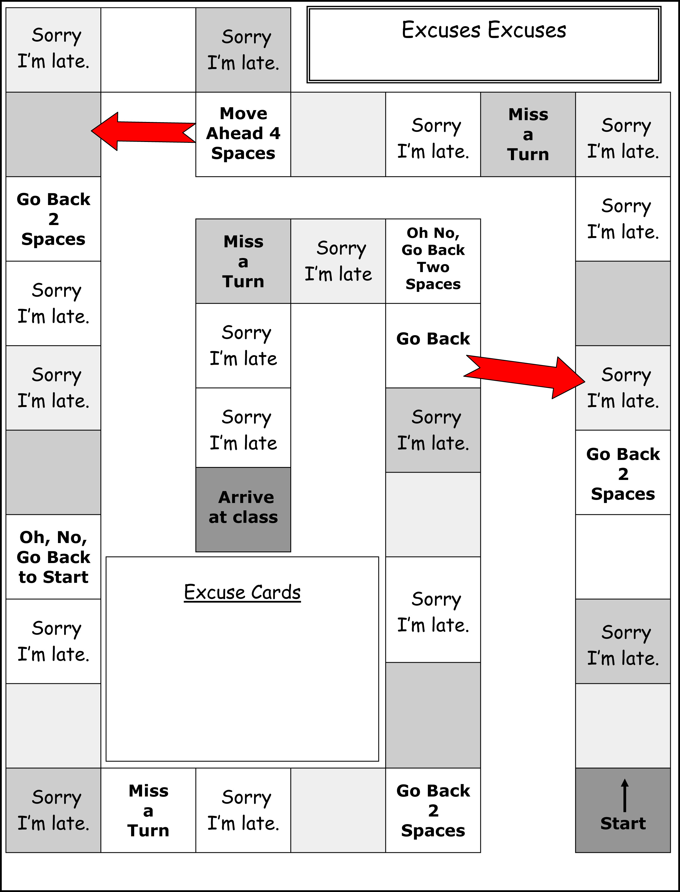

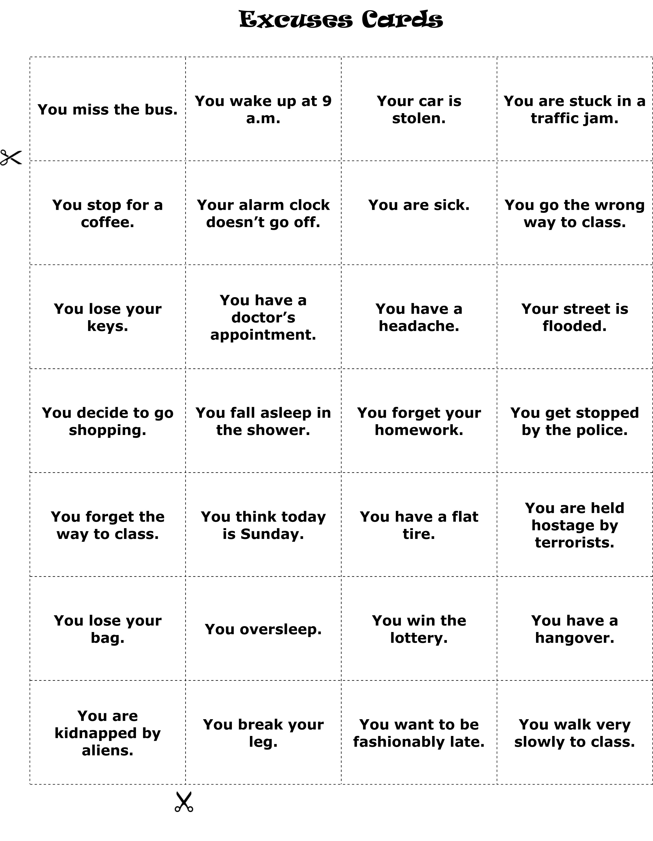

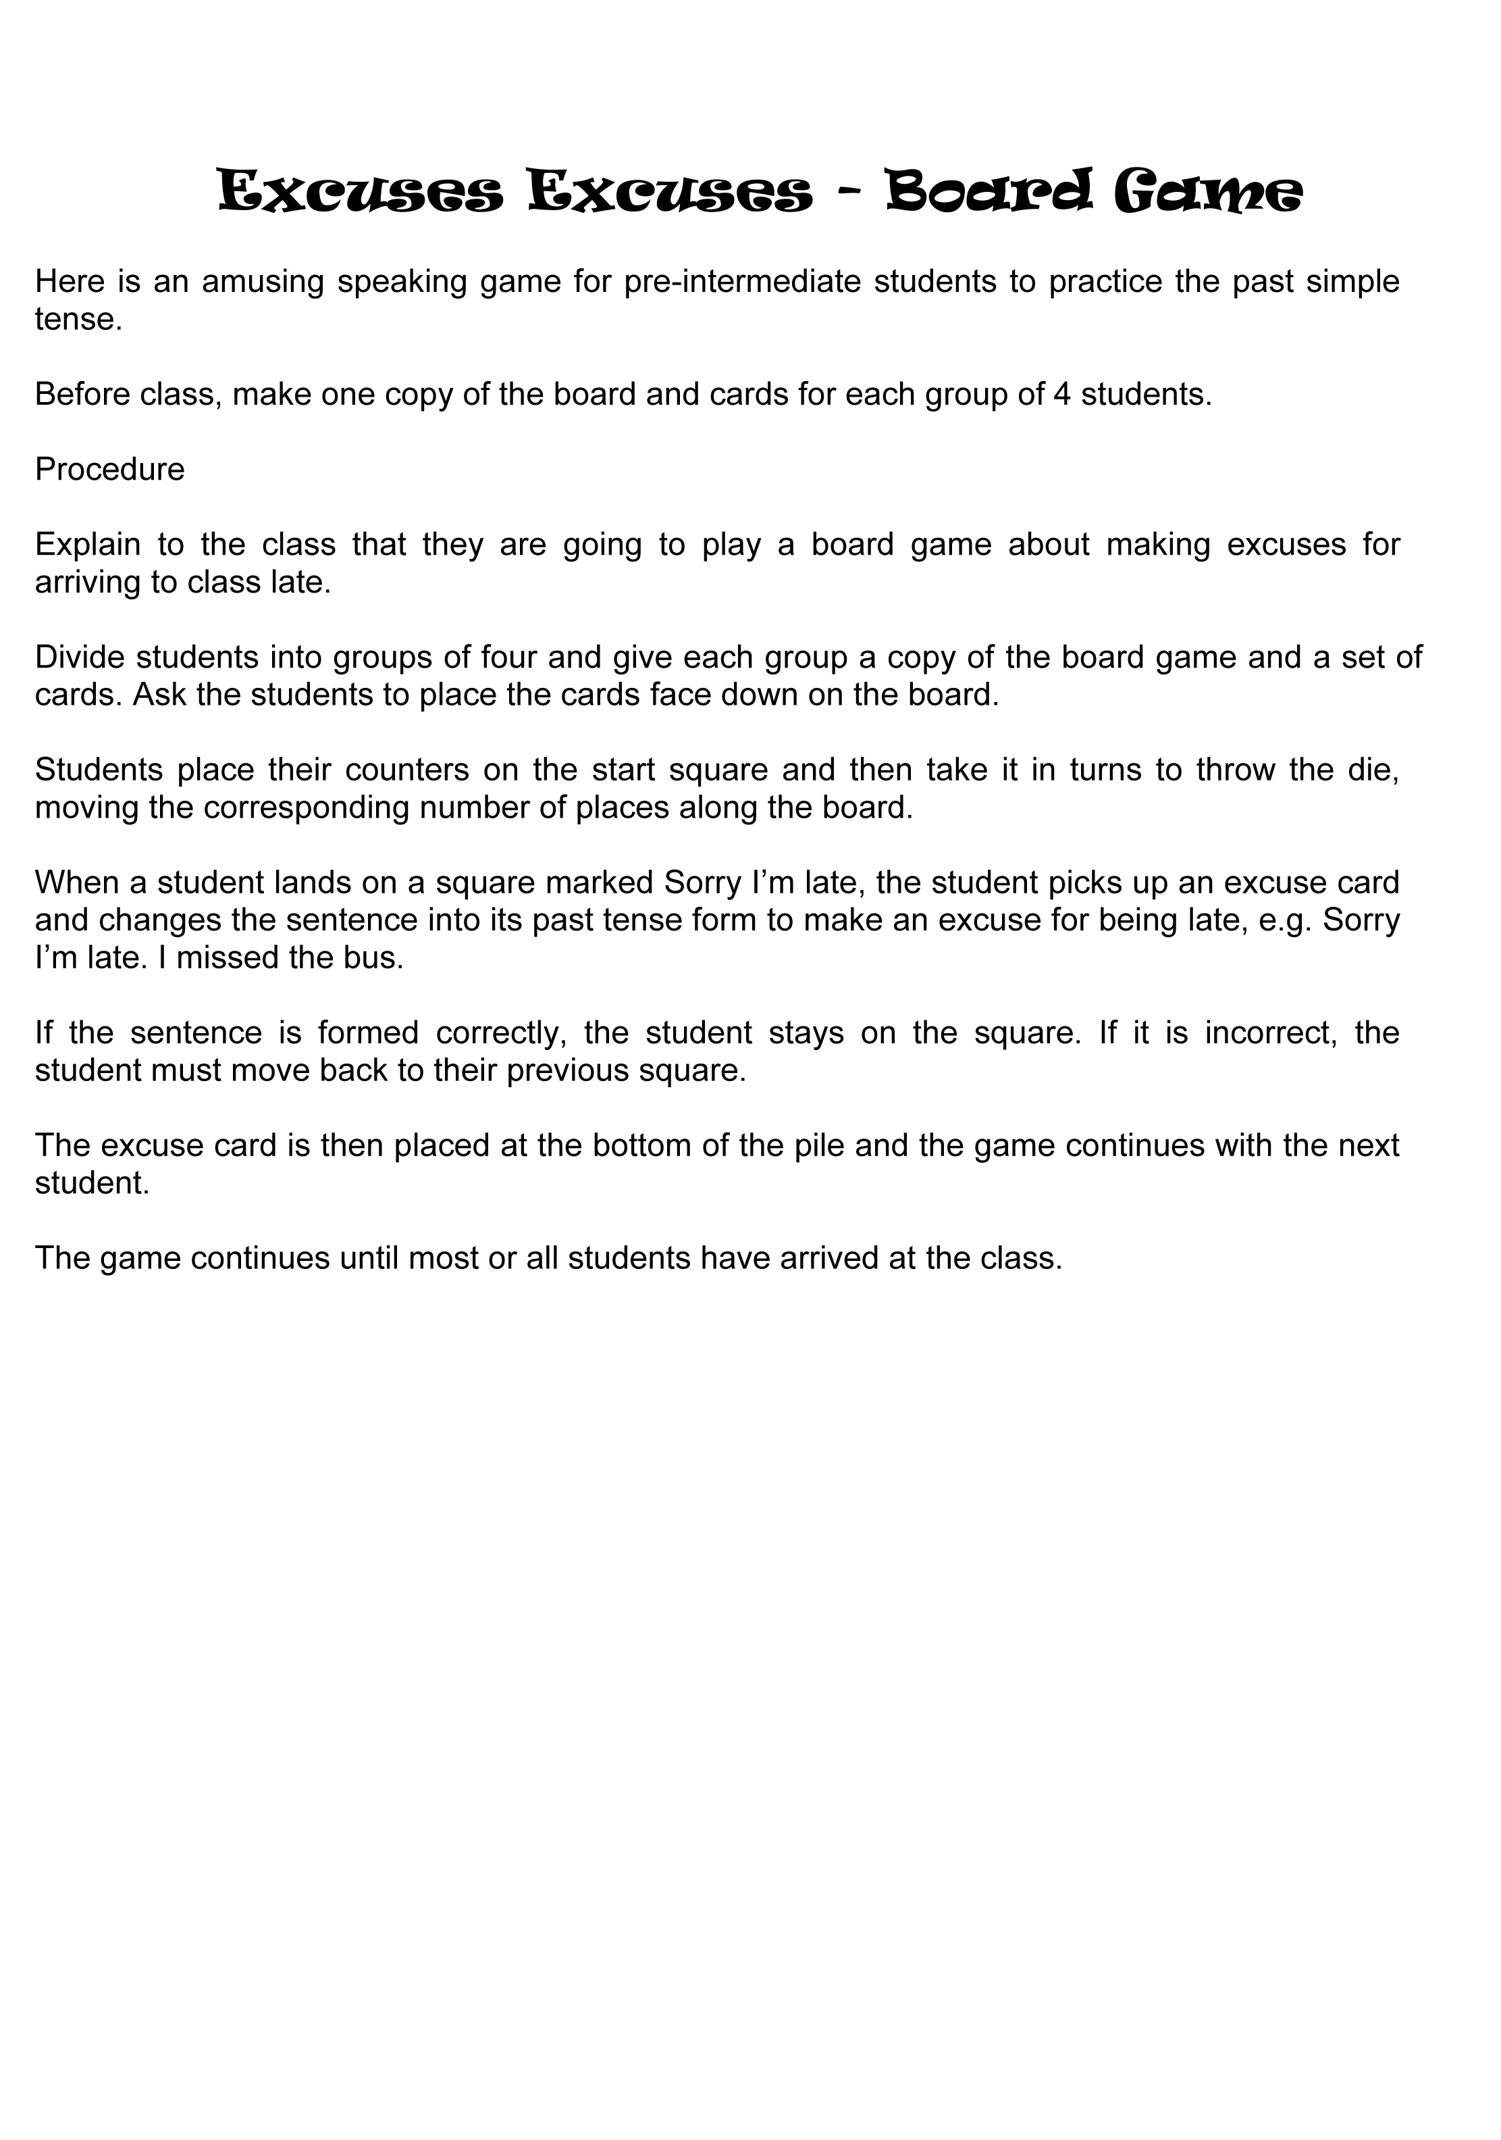
Irregular Verbs

- Wake - Woke - Woken

- Lose - Lost - Lost

- Fall - Fell - Fallen

- Forget - Forgot - Forgotten

- Get - Got - Gotten

- Think - Thought - Thought

- Win - Won - Won

- Sleep - Slept - Slept

- Break - Broke - Broken

