TITLE | Famous scientist says A.I. could destroy us
INSTRUCTOR |  |  |  | Ss’ LEVEL | AGE GROUP | No of Ss | LENGTH
Alice(Jungah An) |  |  |  |  | 25 | 7 | 50min

MATERIALS

The handout with the article and activites, Computer and screen.
AIMS 1. |  | Students will study expressions about artificial intelligence
2. |  | Students will practice their reading about artificial intelligence
3. |  | Students will practice how to use the expression about artificial intelligence.

LANGUAGE SKILLS
Listening |  |  | Expressions (e.g. cosmologist, motor neuron, synthesizer)
Speaking |  |  | Discuss about artificial intelligence with comprehension questions
Reading |  |  | The article on handout
Writing |  |  | Write down Ss’ opinions to answer with comprehension questions
LANGUAGE SYSTEMS
Phonology |  |  | See Lexis
Lexis |  |  | cosmologist, motor neuron, synthesizer
Grammar |  |  | noun
Discourse |  |  | Discussion with the expression about artificial intelligence
Functions |  |  | Discussing their opinion

ASSUMPTIONS

Students are have some idea and understanding about artificial intelligence.

ANTICIPATED GRAMMATICAL ERRORS AND SOLUTIONS

REFERENCES

http://www.breakingnewsenglish.com/1412/141209-stephen-hawking.html

NOTES

SOS actvitiy- 'Who am I' activity. Teacher would put the name of celebrities or characters one the whiteboard. and One student come out and ask 20 yes/no questions to find out who she/he is.

PRETASK TITLE |  |  | Guessing the topic through pictures
AIMS |  |  |  | MATERIALS
Students will guess what would be the debate topic with pictures. |  |  |  | Pictures on the screen
TIME | SET UP | STUDENTS |  |  | TEACHER
5min |  | Students supply appropriate language based on the pictures to guess the reading topic. (e.g. artifical intelligence, War between human race and AI machine, science fiction/Imagination) |  |  | Teacher elicits the topic from students as giving clues with pictures

NOTES

TASK PREPARATION TITLE |  |  | Read article and answer comprehension questions
AIMS |  |  |  | MATERIALS
Students will practice their reading with the article. |  |  |  | an article for students(handout)
TIME | SET UP | STUDENTS |  |  | TEACHER
15mins |  | Students will read article and check unfamilar vocabularies. After student finish their reading, discuss in groups shotly with comprehension questions on the handout. |  |  | Teacher distributes the handout.  Teacher will monitor student's discussions and answer the student's questions.

NOTES

TASK REALISATION TITLE |  |  | True & False, multiple question, CLOZE
AIMS |  |  |  | MATERIALS
Students will study with True & False, multiple question ,and CLOZE to exam their understanding. |  |  |  | Handout
TIME | SET UP | STUDENTS |  |  | TEACHER
25min |  | Students will study with True & False, multiple question ,and CLOZE to exam their understanding about the article. Students may read again the article several times to find out the answers. |  |  | Teacher will monitor and answer the student's questions.
 |  | . |  |  | .

NOTES

POST TASK TITLE |  |  | Check right answer
AIMS |  |  |  | MATERIALS

Students will check if they figure out the right answer or not.
TIME | SET UP | STUDENTS |  |  | TEACHER
5min |  | Students will check if they figure out the right answer or not. Students will read out the answer and let all student grad their test papers. |  |  | Teacher correct if the answer is wrong for True & False, multiple question, CLOZE.

NOTES

Famous scientist says A.I. could destroy us

(9th December, 2014)
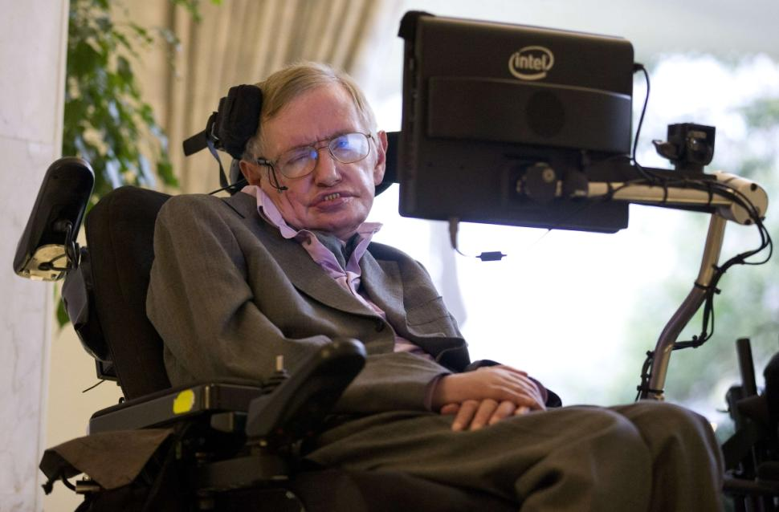
Professor Stephen Hawking, one of the world's most renowned scientists, has warned that robots and machines with artificial intelligence could one day mean the end of us all. Professor Hawking recently told the BBC in an interview that: "The development of full artificial intelligence (AI) could spell the end of the human race." The famous cosmologist(우주론자) made his warning in response to a question about an update to the app he uses to allow him to communicate. Hawking suffers from motor neuron(운동뉴런) disease (also known as ALS) and needs a special voice synthesizer(합성기) to talk. The update will be able to predict words he might want to use based on his previous communication.
Hawking said that AI has given many benefits to many people. He said it is still in its early stages of development, but when it becomes more sophisticated, it could prove a threat to our existence. He said: "It would take off on its own, and re-design itself at an ever increasing rate. Humans, who are limited by slow biological evolution, couldn't compete, and would be superseded(대체되다) not the first time he has issued such a warning. He gave a more chilling warning in April 2014, saying: "One can imagine such technology outsmarting(~보다 한수 앞서다) financial markets, out-inventing human researchers, out-manipulating human leaders, and developing weapons we cannot even understand."

COMPREHENSION QUESTIONS
1. | Which news agency did professor Hawking talk to?
2. | What did Hawking say AI could spell the end of?
3. | Which one of professor Hawking's jobs was mentioned in the article?
4. | What is motor neuron disease also known as?
5. | What will a new app used by Hawking be able to predict?
6. | Who did Hawking say has benefited from AI?
7. | What did Hawking say AI threatens?
8. | What did Hawking say humans are limited by?
9. | When did Hawking previously warn us about the dangers of AI?
10. | What did Hawking say AI would develop that we could not understand?

1. TRUE / FALSE: Read the headline. Guess if they are true (T) or false (F).
a. | The article says Stephen Hawking is a renewed scientist. | T / F
b. | Stephen Hawking spoke about artificial intelligence to the BBC. | T / F
c. | Professor Hawking's job is a cosmologist. | T / F
d. | A special app will predict the words Stephen Hawking might need. | T / F
e. | Hawking said AI could be a threat if it becomes more sophisticated. | T / F
f. | Hawking said AI would evolve at a slower rate than human evolution. | T / F
g. | This is the first time Hawking has warned of the threat from A.I. | T / F
h. | Hawking said A.I would not be better than humans at inventing things | T / F

2. Multiple Questions

1. Which news agency did professor Hawking talk to?

a) BBC
b) CNN
c) ABC
d) CBC

2. What did Hawking say AI could spell the end of?

a) the alphabet
b) computers
c) the human race
d) time

3. Which one of professor Hawking's jobs was mentioned in the article?

a) theoretical physicist
b) cosmologist
c) author
d) lecturer

4. What is motor neuron disease also known as?

a) DLS
b) CLS
c) BLS
d) ALS
5. What will a new app used by Hawking be able to predict?

a) words
b) the future
c) weather
d) new comets

6. Who did Hawking say has benefited from AI?

a) lecturers
b) computer makers
c) scientists
d) many people

7. What did Hawking say AI threatens?

a) the universe
b) our existence
c) mainframe computers
d) Earth

8. What did Hawking say humans are limited by?

a) quantum physics
b) their brains
c) computers
d) biological evolution

9. When did Hawking previously warn us about the dangers of AI?

a) August 1999
b) May 2006
c) April 2014
d) March 2010

10. What did Hawking say AI would develop that we could not understand?

a) cyber-species
b) weapons
c) maths
d) apps

LANGUAGE - CLOZE

Professor Stephen Hawking, one of the world's most (1) ____ scientists, has warned that robots and machines with artificial intelligence could one day (2) ____ the end of us all. Professor Hawking recently told the BBC in an interview that: "The development of (3) ____ artificial intelligence (AI) could spell the end of the human race." The famous cosmologist made his warning (4) ____ response to a question about an update to the app he uses to allow him to communicate. Hawking suffers from motor neuron disease (also (5) ____ as ALS) and needs a special voice synthesizer to talk. The update will be able to predict words he might want to use based (6) ____ his previous communication.
Hawking said that AI has given many benefits to (7) ____ people. He said it is still in its early stages of development, but when it becomes more sophisticated, it could (8) ____ a threat to our existence. He said: "It would (9) ____ off on its own, and re-design itself at an ever increasing rate. Humans, who are limited by slow biological evolution, couldn't compete, and would be superseded." This is not the first time he has (10) ____ such a warning. He gave a more chilling warning in April 2014, saying: "One can imagine (11) ____ technology outsmarting financial markets, out-inventing human researchers, out-manipulating human leaders, and developing weapons we cannot (12) ____ understand."
Put the correct words from the table below in the above article.
1. | (a) | renewed | (b) | renounced | (c) | renowned | (d) | renovated
2. | (a) | mean | (b) | median | (c) | mode | (d) | average
3. | (a) | full | (b) | whole | (c) | entire | (d) | all
4. | (a) | in | (b) | on | (c) | to | (d) | at
5. | (a) | knowing | (b) | known | (c) | knows | (d) | knew
6. | (a) | in | (b) | to | (c) | at | (d) | on
7. | (a) | any | (b) | much | (c) | many | (d) | whole
8. | (a) | proved | (b) | proven | (c) | proof | (d) | prove
9. | (a) | take | (b) | get | (c) | let | (d) | blast
10. | (a) | issued | (b) | thrown | (c) | orated | (d) | done
11. | (a) | thus | (b) | such | (c) | hither | (d) | unto
12. | (a) | alone | (b) | just | (c) | even | (d) | flat



