Reading Task #1
A
What are Fables?
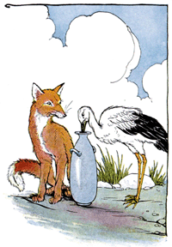
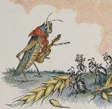
Fables are short stories which illustrate a particular moral and teach a lesson to children and kids. The theme and characters appeal to children and the stories are often humorous and entertaining for kids of all ages. Fables can also be described as tales or yarns which have a message in their narrative such as a parable might have. Fables can often pass into our culture as myths and legends and used to teach about morals to children and kids.

B
Who is Aesop?

There are many possibilities relating to Aesop's place of birth, although he certainly spent much of his life living in Greece at the court of King Croesus in Athens. Suggestions for Aesop's place of birth include Thrace, Greece, Phrygia, Ethiopia and Samos.

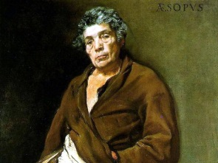
His very name, Aesop, may however give us a clue to his country of origin. The name Aesop is derived from the Greek word Ethiopian which means Ethiopia! And Aesop was described by Maximus Planudes (c.1260-c.1330), the Byzantine scholar who wrote a biography of Aesop and a prose version of Aesop's fables, as follows "His visage was of black hue". In Aesop's biography Planudes describes Aesop an ugly, deformed dwarf, and the famous marble statue at the Villa Albani in Rome depicts Aesop accordingly.

Aesop's fables were first printed in English by William Caxton in 1484, from his own translation made from the French. Aesop's fables were not believed to have been written as Children's literature and the book of fables were originally used to make thinly disguised social and political criticisms. The similarity to parables or allegories can be seen in most of the short tales in Aesop’s Book of Fables.

Worksheet #1

Read the reading task #1 (A) and solve the questions.

1) What is the fable?

2) Why do you think the fables are beneficial to children?

Read the reading task #1 (B) and solve the questions.

3) When were Aesop’s fables first printed in English?

4) Where do you think Aesop might be born? Why would you think that?

Worksheet # 2
Once, a dog found a bone in the forest. He held the bone in his mouth. As he was crossing a stream he looked into the water and saw another dog holding a bone in his mouth. He wanted the other bone also, so he barked at the dog.
“Bow-wow! Bow-wow!”
As he opened his mouth to bark, the bone fell into the water. It was his own reflection. The greedy dog had learnt a lesson.
Moral : We should not be greedy.

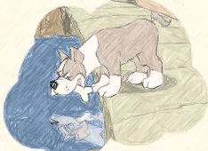

If you were Aesop, what story would you make for greedy kids? Make a story with your partner.

