TITLE | breakfast helps girls stay slim
INSTRUCTOR |  |  |  | Ss’ LEVEL | AGE GROUP | No of Ss | LENGTH
Min |  |  |  |  | 16 | 8 | 50mins

MATERIALS

computer or laptop

worksheets

marker , white board

ppt
AIMS 1. |  | students will practice to reading comprehension skills
2. |  | students will learn the vocabularies relate with the topic through activity

LANGUAGE SKILLS
Listening |  |  | other students ideas and instructions
Speaking |  |  | their own opinion during discuss and read the passage
Reading |  |  | article and worksheeis
Writing |  |  | fill the blanks of worksheet
LANGUAGE SYSTEMS
Phonology |  |  | publish, weight, release, nutrient, conclusion, contain etc
Lexis |  |  | see phonology
Grammar |  |  | past and present tense
Discourse |  |  | during word search and fill the blanks
Functions |  |  | responding, discussing,

ASSUMPTIONS

students already have experienced about topic

ANTICIPATED GRAMMATICAL ERRORS AND SOLUTIONS

Student cannot understand a few words about the article
Provide the chance to use dictionary or ask other student in the same group and teacher

REFERENCES

http://www.breakingnewsenglish.com/0509/050910-breakfast.html

http://www.esl-galaxy.com/wordsearch.htm

NOTES

planB shiritory- Teacher start by saying a word and the next student has to say a word which begins with the last letter of teacher word and then the process continue back and forth

PRETASK TITLE |  |  | Guiding to the topic
AIMS |  |  |  | MATERIALS
practice reading and remind experience |  |  |  | ppt
TIME | SET UP | STUDENTS |  |  | TEACHER
1min |  | greeting  answer the guiding questions  do you usually have breakfast?  what do you have for breakfast? or  why do you skip breakfast?  how about you when you empty stomach? |  |  | greeting  give guiding questions
3mins |  | see the picture and follow read |  |  | show the pictures and  lead students to following read

TASK PREPARATION TITLE |  |  | word search
AIMS |  |  |  | MATERIALS
practice find out the words and fun |  |  |  | ppt, worksheet, marker, whiteboard
TIME | SET UP | STUDENTS |  |  | TEACHER
2mins |  | listening carefully about explaining  and see the ppt and then receive the worksheet  follow the instruction  find the words relate with breakfast in worksheet  ICQ  can you do this alone? |  |  | explaining about word search activity and show the ppt and then hand out worksheet  and the give instruction and ICQ
12mins |  | discussing to find out words |  |  | during the discussing monitor students
2mins |  | after discussing , write the words on the board  CCQ  what do you find as breakfast? |  |  | after students wrote , match the words together and CCQ

TASK REALISATION TITLE |  |  | gap fill
AIMS |  |  |  | MATERIALS
learning reading comprehensoin and fill the blank |  |  |  | worksheets, marker, white board ,ppt
TIME | SET UP | STUDENTS |  |  | TEACHER
1min |  | receive the worksheet and listening the explaining  and then follow the instruction  fill the blank to the proper words in the worksheet |  |  | show the ppt,hand out worksheet and explaining what we will do and then give instruction so that discussing
16mins |  | discissing as group |  |  | moniter students
2mins |  | after discuss, write the answer on the board |  |  | check together
2mins |  | read the article and answer  CCQ  do you skip breakfast to stay slim? |  |  | give instruction so that read article and CCQ

POST TASK TITLE |  |  | True&fale
AIMS |  |  |  | MATERIALS
find the right answer |  |  |  | ppt,
TIME | SET UP | STUDENTS |  |  | TEACHER
8mins |  | watch the ppt and read the question  find the answer between T and F |  |  | show the ppt about question  give instruction and read together to fine right answer
1min |  | have you fun todays activity ?  do you have any question? |  |  | feedback

Worksheets, handouts and lesson materials
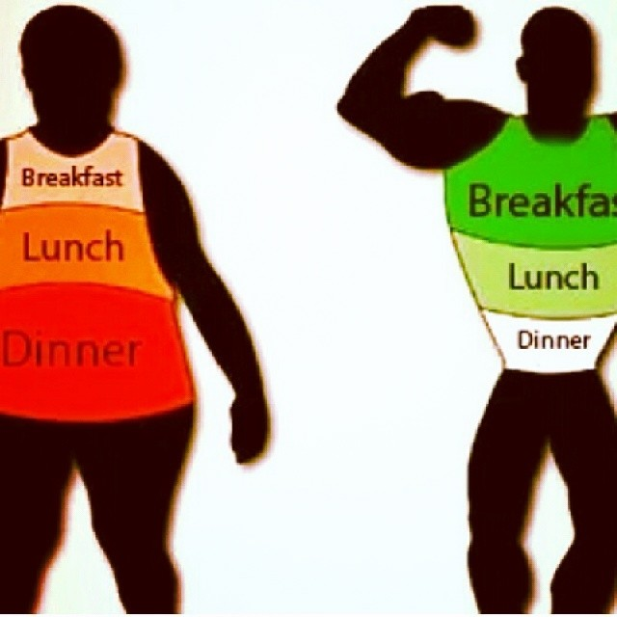
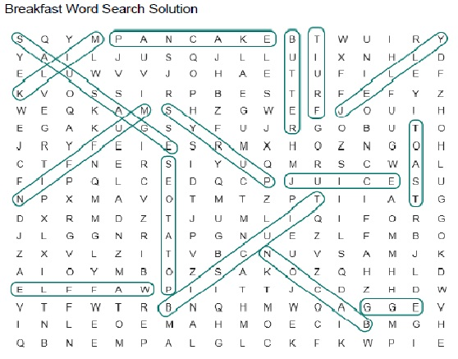
Article – breakfast helps girls stay slim
Worksheet
A newly published report says that girls should eat breakfast every day if they want to stay slim. Researchers from America’s Maryland Medical Research Institute followed the eating habits and weight of nearly 2,400 girls throughout their adolescence. This ten-year period is a time when “girls put on a lot of weight”, according to lead researcher Bruce Barton. The conclusion of the findings was that teenage girls who ate cereal for breakfast three times a week or more were more likely to stay slim.
A press release from the Journal of the American Dietetic Association reports that “cereal consumption had positive effects on the girls”. This is because cereals contain high levels of calcium and fiber and low levels of fat and cholesterol. The researchers suggest that there are other reasons why eating cereal may help girls stay slimmer. One factor is that other healthy things are usually consumed with cereal, such as milk and juice. Researchers also concluded that cereals help girls to get the right amounts of nutrients.
- A newly ________ report says that girls should eat breakfast every day if they want to ________ slim. Researchers from America’s Maryland Medical Research Institute ________ the eating habits and ________ of nearly 2,400 girls throughout their adolescence. This ten-year ________ is a time when “girls ________ on a lot of weight”, according to lead researcher Bruce Barton. The ________ of the findings was that teenage girls who ate cereal for breakfast three times a week or more were more ________ to stay slim.
- A press ________ from the Journal of the American Dietetic Association reports that “cereal consumption had ________ effects on the girls”. This is because cereals ________ high levels of calcium and fiber and low levels of ________ and cholesterol. The researchers ________ that there are other reasons why eating cereal may help girls stay slimmer. One ________ is that other healthy things are usually ________ with cereal, such as milk and juice. Researchers also concluded that cereals help girls to get the right ________ of nutrients.
- 1. TRUE / FALSE: Look at the article and choice whether these sentences are true (T) or false (F):
- a. A new diet breakfast cereal has become popular with girls.
- T / F
- b. Researchers followed the eating habits of 2,400 girls for ten years.
- T / F
- c. Adolescence is not a time when girls put on weight.
- T / F
- d. Girls must eat cereal every day to stay slim.
- T / F
- e. Cereal consumption had positive effects on the girls.
- T / F
- f. Cereal is very high in cholesterol.
- T / F
- g. Milk and juice must be drunk with cereal for people to lose weight.
- T / F
- h. Cereal consumption helps girls get the right amounts of nutrients.
- T / F

