Listening Lesson Plan
TITLE To learn about different kinds of life styles through listening to a passage and introducing expressions

INSTRUCTOR |  | Ss’ LEVEL |  | AGE GROUP |  | No of Ss |  | LENGTH
Rebecca |  | Intermediate |  | Adult |  | 13 students |  | 50 minutes
MATERIAL
White board, markers, Listening CD, CD player, worksheets(#1, #2), and pictures of life styles (E.g. Hiking, Couch potato, Staying at home etc.)
AIMS
- To learn vocabularies related to people’s life styles
- To practice different types of listening questions
- To learn some expressions that will appear in life styles
LANGUAGE SKILLS
-Listening: Students will listen to passages or dialogues.
-Speaking: Each of Students can talk about different life styles
-Reading: After listening, students will find the main idea and check the details through answering questions.
-Writing: Students take dictation on their worksheet.
LANGUAGE SYSTEMS
-Phonology: Practicing new vocabularies and expressions
-Lexis: Learning some vocabularies related to the life styles.
(E.g. rock climbing, couch potato, workaholic etc.)
-Discourse: Try to understand the conversations
-Functions: Sharing ideas about students’ life styles
(E.g. Jason likes hiking. Kyle likes to do things alone at home etc.)
ASSUMPTIONS
-Students may think dictation is difficult. Teacher can control the audio player (E.g. play-pause-play-pause)
-It is possible that the students listen to the passages one more time
REFERENCES
Listening Insight; Nathan Kim
NOTES
Some students may have difficulties on Advanced listening test (Listening Insight, p.28)
Teacher can give some clues for them.
PRETASK TITLE Kinds of life styles
AIMS  To introduce different kinds of life styles |  |  |  |  | MATERIALS  Pictures
TIME | SET UP |  | STUDENTS |  |  |  | TEACHER
2 | Groups |  | Discuss about the picture that shows different life styles. |  |  |  | Elicit by using pictures
6 | Groups |  | Share what they discuss in front of the class |  |  |  | Monitor
TASK PREPARATION TITLE Words & Expressions
AIMS  To introduce the vocabularies and expressions that will appear in the certain situation |  |  |  |  | MATERIALS  -Listening Insight, p.24  -Worksheet #1
TIME | SET UP |  | STUDENTS |  |  |  | TEACHER
4 | Class |  | p.24  -Read some words and expressions out loud  -Write down the answers |  |  |  | -Check pronunciations  -Monitor
8 | Class |  | Worksheet #1  -Write down the meaning of the vocabularies.  -Match the sentences (expressions) on right situation |  |  |  | -Instruct  -Help with difficult words
NOTES
If there are some students who can’t finish the worksheet on time, let them do it as homework
TASK REALISATION TITLE Listening Practice
AIMS  To find the main idea & understand details |  |  |  |  | MATERIALS  CD, CD player, Listening Insight, p25-28
TIME | SET UP |  | STUDENTS |  |  |  | TEACHER
10 | Class |  | P25-28  -Listen carefully and choose the correct answers |  |  |  | -control the device  -monitor
10 | Class |  | -Grade their own answers  -Listen to the passage which Ss don’t understand properly again |  |  |  | -Tell them correct answers  -Give corrections
NOTES
The students must be monitored; if there are some students who got bad grades, teacher should encourage them to do better next time.

POST TASK TITLE Worksheets #2 (Dictation)
AIMS  To help students understand sentences |  |  | MATERIALS  CD, CD player, Worksheet#2 (Dictation)  White board, marker
TIME | SET UP | STUDENTS |  | TEACHER
7 | Class | Worksheet #2  -Listen and fill in the blanks |  | -control the device  -monitor
3 | Class | -Grade their own answers  -Listen to the passage which Ss don’t understand properly again |  | -Tell them correct answers  -Give corrections
NOTES
-Teacher can control the audio player freely (E.g. play-pause-play-pause)
-If there are some students who are having hard time to write the spelling, teacher can write it on the whiteboard
Materials
1. Pictures
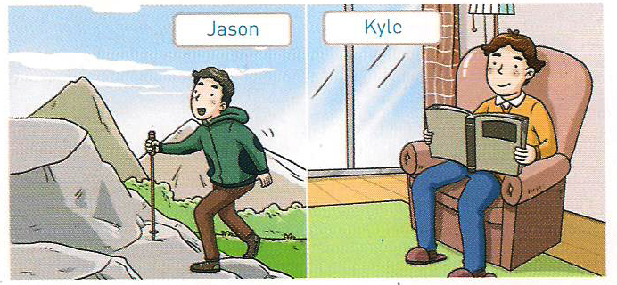

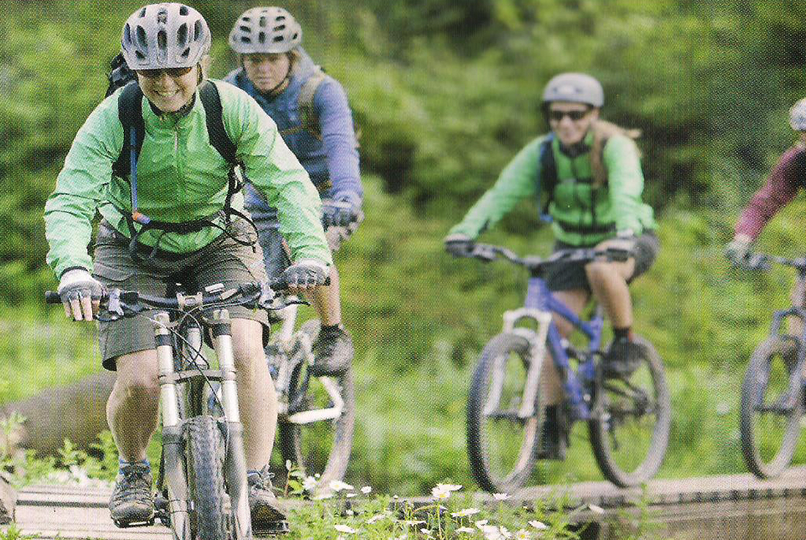
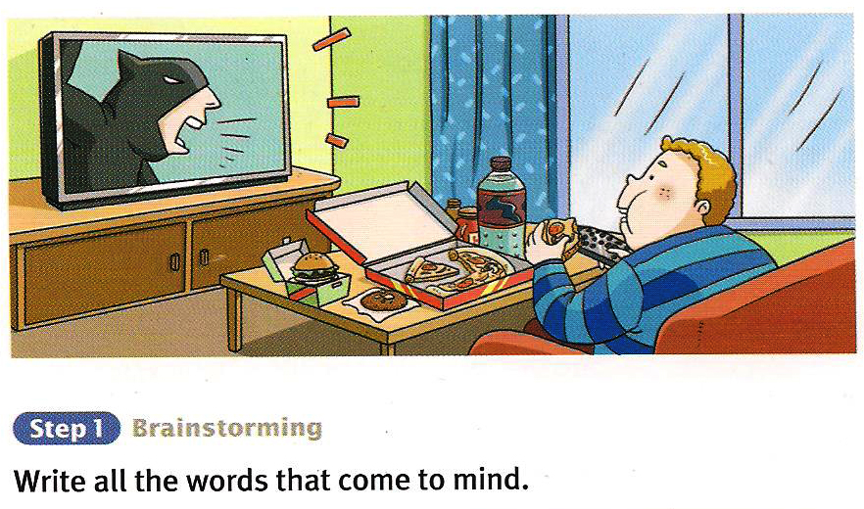

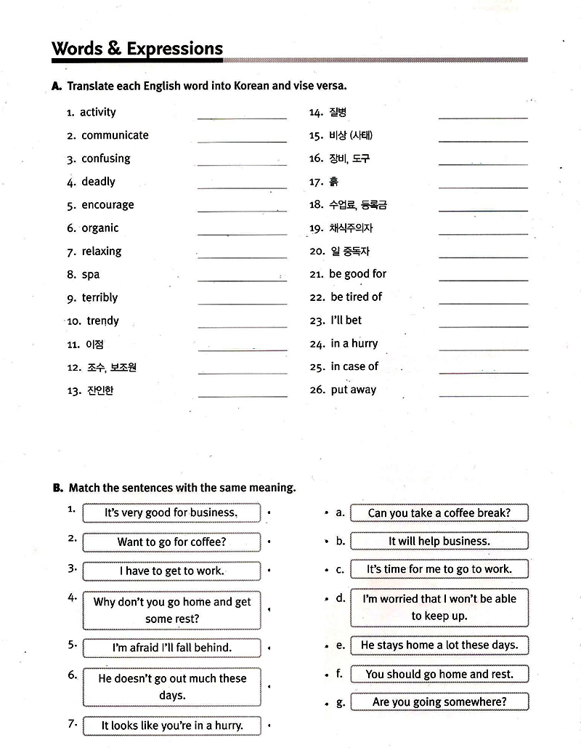
2. Worksheet #1

3. Worksheet #2 (Dictation)
[Listen and fill in the blanks]
1. M: We’ve been selling a lot of lately
W: Yes, that’s because of a special show that was on TV.
M: It was a show about camping
W: Yeah, they gave lots of where to go and what you need to take
M: Oh, well, it’s very good for business
W: I know. We’re almost tents, sleeping bags, and camp stoves

2. It’s important to save money. That way, you will always have money an emergency. The first step in saving money is to always be diligent about it. It’s sometimes to think “I’ll put away money next month,” but you have to do it every month. Then saving money will become a habit. Also, you should money for savings right after you are paid. IF you wait too long, you may want to spend it. Put the money into a savings account every month, and it will be to spend.

3. W: Murray, I heard you’re moving to a farm in the country.
M: Yes, that’s right. to become a farmer
W: Why? Are you tired of the city?
M: Yes, but I also heard of a new kind of farming
W: What’s it about?
M: I want to be an . That means I want to grow foods carefully
W: You mean, you want to be an organic farmer?
M: Sort of. To be an intelligent farmer means I have to make sure the
is
W: Then, if the soil is healthy, the food will be health?
M: Yes, that’s it.

4. Bill is worried about his girlfriend. He thinks that they are too .
For example, Bill likes music because it is exciting, but his girlfriend likes because it is relaxing. Bill likes doing things , like taking walks or going to festivals, but his girlfriend likes and watching TV or reading. Bill told his friend Jenny about his problem. He asked her what he should do. Jenny that he should try doing the things that she likes, and she should try things Bill likes

5. Smart phones are very popular these days. Almost the cell phones are smart phones, and soon, everyone will be using a smart phone. There are many smart phones. They make it easy to check for emails, chat online with friends, and use the Internet. Some people think smart phones are bad, because they say people spend too much time checking the Internet. Then, they don’t talk to people or . However, experts find that most people actually communicate MORE because of smart phones. That is because the smart phones make it communicate with friends and family. They may not talk to each other, but with chatting, social websites and emails, they certainly know .

6. M: What do you want for lunch? Is a hamburger and fired OK?
W: Sure, if it’s a veggie burger. I’m a
M: I didn’t know that. When did you become a vegetarian?
W: Last year. I decided not to eat
M: Is it for ?
W: A little. But also, I think is cruel.
M: I see. Was it very easy to a ?
W: Not really. It seems every restaurant is a meat restaurant.
Sometimes it’s hard to find food in it.

