Speaking Lesson Plan
TITLE | How to order menu at a fast food restaurant
Instructor |  | Ss' Level | Age Group | No of Ss | Length
Adele |  | Lower Intermediate | Adult | 13 | 50 minutes
Materials:
- A board and markers
- Dialogue hand-out (14 copies)
- Speaking worksheet “Get orders” (14 copies)
(Make sure the budget is unseen in each paper)

Aims:

- Students will practice and improve speaking and listening skills by having casual conversation at a restaurant
- Students will learn vocabulary and expressions about food and ordering food through a dialogue and role-play activity

Language Skills :

- Listening: Listening to teacher's instructions and classmates in activity
- Speaking: Practicing conversation using sentences from the dialogue
- Reading: Reading a script and words on a dialogue and worksheet

Language Systems :

- Phonology: Students will be practicing pronunciation during dialogue exercises
- Lexis: Students will be focusing on words, phrases commonly used at a restaurant
- Discourse: Students will have a conversation with partners by role-play, and communication with many classmates by activity
- Function: To be familiar with ordering menu at a restaurant

Assumptions :

- Students can speak basic sentence and can read the amount of US dollar
- Students have experiences of ordering food at a fast food restaurant so they know about famous fast food restaurant and typical menus.

Anticipated Errors and Solutions :

- Students may not be familiar with fast food
- Briefly show more picture of fast food and elicit from other students
- If time is short
- Make pair discussion short or make post-activity short
- If activity is finished earlier than expected
- Make post-activity long by sharing the result of their sales from all the students

References :
- https://en.islcollective.com/resources/printables/worksheets_doc_docx/ordering_in_a_fast_fast_restaurant/food-ordering-fastfood/51741

Notes :

- Focus on giving students more time to speak
- Monitor students' activity and try to find out the difficulties

Lead-In
Materials | Board, Pictures
Time | Setup | Students | Teacher
5 min | Whole class | Students say words related to the picture | Start with showing picture of 'McDonald'  Elicit the word "burger" and "order" with following questions;
Notes
In case of students do not saying the word "burger" and "order", prepare more pictures

Pre-Activity
Materials | Dialogue, Board
Time | Setup | Students | Teacher
10 min | Whole Class | Students read the dialogue as role-play with teacher.  (Students will be the customer at first, and the waiter at second time)  Students get to know the meaning and usage of new vocabulary | Hand out dialogue.  Give instructions to go on a role-play with the dialogue. First time, Teacher take the waiter role and students take the customer role, and read one more with switching roles.  Elicit the meaning of "would you like" and "for here or to go"  Explain the functions of these two expression
Notes
If students have difficulties to understand the meaning of the vocabulary besides the vocabulary covered at the class, try to elicit and make them understand

Main Activity
Materials | Dialogue, Worksheet(activity), Board
Time | Setup | Students | Teacher
10mins | Pair work | Students speak with their partners using the dialogue. They can change the word underlined using the "menu" on the bottom of the paper  Students find out new partner and speak with another partner | Give instructions of pair work  ICQ  Monitor  Make students find new partner and continue
10min | Whole class | Students have the worksheet with food menus and the prices.  Students will stand up and try to have conversation as many as classmates.  Students will buy as customers and sell as waiters.  When they buy, they cannot order more than their budget. - Each student have different budget to buy the item (the budget can be seen only to the owner).  When they sell, try to get orders from classmates. And write down classmates' name, their order, whether they eat there or outside, and the total price of their order on the worksheet.  When the time is up, student who earn the highest amount of money in total will be the winner. | Give instructions of activity "Get orders" showing the worksheet  Explain the aim of this activity, get orders from classmates and earn money as much as possible.  Hand out the worksheet  ICQ  Monitor
Notes
Monitor if the activity is not going well and if the students go wrong way. When guide is needed, stop the activity for a moment, and explain again

Post Activity
Materials | board
Time | Setup | Students | Teacher
10 min | Whole class | Students say how much they earn in total. The selected students share the orders they sold and the price to the whole class. | Look for students who earn money the most and the least and find out who is the winner.  Ask students to share their list of sales item and price
5 min | Whole class | Students review vocabulary and share feedbacks | Eliciting some of the essential vocabulary and phrase
Notes
If many students tied and time is not enough, just make one or two students share their sales.

Dialogue
Ordering food at a fast food restaurant
Waiter | : May I take your order?
Customer | : Yes, I would like a hamburger, please.
Waiter | : Would you like medium or large?
Customer | : Medium, please.
Waiter | : Would you like side menus?
Customer | : Yes, I want french fries, too.
Waiter | : Would you like something to drink?
Customer | : Yes, I would like one coke, please.
Waiter | : Would you like anything else?
Customer | : No, thanks. That’s it.
Waiter | : For here or to go?
Customer | : For here, please.
Waiter | : Your total is $7.00.
Customer | : OK. Here’s my credit card.
Waiter | : Thank you very much. Enjoy your meal.

MENU
Burgers | Side Menus | Drinks
Hamburger Cheese burger Chicken burger M $4.0 $5.0 $4.5 L $4.5 $5.5 $5.0 | Salad French fries Onion rings Corn salad $2.0 $2.0 $2.5 $1.5 | Coke Orange juice Milkshake Coffee $1.0 $1.5 $2.0 $1.0

Speaking worksheet
Get Orders!!!
Let's get the orders from your classmates!!!
Main Menu
Hamburger  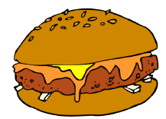  $3.0 | Cheeseburger  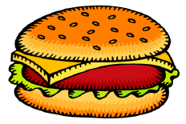  $3.5 | Sandwich  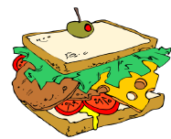  $3.5 | Sub  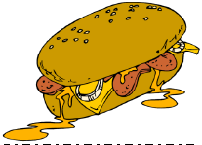  $3.0
Hotdog  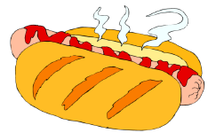  $2.0 | Burrito  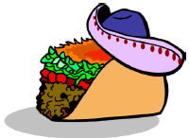  $3.5 | Chicken  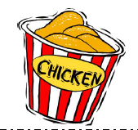  $5.0 | Pizza  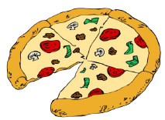  $10.0
Side Menu
French fries  $1.0 | Onion Ring  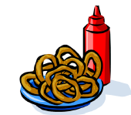  $1.5 | Muffin  $1.0 | Salad  $2.0
Drinks
Coke  $1.0 | Lemonade  $1.5 | Milkshake  $2.0 | Coffee  $1.0

Name | Order | For here/to go | Total
Your total is $___________ !!!!

Your budget is $___________

