Reading Lesson Plan

Title: A New Heart for Mt. Fuji

INSTRUCTOR |  |  | Ss’ LEVEL |  | AGE GROUP |  | No of Ss |  | LENGTH
Lisa  (Jiwon Moon) |  |  | Intermediate |  | Adult |  | 12 students |  | 50 minutes
MATERIAL
White board, Markers, Picture #1, 2, Organ shapes, Article sheet, Worksheet #1, #2, #3 (twelve copies each for the student)
AIMS
-Students will learn new vocabularies through teacher’s explanation and CCQs
-Students will practice skimming and scanning skills by reading text and answering a guiding question
-Students will express their opinion about the text by discussing in pair and group.
LANGUAGE SKILLS
-Reading: text and comprehension worksheet
-Listening: teacher’s instructions, questions and classmate’s idea
-Writing: answering comprehension questions/ taking notes of worksheets
-Speaking: response to teacher’s question. Sharing their opinions with partner
LANGUAGE SYSTEMS
-Discourse: discussing and sharing opinion related to topic.
-Phonology: correct pronunciation of lexis
- Lexis: Vocabularies connect with donation and operation.
-Function: expressing and presenting their opinions
ASSUMPTIONS
- Ss have already thought about the importance of organ donation.
- Ss are used to working individually and in groups of 3~4.
-Ss know how to skim and scan.
REFERENCES
Text: Adventures in Reading (Henny & Melissa Billings, 2003)
Picture: google.com (image)
Anticipated Errors and Solutions
Ss don’t understand key vocabulary
- T tells example sentences using the key vocabularies.
Ss may not be able to pick up details from the reading
- Chunk the story and give them more time to read
Ss might need more time to finish their activity.
- Be flexible with time to finish the activity or cut off the discussion.
There may not be enough time to complete the lesson.
- Assign the post activity writing task as a homework assignment.
PRETASK TITLE Guessing the topic
AIMS  To introduce the topic through brainstorming |  |  |  |  |  | MATERIALS  Picture #1, 2
TIME | SET UP |  |  | STUDENTS |  |  |  | TEACHER
5 | Whole Class |  |  | Picture #1,2  -Talk about the picture and answer about the questions. |  |  |  | - Elicit  -Write words on the whiteboard.  “Donate life”
TASK PREPARATION TITLE Vocabulary
AIMS  To learn key vocabulary |  |  |  |  |  | MATERIALS  Worksheet #1, organ shapes
TIME | SET UP |  |  | STUDENTS |  |  |  | TEACHER
8 | Whole class  &  Pairs |  |  | -Guess the meaning of vocabulary  -Ss follow the Phonology 2~3times.  -Complete the sentence; write the missing word with partner.  -Make sample sentences on the worksheet and Read own answers to classmates. |  |  |  | -Distribute  worksheet #1  -Write the vocabulary on the board  -Elicit  -Check answers  (give correction)
NOTES
While filling in the blanks, Ss can share the answers
￫ If there are some difficult words, Ss will discuss about them
TASK REALISATION TITLE Reading the topic
AIMS  To get the main idea and remember the details |  |  |  |  |  | MATERIALS  Worksheet #2, #3
TIME |  | SET UP |  | STUDENTS |  |  |  | TEACHER
5 |  | Class |  | -Skim passages for 2mins.  - While skimming, Ss try to find the three people in the story, underline the names of the three people.  -Tell the answer to classmates |  |  |  | -Distribute  the Article & worksheet #2.  -Before skimming, give Ss the guiding instruction.  -ICQ  -Monitor
10 |  | Individually |  | -Read the text and try to remember the details  -Do comprehension quiz worksheet#2  (Fill in the correct bubble.)  -Tell the answer to classmates |  |  |  | -ICQ  -Monitor  -Check answers
10 |  | Pairs |  | - Read again for detail and answer “Putting Events in Order” question with partner.  - Tell classmates the answers |  |  |  | -ICQ  -Monitor  -Check answers

POST TASK TITLE Debating
AIMS  To tell Ss’ own opinion about the topic |  |  | MATERIALS  Worksheet #3
TIME | SET UP | STUDENTS |  | TEACHER
12 | Group | - After writing, discuss and share in group.  -Present your group’s opinion to the class.  - Error Correction  -Feedback & Assignment  : Do an internet search About climbing Mt. Fuji. |  | -Distribute worksheet #3  -ICQ  -Monitor
Notes
-Assignment: Use a search engine like Google. Visit two or more websites. Find three facts about climbing Mt. Fuji. Share your information with class.

Picture #1, 2

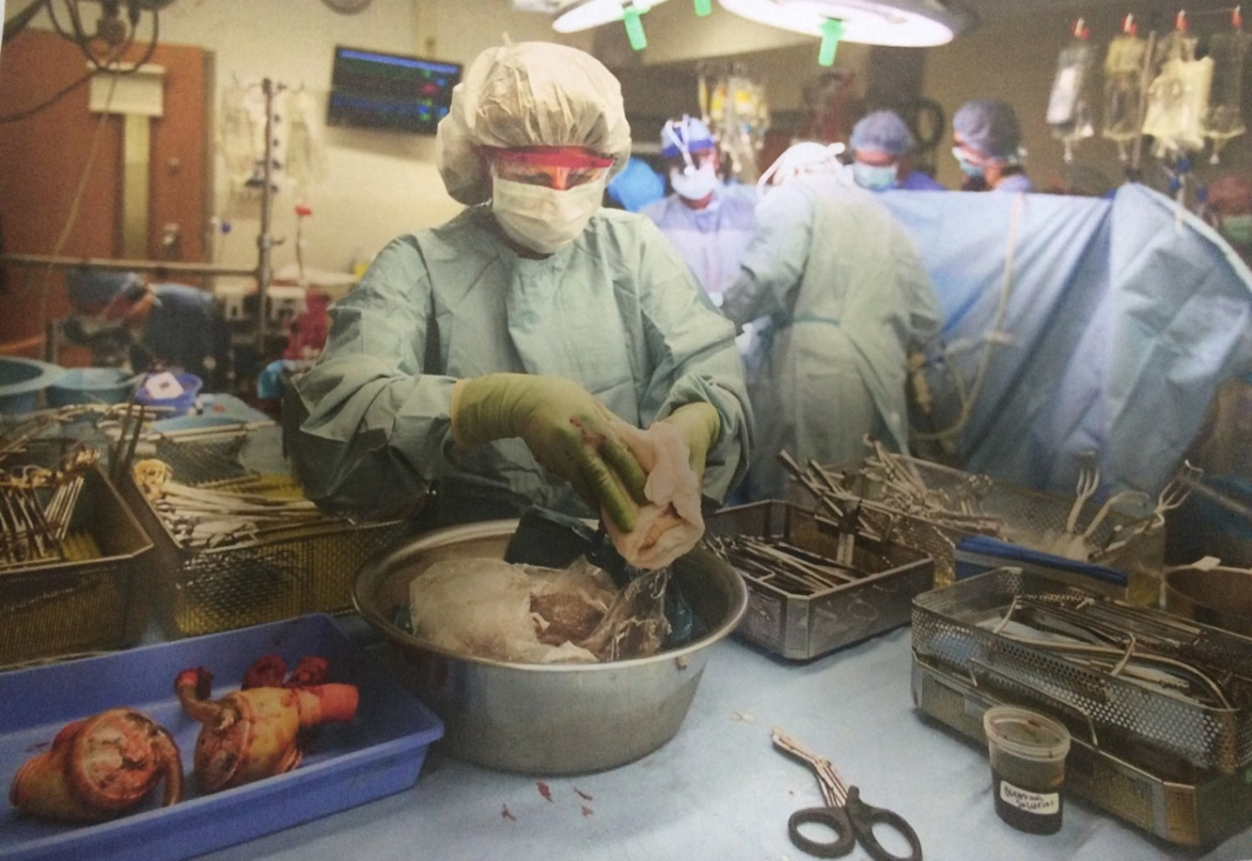

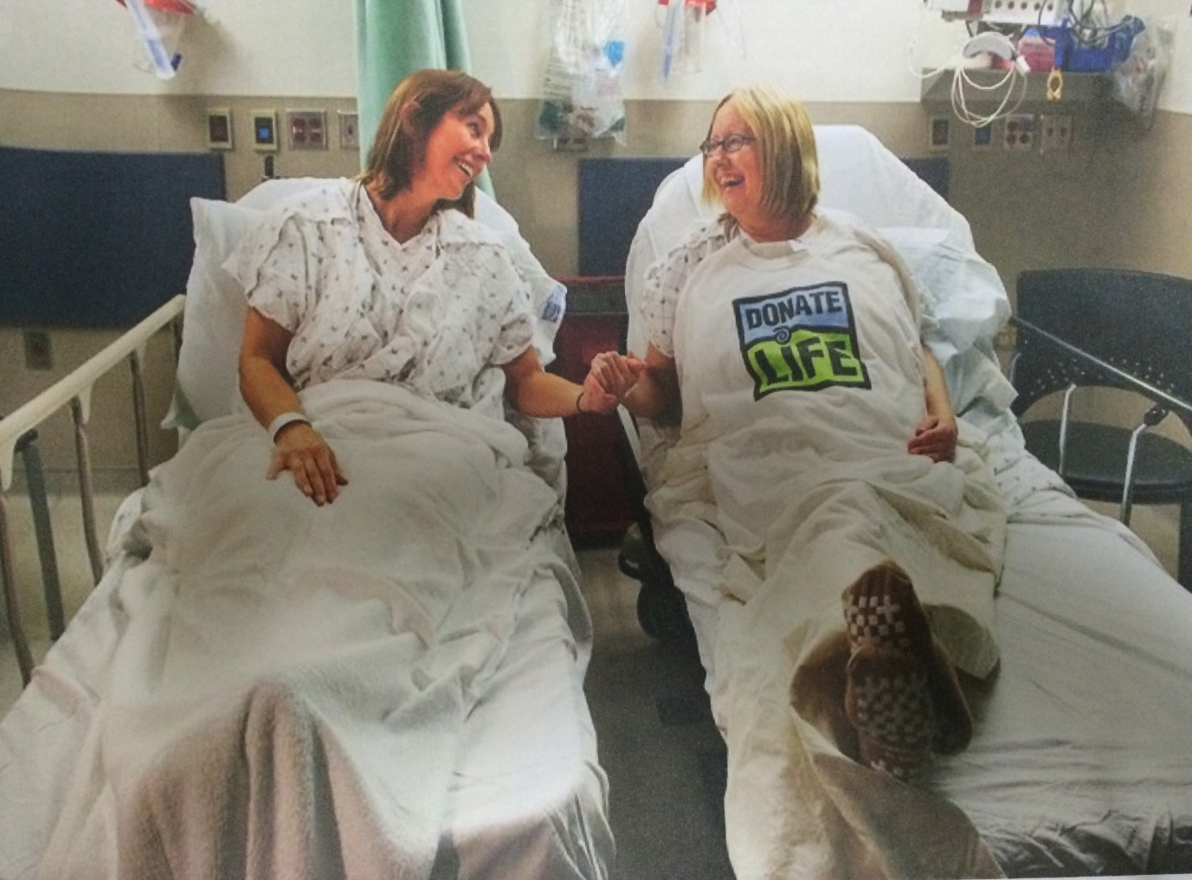
< Article>

A New Heart for Mt. Fuji

Kelly Tanaka felt great and she wanted everyone to know it. A few years earlier, this Japanese-American woman was very sick. She almost died. Kelly had a heart disease. When she was 35, her doctor told her she needed a new heart. He said a new heart was the only thing that could save Kelly’s life.
The list of people needing new hearts was very long. It took more than two years before Kelly’s surgeon told her there was a new heart for her. That day Kelly went to the hospital for an operation.
Kelly didn’t know much about the heart donor-only that he was a 45-year-old man who died in a car accident. She didn’t know his name, but she was happy that his family donated his heart. She wished that everybody waiting for hearts and other organs could be as lucky as she was.
After the operation, it took Kelly months to feel better. On her 40th birthday, Kelly did something she loves. Kelly and her husband Gil went mountain climbing. Soon Kelly and Gil went mountain climbing every month. At first they climbed small mountains that were easy, but after a while they climbed bigger mountains.
One night Kelly told Gil she wanted to climb Mt. Fuji in Japan. “I’ve always wanted to go to Japan. I want to see where my parents grew up, and I want to climb Japan’s highest mountain with you.”
Kelly paused, “There’s another reason I want to go,” she said softly. “Until a few years ago, people could not get new hearts in Japan. Doctors are starting to give people new hearts now, but there are only a few Japanese

organ donors. If I climb Mt. Fuji, maybe more people in Japan will learn about organ donations.”
Gil thought it was a great idea. Two months later, he and Kelly flew to Tokyo. They met Kelly’s cousin Mikoto. Mikoto wanted to help Kelly, so she asked a reporter and a photographer to climb Mt. Fuji with Gil and Kelly.
“Great,” said Kelly. “I want people to read about my story. I want everyone to know what people who have new heart can do.”
The first part of the climb was a three-hour bus ride to Gogome (pronounced go-go-may). With an altitude of 7500feet (2286 meters), Gogome is where most climbers start. From Gogome, It was a six-hour climb to the top. Kelly couldn’t make the whole climb in one day. She knew she had to be careful. After three hours of climbing, Kelly and the other climbers stopped to spend the night in a cabin. They were halfway up the mountain.
On the second day, the climb became more difficult. Around 4:00 p.m., they made it to the top. As the photographer took pictures, Kelly pulled out a sign she had in her backpack. In both Japanese and English, it said, “Organ Donations save Lives.”

Worksheet #1
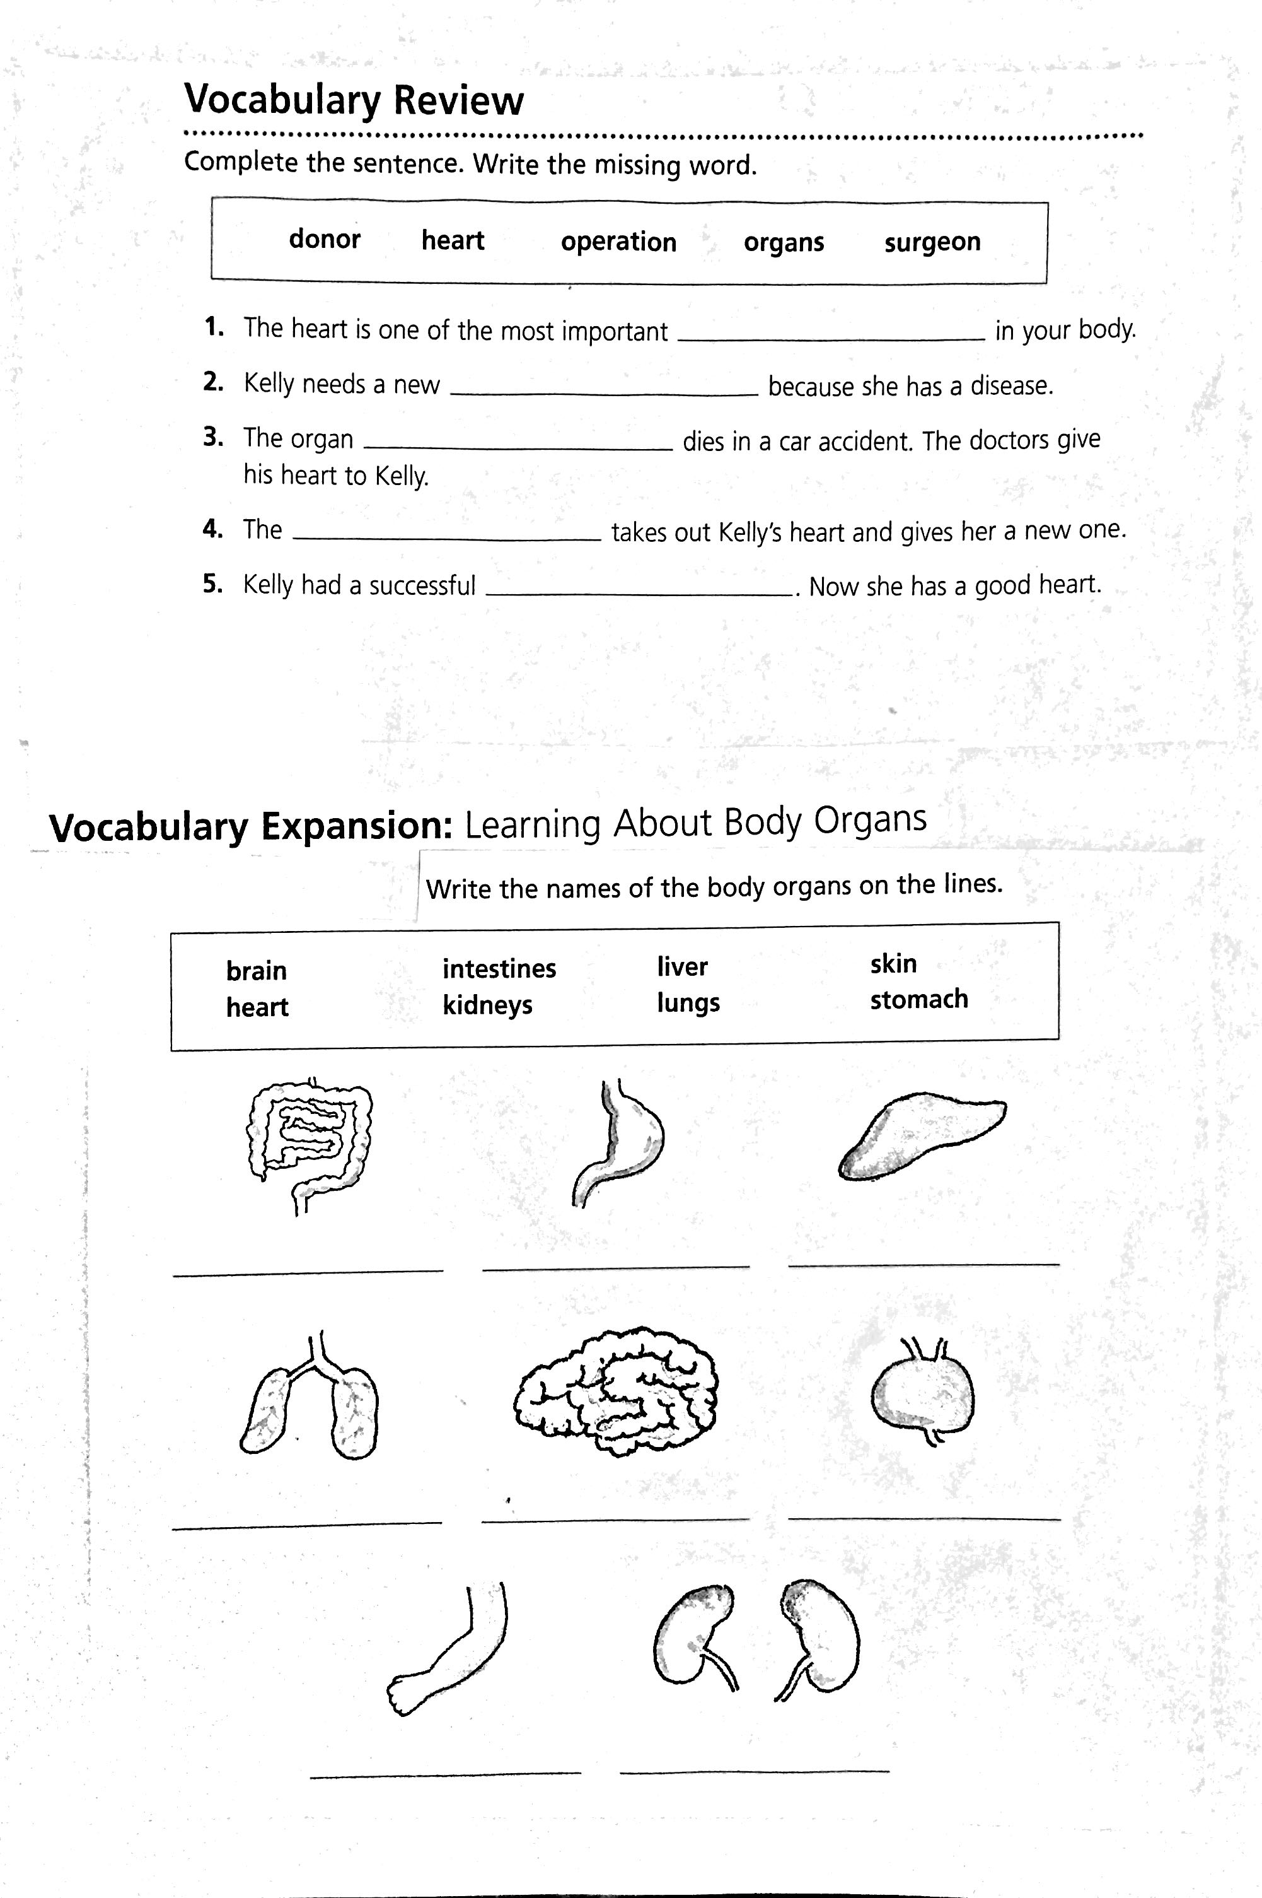

Vocabulary Sample sentence
words

Worksheet #2
Comprehension

1. Complete the sentence. Fill in the correct bubble.
visit her relatives takes photos climbs Mt. Fuji
2. Kelly waits more than two years to .
get a new heart move to Japan meet Mikoto
3. Mikoto wanted to .
be a photographer help Kelly report on Kelly’s climb
4. Kelly climbed Mt. Fuji in .
three hours nine hours two days
5. From the story you can guess that Mt. Fuji is .
almost 7500 feet exactly 7500 feet more than 7500 feet

Reading Skill: Putting Events in Order.
(To put events in order look for words like first, next, and finally.)

Put the events from “A New Heart for Mt. Fuji” in the right order. Write the correct number on the line.
Over time, Kelly recovers from her operation.
Within hours of the donor’s death, Kelly gets a new heart.
After recovering, Kelly slowly starts mountain climbing again.
Next, Kelly learns that she will die without a new heart.
Finally, Kelly and Gil climb Mt. Fuji.
First, Kelly becomes very sick with a heart disease.
Two years later, a 4~5 years old organ donor dies in a car accident.

Worksheet #3

Group Work

Kelly wants to tell people that donating organs is important. What do you think? Are you interested in being an organ donor?
Discuss in your group and write down the opinions.

Example: I think organ donation is a good idea because…

