Grammar Lesson Plan
TITLE | Putting adjectives in order
INSTRUCTOR | LEVEL | STUDENTS | AGE GROUP | LENGTH
A-RA CHO | Elementary | 8 | Adult | 45 min

MATERIALS
- 2-3 pictures of magazine.
- 16-20 items in the magic bag or box(Realia)
- 1 dice
- No.1 and No.2 ordering adjectives practice worksheet (8 copies)
- A table with the adjectives in order(8 copies)
- Writing worksheet (SOS plan or homework - 8 copies)
- White board and board markers

AIMS
- To learn the right order of adjectives with noun during pre and main activities.
- To choose adjectives to describe selected objects by using their senses like visual and tactile ability based on their experiences.
- To extend vocabularies and build up more associations of each word while exchanging opinions in group works.
- To create new sentences using different sets of adjectives and nouns and make their writing and speaking more interesting and comprehensible.
- To speak fluently by drilling various types of adjective order.

LANGUAGE SKILLS
Listening  Speaking  Reading  Writing | Teacher’s instruction and explanation and classmate’s opinion and answer.  Drilling and verbally sharing ideas  All exercises in the worksheets and adjective charts or list and ordering table.  Answering worksheets and doing an extra activity (SOS plan or homework).

LANGUAGE SYSTEMS
Grammar  Lexis  Phonology  Function | The order of adjectives.  New vocabularies during pre and main activity.  Drilling new adjectives and nouns.  Expressing and describing objects and pictures.

ASSUMPTIONS
- Students have already learned some adjectives in a previous class.
- Students already know which word is the noun and which is the adjective coming before the noun.
- Students as adult learners have previous experiences using adjectives in their native language.
- Students already know the teacher’s style of teaching and the pace of the course.

ANTICIPATED ERRORS AND SOLUTIONS
- Students may have hard time listing diverse adjectives connected to nouns.
- Start with the review the words that they’ve learned in previous class to arrange their thoughts
- Explain and give some examples with easy words or write them down on one side of the board.
- If time is short and students might need more time
- Cut 1st or 2nd activity (Choose one activity) and give more time to practice.
- If students finish their activities earlier than expected
- Teacher makes a Plan B like using the SOS plan to improve student’s writing skills and spelling.

REFERENCES
- www.google.com
- http://www.educationquizzes.com/in/upper-primary/english/grammar-13-order-of-adjectives-1/
- http://www.grammar-quizzes.com/adj_order.html
- http://www.learnenglishfeelgood.com/esl_adjectiveorder4.html
- http://www.englishexercises.org/makeagame/viewgame.asp?id=6877
- http://www.englishisapieceofcake.com/order-of-adjectives.html

LEAD-IN
AIMS  To review previous class and elicit more adjectives to extend student’s vocabulary. |  |  | MATERIALS  2-3 pictures of magazine, white board, white board markers,
TIME | SET UP | STUDENTS |  | TEACHER
1 min | Whole class | Greeting teacher and classmates. |  | Greeting students.
4 min | Whole class | Students will call out some words quickly to show their opinions and interests.  Students will make a sentence more interesting by giving details.  Students will guess and predict today’s activity. |  | Elicit from students’ opinions or ideas about pictures from magazine that teacher’s showing.  Lead students to use proper and various adjectives related to the picture and list them on the board with sentence.
NOTES
-Especially elicit adjectives to describe each picture.
-Divide the white board into 2 sections for each picture.

PRE-ACTIVITY
AIMS  To build on vocabulary and get accustomed to pattern and rule about ordering adjectives. |  |  | MATERIALS  Table with the adjectives in order(8 copies), No.1 and No.2 ordering adjectives practice worksheet(8 copies), white board, white board markers
TIME | SET UP | STUDENTS |  | TEACHER
4 min | Whole class  /Groups | Students will discuss about how to order adjectives and prepare for the correct form of sentence with teammates.  Come to the board and write down the answer.  Explain the reason and listen to the other team’s opinion. |  | Make 2 groups to combine randomly listed adjectives on the board into 1 sentence.  Let each team come to the board and write down their sentence.  Ask why students made this order and who found any pattern of the order.
5 min | Whole class | Students will receive the hand out and take note about the rule.  Listen to teacher’s explanation and categorize adjectives on the table matching with each column.  Go back to the previous sentences they already wrote on the board and correct them. |  | Distribute a table with the adjectives in order and present grammar rule.  Explain the pattern of order with easy words and examples.  Get students to fill adjectives in as many as they can.  Make students fix the sentences that they wrote on the board in correct order and check it out.
6 min | Individual | Students will respond questions on the sheets.  Check out the answer and try to be familiar with the pattern and use it naturally. |  | Distribute No.1 and No.2 ordering adjectives practice worksheets.  Check out the answer and give the reason or explanation.
NOTES
-Let students know that there are some exceptions and different combinations putting adjectives in order with possible examples if necessary.
-Monitor discreetly and answer students if they ask questions.

MAIN ACTIVITY
AIMS  To practice the correct order of adjectives through describing items of team competition and individual division. |  |  | MATERIALS  16-20 items in the magic bag or box (Realia), 1 dice, white board, white board markers.
TIME | SET UP | STUDENTS |  | TEACHER
2 min | Whole Class | Rearrange their seating.  Listen carefully what teacher says.  Decide who goes first in each team and prepare for the game. |  | 1st activity: Describe it!  (Expanding sentences)  Put students in new groups.  Explain how to do it.  (Let a player add a different adjective in turn.)  Choose which team first starts.
9 min | Groups | Start and take part in the game actively to win.  When students begin the activity, they should try and use correct adjective order.  Fix a wrong sentence together. |  | Let students start the game.  (Show the item and give a player 10 seconds to make a sentence.)  Keep scoring fairly.  After the activity, fix a wrong sentence together, select the winning team and give them a compliment.
2 min | Whole class | Listen carefully what teacher says. |  | 2nd activity:  What does it look like?  Prepare for a dice and the magic bag with hidden items having number tag.  Explain how to do it.  Choose who goes first.
9 min | Individual | Choose the number and object to describe.  Throw a dice.  Make sentence with from 2 to 5 adjectives indicated by the dice.  Get the score. |  | Let each student to pick up the number and identify the object related to that number.  Make them throw a dice.  Give 15 seconds to respond own sentence.  Keep scoring according to the figure of the dice and student’s accuracy.  Continue the game with the next student.
NOTES
-Monitor and note down examples of errors and good language to discuss after the activity.
-Encourage students to create their own sentences making use of the vocabulary and the ‘right’ order of adjectives that they’ve learned today.
-Even though students getting higher number of dice have hard time making a long sentence, they will practice more and get higher score if they’re correct! This is the attraction and advantage of the activity.

POST-ACTIVITY
AIMS  To confirm comprehension of the today’s activities and further build on using adjectives. |  |  | MATERIALS  Writing worksheet(SOS plan or homework), white board, white board markers
TIME | SET UP | STUDENTS |  | TEACHER
3 min | Whole Class | Students will learn from their mistakes and improve their vocabulary and speaking skills.  Students will ask for feedback.  Students might be proud of their achievement and make use of what they’ve learned today. |  | Correct errors from students and encourage them to speak correctly and fluently.  Give feedback to students and tell their achievement.  (Give homework if necessary.  Make students use sentences learned today.)  Give students a compliment and conclude the class.
NOTES
-Students finally can describe people, place, and things and make their sentences by using various adjectives in real-life situations.

Basic type of adjectives and the correct order
Opinion Fact >>>>>>>>>>>>>>>>>>>>>>>>>>>>>>>>>>>>>>>>> difficult to change
OPINION | SIZE | SHAPE | AGE | COLOR | ORIGIN | MATERIAL | PURPOSE
What do you think about…? | How big or small? | What shape? | How old or young? | What color? | Where from? | What is it made of? | What is it used for?

PRACTICE WORKSHEET NO.1

- Put the adjectives in order.
 |  |  | 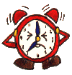 | 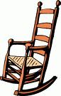 | 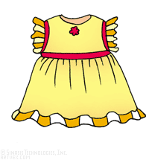
 | A car. | A teacher. | A clock. | An chair. | A dress
 | Italian / sports / fantastic | French / nice / old | alarm / red / small | old / rocking / wooden | cotton / pretty / yellow
 |  | 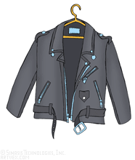 |  |  | 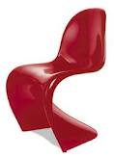
 | An bowl. | A jacket. | A boat. | grapes. | A chair.
 | African / interesting / old | black / leather / smart | red / sailing / beautiful | Chilean / delicious / green | plastic / red / strange
PRACTICE WORKSHEET NO.2

- Make a sentence with a correct adjective order.
 |  |  | 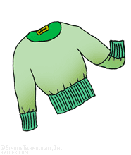 | 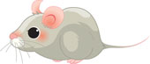
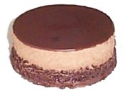 |  | 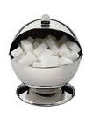 | 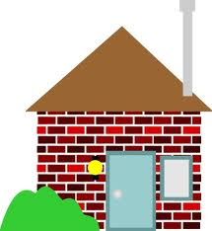
WRITING (SOS PLAN or HOMEWORK)
Play a matchmaker for a lonely friend or family member. You can make a list of adjectives which describe your single friend. It should describe outlook and personality. You can bring your friend’s picture if necessary.

