Grammar Lesson Plan

Imperatives

Age Group:
Adult
Instructor:
Debbie Hong
Students:
12
Length:
50 minutes
Level:
Intermediate

Materials:
- Realia of care label on the clothes.
- White board, board marker, board eraser, scotch tape
- Picture of cat sheet (1 copy), computer, overhead projector, grammar pwpt
- ‘Put the Words in the Correct Order’ worksheet (12 copies)
- Answers for ‘Put the Words in the Correct Order’ (1 copy)
- 3 color pencil set, markers, and 3 white poster papers
- ‘Good Manners Crossword- Taboos’ worksheet (12 copies)
- Answers for ‘Good Manners Crossword- Taboos’ worksheet (1 copy)

Aims:
- To have Ss use imperatives inductively through playing the game Simon Says.
- To put the words in order to make imperative sentences by doing the worksheet.
- Brainstorming to produce imperative sentences by making a ‘Classroom Rule’ poster for the classroom.
- To promote discussions, sharing ideas, and using their resources by doing pair/group activities.
- To make Ss think actively through diverse activities.

Language Skills:
Writing Ss will write down the correct order of words when doing the worksheets and write on the poster imperative sentences when making classroom rules.
Speaking Ss will speak imperative sentences when playing Simon Says. Ss will discuss and brainstorm with each other for diverse activities and to work on the worksheets.
Reading Ss will read the worksheet.
Listening Ss will listen to T’s instructions and classmates when playing Simon Says and to answer the worksheets.

Language Systems:
Grammar Ss will be giving examples of imperative sentences and using them in diverse activities.
Function Ss will be expressing opinions & reaching agreements within group.
Discourse Ss will be talking in pairs and groups to do the activities.
Lexis Ss will be discussing to correct the order of words in a sentence.
Phonology Ss will be learning how to pronounce words that they did not know by discussing in groups and as a class.

Assumptions:
- How the class is set up and the number of students.
- Ss are tired and dull of sitting on the chair for a long time.
- Most Ss know how to play Simon Says are game of similar sort.
- Ss know T style of teaching

Anticipated Errors and Solutions:
Ss may need more time to work on their posters.
- If there is more spare time, be flexible with time.
- If none, encourage Ss to wrap up.
Ss may finish making their posters earlier than expected,
- Encourage Ss to decorate the poster by drawing related pictures beside it.
If Ss finish their worksheet earlier than expected,
- Ss will discuss on which occasions we use imperatives.
- Ss will do worksheet for SOS Activity.

References:
- www.google.com
- http://www.esl-galaxy.com/crosswords/goodmannerscw.pdf
- http://www.brainpop.com/educators/community/lesson-plan/1-1-5-commands-imperatives-lesson-plan/#alignment-list-41100
- http://www.tolearnenglish.com/exercises/exercise-english-2/exercise-english-8768.php
- http://www.esl-galaxy.com/crosswords/goodmannerscw.pdf
- http://www.k12reader.com/imperative-sentences-learning-activity-%E2%80%93-new-%E2%80%9Cschool-rules%E2%80%9D-posters/

Note:
- Monitor the students during the activities!
- E L I C I T from Ss!!
- More STT and less TTT

Share ideas/words they think relates to ‘airport’.
Elicit words on ‘airport’ and write down their ideas on the white board.

2
Class

Lead-In
Materials: Realia of care label on the clothes.
Teacher
Time
Set Up
Students
Aims: Elicit for the word ‘instructions’ or ‘directions’, and have Ss actively participate in sharing ideas.
Greetings
Students will elicit with active participation.

Class
Greetings
Elicit for the word ‘instructions’ or ‘directions’. Show realia of care label on the clothes.
3

Notes

Pre-Activity

Materials: N/A
Aims: To have Ss use imperatives inductively through playing the game Simon Says.

Students
Teacher
Set Up
Push the tables/chairs to the back and stand at the front of class. Listen carefully to the instructions. Form 2 circles (6 people each).
Have Ss stand at the front of the class. Give instructions and demonstrate.
Class
Play Simon Says.
Monitor both circles passively.
3

Time

Class
8

Notes

- Form 2 circles to play the Simon Says game so everybody gets at least 2 turns to speak.
- Be aware of time!
- Write down some of Ss Simon Says on the board and use as examples for introducing ‘imperatives’.

Main Activity
Materials: picture of cat sheet (1 copy), Computer, overhead projector, grammar pwpt, ‘Put the Words in the Correct Order’ worksheet (12 copies), Answers for ‘Put the Words in the Correct Order’ (1 copy)
Aims: To put the words in order to make imperative sentences by doing the worksheet.
Class
10
Eliciting, participating, and learning.
3
Class
Students

Set Up
Time
Teacher

Elicit on what tense we have used to play the game. Introduce ‘imperatives’ in a student-friendly language and conduct drill. CCQ

Give instructions, demonstrate and perform ICQ. Give 1 minute remaining time alert.
6
Put the words in the correct order to make imperative sentences.
Pairs

Go over the answers and error corrections.
Read aloud the answers.

Notes

- Imperatives: Used to give commands, make requests, grant or deny permission, make offers, apologize, well-wishing (e.g. recipe, instructional manual).
- If tight on time, have Ss only answer the worksheet until question number 4.
- When checking the answers for the worksheet, don’t choose on Ss to read aloud the answer. Go over it as a whole class.

Post Activity
Brainstorm creative classroom rules to write and draw on the poster paper. Use colored pencils and markers to decorate.
Group
Have each group share their poster in front of the classmates.
Group
Have Ss share and discuss on their posters. Closing.

Materials: 3 color pencil set, markers, and 3 white poster papers

Time
Aims: To produce imperatives through making a ‘Classroom Rule’ poster for the classroom.
Teacher
Notes
Set Up
7
Students
10
Give instructions, demonstrate and perform ICQ.
Monitor passively.
Give 1 minute remaining time alert.

- Promote creativity on the classroom rules!

SOS Activity
Materials: ‘Good Manners Crossword- Taboos’ worksheet (12 copies), Answers for ‘Good Manners Crossword- Taboos’ worksheet (1 copy)
Aims: To fill in the blanks with the appropriate commands by doing the crossword puzzle.

Students
Teacher
Time
Set Up

Share ideas within groups and fill in the crossword puzzle.
Hand out the material and monitor passively.
3
Group

Read aloud the answer.
Go over the answers and error corrections.
1
Class

Notes

It is used to make people do something!

Put the Words in the Correct Order

- camera | don’t | wet | get | let | the |

- go | the | cinema | to | let’s |

- attention | her | pay | don’t | to |

- tonight | the | let | her | to | party | go |

- page | open | your | and | sit | book | 26 | down | to |

- to | me | you, | listen |

- piece | have | this | a | of | cake |

[Answers] Put the Words in the Correct Order

- Don't let the camera get wet.
- Let's go to the cinema.
- Don't pay attention to her.
- Let her go to the party tonight.
- Sit down and open your book to page 26.
- You, listen to me.
- Have a piece of this cake.

Good Manners Crossword- Taboos
Dos and Don’ts

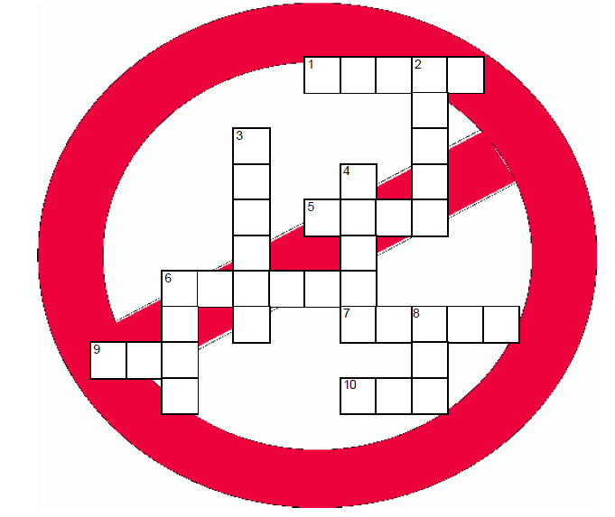

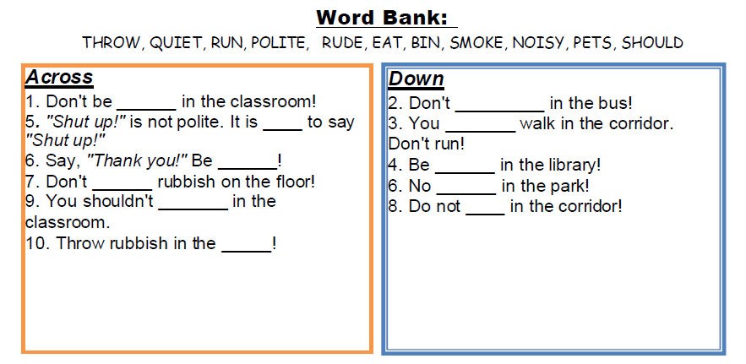

[Answers] Good Manners Crossword- Taboos

