Grammar Lesson Plan
TITLE | Sequence Adverbs - Yoga Poses
INSTRUCTOR | LEVEL | STUDENTS | AGE GROUP | LENGTH
Hauri Park | Beginner | 10 | Adult | 50 mins.

MATERIALS
- White board and board markers
- Word plates with sequence adverbs and yoga steps (2 sets)
- Pictures of yoga poses (2 sets)
- Hand out - pictures of yoga poses (3 sets – 2 copies each set)
- Self-evaluation Questions (2 copies)
- SOS Plan - Sequence Adverb Worksheet (10 copies)

AIMS
- Students will predict the use of sequence adverbs while reviewing simple present tense through brain storming activity.
- Students will enhance language fluency using sequence adverbs and simple present tense by performing the given task with their group members.
- Students will know the form of sequence adverbs through self-evaluation and group discussion.
- Students will improve speaking and listening skills by sharing ideas during the class discussion.

LANGUAGE SKILLS
Speaking  Listening  Reading  Writing | Giving instructions using sequence adverbs, participating in group activity, sharing ideas  Teacher's elicitation, group member's instructions, other Ss' ideas during class discussion  Hand out of yoga poses, self-evaluation questions  Note taking

LANGUAGE SYSTEMS
Grammar  Lexis  Discourse  Function | Sequence adverbs, simple present tense  First, next, after that, then, finally  Group activity, sharing ideas, class discussion  Giving step by step (sequential) instructions

ASSUMPTIONS
Students are familiar with:
- the teacher's teaching style
- the vocabulary words associated with body parts and their movement
- the use of simple present tense learned from previous lesson
- expressing their opinions in simple English

ANTICIPATED ERRORS AND SOLUTIONS
- Students may not know some vocabulary in the hand out
  - Encourage students to guess from context; help them along during monitoring
- Students may take longer to finish the task than expected
  - Adjust the time allotted for other activities
- If all activities finish early
  - Make use of the SOS plan to further develop students' knowledge on the topic
  - Review the topic and get feedback from students
- If not all students have comprehended the topic
  - Give out homework to further enhance their comprehension

REFERENCES
http://www.sheknows.com/health-and-wellness/articles/1029405/partner-yoga-poses-for-beginners
http://www.wikihow.com/Make-a-Quick-Sandwich

Pre-task
Aims  To help Ss be familiar with the topic prepared |  |  | Materials  Whiteboard, markers, yoga picture
TIME | SET UP | STUDENTS |  | TEACHER
5 | Class | Ss will talk about different ways and work outs to stay healthy; and eventually guess ‘yoga’. |  | Greet Ss and open the discussion about work outs that can be done to stay healthy.
5 | Class | Ss will guess certain steps and action words associated with a certain yoga pose. |  | Elicit from to students to talk about the steps associated with the yoga pose picture shared by the teacher.
Notes
Have Ss share their opinions about different work outs that can be done to stay healthy. Show the yoga picture and naturally add sequence adverbs to explain the steps to do the pose.

Task Preparation
Aims  To familiarize Ss with the use of sequence adverbs |  |  | Materials  Whiteboard, markers, word plates (sequence adverbs), yoga pictures
TIME | SET UP | STUDENTS |  | TEACHER
10 | Group | Ss will form two groups. Ss will listen to Teacher's instruction and use the sequence adverbs word plates and place them matching the correct yoga steps. |  | Inductively introduce sequence adverbs through group activity. Monitor.
Notes
Ss are at a beginner level. They are familiar with body parts and simple action words associated with body parts. Engage the group to participate in the activity. Monitor to see if the Ss are using sequence adverbs and simple present tense.

Task Realization
Aims  To have Ss perform giving instructions using sequence adverbs |  |  | Materials  Hand out - yoga poses, self-evaluation questions
TIME | SET UP | STUDENTS |  | TEACHER
10 | Group | Two Ss will perform the instruction given by the other S/Ss. Take turns in giving the instructions |  | Instruct, distribute the hand out and monitor the class.
10 | Group | Ss will share their ideas about the questions in the self-evaluation. Ss will write the instructions in correct grammatical form. |  | Instruct, distribute the self evaluation questions and monitor. Distribute the yoga pose pictures with no steps for Q number 4.
5 | Class | Ss will share their group's idea to the class. |  | Instruct and monitor.
Notes
Fluency is the main focus. Encourage the Ss to use sequence adverbs and simple present tense (learned from previous lesson), and gently correct their errors. During self-evaluation, ask Ss what errors they think they made when giving instructions and ask them to write down the instructions again with the correct grammatical form.

Post Task
Aims  To confirm the effectiveness of the activity and to check whether Ss have enjoyed the activity |  |  | Materials  Whiteboard, markers, sequence adverb worksheet
TIME | SET UP | STUDENTS |  | TEACHER
5 | Class | Ss will give their feedback and share their opinions about the effectiveness of the lesson/task. |  | Ask if Ss enjoyed the activity. Review. Ask about the application of the lesson learned.
Notes
While Ss are giving their feedback, monitor to check if all the Ss have understood the lesson. If the teacher feels that not all Ss have understood the lesson, ask the Ss to further enhance their skills by doing a self study on the sequence adverb worksheet.

Yoga Pictures
BUDDY BOAT POSE

PARTNER BREATHING

Handout - Yoga Poses

TWIN TREES
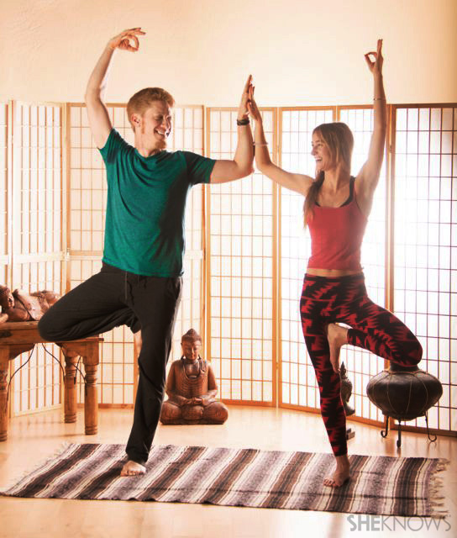
- Stand next to each other facing front
- Balance for five seconds and put both the legs and arms down
- Bend the outer leg and bring the foot to the inner thigh of the standing leg
- Bring the inner elbow, arm and hand toward each other
- Raise the outer arm create an 'ok' sign - optional)

TEMPLE POSE
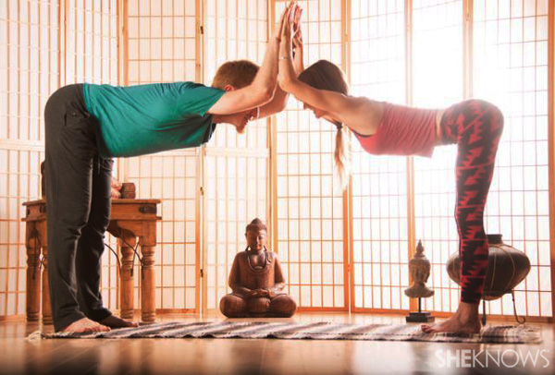
- Face each other while standing
- Stretch your arms and bend them, bringing elbows, arms and hands to rest against each other
- Bend towards each other
- Slowly walk toward each other, bringing your body straight and put your arms down
- Hold for five seconds

PARTNER TWIST
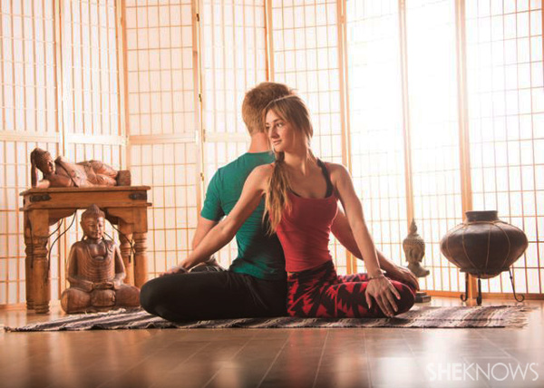

PARTNER FORWARD FOLD

Self Evaluation

Take time to reflect on the following questions and share your opinions with your group mates.

1. How did your group finish the given task?

2. Were you able to use the words to show order (first, next, then, after that, finally) of the yoga steps?

3. Were you able to give your instructions in present action words?

4. Talk with your group mates on how you can give the instructions for the yoga pose in the picture using present action words and words to show order (first, next, then, after that, finally). Write down the instructions below.

Sequence Adverbs Worksheet

Write down the steps to prepare a sandwich by using words to show order (First, Next, Then, After that, Finally).

