Grammar Lesson Plan

Name: Joeun Lee
Course: Times TESOL 110th WK
Instructor: Mr. Roger
Date: April 22th, 2015

Grammar Lesson Plan
TITLE |  | Practicing indirect speech
INSTRUCTOR |  |  |  | Ss’ LEVEL | AGE GROUP | No. of Ss | LENGTH
Joeun Lee |  |  |  | Advanced | Adult | 12 | 50 mins
MATERIALS
Whiteboard, markers, worksheets 1-2 (13 copies each), PC, video clips, PPT file, beam projector, colour pens, colour pencils, empty diaries, pictures and stickers
AIMS | 1. Ss will find out when and how to use indirect speech by listening to the music and group discussion and understand through T’s explanation.  2. Ss will practice indirect speech patterns when they practice with the PPT file and worksheets.  3. Ss will actually use indirect speech by doing activities named ‘Sneaking a look at another person’s diary.
LANGUAGE SKILLS
Speaking |  |  | Ss will be practicing indirect speech patterns and using the patterns during ‘Sneaking a look at another person’s diary’ activity.
Writing |  |  | Ss will be writing when they discuss grammar patterns with their group members, practice indirect speech patterns using worksheets and make their own diaries.
Reading |  |  | Ss will be reading the sentences from the PPT file, worksheets and other person’s diary.
Listening |  |  | Ss will be listening to the song, T’s explanation and instructions, and other classmates during the tasks
LANGUAGE SYSTEMS
Grammar |  |  | Ss will learn, practice and use indirect speech through predicting by themselves, T’s explanation and doing activities.
Phonology |  |  | Ss will focus on T’s and their pronunciation to communicate and the singer’s pronunciation during gap-fill exercises.
Lexis |  |  | Ss will use some words which they already know when they write their diaries.
Functions |  |  | To communicate what someone else said without using the exact words
Discourse |  |  | To tell other people what they are told
ASSUMPTIONS
- Ss are at advanced level and they know the grammatical terms such as past, present, future, continuous and perfect tenses. Therefore, T uses these words when he/she explains the target grammar pattern to help Ss understand easier.
- Grammar lesson, by its nature, is easy to get boring soon. T should encourage Ss’ involvement as much as possible rather than lecture so that Ss can apply the target grammar pattern to their real life.
- Even though T is going to teach indirect speech with tense change, some Ss might know other indirect speech patterns which do not need to change the tense. In this case, T should tell Ss that it would be dealt with another time soon because Ss might be confused if they learn them all at once.
PREFERENCES
Advanced Grammar in Use, Martin Hewings, 70-71
http://www.bbc.co.uk/worldservice/learningenglish/grammar/learnit/learnitv309.shtml
NOTES
- Check the volume of the speaker in advance.
- Students are monitored during every task.
- Prepare some spare worksheets in advance.

PRETASK TITLE |  |  | Predicting the target grammar pattern
AIMS |  |  |  |  | MATERIALS
To find out the pattern of indirect speech |  |  |  |  | PC, video clip, whiteboard, markers and worksheet 1
TIME | SET UP | STUDENTS |  |  |  | TEACHER
3 | Class | - Listen to the song (Somebody that I used to know) without worksheet  - Listen to the song again and fill in the blanks |  |  |  | - Play the music  - Hand out worksheet 1
7 | 3 Groups | - Discuss with group members and find out the grammar pattern (indirect speech)  - Share the idea about the pattern (e.g. when to use, how to use …)  - Write on the whiteboard and present the result of discussion |  |  |  | - Set task, ICQ  - Monitor
NOTES
- If Ss cannot find out the grammar pattern soon, T gives more example sentences to help them.
TASK PREPARATION TITLE |  |  |  | Learning indirect speech
AIMS |  |  |  |  | MATERIALS
To learn when and how to use indirect speech |  |  |  |  | PPT file, beam projector, worksheet 2
TIME | SET UP | STUDENTS |  |  |  | TEACHER
7 | Class | - Listen to the T’s explanation while comparing to their own ideas  - Practice indirect speech watching PPT  - Answer to the T’s questions  - Write and practice the pattern with the sentences on worksheet 2 |  |  |  | - Give a short explanation  - CCQ  - Hand out worksheet 2
NOTES
- T explains about indirect speech as short but clear as possible.
- T asks CCQs to check whether Ss fully understand about indirect speech.
TASK REALISATION TITLE |  |  |  | Sneaking a look at another person’s diary
AIMS |  |  |  |  | MATERIALS
- To actually use indirect speech |  |  |  |  | Colour pens, colour pencils, empty diaries, pictures and stickers
TIME | SET UP | STUDENTS |  |  |  | TEACHER
10 | 3 Groups | - Ss are divided into 3 groups each named Daenerys, Cersei and Joffrey  - Ss choose pictures, stick them on empty pages and write one sentence about each picture  - Ss should make the sentence using given tense each page |  |  |  | - Hand out empty diaries, pictures  - Set task, ICQ,  - Demonstrate  - Monitor
15 | Pairs | - Ss get other person’s diary  - Ss look at each page and tell their partners what they are looking at using indirect speech patterns  - Ss can show the pictures but should not show the sentence written on the diary  - Ss meet different partner, get another diary and tell their partners the story in the diary again |  |  |  | - Set pairs  - Set task, ICQ,  - Demonstrate  - Monitor
NOTES
- Daenerys, Cersei and Joffery are characters of very famous American drama named ‘Game of Thrones’.
- T chooses this drama because the pictures from this drama have a lot of interesting episodes and actions.
- It does not matter even if Ss are not familiar with this drama. Ss can make their own creative stories.
- Ss cannot get their own diaries when they practice indirect speech pattern.

POST TASK TITLE |  |  | Check, Feedback and error correction
AIMS |  |  |  | MATERIALS
- To check if Ss fully understand the grammar pattern  - To improve grammatical accuracy |  |  |  | Whiteboard, markers and completed diaries
TIME | SET UP | STUDENTS |  |  | TEACHER
5 | Class | - Answer to the T’s questions  - Practice patterns again when T shows the pictures in the diaries |  |  | - Ask questions about indirect speech grammar  - Show the diaries
3 | Class | - Correct grammar or vocabulary errors which T found during monitoring |  |  | - Write the errors - Elicit
NOTES
- T shows many pictures using different tenses so that Ss can practice various patterns.
- T elicits from the students how to correct errors.
- Ss read the correct sentences repeatedly following the T.

Worksheet 1. Lyrics of “Somebody That I Used To know”
(Sung by Walk Off The Earth)

Now and then I think of when we were together
Like when you said you ( ) so happy you ( ) die
I told myself that you ( ) right for me
But felt so lonely in your company
But that was love and it’s an ache I still remember

You can get addicted to a certain kind of sadness
Like resignation to the end
Always the end
So when we found that we could not make sense
Well you said that we ( ) still be friends
But I’ll admit that I was glad that it was over

……….
Worksheet 2. Learn and practice indirect speech

* “The one-tense-further-back rule”
- The verbs used in the original speech are usually moved one tense further back.

* Why?
- Because the time and place where we are reporting the action are different from where the original words were spoken.

Direct Speech |  | Indirect Speech
present simple | → | past simple
present continuous | → | past continuous
present perfect | → | past perfect
past simple | → | past perfect

* Let’s practice!

Change the sentences into indirect speech using appropriate verb from the list.
alleged | conceded | denied | estimated | repeated

① ‘I have never been in love with James.’
→ She
② ‘Thomas has stolen jewellery from my house.’
→ She
③ ‘I think the vase is around 250 years old.’
→ She
④ ‘I’ve told you once. I’ve already seen the film.’
→ She
⑤ ‘Well, perhaps you’re right. Maybe I did treat Jane unkindly.’
→ She

Appendix 1. PPT file

Appendix 2. Examples of task realisation activity

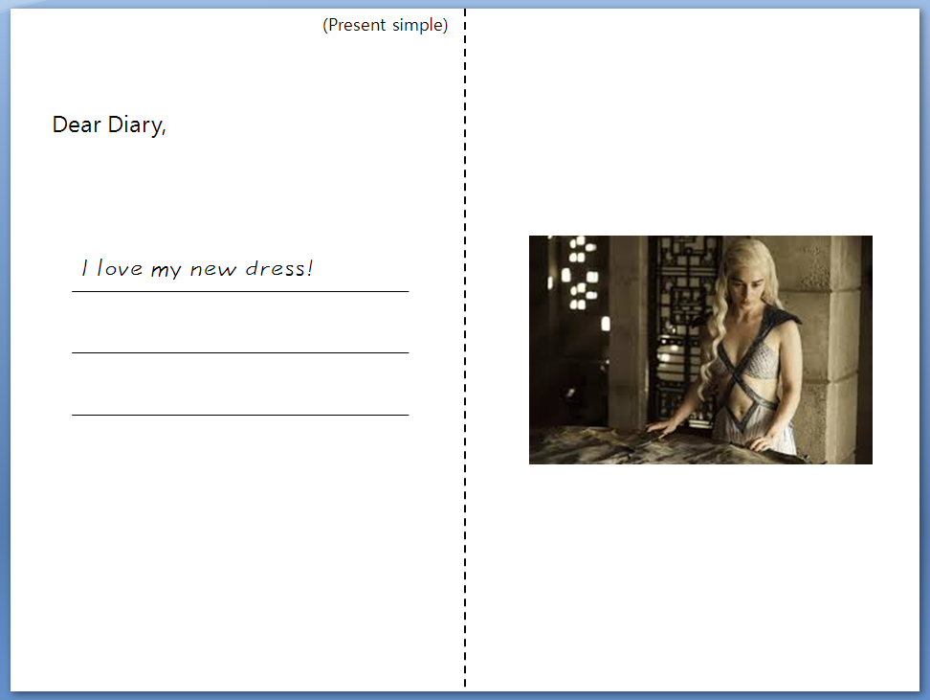
→ S will tell her partner “Daenerys said that she loved her new dress.”

→ S will tell her partner “Cersaid told me that she had been fighting with her sister when her husband had come in.”

