|  |  |  |  |  |  |  |  |
| --- | --- | --- | --- | --- | --- | --- | --- |
|  | | | | | | | |
| TITLE | I can see a bed in the bedroom. | | | | | | |
| INSTRUCTOR | | | | Ss’ LEVEL | AGE GROUP | No of Ss | LENGTH |
| Melle | | | | Elementary | 11 | 10 | 50 |
| MATERIALS | | | | | | | |
| List all the materials and equipment you will need for the lesson -Worksheet #1 for Vocabulary (10 copies)  -Worksheet #2 (10 copies)  -Worksheet #3 for dictation (10 copies)  -Flashcards (words)  -Pictures of rooms  -Listening CD & CD player  -White board, board markers | | | | | | | |
| AIMS 1. | | Your main learning aim goes here : Students will practice listening by listening to four short speeches. | | | | | |
| **2.** | | Your secondary learning aim goes here : Students will practice speaking when they describe a room. | | | | | |
| 3. | | Your supporting aim goes here : Students will learn vocabularies to describe a room through various activities. | | | | | |
| LANGUAGE SKILLS | | | | | | | |
| Listening | | | Enter what students will be listening to : 4 speakers’ short speeches | | | | |
| Speaking | | | Enter what students will be talking about : prediction, comparing answers within groups, presentation of the sentences they wrote about describing their room | | | | |
| Reading | | | Enter what students will be reading : a worksheet for idioms, a script for dictation | | | | |
| Writing | | | Enter what students will be writing : sentences to describe a room, details(dictation) | | | | |
| **LANGUAGE SYSTEMS** | | | | | | | |
| Lexis | | | Vocabularies and idioms used to describe a room | | | | |
| Discourse | | | Sharing opinions with groups | | | | |
| Functions | | | Describing a room | | | | |
| ASSUMPTIONS | | | | | | | |
| Enter things you are sure the students already know which will help the teacher during the lesson : -How the class is set up and run (there will be 3 or 4 student groups at each table)  -The teacher’s style of teaching and the pace of the course  -The classroom English that the teacher uses in the class | | | | | | | |
| ANTICIPATED GRAMMATICAL ERRORS AND SOLUTIONS | | | | | | | |
| Enter any grammatical errors you think your students might make during the lesson -Students may be confused about the difference between ‘a’ and ‘an’.  Enter possible solutions for the potential errors here  -Give the students as many examples as possible so that they can distinguish clearly between right and wrong in grammatical problems. | | | | | | | |
| REFERENCES | | | | | | | |
| Enter key references here for sources of the ideas and materials you used to plan this lesson -<My First Story> BOOK 5, Beyond Advanced  -<Learning Teaching> The Essential Guide to English Language Teaching (Third Edition), Jim Scrivener, Macmillan Books For Teachers | | | | | | | |
| NOTES | | | | | | | |
| Enter your Plan B, your Cut-off plan and your SOS activity here -Plan B  The teacher can read the script instead of using the CD player if it is not properly working.  -Cut-off plan  The teacher can give students a homework to take dictation and fill in the blanks of Worksheet #3 if the time is short.  -SOS activity  The teacher can do an activity for a SOS plan. First, tell students to find out 20 words which are in the classroom. For example, an eraser, a white board, a pencil, a teacher, Melle, Jenn and etc. Next the teacher tells students to make 10 sentences including at least 10 words they found and to write down on a paper. Finally, tell students to present the sentences one by one in front of the class. | | | | | | | |

|  |  |  |  |  |  |
| --- | --- | --- | --- | --- | --- |
| PRETASK TITLE | | | What room is this? What do you see in the classroom? | | |
| AIMS | | | | MATERIALS | |
| -To make the students activate and get interested in the class -To help the students understand the main concept of today’s lesson | | | | -White board, board markers | |
| TIME | SET UP | STUDENTS | | | TEACHER |
| 2 min | Whole class | Students listen to the teacher and answer the questions. | | | Hello everyone, how was your weekend?  Today, I will ask you three questions before the class.  “What room is this?”  (Elicit the students’ answer)  Great!  “This is a classroom.”  CCQ  Then what am I doing in the classroom?  Yes!  “I’m teaching English in the classroom.” |
| 3 min | Individually  Groups | Students answer the question.  For example, “I see a white board, a computer and a desk in the classroom.”  They compare the answers with groups and one person each group put at least 3 things in the classroom on the white board. | | | Now, I’ll ask you a third question.  “What do you see in the classroom?”  CCQ  Compare the answers with your group members.  Choose a representative to put at least 3 things in the classroom on the white board. |
|  | Whole class | Students see what the others wrote on the board.  They correct errors with the teacher. | | | (Talk about what they wrote on the board, correct the answers) |
| NOTES | | | | | |
| Enter any useful information or comments which might help another teacher to teach this class from this lesson plan -Use realia to explicit what students can see in the classroom  For example, if a student put ‘a desk’, point to the desk to check the students’ understanding of the item or the concept. | | | | | |

|  |  |  |  |  |  |
| --- | --- | --- | --- | --- | --- |
| TASK PREPARATION TITLE | | | Vocabularies to describe a room | | |
| AIMS | | | | MATERIALS | |
| -To learn vocabularies or expressions to describe a room | | | | -Pictures, flashcards, worksheet #1 | |
| TIME | SET UP | STUDENTS | | | TEACHER |
| 2 min | Individually | Students match up the pictures with the words. | | | There are some vocabularies to describe a room.  (Distribute the idioms worksheet)  Match up the pictures with the words. |
| 1 min | Pairs | Students compare the answers with their partner. | | | Compare the answer with your partner. |
| 4 min | Whole Class | Students learn the right words and correct the errors. | | | Now correct the answers.  (Put the materials, pictures and flashcards, on the board and match up the pictures with the flashcards)  CCQ  (Give the meaning of each word in Korean) |
| NOTES | | | | | |
| Enter any useful information or comments which might help another teacher to teach this class from this lesson plan -Ask some CCQs for each vocabulary to check students’ understanding  -Mingle and check if all the students are doing well during the activity | | | | | |

|  |  |  |  |  |  |
| --- | --- | --- | --- | --- | --- |
| TASK REALISATION TITLE | | | I see a bed, a lamp, a dresser, a closet, and a trash can in the bedroom. | | |
| AIMS | | | | MATERIALS | |
| -To practice listening-To make sentences to describe a room -To practice writing -To practice speaking | | | | -Listening CD&CD player, pictures of various rooms, Worksheet #2 | |
| TIME | SET UP | STUDENTS | | | TEACHER |
| 2 min | Individually | Students listen to the tracks. | | | **1.Listening for the Main Idea (general understanding)**  Now, listen to the 4 speakers. |
| 10 min | Groups | Students listen again and discuss which picture each speaker describes with their partners. | | | **2.Listening for Details**  Now listen to the speakers one by one this time.  Find out which picture each speaker describes.  Discuss with your groups.  (Correct the answers) |
| 10 min | Individually | Students make 3 sentences to describe a room, using “I see certain things in a certain room.”  For example, “I see a chair, a table and a coffee machine in a café.” | | | Make 3 sentences to describe a room and write down in your worksheet.  (Distribute worksheet #2) |
| 8 min | Whole class | Some students present the sentences they made in front of the class.  The others listen to the presentation. | | | (Ask some students to present the sentences they made in front of the class and correct the errors) |
| NOTES | | | | | |
| Enter any useful information or comments which might help another teacher to teach this class from this lesson plan -If the students need to listen again, play tracks again.  -If there is anything missing, pause the CD right there and let students say it out loud. | | | | | |

|  |  |  |  |  |  |
| --- | --- | --- | --- | --- | --- |
| POST TASK TITLE | | | Dictation for checking | | |
| AIMS | | | | MATERIALS | |
| -To check the students’ understanding-To review the vocabularies-To get used to the expressions-To practice listening more | | | | -Listening CD&CD player, worksheet #3 | |
| TIME | SET UP | STUDENTS | | | TEACHER |
| 8 min | Whole Class | Students listen again and take diction. | | | Now, listen lastly and take dictation.  (Distribute worksheet #3)  (Listen 2 or 3 times if the students need)  Good job, everyone.  Let’s call it a day.  See you tomorrow! |
| NOTES | | | | | |
| Enter any useful information or comments which might help another teacher to teach this class from this lesson plan -If there is anything missing, pause the CD right there and let students say it out loud. | | | | | |

Worksheets, handouts and lesson materials

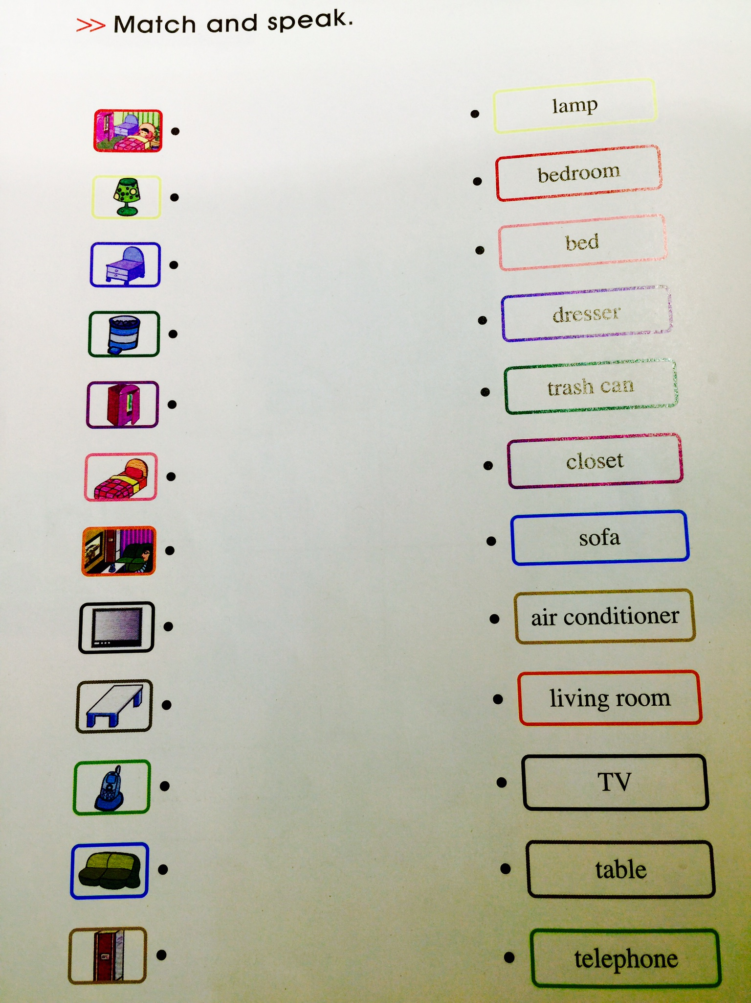Listening worksheet #1

Listening worksheet #2

Make 3 sentences to describe a room like the example below.

-Example-

I see a chair, a table and a coffee machine in a café.

Listening worksheet #3

Listen again and take diction.

What _____ is this?

My sister is sleeping in the _______.

I see __________________________________ and ____________ in the ________.

My father is watching TV in the _______.

I see __________________________________ and _____________ in the _________.

My mother is cooking in the _________.

I see ______________________________ and ___________ in the __________.

I am washing my hands in the _________.

I see _______________________________ and _______ in the _________.