TITLE | Describing People’s physical appearance
INSTRUCTOR |  |  |  | Ss’ LEVEL | AGE GROUP | No of Ss | LENGTH
Grace |  |  |  | Intermediate | 13 | 12 | 50

-White board, marker, eraser, audio speakers, computer, scotch tape

-Four students’ pictures ( Kate, Eric, Christina, and Ronald) –lead in time-

-Matching vocabulary and definition worksheet A (13 copies)
-Answer for worksheet A (1 copy)

-Dialogue worksheet B (13 copies)

-Three people’s pictures -post task time-
-SOS material
-The list of the physical appearances
AIMS 1. |  | Students will practice and improve their speaking skill by discussing physical appearance and role-play.
2. |  | Students will practice expressing their opinions when they discuss the appearance of the pictures.
3. |  | Students will learn vocabulary and expression related to appearance through brainstorming, matching vocabulary and definition, and role-playing..

LANGUAGE SKILLS
Listening |  |  | Listening to teacher’s instructions and classmates in group activity Listen to the dialogue through the audio.
Speaking |  |  | Sharing their opinions in pairs or in group activity Verbally practicing the dialogue through role-play
Reading |  |  | Reading the dialogue (worksheet distributed) and checking their understanding through reading comprehension
Writing |  |  | Matching vocabulary and definition and complete the dialogue.
LANGUAGE SYSTEMS
Phonology |  |  | Listening to the teacher, audio, and classmates speaking
Lexis |  |  | Learning the vocabularies related to appearance (e.g Height, Weight, Hair)
Grammar |  |  | Learning and practice interrogative sentences
Discourse |  |  | Expressing opinions and ask questions
Functions |  |  | Using the diverse functions (debating, giving and receiving opinions, prediction)

ASSUMPTIONS

-Students already know teacher’s style of teaching and pace in class.

-Students are at an intermediate level and have already known how to express their opinions in English.

-Students are mostly active and familiar with working in pairs or groups..

-Student are comfortable sharing their opinions and giving descriptions in pairs..

ANTICIPATED GRAMMATICAL ERRORS AND SOLUTIONS
Students may not know the vocabularies in the dialogue.
➔ Encourage students to guess from context. or picture.
It is hard for students to understand the dialogue..
➔ Chunk the listening..
Students may not know how to give detailed descriptions of someone.
➔ Provide students with a list of descriptive adjectives for students to use during pair and group discussions.
The main activity main finish earlier than expected.
➔ Review the topic and get feedback from students.
➔ Have SOS activity prepared.

REFERENCES

www.google.com : images of skinny, muscular, chubby, bald, shoulder-length, straight, wavy, curly,

ponytail, blond, mustache, sideburns, beard,, pain,
I can speak (1 Blue) –PAGODA / p38~40 images and dialogue
www.dictionary.com (google) : vocabulary definitions

NOTES

-Monitor the students all the time!

PRETASK
AIMS |  |  |  | MATERIALS
To describe people’s physical appearance |  |  |  | White board, board marker, board eraser  Visual : four people’s pictures, scotch tape
TIME | SET UP | STUDENTS |  |  | TEACHER
1 | Whole class | Greetings |  |  | Greetings
5 | 4groups  of 3tudents | Students will guess and share ideas and words related to physical appearance, .showing the pictures |  |  | Set up task  Give instructions  Monitor passively
3 | 4groups  of 3tudents | Each group will write down things they have discussed on the whiteboard under each given picture |  |  | Invite students to whiteboard to write things under each given picture

NOTES

When students may have difficulty sharing their thoughts, try to share their ideas and opinions

TASK PREPARATION
AIMS  To learn vocabularies related to physical vocabularies |  |  |  | MATERIALS  Worksheet A (13 copies), Answer for worksheet A (1 copy)
TIME | SET UP | STUDENTS |  |  | TEACHER
2 | Pairs | Students pronounce the vocabularies in worksheet together  Students match the vocabularies and definition with your partner |  |  | Give instructions  Distribute worksheet(A)  Monitor
4 | Whole class | Read the right answers aloud together.  If there is the wrong answer, try to find out and correct what is wrong with each other. |  |  | Verbally draw answers from students about each vocabulary  Encourage students to help each other when finding out the wrong answer

NOTES

-check the students’ understanding of vocabularies

TASK REALISATION 1
AIMS |  |  |  | MATERIALS
To practice listening to the dialogue  To understand the dialogue through dialogue comprehension  To practice speaking the dialogue using their own personal information |  |  |  | Worksheet B (13 copies) –the dialogue ( related to physical appearance), 3pctures (one picture in pairs)
TIME | SET UP | STUDENTS |  |  | TEACHER
5 | Whole class | Listen to the dialogue and read the dialogue together by dividing two groups  -Dialogue related to physical appearance  Kevin : Hey, I’m glad you came. Who are you?  Nancy : I’m with my boyfriend. He’s over there.  Kevin : Oh, really? Which one is your boyfriend?  What does he look like?  Nancy : He’s tall and muscular. And he has short brown hair.  Kevin : Hum… is he wearing a white shirt and blue jeans?  Nancy : Yes, he is. That’s my boyfriend.  Kevin : I see, Enjoy the party. |  |  | Click the ‘Audio’ button and set audio speakers volume.  Give instructions  Distribute worksheet B
2 | Whole class | Listen to the dialogue again |  |  | Play the audio again
3 | Whole class | Answer questions about dialogue |  |  | CCQ about dialogue  e.g)  Who is Nancy with at the party?  What does Nancy’s boyfriend look like?  What is he wearing?
5 | In pairs | Discuss how to describe the physical appearance with the given picture with a partner  Complete the dialogue in worksheet, using physical appearance information you have discussed with a partner |  |  | Give instructions  Set up the class  Distribute the pictures( one picture in pairs)  Monitor

NOTES

If necessary, listen to dialogue at the normal speed again

TASK REALISATION 2
AIMS |  |  |  | MATERIALS
To practice listening and speaking skills through role-play  To listen to other students’ role-play |  |  |  | Whiteboard, board marker, board eraser
TIME | SET UP | STUDENTS |  |  | TEACHER
3 | In pairs | Practice role-play through the dialogue which is completed with your partner |  |  | Give instructions
12 | In pairs | Draw the picture to describe and write down key words on the whiteboard before the students role-play in front of classmates.  Presenters : Perform role-play in front of classmates  Listener : Pay attention and encourage students to do their best |  |  | By monitoring, check their grammar and spelling

NOTES

Encourage the students to take an active prat in role playing
Monitoring students is essential as they will each be role-playing about the various physical appearances, so their participation and comprehension id important in completing the task and understanding the concepts.
Ensure students are sharing the speaking responsibility equally during the role-play

POST TASK
AIMS |  |  |  | MATERIALS
To confirm comprehension of describing people’s physical appearance |  |  |  | Whiteboard, board maker, board eraser
TIME | SET UP | STUDENTS |  |  | TEACHER
5 | Whole class | Answer Yes or No through the teacher’s questions with pictures  Take notes about homework |  |  | Give instruction  Check concepts  Assign homework

NOTES

H*W : Describe my best friend by using the vocabularies that we have leaned today and write it down on the note

Visual : Pictures

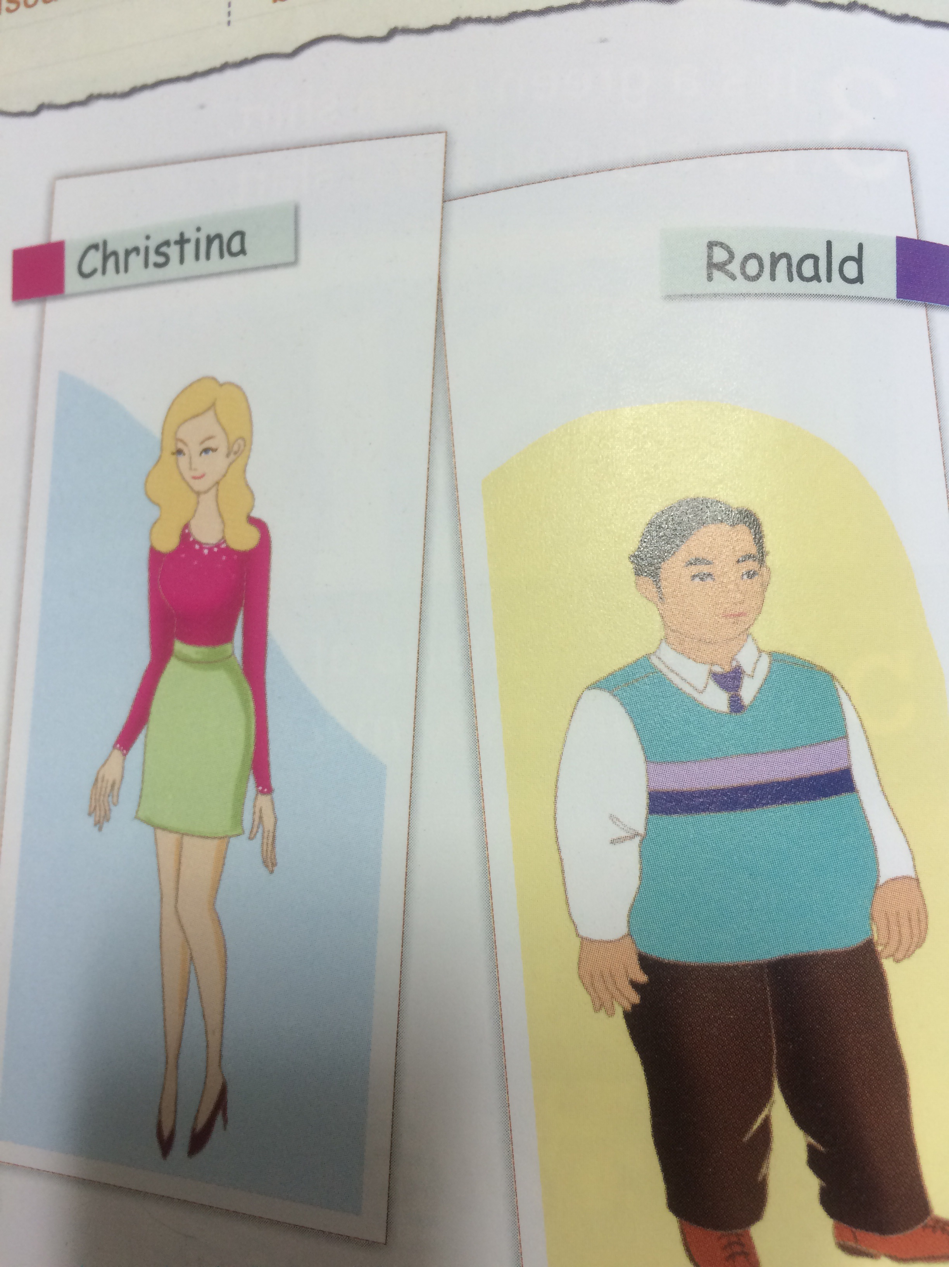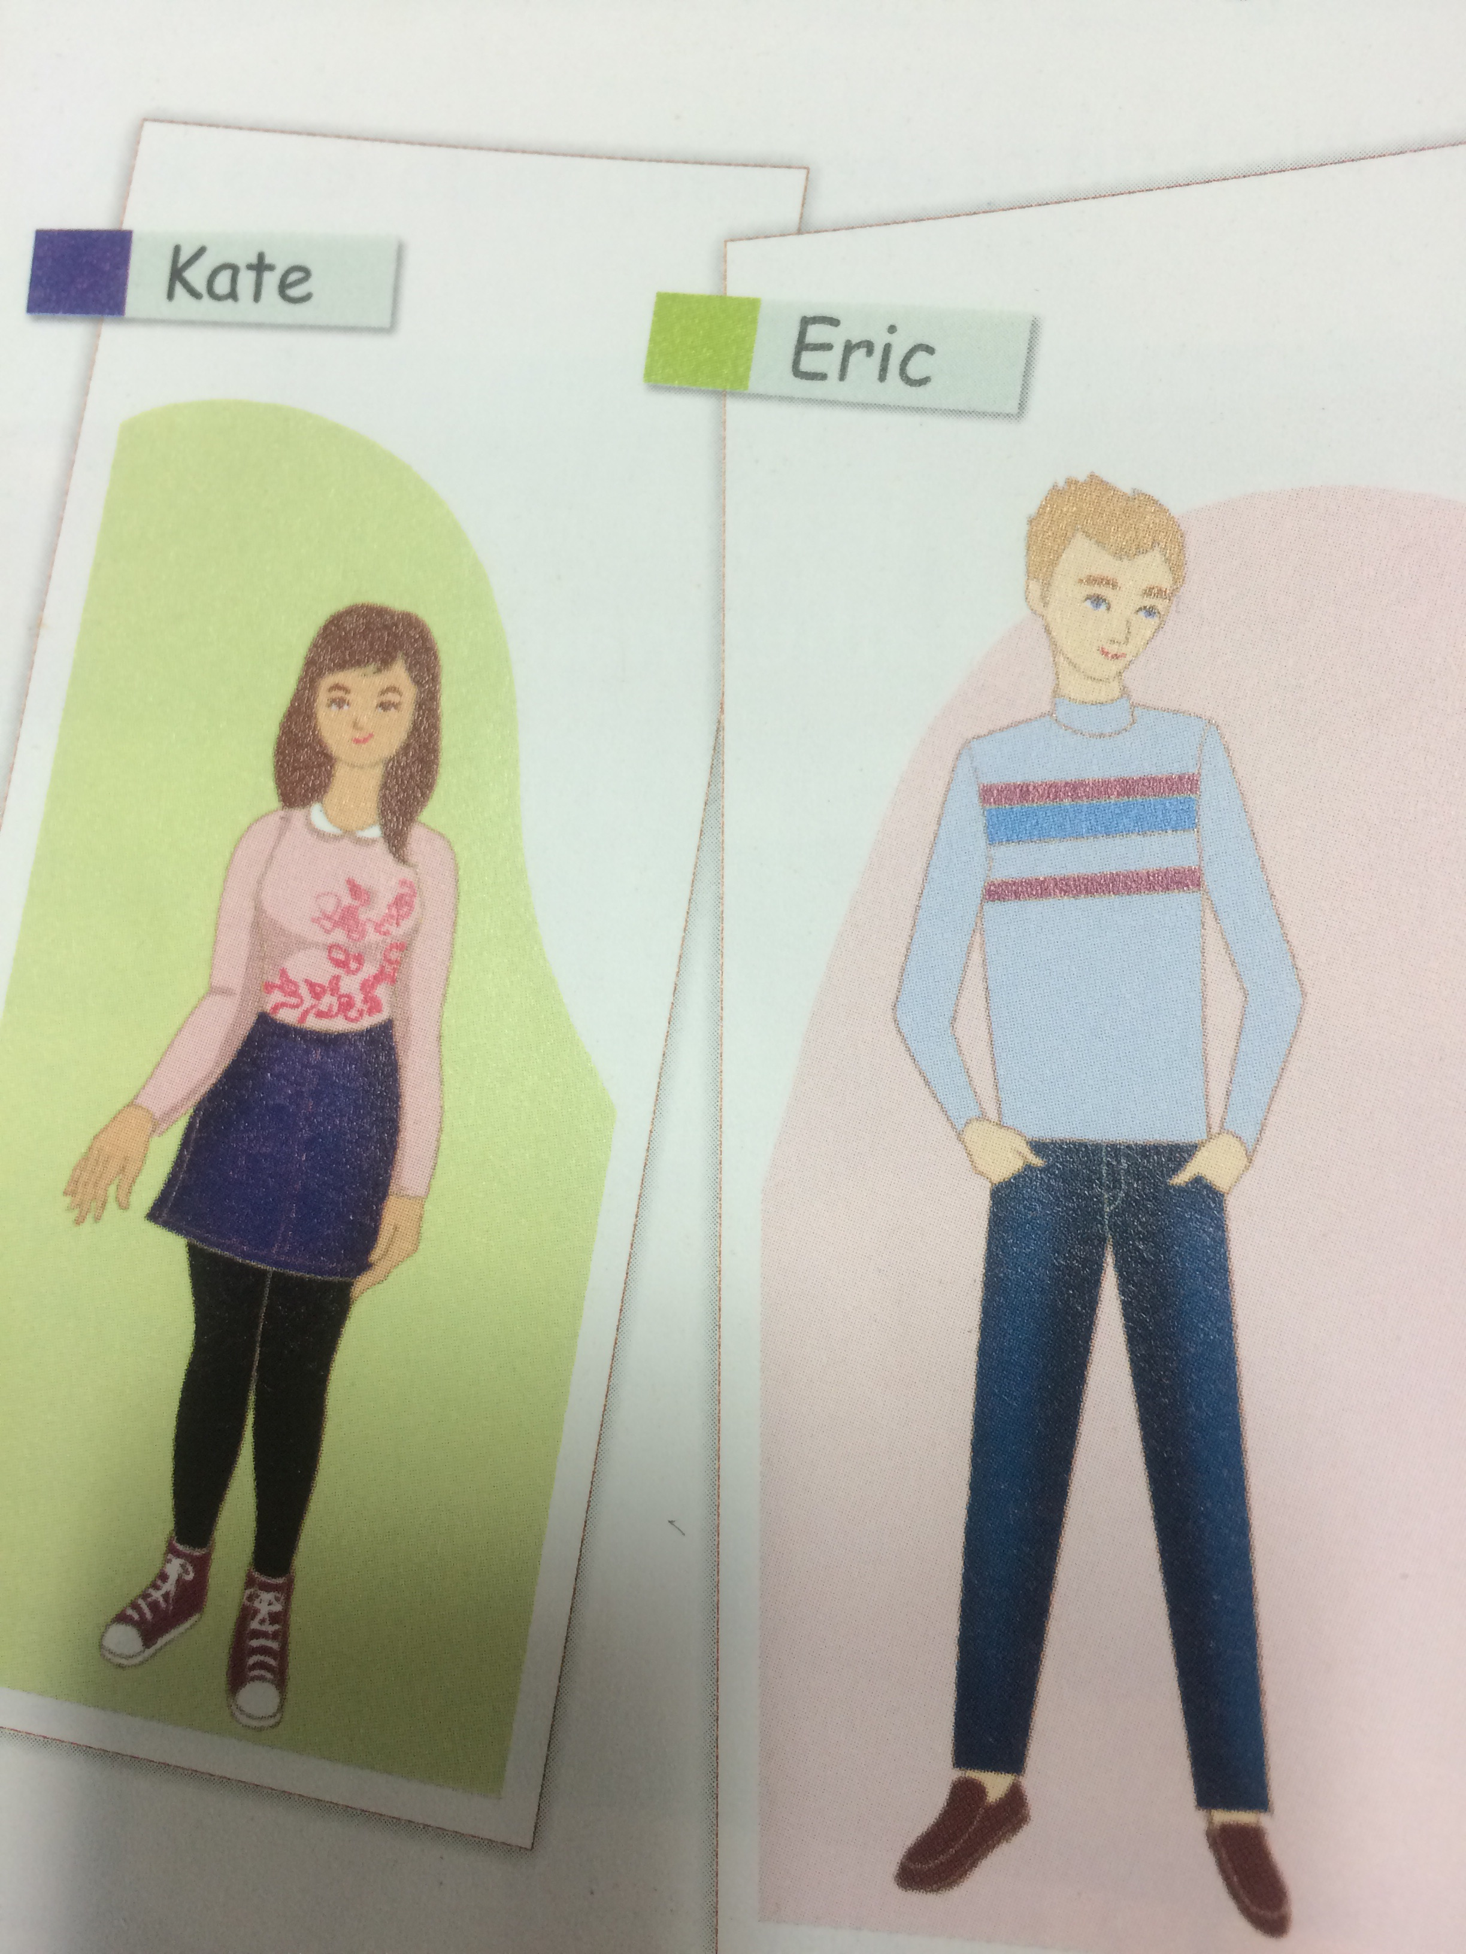

#Mach the vocabularies to the definitions Worksheet A
A) Skinny B) Short C) Plain D) weight
E) Muscular F) Chubby G) Overweight H) Bald I) Shoulder-length
J) Straight K) Wavy L) Curly M) Ponytail N) Blond
O) Beard P) Mustache Q) Sideburn R) Freckles
S) Pimples T)height

- their size or length from the bottom to the top.
- a very light blond color
- long enough to reach your shoulders
- Is extremely thin.
- Not long.
- physically just average features not ugly or pretty
- how heavy they are/, measured in units such as kilograms, pounds, or tons.
- or relating to muscle or the muscles
- plump or fat
- weighing too much or more than is considered normal, proper
- having little or no hair
- without a bend, angle, or curve; not curved; direct
- is not straight or curly, but curves slightly.
- full of curls
- a hairstyle in which someone's hair is tied up at the back of the head and hangs down like a tail.
- the hair that grows on his chin and cheeks.
- the hair growing on the upper lip
- he has a strip of hair growing down the side of each cheek .
- small light brown spots on someone's skin, especially on their face.
- small raised spots, especially on the face.

Dialogue worksheet B

Kevin : Hey, I’m glad you came. Who are you?
Nancy : I’m with my boyfriend. He’s over there.
Kevin : Oh, really? Which one is your boyfriend?
What does he look like?
Nancy : He’s tall and muscular. And he has short brown hair.
Kevin : Hum… is he wearing a white shirt and blue jeans?
Nancy : Yes, he is. That’s my boyfriend.
Kevin : I see, Enjoy the party.

# Complete the dialogue by using the given picture information.
- Decide your names and fill in the blank.

: Hey, I’m glad you came. Who are you?
: I’m with my . ’s over there.
: Oh, really? Which one is ? ?
: .
: Hum… is wearing ?
: Yes, is. That’s my .
: I see, Enjoy the party.

Visual : Pictures

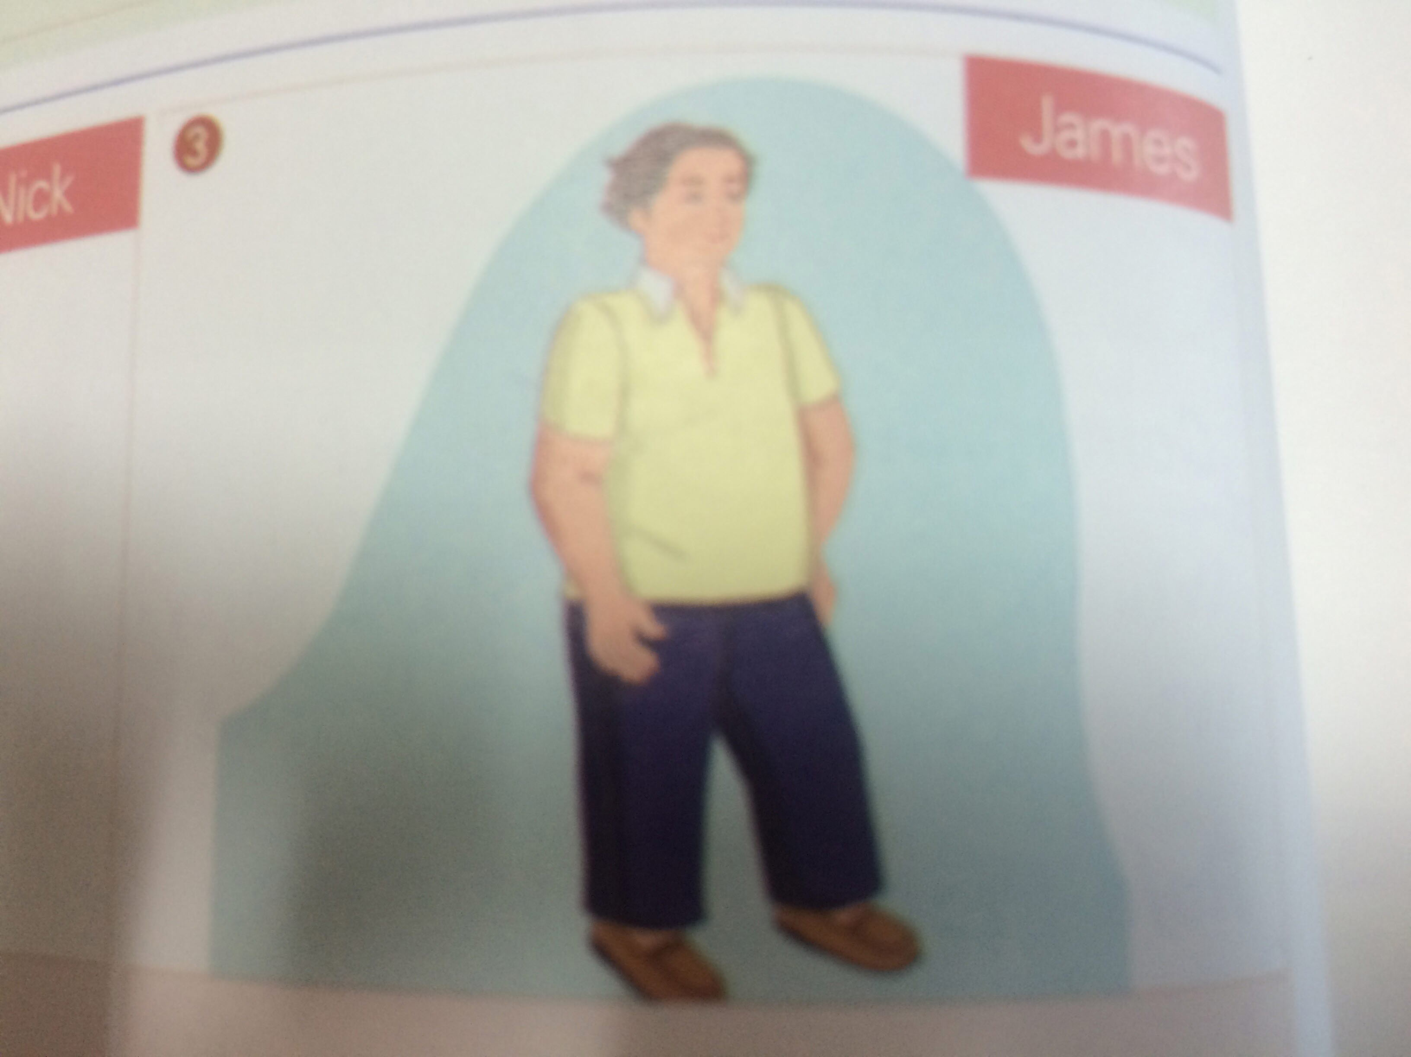

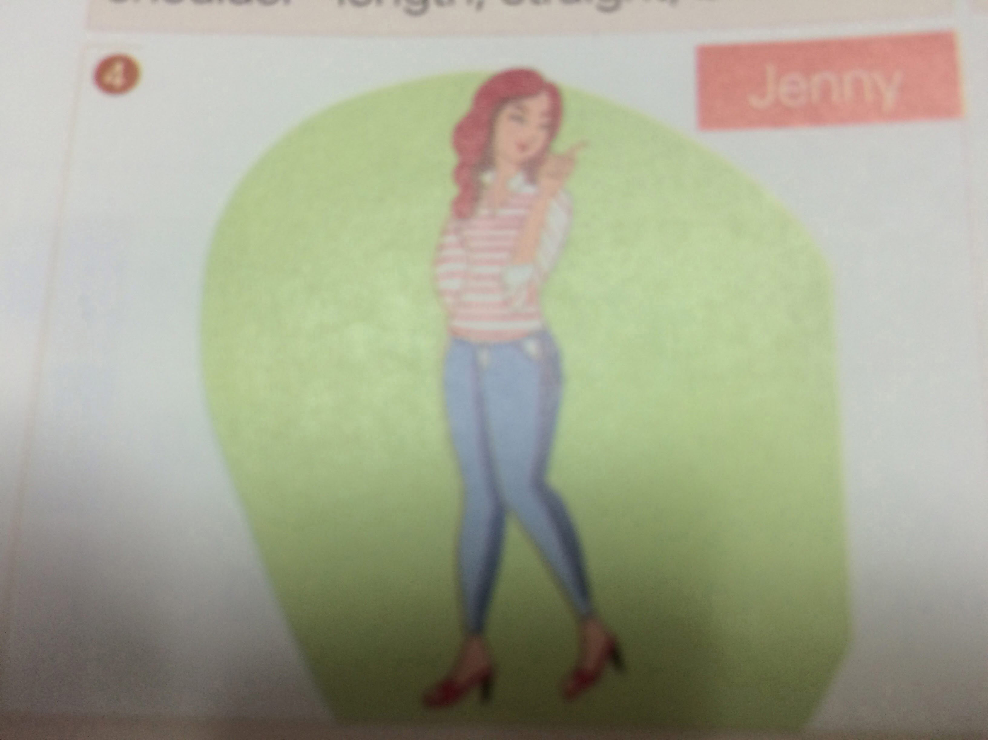

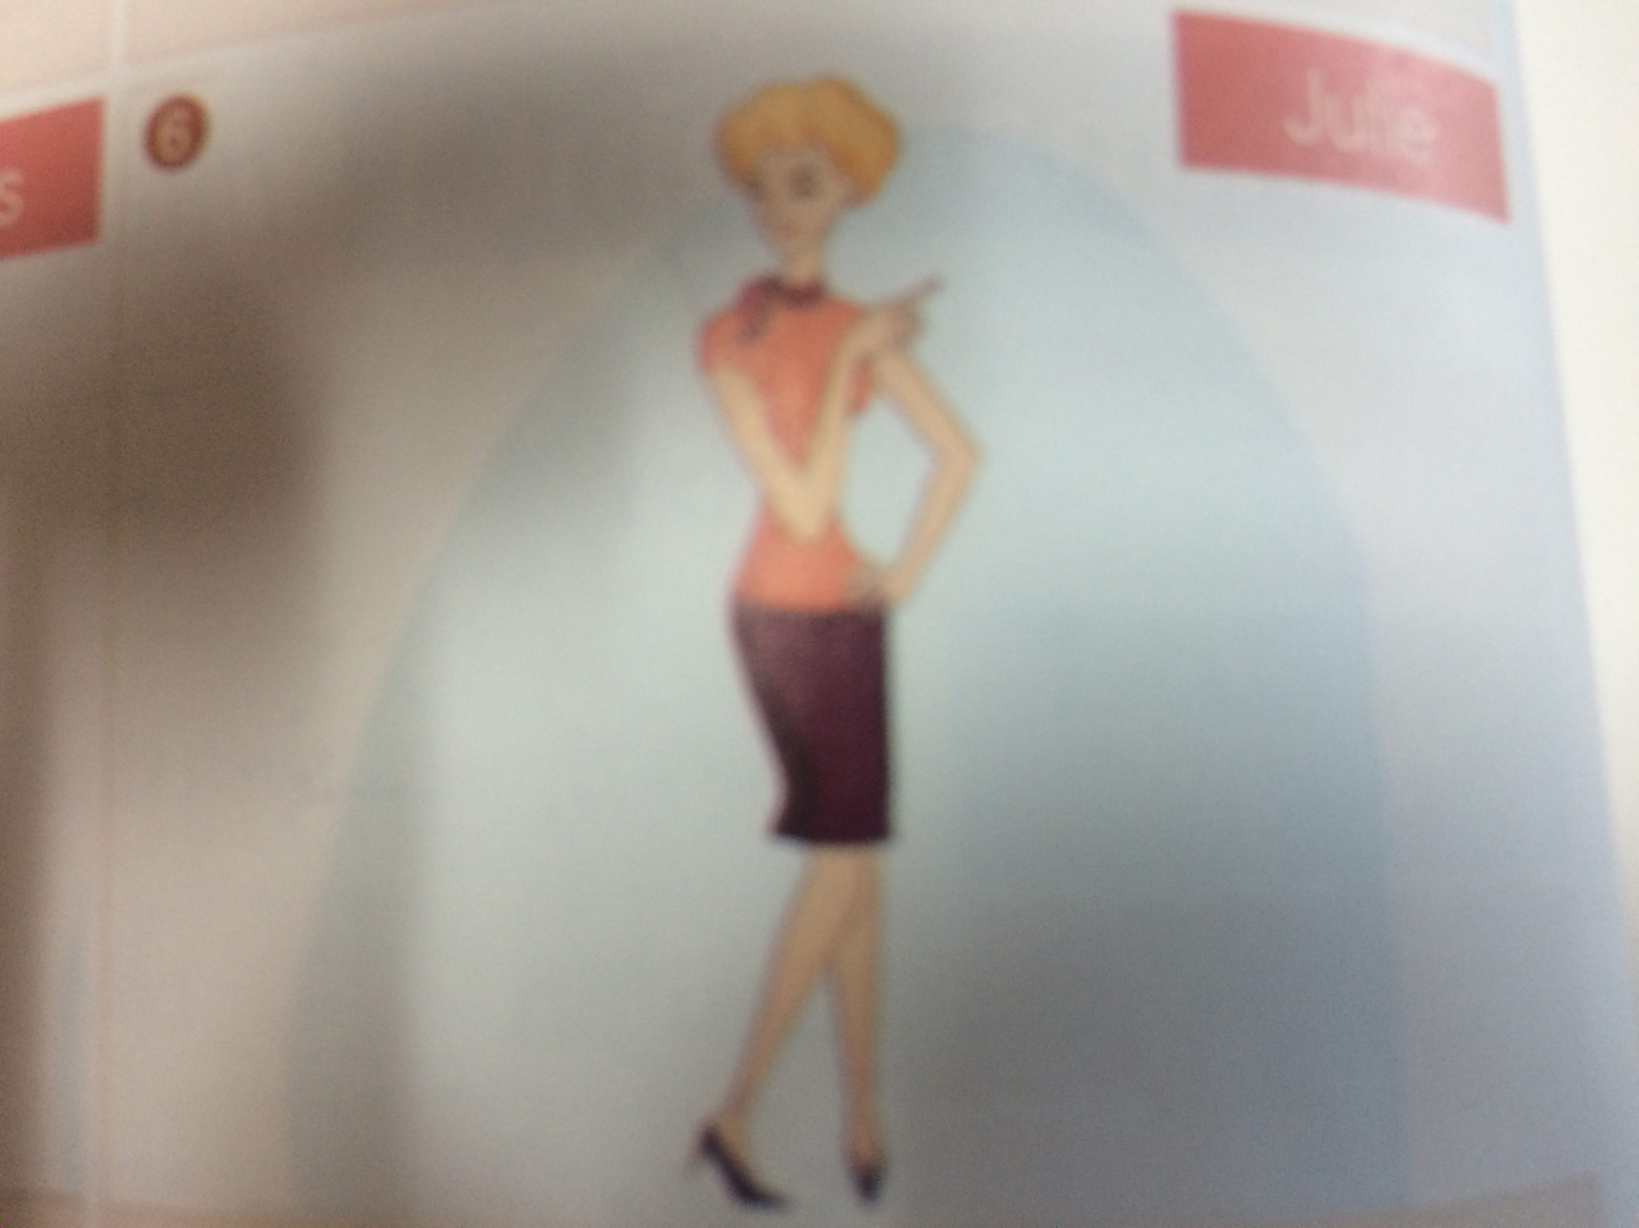

SOS material

I’ll have the students write 20 vocabularies related to the physical appearances and they have to consider the letter of the vocabulary is more than 4letters. And then, I’ll check the letters they write and the students will make a 10-sentence story which includes one vocabulary from the 20 vocabularies in each sentence, After finishing this activity, they’ll present their stories in front of classmates
List of Physical Appearances

Height | Short, average height, tall
Weight | Skinny, slim (thin), average weight, muscular, chubby, overweight
Hair | Length | Bald, short, shoulder-length, long
Hair | Style | Straight, wavy, curly, ponytail
Hair | Color | Blond, brown, black, red, grey
Age | Young, middle-aged, old, in his/her early twenties  Mid thirties  Late forties
Other | Beard, mustache, sideburn (sideburns)  Freckles, pimpled, beauty mark/mole
Looks | Pretty, beautiful, handsome, cute, attractive  Good-looking, plain, ugly

#Mach the vocabularies to the definitions Worksheet A
(Microteaching Presentation)

A) Skinny B) Short C) Straight D) ) Mustache
E) Muscular F) Chubby G) Sideburn s H) Bald I) Wavy

- Is extremely thin.
- Not long.
- or relating to muscle or the muscles 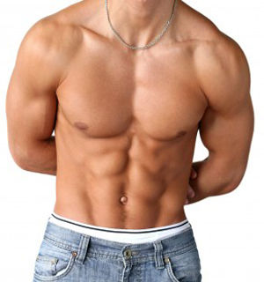
- plump or fat 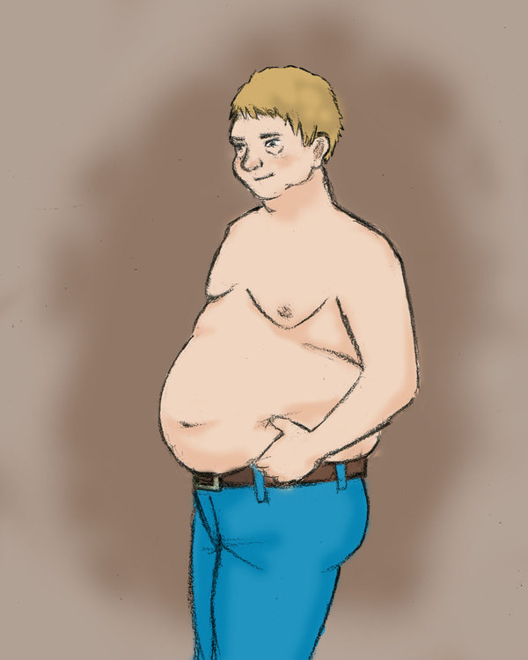
- having little or no hair 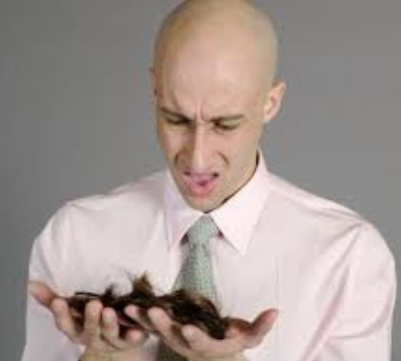
- without a bend, angle, or curve; not curved; direct 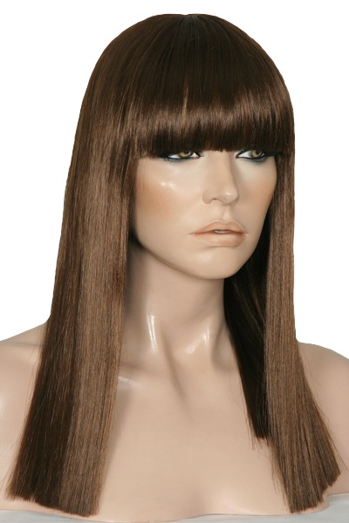
- is not straight or curly, but curves slightly. 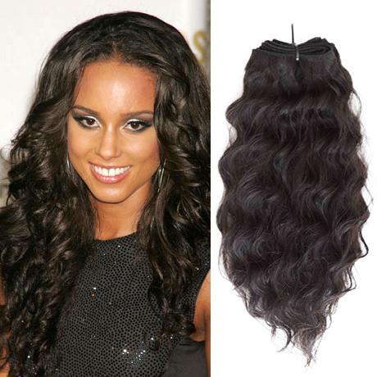

- the hair growing on the upper lip 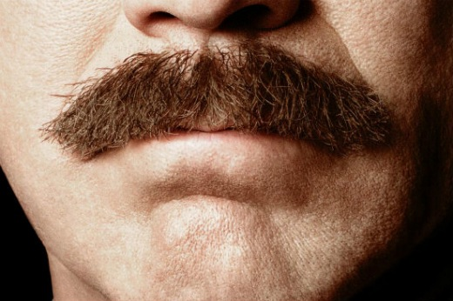
- he has a strip of hair growing down the side of each cheek . 

