TITLE | Comparatives through pictures
INSTRUCTOR |  |  |  | Ss’ LEVEL | AGE GROUP | No of Ss | LENGTH
Elena Shmidt |  |  |  | Elementary | 7-8 | 12 | 50

MATERIALS

Whiteboard and markers
Realia (objects to compare by size and length)
Printed out outlines of a steam engine with carriages (A4 size, to use as flashcards for letters)
Comparative adjectives worksheets (see attached)
Blank paper (A4) and crayons/pencils for drawing
AIMS 1. |  | Learning comparatives to be able to compare similar objects when ranging the drawings from small to large in a group activity.
2. |  | Preparing to learn superlatives by listening to the teacher’s introduction of the concept when doing the group activity.
3. |  | Practicing speaking in full sentences when describing the difference between own drawing and the one of a partner.

LANGUAGE SKILLS
Listening |  |  | Teacher’s demonstration and explanation, other Ss’ answers.
Speaking |  |  | Comparing objects by size/length using one-syllable adjectives.
Reading |  |  | Comparative adjectives describing size and length of objects, as well as full sentences expressing comparison between two similar objects.
Writing |  |  | Single adjectives and full sentences where two similar items are compared.
LANGUAGE SYSTEMS
Phonology |  |  | -er suffix of comparative adjectives, voiced dental fricative -th of conjunction -than.
Lexis |  |  | One-syllable adjectives defining nouns by size and length (big/bigger, small/smaller, long/longer, short/shorter)
Grammar |  |  | Superlative adjectives
Discourse |  |  | Comparing drawings of stars
Functions |  |  | Comparing the difference between two nouns.

ASSUMPTIONS
Ss know adjectives defining object’s size (short, long, big, small). Ss can use “personal pronoun + noun”collocation in simple sentences (“My star is big.”)

ANTICIPATED GRAMMATICAL ERRORS AND SOLUTIONS

Omitting suffix -er and conjunction -than when making a sentence to compare two objects.
Teacher will offer immediate correction and ask Ss to repeat the correct adjective.

REFERENCES

www.teachingenglish.org.uk for the main activity.

NOTES

Plan B
To introduce and practice comparatives, T. can use a fun learning activity that gets the entire class involved.
First, the T. demonstrates how to draw an outline of a simple square object on the whiteboard by pressing a sqare/rectangular pice of cardboard or a similar light object against the whiteboard and outlining it with a marker. “This is a brick”, - explains the T. Then the teacher shows how to “stack” such bricks one of top of the other to “build” a tower.
“Tall”, - guides the teacher.
Then the class is divided into 2 teams. Students from each team take turns, running to the whiteboard and adding such “bricks” to their tower - one brick at a time. The student should return to his/her team to pass the template and the marker to the next student.
When the time is up, the teacher compares the towers, introducing “taller”. The team that managed to draw more bricks, e.g. the team with the taller tower, wins.
Next the T. introduces “long” - “longer”. The routine is the same, only this time the Ss should race to depict a longer train etc.
T. can experiment with shorter or smaller: teams race to erase elements, one element at a time (removing slices of pizza, or train carriages for smaller and shorter correspondingly).
After each round, teacher makes the class focus on the comparative form , repeat the words, etc. T. also asks CCQs.

This activity requires minimum preparation.

Cut-off plan
Main task:cut off the writing practice (pairwork activity).
Post-task: if little time is left at the end of the lesson, worksheets can be distributed for homework.
SOS activity
Vocabulary revision game “Snatch the word”
Two/three teams are formed. On the whiteboard/wall the Teacher places large sheets with the words which have been previously studied (one word per sheet, printed in large sized font). The teacher presents a flashcard with a picture for one of the words on the whiteboard. The team should identify the picture with one of the words. As soon as the team knows the answer, a representative (a different student every time) is sent to snatch the word from the whiteboard. The team that collect more sheets are the winners.

PRETASK TITLE |  |  | Interactive activities “Roll the tape”, “Car race” and others.
AIMS |  |  |  | MATERIALS
Elicit vocabulary.  Introduce target grammar. |  |  |  | Realia (2 rolls of non-sticky tape or ribbons of various length ), other objects.
TIME | SET UP | STUDENTS |  |  | TEACHER
4 min. | whole class | - Help the teacher to hold and demonstrate the unrolled tape/ribbons to the class.  - Answer T’s questions.  - Repeat vocabulary after the teacher. |  |  | Presents realia (produces a roll of tape/ribbon). Asks two students to help unroll it and hold by two ends. Elicits “Long”.  Produces another roll, longer than the previous one.  Introduces “Longer”.
6 min. | whole class | - watching T’s demonstration  - supplying answers  - taking part in the car race to compare the speed (fast-faster) |  |  | -demonstrates realia to describe difference in size (big-bigger, small-smaller, fast-faster)  -elicits correct comparative form  -invites 2 students to race toy cars to see which one is faster

The realia to be used:

two rolls of ribbons of different length to demonstrate long-longer

a set of nesting dolls to introduce and elicit small-smaller and big-bigger;

two similar-sized pull back toy cars to compare speed and demonstrate fast-faster.
Plan B:
Any comparable objects available in the classroom can be used as realia: books, pencils, very simple drawings (or last-minute printouts).

TASK PREPARATION TITLE |  |  | Spelling of new grammar forms.
AIMS |  |  |  | MATERIALS
Focus on target grammar  - Practicing pronouncing, spelling, reading and writing target grammar word form. |  |  |  | - Whiteboard and markers  - 2 sets of A4 sheets designed as train carriages with large letters “l”,”o”,”n”,”g” plus one sheet with suffix “-er”. Sticky tape to attach the sheets to the whiteboard. terials and equipment needed for this activity
TIME | SET UP | STUDENTS |  |  | TEACHER
7 min | whole class | - Spell the words presented by the teacher.  - Read the words on the whiteboard.  - Copy the pairs “long-longer”, “small-smaller”, “big-bigger” into their workbooks. |  |  | - Presents the letters on A4 sheets to compose the word “long” on the whiteboard in the shape of a train.  - Draws a line (diagram) under the “letter-train” to convey the concept of length.  - Adds “-er” suffix to the word “long”, draws a longer line to demonstrate the difference in length.  - Introduces “small-smaller”, “big-bigger” (one or two-syllable words).

NOTES

The A4 sheets can be easily substituted by simple drawings on the whiteboard. The reason to use A4 in this activity is to save classroom time. Also, printed out letter “carriages” allow for graphic elements that will be visually appealing to the young learners.
Additional vocabulary (small-smaller, big-bigger) can be simply written down with markers.

TASK REALISATION TITLE |  |  | Drawing and mingling group activity.
AIMS |  |  |  | MATERIALS
- Practice new grammar  - Speaking in full sentences to compare objects  - Improving pairwork skills |  |  |  | - Blank paper and crayons/pencils for drawing  - Whiteboard, markers
TIME | SET UP | STUDENTS |  |  | TEACHER
4 min | whole class | - Answer ICQs  - Draw the star. |  |  | - Gives students a blank piece of paper and asks them to draw an easy to draw object, such as a star.  - Asks ICQs.  - Monitors.
4 min. | whole class | - Line up according to the size of the object that they drew |  |  | - Ask the students to line up according to the size of the object that they drew.  - Monitors by helping the Ss to line up.
5 min. | whole class | - Answer T’s questions.  - Speak in full sentences when comparing their drawings (“My star is bigger than John's star but smaller than Mary's star”) |  |  | - Asks Ss questions such as:  “Is student X's star bigger or smaller than student Y's star?”  - Induces Ss to speak in full sentences when comparing their drawing to other Ss’.
6 min |  | - Read the model sentence after the teacher (“My star is bigger/smaller than [student’s name]’s star”).  - Compare their drawing with the one of the partner’s.  - Write down the sentence according to the pre-taught pattern. (“My star is bigger/smaller than [student’s name]’s star”). Students write below the picture they have drawn. |  |  | - Tells the Ss to return to their seats.  - Writes down the model sentence on the whiteboard.  - Pairs Ss for the writing practice activity.  - ICQ.  - Monitors.
6 min. | whole class | - Read out their sentences.  - Pin their pictures onto the wall to create a display for all the class to read. |  |  | - Asks the Ss to read out their sentences.  - Tells Ss to pin their pictures on the wall

NOTES
Though the study of the superlatives is not the aim and focus of the lesson, the T. can comment on the biggest and on the smallest stars, using superlative adjectives thus introducing the concept.
Plan B: the drawing and mingling activity requires minimum preparation. However, if the teacher chooses to do something else, Plan B activity described in the main section, is a good alternative to this task.

POST TASK TITLE |  |  | Writing practice: comparative worksheets.
AIMS |  |  |  | MATERIALS
Practicing writing new grammar forms |  |  |  | Worksheets.
TIME | SET UP | STUDENTS |  |  | TEACHER
5 min | whole class, individual work | - Anser ICQs.  - Work individually to fill in the blanks with corresponding comparative adjectives.  - Read out their answers. |  |  | - Instructions  - Distributes worksheets  - ICQs  - Monitors
3 min | whole class | - Providing feedback  - Answering ICQs. |  |  | - Invites feedback  - Gives home assignment.  - ICQs

NOTES
Plan B/cutout:

If no time is left for this activity in the classroom, the T. may give short instructions to complete this worksheet at home as homework.

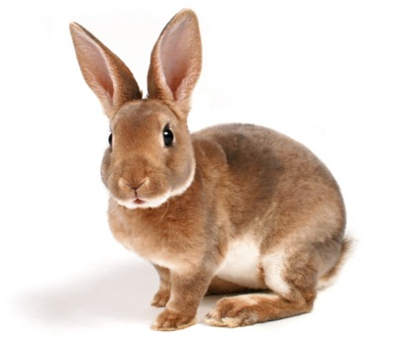
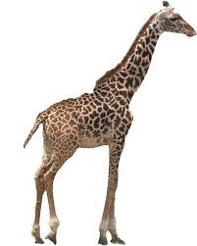
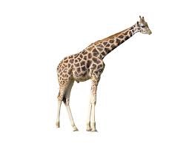
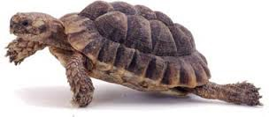
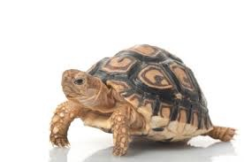
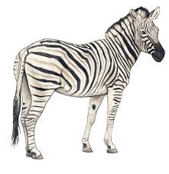
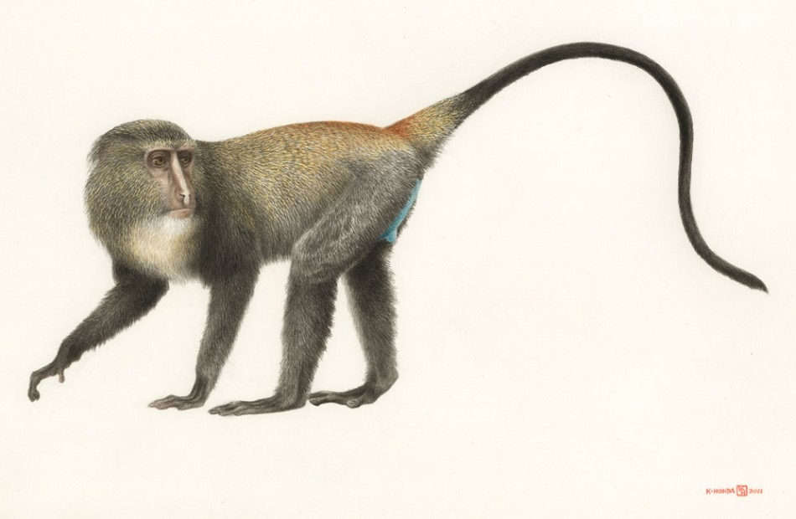
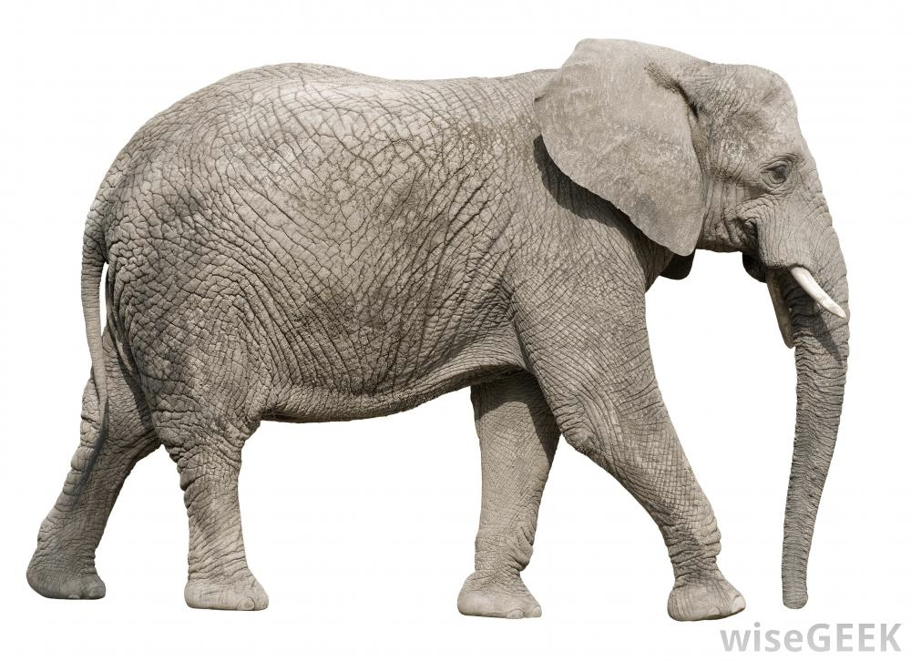
The g _ _ _ _ _ _ is tall _ _ than the r _ _ _ _ _.
3.
rabbit
giraffe
tall
2.
1..
fast
tortoise
zebra
The z _ _ _ _ is fast _ _ than the t _ _ _ _ _ _ _ .
The e _ _ _ _ _ _ _ is bigg_ _ than the m_ _ _ _ _.
monkey
elephant
big
