---------------------------------------------------part1-----------------------------------------------------
Change of Focus Lesson Plan

Title: I like My body

Instructor:  NARI KIM  (ELLA) | Level: beginner  Age Target: 5 | Student: 8~12 | Length:  30 min

Materials:

A story book – “Here and my hand”
Body part picture, Body parts pieces(stickers), Body map, basket, board, Flash card, cd, cd player, worksheet, crayons, color pencils scissors, glue

Objectives:

-Ss get comfortable and interested in lesson by T presentation.
-Ss will learn key words excitingly
-Ss will learn a song “move your body”, “head, shoulders, knees & toe “
by singing and dancing together.
-Ss will be able to say parts names by seeing the body part pictures and
listening to T’s explanation, coloring the body part identification,
writing the name on the cards and do worksheets.-
-Ss practice speaking short sentence “This is my nose” by reading along T
And answering to T’s questions.
-Ss will improve listening ability by T reads a story book <Here and my Hands>

Language Skills:

-Reading: Repeating after T flash cards
-Listening: T’s explanation about body parts, repeating after T.
listening to the new song and story
-Speaking: Answering, singing the song, repeating the words, and sentence
-Writing: Tracing the letters and color the body parts words

Language systems:

-Phonology: drilling wall chart, teacher and students talk
-Lexis: knowing words about body part
Ex) head,face,hair,elbow,eyes,nose,ears,cheek,mouth,lips,chin,fingers,hands
Legs, knees, ankles, foot, feet etc….
-Grammar: (pattern) I have _______________
Ex) I have two eyes, I have two ears, I have 10 fingers, ...
-Function: speaking what they did at that time
-Discourse: making sentence activity
Ex) Where is your nose? Touch your mouth, Show me your fingers,
Can you point your eyes? Clap your hands, It’s a mouth ..etc

Assumptions about Students:

-Ss can remember what they did
-Ss will show interest in the subject and can answer to questions.
-Ss can color the picture and fix up the body and body parts
-Ss will easily learn what can we do with our body parts
and can match the work with each body parts

Anticipated Errors and Solutions:

If Ss may not understand the contents, T should explain as simple as possible
If Ss have difficult matching the picture, T should help them to matching easily
If Ss remember the song, T sing a song again
If Ss don’t concentrate on the class, T show simple finger play to pay attention
And to calm their self
If Ss need more time to finish their activity, T gives more time and arranges the
Other activity

References:
https://youtu.be/6I4OanLkiDI
https://youtu.be/8LTl_m8V0c8
http://www.kizclub.com/storypatterns/myhands(C).pdf
http://www.kizclub.com/storypatterns/myhands.pdf
Part2
Core Activities
Time | Set up | Review>  (Materials: CD, CD player )
3min  2min | Whole  class | Greet students  T sings “ Hello song “ Ss sing with T  T takes out things that are body part for and review  Ss response and review
Time | Set up | Introduction of New target>  (Materials: A Story book “ Here and my hands” ,  Topic Card, body map, board )
1min  4min | Whole  class | T introduces the topic and the put the title on the board  T reads a book – “Here my hands” Ss listen
Change of Focus
Time | Whole  class | Oral Activity>  (Materials: Body parts flash card, Body parts pieces, basket )
3min | Whole  class | T shows body parts pieces on the board  T shows flesh cards and explains body parts  Ss see the flesh cards and listen and repeat after T
Core Activities
Time | Set up | Practice of new target>  (Materials: CD , CD player, worksheet, color pencils)
3min  3min | Whole class  S | T sings a song with rhythm  “ Move your body / Head and shoulders knees and toes “  Ss listen and sing together  Hands out worksheets and picture of body parts  S do the worksheet, trace the letters.
Change of Focus
Time | Set up | Review>  (Materials: Body map , sticker of body parts )
3min | Group | T says a body part and Ss to complete to “body map”  S comes out and make “body map” with a body part
Core Activities
Time | Set up | Linking of new target with old targets>  (Materials: Body parts flash card )
3min | S | Card game : Speed Quiz on the topic “Body”  Ss guess what the name of the card, then check the exact naming together
Time | Set up | Consolidation of new target through writing>  (Materials: worksheet, color pencils, crayons )
3min  2min | S  Whole  class | Draw your body  Ss draw Ss body  T gives a feedback and thanks Ss for effort.  Good bye song together

*A STORY BOOK – HERE ARE MY HANDS
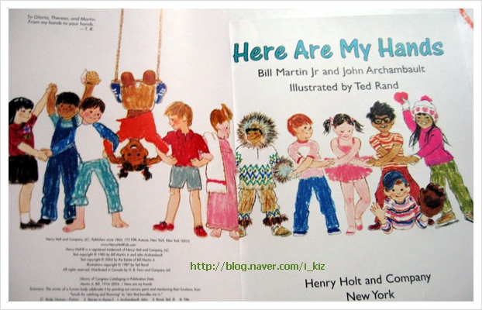
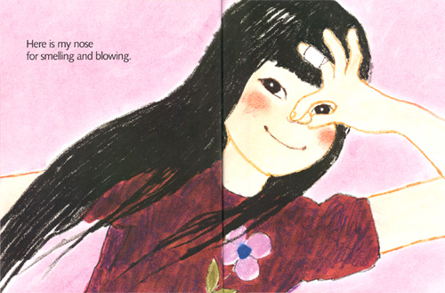
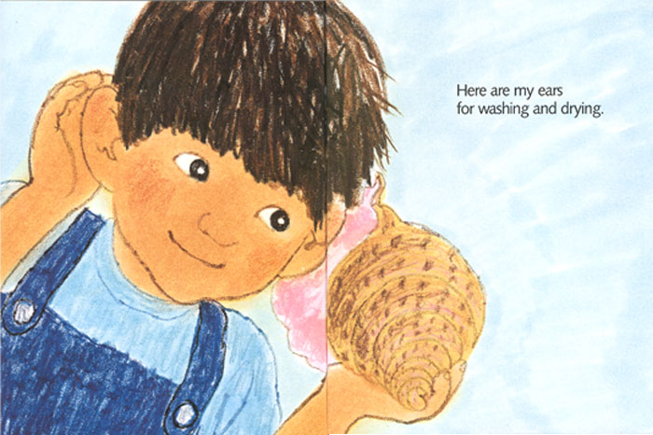
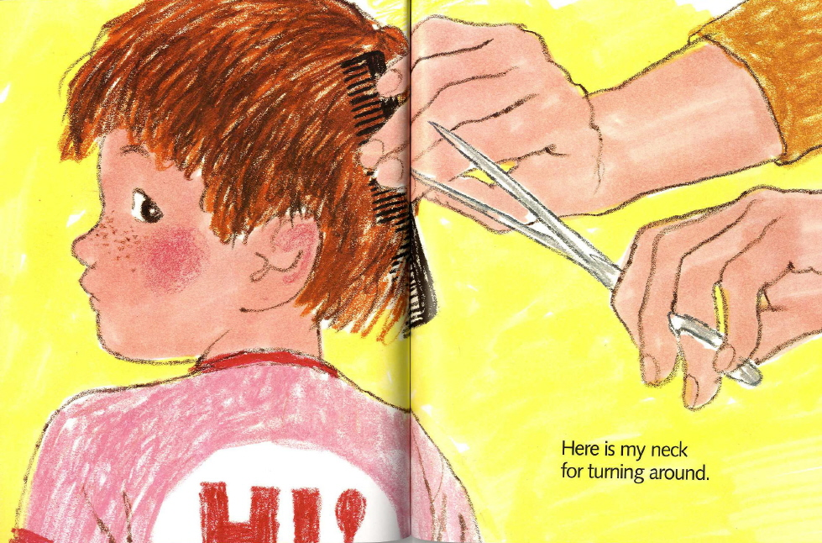

*Materials
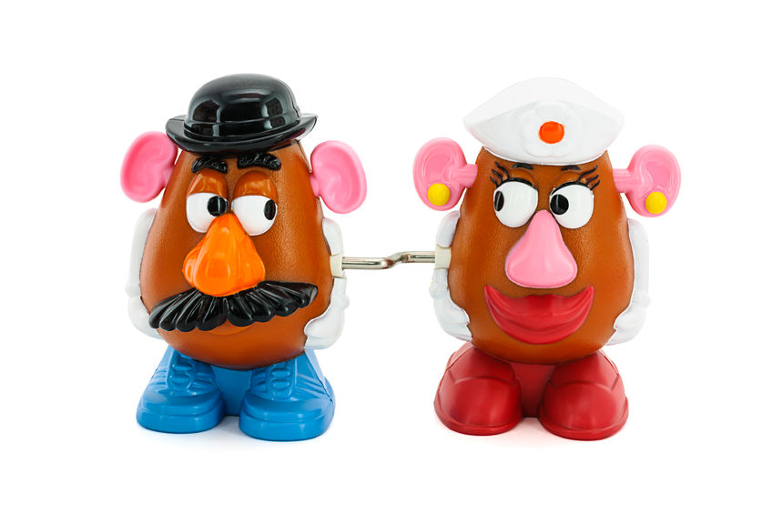
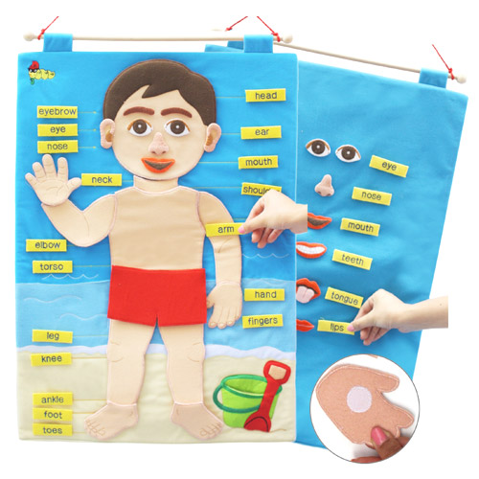

*BODY MAP
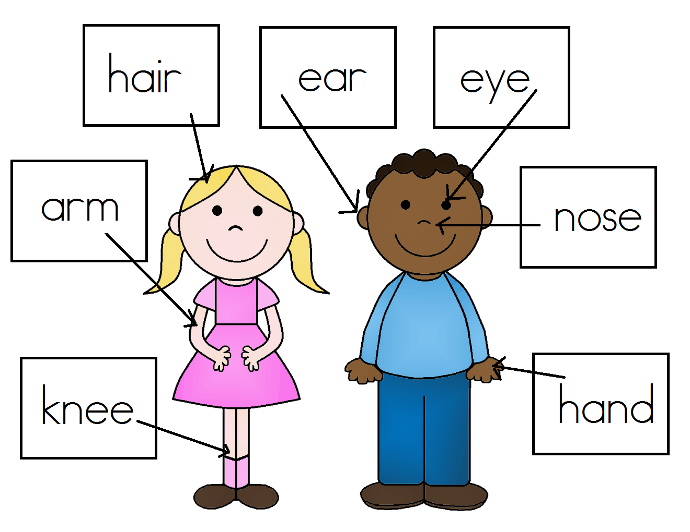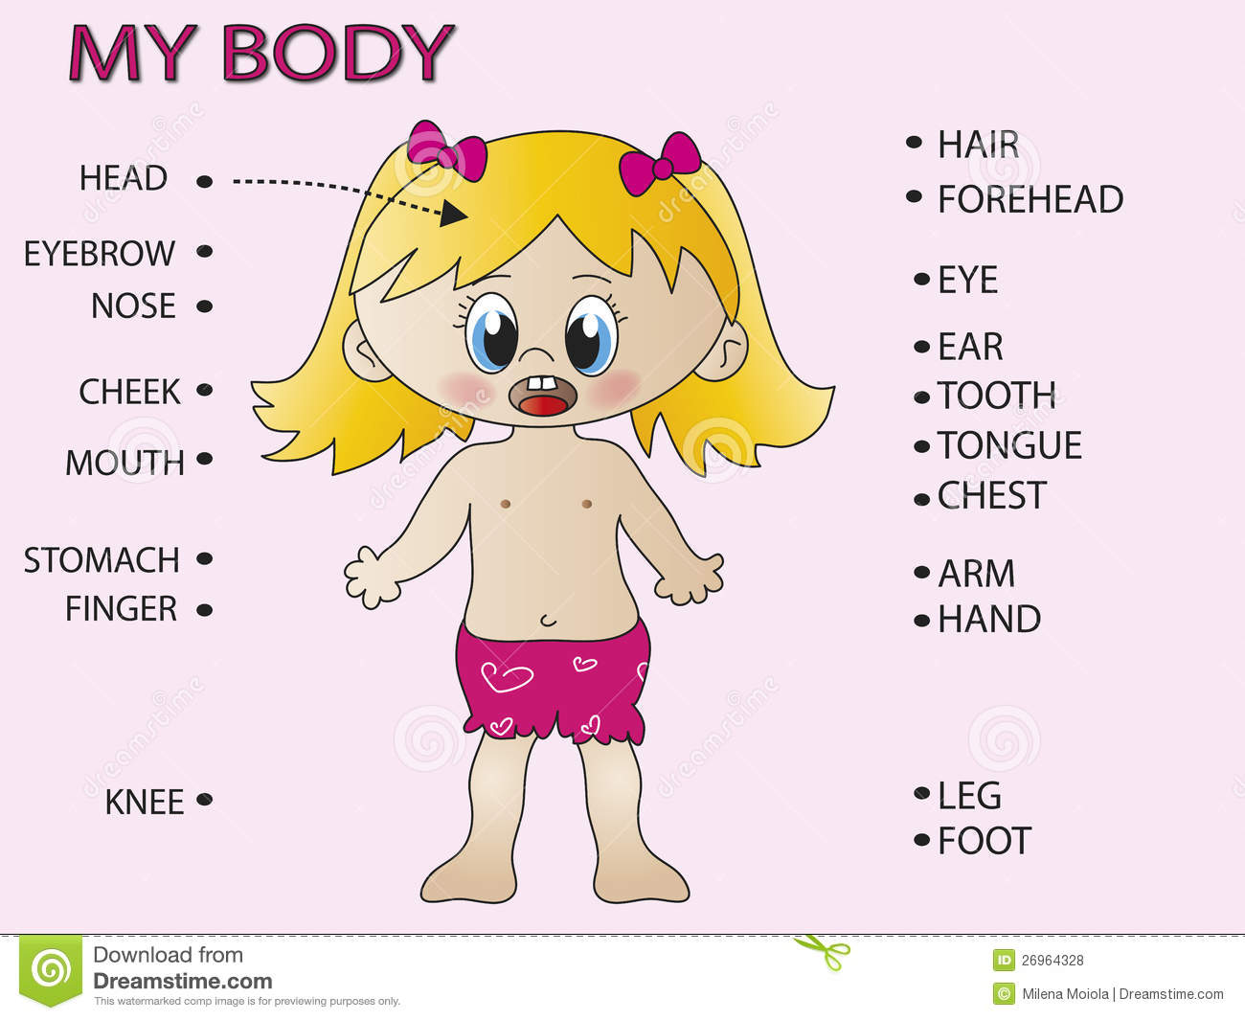

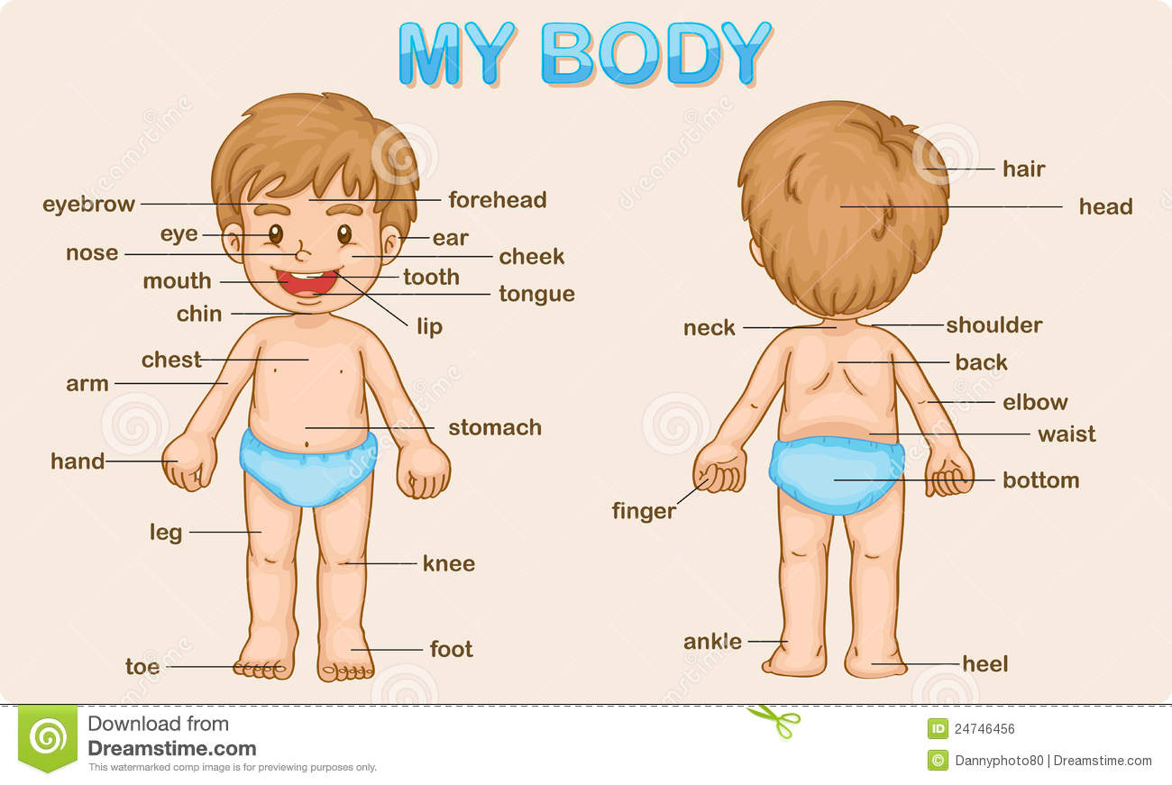
*Flesh Card
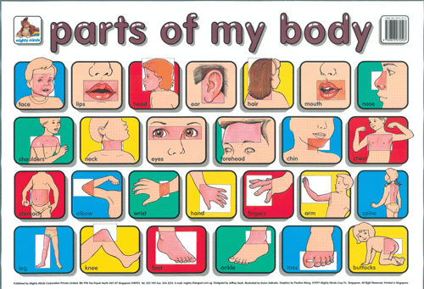
*Name Card
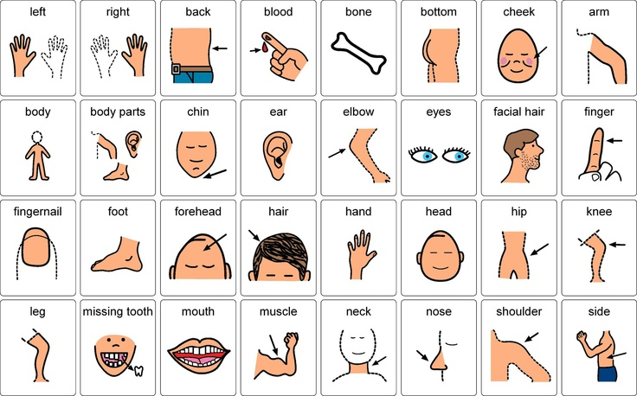
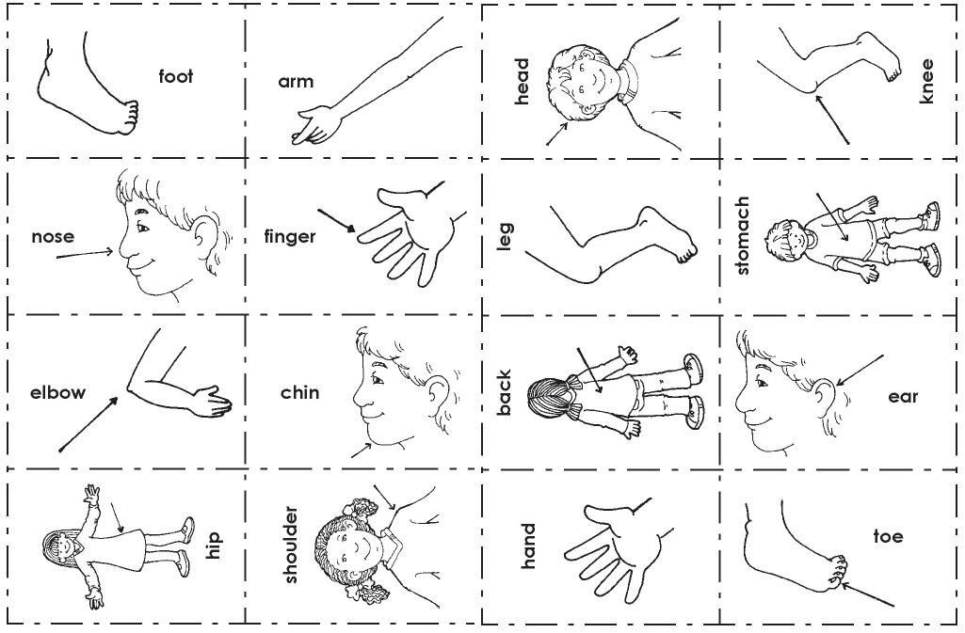
*Worksheet
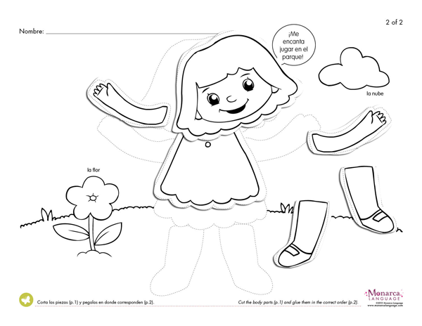

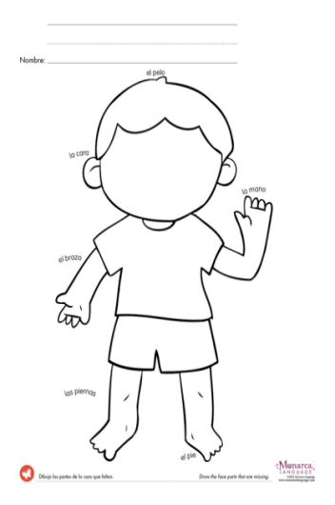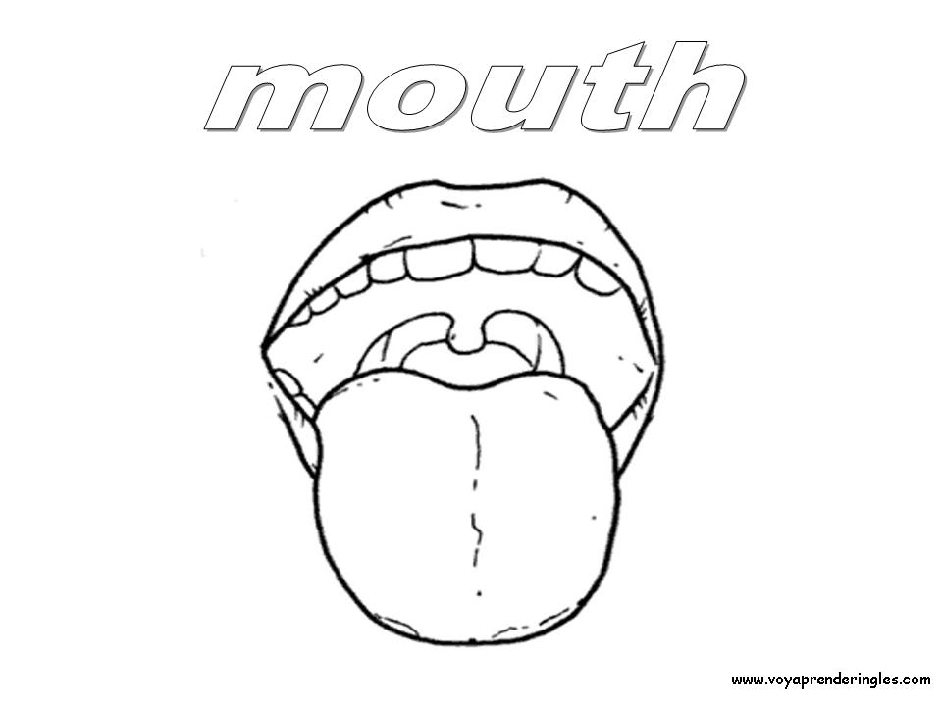
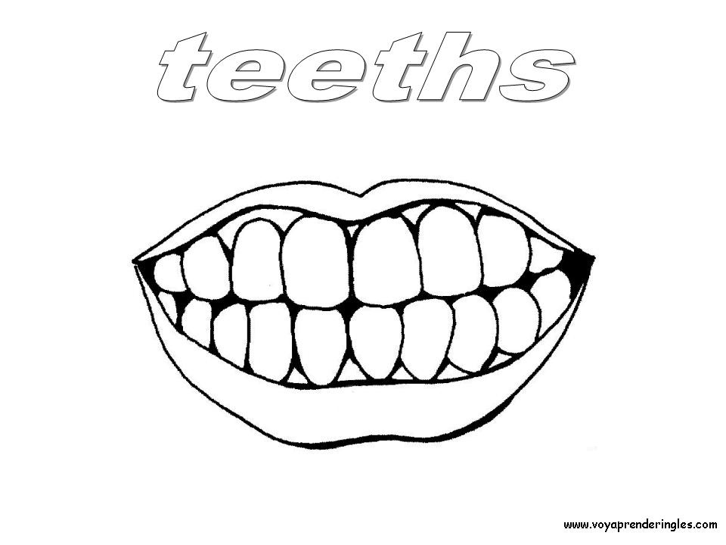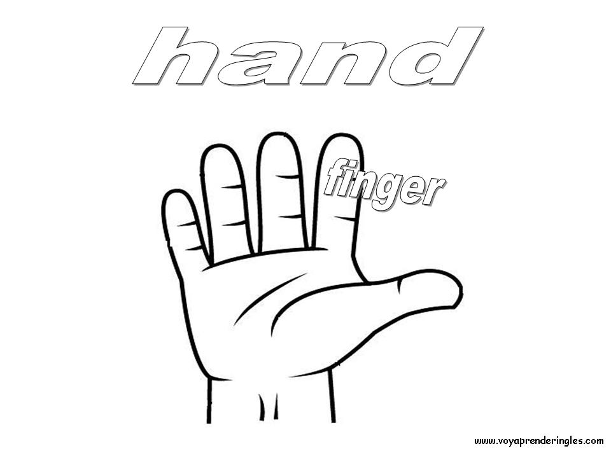

*Song (lylics)
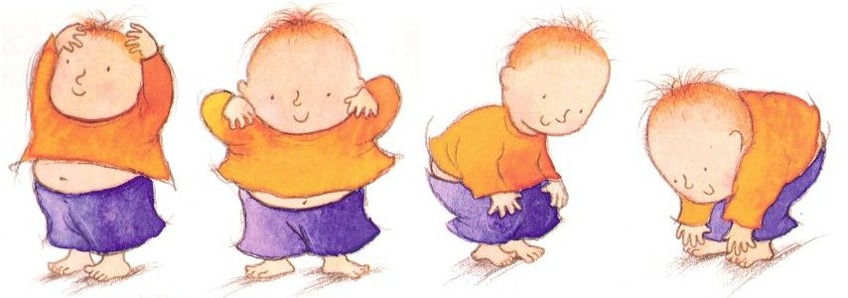
Head and shoulders knees and toes
Head and shoulders knees and toes Knees and toes
Head and shoulders knees and toes Knees and toes
And eyes and ears And mouth and nose
Head and shoulders knees and toes Knees and toes
Feet and tummies arms and chins Arms and chins
Feet and tummies arms and chins Arms and chins
And eyes and ears And mouth and shins
Feet and tummies arms and chins Arms and chins
Hands and fingers legs and lips Legs and lips
Hands and fingers legs and lips Legs and lips
And eyes and ears And mouth and hips
Hands and fingers legs and lips
Legs and lips
Repeat first verse
-------------------------------------------------------------------------------------------
Move your body
Move your body
Clap your hands ( clap clap clap )
Kick your feet ( kick kick kick )
Jump over your leg ( jump jump jump)
Move your body
Repeat first verse

