Listening Lesson Plan (PPP Lesson Plan)

Topic: Let’s Listen a song called “A way back into Love”
Instructor | Level | Age | Number of students | Length
Sally Seo | High intermediate | Adult | 9 | 50 minutes

Materials:
- YouTube access so that Students listen to the song
One without Lyrics. One with Lyrics on
- Lyrics worksheet with blanks to fill in (9 copies)
- poster of Movie “ Music and Lyrics, 2007”

Aims:
- To practice listening skills by listening to the song
- To practice speaking when discussing with group members
- To improve writing skills through remaking students own lyrics

Language skills:

- Listening : Listen to the music, teachers instruction and classmates opinions
- Speaking : verbally sharing opinions and information
- Writing : filling out blanks of lyrics and re-making lyrics
- Reading : reading lyrics out loud after completing

Language systems:

- Phonology : Students focus on pronunciation by listening and reading out lyrics
- Lexis : Vocabulary used in the song
- Grammar: Students know present perfect progress ( Have been ~ing) in the song
- Discourse : Expressing opinions
- Function : To understand the lyrics and re-make own lyrics

Assumptions:
- Students already know most of vocabulary of the lyrics
- Students are at a high intermediate level and have already know how to express their opinions and write in English
- Students are mostly active and familiar working in groups.

Anticipated Errors and Solutions:
- The main activity may finish earlier than expected
Review the topic and get feedback from students
Have SOS activity prepared
- Internet connection problem might take placed during class
Save them in USB as well as smart phone.

References:
- YouTube, A Way back into love http://youtu.be/m3Ztq2hu5Kg
- http://Google.com/search

Notes:
- Students must be monitored during practice and production. Teacher to involve in the process so that students can complete practice and production in time

Presentation:
Materials: Poster of movie “ music and lyrics”
Time | Set Up | Student | Teacher
5 mins | Pair | Students will discuss their favorite movies and OST in pair. Exchange opinion why they like. | Greeting  Ask guiding questions and elicit
2 mins | Whole class | Students will guess the OST upon seeing poster of movie and share their ideas. | Show poster of the movie “Music and lyrics” and elicit the OST from the movie
Notes:
Give teacher’s favorite movies and OST to guide if necessary

Practice:
Materials: Youtube for song and music video, Worksheet 1 and pens
Time | Set Up | Student | Teacher
10 mins | individual | Student will listen to song twice and filling the blanks of lyrics in the worksheet.  1st time will be full version of song without worksheet.  2nd time of playing, song will be stopped 3 times for student to have time to fill in blanked lyrics | Give instruction  ICQ  Play music twice. ( No screen)  Monitor
10 mins | 3 Groups | Student will check what they heard and help to complete full lyrics.  Each group will read out loud each paragraph after completing. | Give instruction  ICQ  Monitor
5 mins | 3 Groups | Listening song 3rd time but with Lyrics on the screen.  Student will check what they are missing or wrong. | Give instruction  Play music video with lyrics  Monitor
Notes:
Monitoring students is essential as they will be filling blanked part of lyrics so their attention to listening and discussing in groups is important in completing task.

Production:
Materials: pen and paper
Time | Set Up | Student | Teacher
10 mins | 3 Groups | Students will change some words in lyrics to make their own lyrics | Give instruction  ICQ  Monitor
6 mins | 3 Groups | Each group will sing a song with new lyrics | Give instruction  Monitor
Notes:
Monitoring is particularly important to ensure that stronger students are not too influential in the completion of task.
Engage with student to complete take in time.
Encourage student sing a song with their lyrics to make it interesting. If some group are not willing, have them reading out loud can be option.

Post Activity
Materials:
Time | Set Up | Student | Teacher
2 mins | Whole class | Students give feedback about usefulness of class | Elicit feedback
Notes:

Poster of Movie- music and lyrics
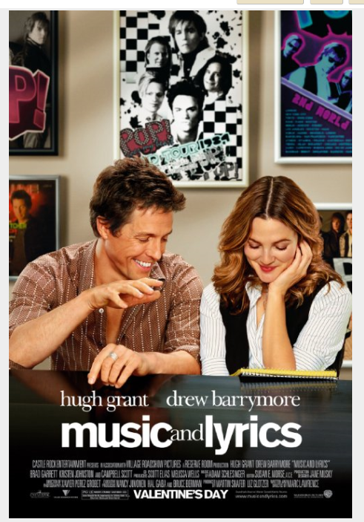

Worksheet 1
Pls fill blanks.
“A way back into Love”

I’ve with a . I’ve with a my bed.
I’ve been for . in the , I just can’t to on.
I’ve been all my and . I em again some day
I’ve been . To clear in the of my mind
All is find a way back into love. I can’t a way back into love.

I’ve been but the . I’ve been but I just don’t .
I know that . There for my .
I’ve been someone to .Not somebody the night
I could some . And I am to your .
All is find a way back into love. I can’t a way back into love.
And if I again. I I am you will be .

There are when I don’t . Or feels the way .
I need . Not just another .
All is find a way back into love. I can’t a way back into love.
And if I to you. I am you will me .
And if you me to . You know that for you .

Full lyrics ( for teacher’s keep)

“A way back into Love”
I’ve been living with a shadow overhead. I’ve been sleeping with a cloud over my bed.
I’ve been lonely for so long. Trapped in the past , I just can’t seem to move on.
I’ve been hiding all my hopes and dreams away. Just in case I ever need em again some day
I’ve been setting aside time. To clear a little space in the corners of my mind
All I want to do is find a way back into love. I can’t make it through without a way back into love.

I’ve been watching but the stars refused to shine. I’ve been searching but I just don’t see the signs.
I know that it’s out there. There’s got to be something for my soul somewhere.
I’ve been looking for someone to shed my lights. Not somebody just get me through the night.
I could use some direction. And I am open to your suggestion.
All I want to do is find a way back into love. I can’t make it through without a way back into love.
And if I open my heart again. I guess I am hoping you will be there for me in the end.

There are moments when I don’t know if it’s real. Or if anybody feels the way I feel.
I need inspiration. Not just another negotiation.
All I want to do is find a way back into love. I can’t make it through without a way back into love.
And if I open my hearts to you. I am hoping you will show me to start again.
And if you help me to start again. You know that I will be there for you in the end.

