Speaking Lesson Plan
Topic: Who is this?
Instructor | Level | Age | Number of students | Length
Jin Hyung Kim | Intermediate | 10-12 grades | 7 | 50 min

Materials: Caricatures 1,2,3, work sheet 1,2,3,4, paper, pencil and marker,cards, SOS plans

Aims:
Learning vocabulary about face and shapes of facial features.
Learning about their own shapes of facial features.
Learning how to verbally describe how faces look.
Learning how to verbally describe how drawings look.

Language skills:
Speaking : Presentation of their caricatures and facial features.
Reading : Reading about shape descriptions
Listening : Listening other people’s presentation

Language systems:
Lexis : Vocabulary of faces and shapes of head, eyes, ears and mouths.
Phonology : Right pronunciation of words.
Grammar : Present tense for facial shapes.
Function : Specific usages of words describing shapes of facial parts.

Assumptions:
Students have interests in celebrities.
Students can recognize basic shapes of human faces.

Anticipated Errors and Solutions:
Students could have hard time to draw face - they can draw with basic shapes and also reference worksheet.
Time left - SOS plan

References:
http://www.cruzine.com/2011/11/09/caricature-illustrations/
http://www.ayblog.com/tom-cruise-funny-caricature/
http://www.chilloutpoint.com/art_and_design/31-funny-caricatures-of-the-celebrities.html
http://www.healthandstyleinstitute.com/blog/2012/12/28/makeup-and-face-shape-what-works-for-you/
http://pakifashion.com/try-lipstick-according-to-lip-size-shape/
http://www.girlsaskguys.com/how-do-i-look/q1385102-ear-shape-preference-help-please
https://www.pinterest.com/pin/510947520198815791/

Notes:

Presentation: Introduction about caricature
Aim: Getting hints about shapes used by caricatures. |  |  | Materials: Work sheet about facial features and shapes
Time | Set Up | Student |  | Teacher
2min  3min | Whole Class  Whole Class | Guessing whom the caricature is.  Answering what kind of shapes artists use for caricatures. |  | Guiding questions and elicit answers about it and caricatures of celebrities  Elicit answers about shapes
Notes: Introduce some new words about shapes.

Practice: Practicing with work sheet
Aim: Learn about facial shapes and vocabulary |  |  | Materials: Work sheet and pencil
Time | Set Up | Student |  | Teacher
15min  5min | Whole  Class  Pair | Working on work sheet learning about shapes of facial features.  Discussing about each other's facial shapes. |  | Hand out work sheet and elicit answers and teach them new vocabularies.  Give clear instruction and let them discuss about partner's face-ICQ
Notes: Give all answers of work sheet.

Production: Drawing students' own caricature by hearing partner's description and show and tell about it.
Aim: - Describing shapes and features of faces.  - Drawing him/herself and verbally present. |  |  | Materials: paper and marker
Time | Set Up | Student |  | Teacher
12min  12min | Pair  Whole Class | Drawing his/her own caricature by getting help from partners' description and discuss about it with partners. Students should follow partner's description.  Each person show and tell his/her drawing; shapes, facial features. |  | Give Clear instruction and demonstration, ICQ  Give Instruction
Notes: No mirrors or photos should be used. They could research words for other facial parts.

Post Activity : Getting Feedback
Materials:
Time | Set Up | Student | Teacher
1 min | Whole Class | Giving feedback to teacher. | Ask how was the activity.
Notes:

Caricature1
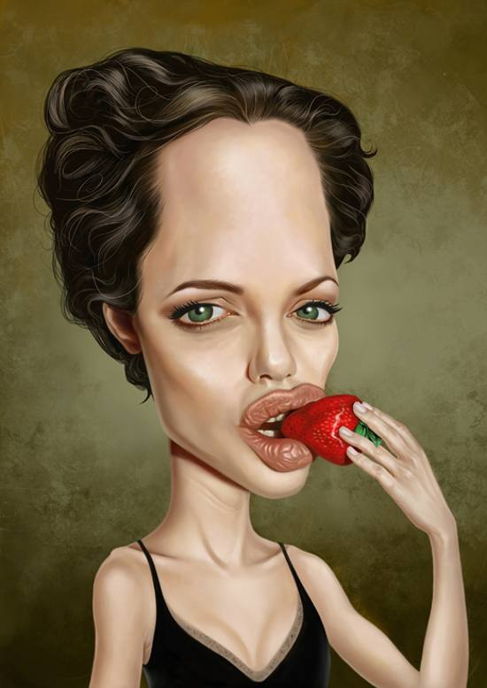

Caricature2
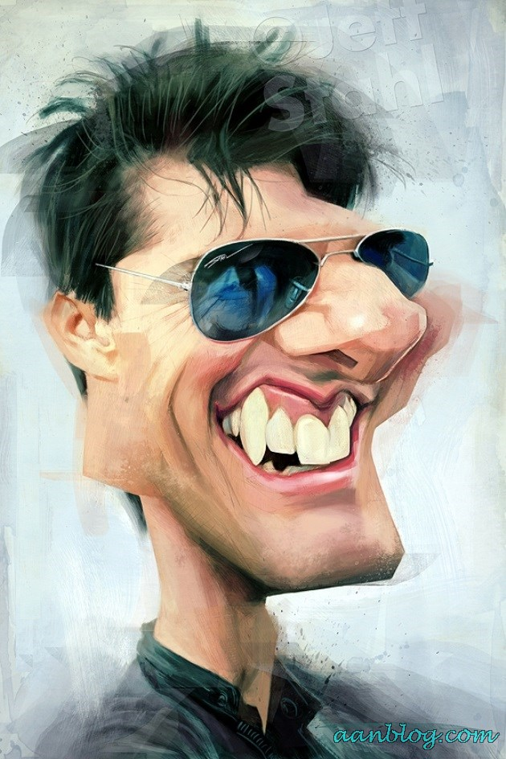
Caricature3
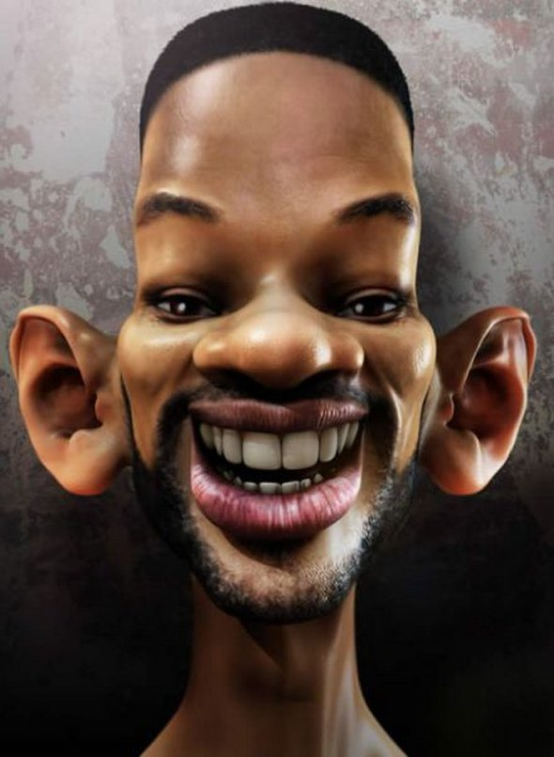

Worksheet 1.
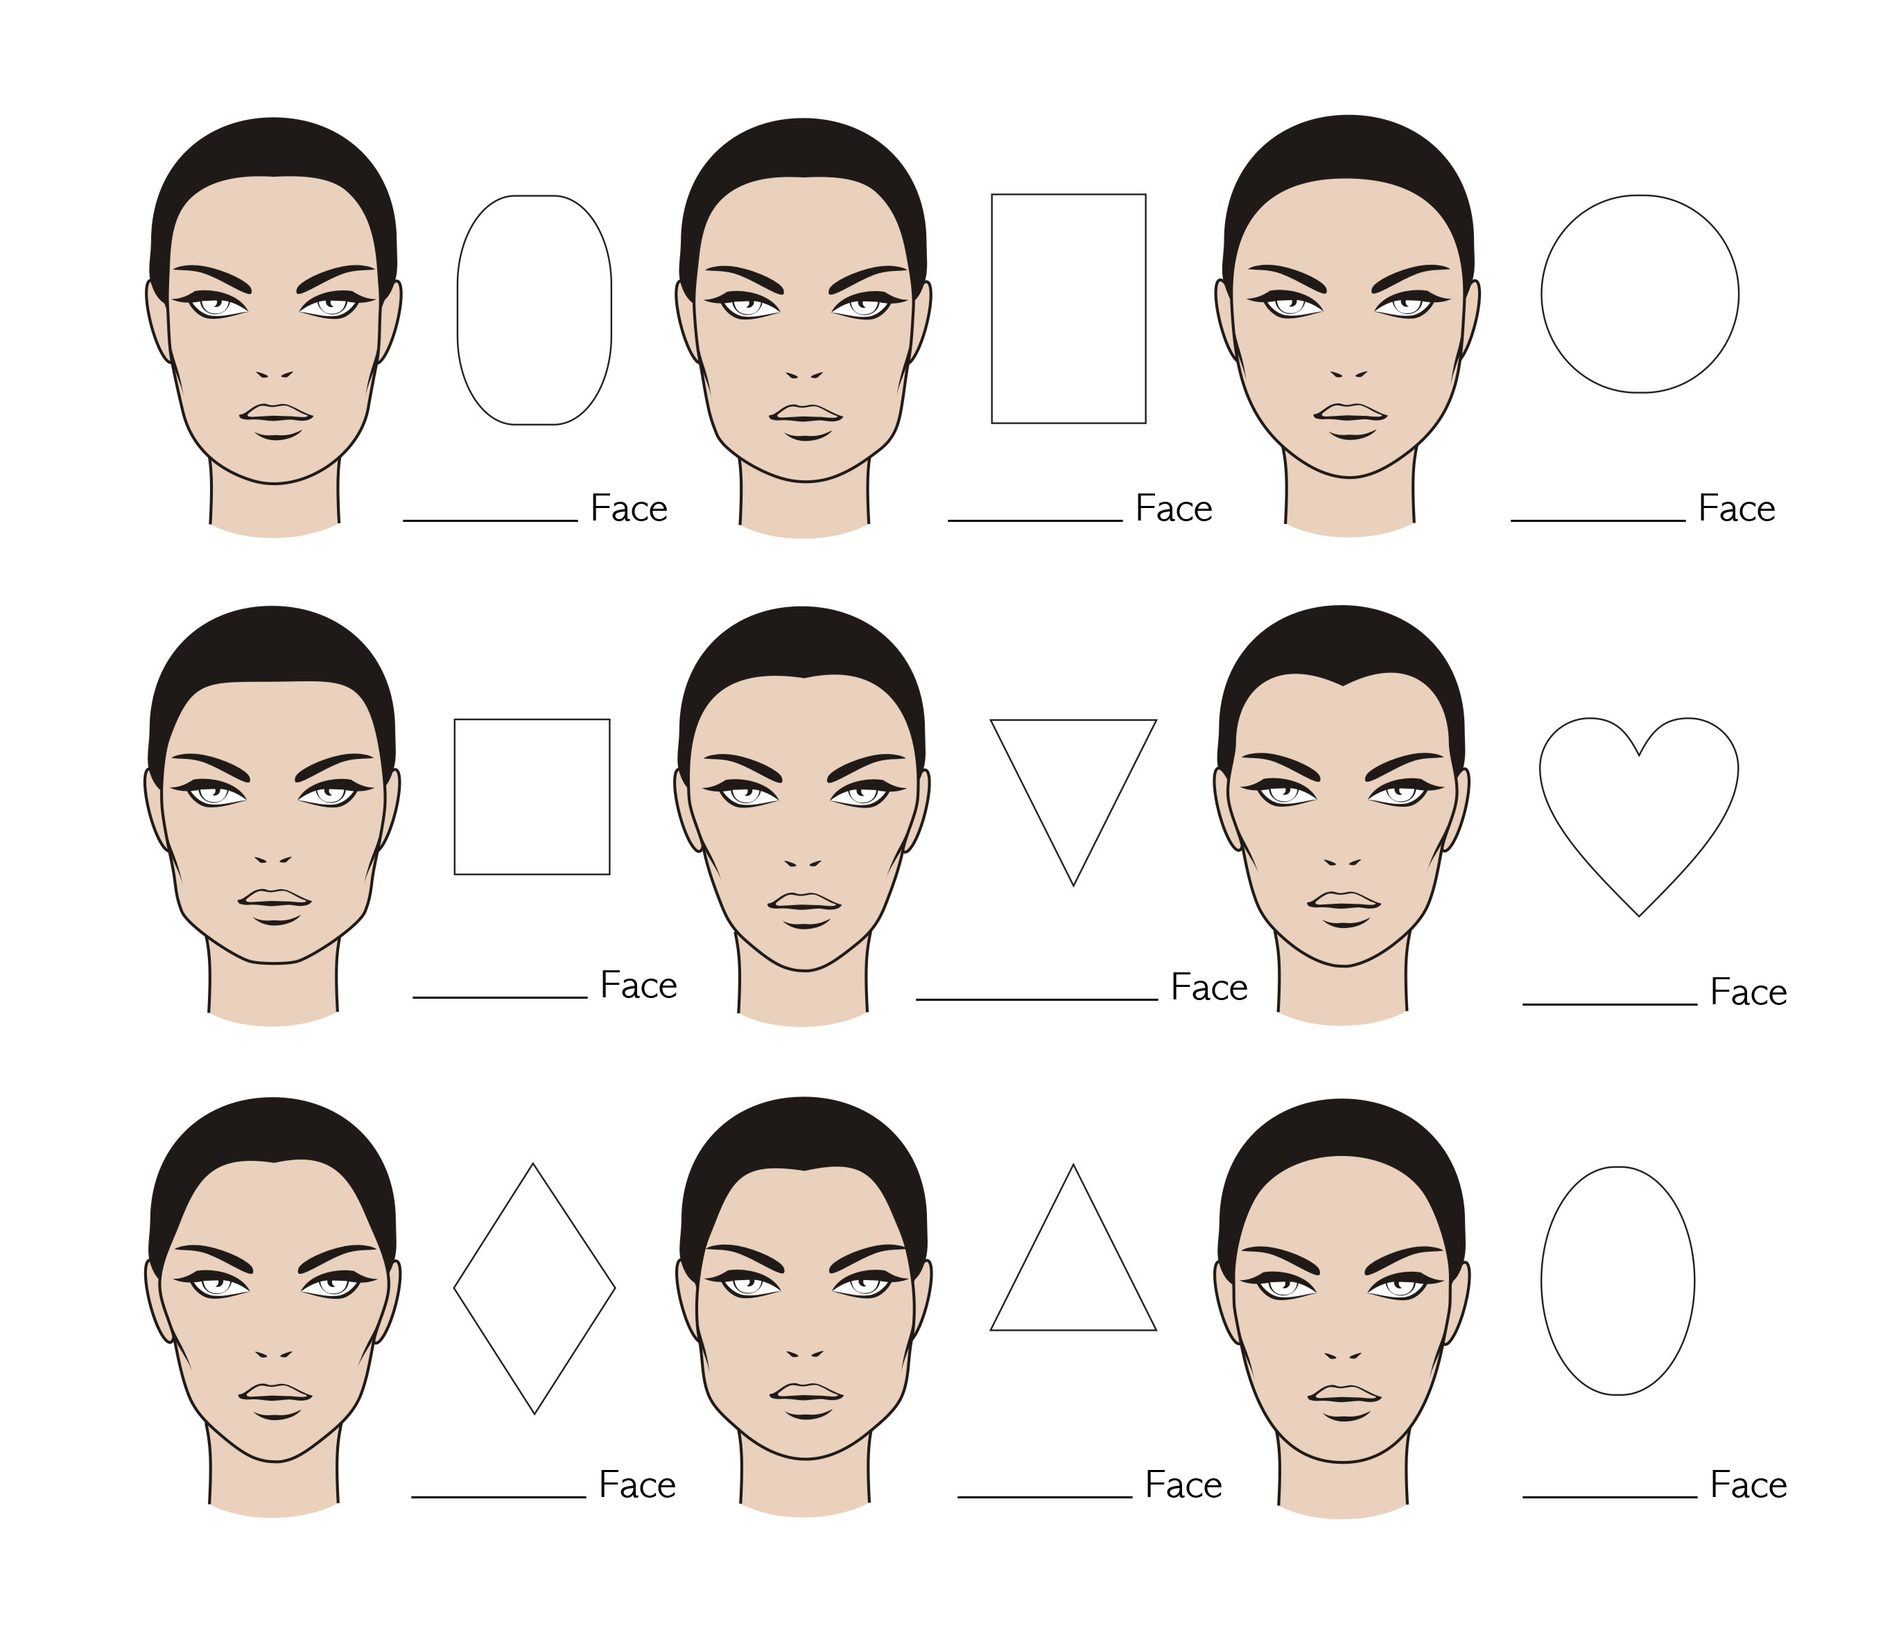

Worksheet 2.
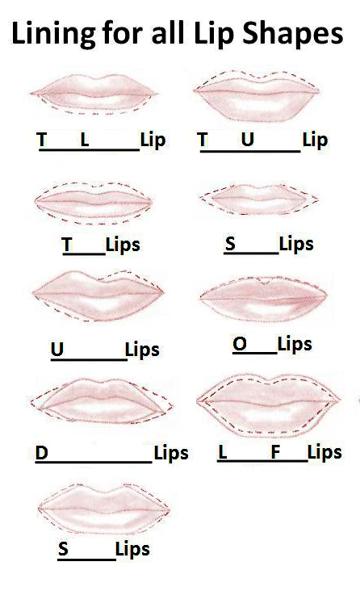

Worksheet 3.

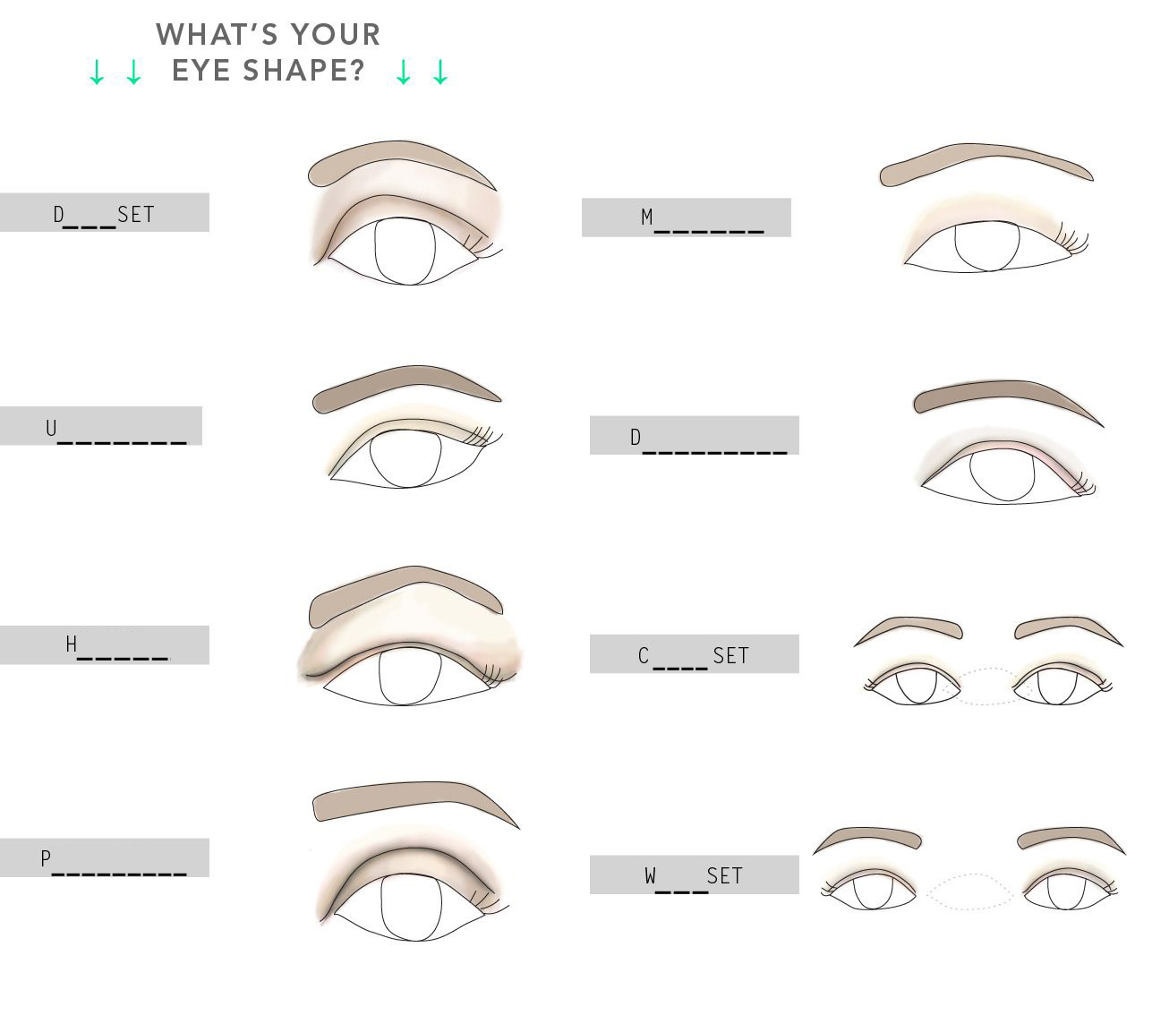

Worksheet 4.
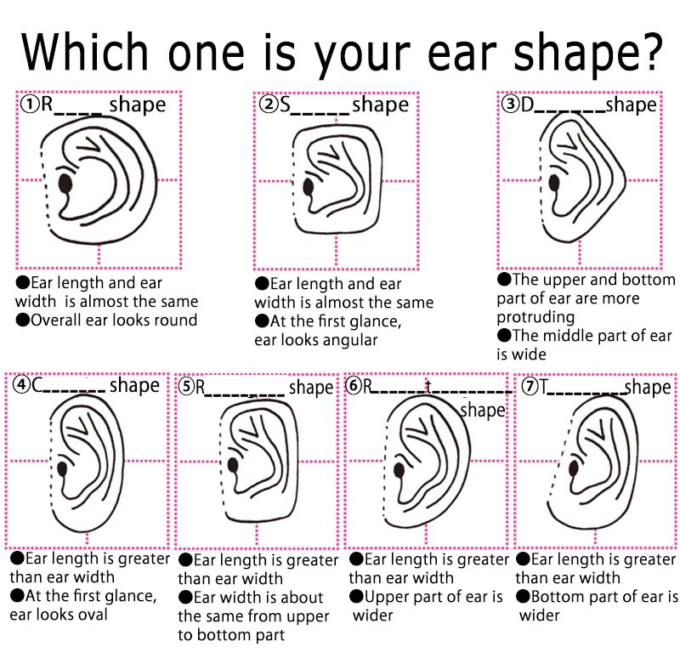

Answers

<Worksheet 1>
Long, Rectangle, Round
Square, Inverted Triangle, Heart
Diamond, Triangle, Oval
<Worksheet 2>
Thin Lower Upper
Thin Small
Uneven Oval
Downturn Large Full
Sharp
<Worksheet 3>
Deep Monolid
Upturned Downturned
Hooded Close
Protruding Wide
<Worksheet 4>
Rectangle Square Diamond
Crescent Rectangle Reverse Triangle Triangle

