TBLT Lesson Plan
Topic: Dracula by Bram Stoker
Instructor | Student’s Level | Age group | Number of Students | Length
Ahyoung Shin (Katie) | Upper/High Intermediate | 18 | 10 | 50 min
Materials:
- Work sheet #1 (12 copies)
- Work sheet #2 (12 copies)
- Matching Card
- Power point
- Projector and computer
Aims:
- Students will learn about Bram Stocker
- Students will practice reading skill through short reading passages from the book ‘Dracula’.
- Students will learn their listening by explanation and instruction.
- Students will develop reading comprehension when they do an activity
Language skills:
- Listening: Listening to teacher’s instruction and lecture about ‘Dracula’
- Reading: reading comprehensions from T/F questions and matching card
- Speaking: Discussion for matching card and T/F questions
Language systems:
- Phonology: Listen to lecture of Dracula and instruction
- Function: Solve short T/F questions
- Lexis: New vocabulary from the reading
- Grammar: See structure from the reading
- Discourse: reading comprehension
Assumptions:
- Students know many vocabularies.
- Students have a literature class.
- Students have high reading skill.
Anticipated Errors and Solutions:
- Student will not understand reading
- Reading comprehension (T/F question)
- Students will not interested the lecture
- Short time video
- Group activity with competition
References:
- https://www.youtube.com/watch?v=QMvD2Jlyy9U
- http://www.planetebook.com/ebooks/Dracula.pdf
- https://prezi.com/ovmr3wgmlujx/edit/#26_238900 (Power point)
- Ebook (56p~57P)
Note:
- Check internet is working well for Priz (power point)

Practice: Lecture of Dracula
Aims | Materials
- Students are getting information about Bram Stoker.  - Learn new literature and develop listening skill. | - Priz (presentation)  - Computer, Internet, projector
Time | Setup | Students | Teacher
5 min | Whole class | Students watch a video clip and listening a lecture. | Teacher presents about information of the Dracula and the author.
Note:
- Monitoring during lecture
- Play video clip just 1 min.

Production: Reading short passage and matching card
Aims | Materials
- Develop Reading skill  - Sharing opinions | - Work sheet #1  - Matching card

Time | Setup | Students | Teacher
3 min | Whole class | - Reading a part of the Dracula. | - Give instruction  - Monitoring
12 min | 2 Groups | - Matching card with group members  - Sharing opinions for matching card | - Give instruction  - ICQ  - Monitoring (passive)  - Prepare for tape to stick on the white board
Note:
- Time warning before 1 min

Post Activity: T/F questions
Aim | Materials
- Check what they understand | - Work sheet #2

Time | Setup | Students | Teacher
3 min | Group | - Solve T/F questions  - Discussion for answer | - Giving work sheet and instruction  - ICQ  - Monitoring
2 min | Whole class | - Check the answer | - Feed back
Note:
- Answer: F, T, F, T, F, F, T
- Feed back!!

Work sheet #1 (Reading)
2. The other was fair, as fair as can be, with great masses of golden hair and eyes like pale sapphires. I seemed somehow to know her face, and to know it in connection with some dreamy fear, but I could not recollect at the moment how or where. All three had brilliant white teeth that shone like pearls against the ruby of their voluptuous lips. There was something about them that made me uneasy, some longing and at the same time some deadly fear. I felt in my heart a wicked, burning desire that they would kiss me with those red lips. It is not good to note this down, lest some day it should meet Mina’s eyes and cause her pain, but it is the truth. They whispered together, and then they all three laughed, such a silvery, musical laugh, but as hard as though the sound never could have come through the softness of human lips. It was like the intolerable, tingling sweetness of water glasses when played on by a cunning hand. The fair girl shook her head coquettishly, and the other two urged her on. One said, ‘Go on! You are first, and we shall follow. Yours is the right to begin.’ The other added, ‘He is young and strong. There are kisses for us all.’ I lay quiet, looking out from under my eyelashes in an agony of delightful anticipation. The fair girl advanced and bent over me till I could feel the movement of her breath upon me. Sweet it was in one sense, honey-sweet, and sent the same tingling through the nerves as her voice, but with a bitter underlying the sweet, a bitter offensiveness, as one smells in blood. I was afraid to raise my eyelids, but looked out and saw perfectly under the lashes. The girl went on her knees, and bent over me, simply gloating. There was a deliberate voluptuousness, which was both thrilling and repulsive, and as she arched her neck she actually licked her lips like an animal, till I could see in the moonlight the moisture shining on the scarlet lips and on the red tongue as it lapped the white sharp teeth. Lower and lower went her head as the lips went below the range of my mouth and chin and seemed to fasten on my throat. Then she paused, and I could hear the churning sound of her tongue as it licked her teeth and lips, and I could feel the hot breath on my neck. Then the skin of my throat began to tingle as one’s flesh does when the hand that is to tickle it approaches nearer, nearer. I could feel the soft, shivering touch of the lips on the super sensitive skin of my throat, and the hard dents of two sharp teeth, just touching and pausing there. I closed my eyes in languorous ecstasy and waited, waited with beating heart.

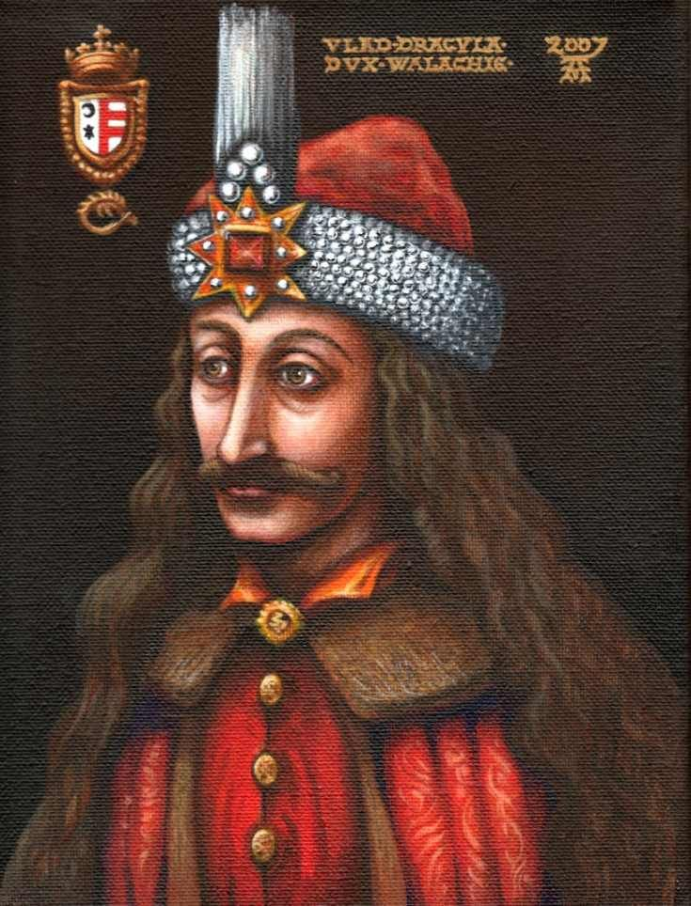

Matching card right order
- I was not alone. The room was the same, unchanged in any way since I came into it. I could see along the floor, in the brilliant moonlight, my own footsteps marked where I had disturbed the long accumulation of dust. In the moon- light opposite me were three young women, ladies by their dress and manner. I thought at the time that I must be dreaming when I saw them, they threw no shadow on the floor.
- They came close to me, and looked at me for some time, and then whispered together. Two were dark, and had high aquiline noses, like the Count, and great dark, piercing eyes, that seemed to be almost red when contrasted with the pale yellow moon. But at that instant, another sensation swept through me as quick as lightning.
- I was conscious of the presence of the Count, and of his being as if lapped in a storm of fury. As my eyes opened involuntarily I saw his strong hand grasp the slender neck of the fair woman and with giant’s power draw it back, the blue eyes transformed with fury, the white teeth champing with rage, and the fair cheeks blazing red with passion.
- But the Count! Never did I imagine such wrath and fury, even to the demons of the pit. His eyes were positively blazing. The red light in them was lurid, as if the flames of hell fire blazed behind them. His face was deathly pale, and the lines of it were hard like drawn wires.
- The thick eyebrows that met over the nose now seemed like a heaving bar of white-hot metal. With a fierce sweep of his arm, he hurled the woman from him, and then motioned to the others, as though he were beating them back. It was the same imperious gesture that I had seen used to the wolves. In a voice, which, though low, and almost in a whisper seemed to cut through the air and then ring in the room he said,
- ‘How dare you touch him, any of you? How dare you cast eyes on him when I had forbidden it? Back, I tell you all! This man belongs to me! Beware how you meddle with him, or you’ll have to deal with me.’
- The fair girl, with a laugh of ribald coquetry, turned to answer him. ‘You yourself never loved. You never love!’ On this the other women joined, and such a mirthless, hard, soulless laughter rang through the room that it almost made me faint to hear. It seemed like the pleasure of fiends.

Work sheet #2 (Post activity)
T/F Question

1. She licked her lips and bite Jonathan’s neck using sharp teeth. T/F

2. There were three young women. T/F

3. The story is the nightmare of Jonathan. T/F

4. Two women have dark hair, high aquiline noses. T/F

5. Jonathan was kidnaped from Dracula. T/F

6. Three women meet Mina before they meet him. T/F

7. She paused his neck and he could feel the hot breath. T/F

Matching card
I was not alone. The room was the same, unchanged in any way since I came into it. I could see along the floor, in the brilliant moonlight, my own footsteps marked where I had disturbed the long accumulation of dust. In the moon- light opposite me were three young women, ladies by their dress and manner. I thought at the time that I must be dreaming when I saw them, they threw no shadow on the floor. | They came close to me, and looked at me for some time, and then whispered together. Two were dark, and had high aquiline noses, like the Count, and great dark, piercing eyes, that seemed to be almost red when contrasted with the pale yellow moon. But at that instant, another sensation swept through me as quick as lightning.
I was conscious of the presence of the Count, and of his being as if lapped in a storm of fury. As my eyes opened involuntarily I saw his strong hand grasp the slender neck of the fair woman and with giant’s power draw it back, the blue eyes transformed with fury, the white teeth champing with rage, and the fair cheeks blazing red with passion. | But the Count! Never did I imagine such wrath and fury, even to the demons of the pit. His eyes were positively blazing. The red light in them was lurid, as if the flames of hell fire blazed behind them. His face was deathly pale, and the lines of it were hard like drawn wires.
The thick eyebrows that met over the nose now seemed like a heaving bar of white-hot metal. With a fierce sweep of his arm, he hurled the woman from him, and then motioned to the others, as though he were beating them back. It was the same imperious gesture that I had seen used to the wolves. In a voice, which, though low, and almost in a whisper seemed to cut through the air and then ring in the room he said, | How dare you touch him, any of you? How dare you cast eyes on him when I had forbidden it? Back, I tell you all! This man belongs to me! Beware how you meddle with him, or you’ll have to deal with me.’
The fair girl, with a laugh of ribald coquetry, turned to answer him. ‘You yourself never loved. You never love!’ On this the other women joined, and such a mirthless, hard, soulless laughter rang through the room that it almost made me faint to hear. It seemed like the pleasure of fiends.

