PPP Reading Lesson Plan
Topic: Sitting may be dangerous for your health
Instructor | Level | Age | Number of students | Length
Jin Hyung Kim | Advanced | 20+ | 7 | 50 min

Materials: Comic strip 1,2,3,4,5,6,7 Worksheet, article, pencil, cards, SOS/planB

Aims:
Learning about danger of sedentary life by reading article.
Learning vocabulary about health by guessing and sharing.
Learning how to share your opinions by discussing.

Language skills:
Reading: Reading the article and comic strips about sedentary life.
Speaking: Discussing about health issues on modern life.
Listening: Listening to other people’s opinions.

Language systems:
Lexis: Vocabulary of Health.
Phonology: Right pronunciation of new words.
Grammar: Present tense for facts and daily lives.
Discourse: Understanding the dialogues from comic strips

Assumptions:
Students have experiences of sedentary life.
They are not familiar with several words in the article.
Comic strip will draw students’ attention for teaching vocabulary.

Anticipated Errors and Solutions:
Students could have hard time to understand cartoon strip - let them teach each other
Time left - SOS/planB

References:
http://www.breakingnewsenglish.com/1506/150609-sitting.html
http://bikezou.blogspot.kr/2010/03/does-more-technology-more-sedentary.html
http://www.thecomicstrips.com/subject/The-Sedentary-Comic-Strips-by-Pickles.php

Notes: Don't use "sedentary" for introductory comic strip - you can use "inactive" instead.
Introduce the comic strips and then hand them out to students.

Presentation: introduction to sedentary and active life
Aim: Giving hints about the topic |  |  | Materials: Comic strip 1,2,3, Worksheet.
Time | Set Up | Student |  | Teacher
1min  1min  3min  5min | Whole Class  Whole Class  Whole Class  Pair | Walk around and sit down.  Answering what kind of feeling they had.  Answering sedentary and active life style.  Discussing with T/F questions |  | Tell students walk around and sit down, and let them think how they feel while doing that.  Ask how they feel when they walk and sit  Elicit answers about sedentary and active life style by guiding questions and comic strips  Give instruction and then hand out worksheet 1.ICQ
Notes: Let them think about the topic ahead by questions.

Practice: Reading the article
Aim: Comprehend the article and vocabulary |  |  | Materials: Comic strip 4,5,6, article
Time | Set Up | Student |  | Teacher
10min  6min  8min | Whole  Class  Individual  Pairs | Guessing words  Read the article  Make 3 questions questions with partner and answer each other's questions. |  | Teach them new vocabularies by using comic strips - CCQ  Hand out the article-ICQ  Let them make their own 3 comprehensive questions and aks questions to their partner.
Notes: Let them guess the meaning of words by using some dialogues in comic strips.

Production: Read comics and discuss about sedentary life and active life
Aim: Share opinions about life styles. |  |  | Materials: Comic strip 7
Time | Set Up | Student |  | Teacher
2min  11min | Whole Class  Pair | Listen to instruction.  Read and discuss about what would be the healthy and better life. |  | Give a clear instruction and demonstration, ICQ  Monitor them.
Notes: They can use questions under the comic strips for initiating purpose.

Post Activity : Getting feedback and comprehension check
Aim: Getting feedback and evaluation |  |  | Materials: Homework assignment
Time | Set Up | Student |  | Teacher
1 min | Whole Class | Giving feedback to teacher and homework for comprehension check. |  | Ask how the activity was and give home work assignment
Notes: make sure they get the homework assignment.

Comic Strip 1.

Comic Strip 2.

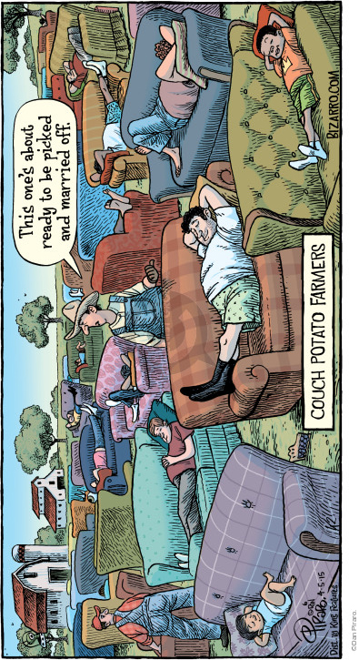
Comic Strip 3.

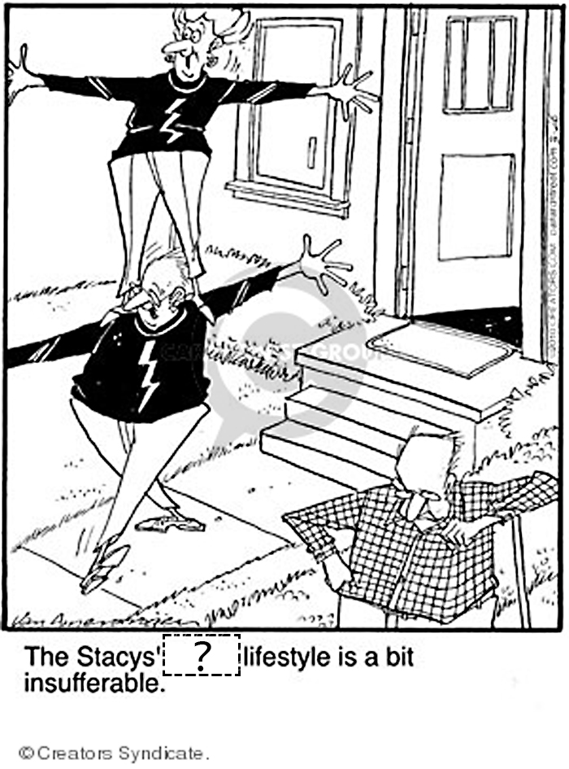

Comic Strip 4.

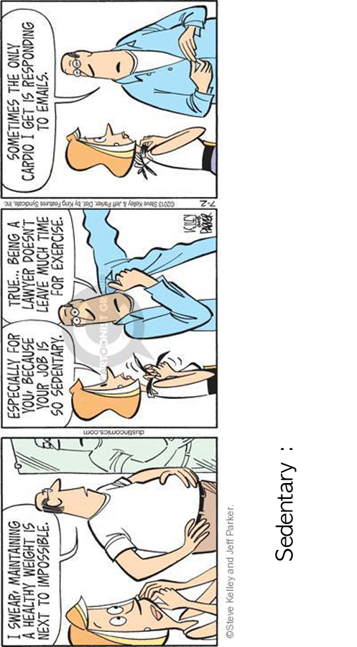

Comic Strip 5.

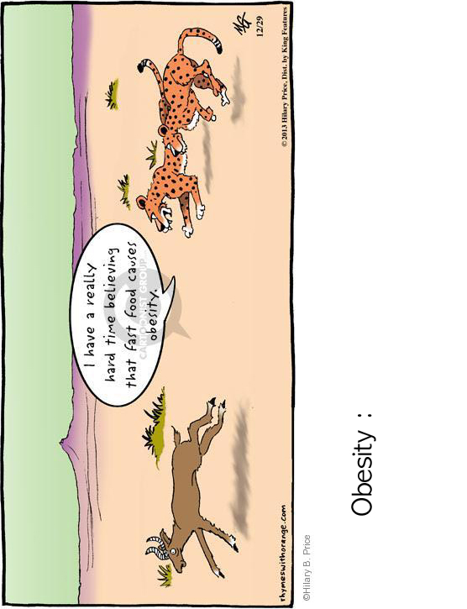

Comic Strip 6.

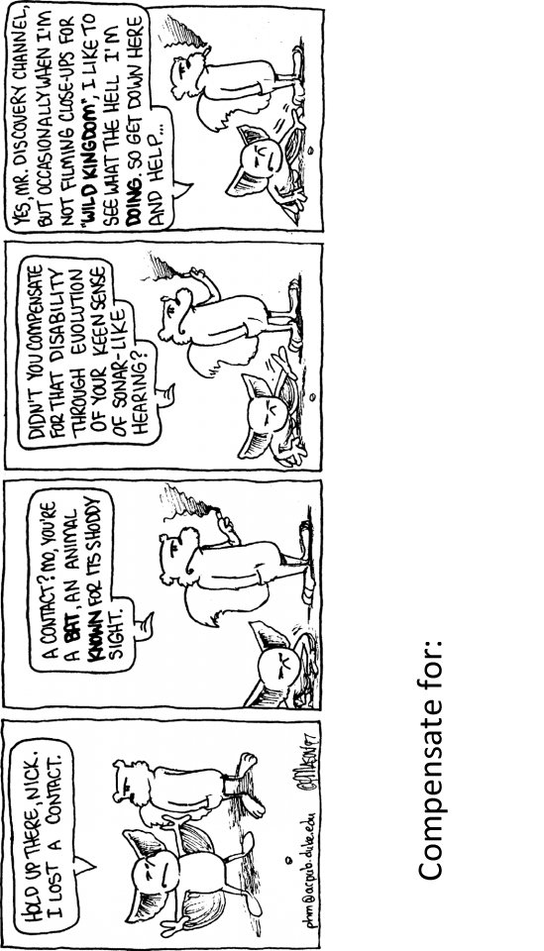

Comic Strip 7.

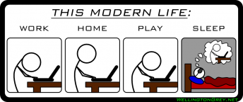

*Compare this man with your or your friends' life.

*What do you think of this "mobile" trend and effect of it?

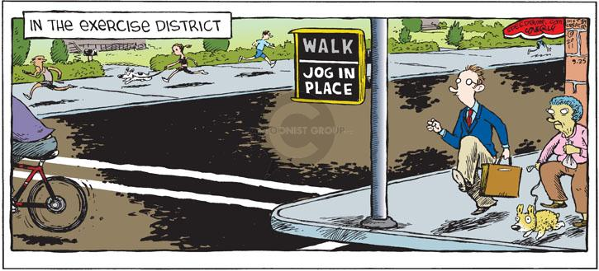

*Can you think of any solutions for healthy life?

Sitting may be dangerous for your health

If you spend most of your days sitting at school, work, at a computer or stretched out on a couch at home, you may be taking up to two years off your life. It is common knowledge that a sedentary lifestyle increases the risk of heart disease, type 2 diabetes, cancer and obesity, and can result in premature death. Many people think they can compensate for sitting around by walking, playing sports or going to the gym. Unfortunately, this might not be so. A new study just published in the journal 'Annals of Internal Medicine' suggests the effect on our longevity from sitting for long periods of time cannot be reversed through exercise. Even 60 minutes of daily exercise may not be enough.
The study is from Dr. David Alter and his colleagues at Toronto University. Dr. Alter and his team analyzed 47 studies that tracked different groups of people, who kept notes on how long they sat down each day and how much they exercised. They found that the most sedentary groups had a 24% increased chance of dying during the course of the study than the least sedentary ones. This remained the case even though those who sat a lot also did 60 minutes of daily exercise. Dr. Alter writes: "Reducing your sit-down time by 2-3 hours each day by standing up at your desk, taking frequent breaks to stretch and walk, or watching TV…on your feet may be better than an expensive, crowded, smelly gym and be just what the doctor ordered."

Questions
1.
2.
3.

Work Sheet
TRUE / FALSE: Guess if a-c below are true (T) or false (F).
a. | Sitting too much could reduce your life by two years. | T / F
b. | A sedentary lifestyle increases the chances of getting diabetes. | T / F
c. | An hour of daily exercise may not reverse the damage done by sitting. | T / F

