Task based Lesson Plan
TITLE | The Starry Class
INSTRUCTOR | LEVEL | STUDENTS | AGE GROUP | LENGTH
Joy (Jieun Kim) | Lower-intermediate | 8 | 9y~11y | 20 min

MATERIALS
- White board, projector, board pen, song or video clip ♬“Twinkle Twinkle Little Star” , speaker, computer
- PPT file – 1. Vincent Van Gogh “ The starry night”
2. Characters picture for describing personality
3. Words about describing personality
4. Substitution table
- Making poster ”The starry class”
1. background paper of the poster ”The starry class” from T
( T already made: draw tree ,school and school bus in navy colored paper)
2. Part of poster “The starry class” - “My star”
- 8pcs of round shape paper (number of Ss)
- glitter color glues or manicures
- glitter color glues or manicures
- post-it
- glue or double-side tape
- color pencils or pens
(★tip: if you can, prepare every Ss pictures)

AIMS
- Ss improve their speaking and Ss can describe personality in English through activity making a poster “The starry class”.
- Ss learn to personality words naturally by activity and participation.
- Ss will be closed to friends during making a poster ”The starry class” and discover own personality by describing personality with friends.
- Ss have confidence ,fun and cooperation during making a poster ”The starry class”

LANGUAGE SKILLS
Speaking | Describing personality with friends and T
Listening | T’s instruction, Describing personality
Reading | Read words about describing personality
Writing | Writing words about describing personality

LANGUAGE SYSTEMS
Lexis | See the phonology
Phonology | intelligent, sociable, lively, humble, quiet, nervous, lazy, rude
Grammar | Ss complete the correct sentence using characters personality
Discourse | Describing, Speaking
Function | Ss can speak and make up sentence by activity for making their poster “The starry class”

ASSUMPTIONS
Ss can read simply words ( I, friends’ name, am, is …etc).
Ss already learned how to describe their feeling.
If T cannot use multimedia, show pictures with T’s voice.
Ss know each other.

ANTICIPATED ERRORS AND SOLUTIONS
Ss do not know personality words
- T show picture again and ask back.
E.g.) How do you feel when you see this picture?
- T act a play character follow meaning of words.
E.g.) nervous – T act nervous.
Ss have difficult to make the correct sentence using characters personality.
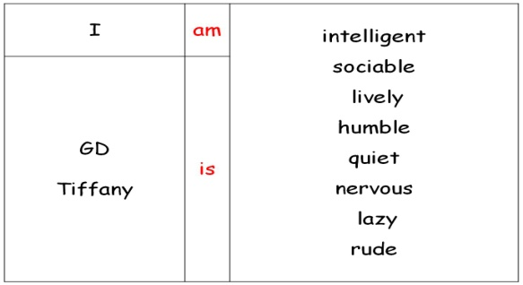
- T show substitution table and Ss speak sentence follow T’s instruction with T’s finger pointing each part.
e.g.)

REFERENCES
Words of describing personality - https://www.pinterest.com/pin/468022586248093037/ Twinkle Twinkle little star song - https://www.youtube.com/watch?v=yCjJyiqpAuU&hd=1
NOTES

Plan B

Cut-off plan : If time is not enough, T cannot explain about picture “The starry night” by Vincent Van Gogh , only show and give the CCQ about the picture to Ss.

SOS activity : If time left, T play “Guess Who? activity”.

Activity instruction : Guess Who?

1. T describe one student with 3~4 patterned sentences . e.g) She/He is kind. She/He has a pet. She/He has brown hair. She/He is smart.

2. Ss guess and answer sentence who it is after listen from T. e.g) Joy is kind. Joy has a pet. Joy has brown hair. Joy is smart.

Pre-task The starry night
Aims  Ss learn and think about words used to describe someone’s personality naturally by guessing Vincent Van Gogh’s character after seeing his picture “The starry night”. |  |  | Materials  whiteboard, board pen, projector, PPT file for picture “ The starry night” by Vincent Van Gogh
TIME | SET UP | STUDENTS |  | TEACHER
2min | Whole Class | Say hello to T with bgm “Twinkle Twinkle Little Star” |  | Greeting
 |  | Ss see the picture by Vincent Van Gogh “ The starry night” and listen from T.  Ss listen T’s feeling when t see picture by Vincent Van Gogh “ The starry night”.  Ss answer T’s question. CCQ1 ) How do you feel when you see this picture by Vincent Van Gogh “ The starry night”?  CCQ2 ) What kind of personality “Vincent Van Gogh” is? |  | Instruction & Eliciting
Notes
Ss already learned how to describe their feeling. CCQ1 is a review question.

If time is not enough, T cannot explain about picture “The starry night” by Vincent Van Gogh , only show and give the CCQ about the picture to Ss.

Task Preparation Guessing character’s personality “ What kind of person, he/she is?”
Aims  Ss learn words used to describe someone’s personality by guessing.  Ss can describe and make up sentences using personality words by themselves. |  |  | Materials  whiteboard, board pen, projector, PPT file for “Characters picture about personality” and ” Words about describing personality”  words : intelligent, sociable, lively, humble, quiet, nervous, lazy, rude
TIME | SET UP | STUDENTS |  | TEACHER
1 min | Whole class | Ss see some characters and then guess what kind of person he/she is. |  | Eliciting
3 min |  | Ss answer and guess character’ personality seeing the picture from T.  Ss learn words used to describe someone’s personality through guessing about character with T. words : intelligent, sociable, lively, humble, quiet, nervous, lazy, rude  CCQ1) What’s kind of person, she/he is? |  | Participation & Instruction
Notes
Ss feel difficult the sentence about character using personality words. - T show substitution table and Ss follow T’s instruction with pointing each part.
T make Ss answer the correct sentence.
If T cannot show picture about personality, T play act character and list up words with Ss e.g.) T : What’s kind of person, I do like? Ss: kind. nice – T write Ss answer on the board.

Task Realization Describe your friends.
Aims  Ss is closed to friends and Ss discover own personality during making a part of poster “My star”. |  |  | Materials  8pcs of round shape paper (number of Ss), 64pcs of post-it, glitter glues or manicures, color pencils or pens
TIME | SET UP | STUDENTS |  | TEACHER
5 min | Whole class | Ss make craft “ My star” follow T’s instruction.  My star 1. Ss write their name on upper side of round-paper from given T.  2. Ss decorate paper with color pencils or pen and glitter glues or manicures.  3. Ss pick 8 types of personality words on 8 pieces of post-it. Ss should be write 1 word on 1 post-it.  Kind, Nice - Kind Nice  4. SS put personality words in each friend’s paper after writing words finish. Ss should be write one post-it on one friend’ paper.  5. Ss read their craft “My star”. |  | Instruction
Notes
T give chunk instruction and show how to make craft “My star” for Ss understanding better.

Post Task Making poster “The starry class”
Aims  Ss can expression and describe character during presentation.  Ss learn cooperation by making poster “The starry class: |  |  | Materials  background paper(T already made: draw tree ,school and school bus in navy colored paper), - 8pcs of Paper (number of Ss), glue or double-side tape
TIME | SET UP | STUDENTS |  | TEACHER
6 min | Individual | Ss pick best one word of personality words written by their friends up own paper and speak the sentence about own personality.  e.g.) I am intelligent. Joy – intelligent, rude, cute…(Joy choice- intelligent)  The other Ss speak and remake up a sentence to change from I to friend’s name.  e.g.) I am intelligent.(Joy said) Ss – Joy is intelligent. |  | Presentation
3 min | Whole class | Ss see the background of poster “The starry class” at the wall from T’s decoration.  Ss put before making craft “My star” on the background of poster ”The starry class” with glue or double side tape. (listen bgm “Twinkle Twinkle Little Star”)  Ss make the poster “The Starry Class” on classroom wall. |  | Puzzle
 |  | Ss say “good bye” to T with sing a song “Twinkle Twinkle Little Star”. |  | Greeting
Notes
Ss know how to sing a song “Twinkle Twinkle Little Star”. Ss cannot speak the correct sentence using characters personality. - T show substitution table and Ss follow T’s instruction. If time is short, Ss decoration their craft “My star” after greeting with T.

PPT file – 1. Vincent Van Gogh “ The starry night”
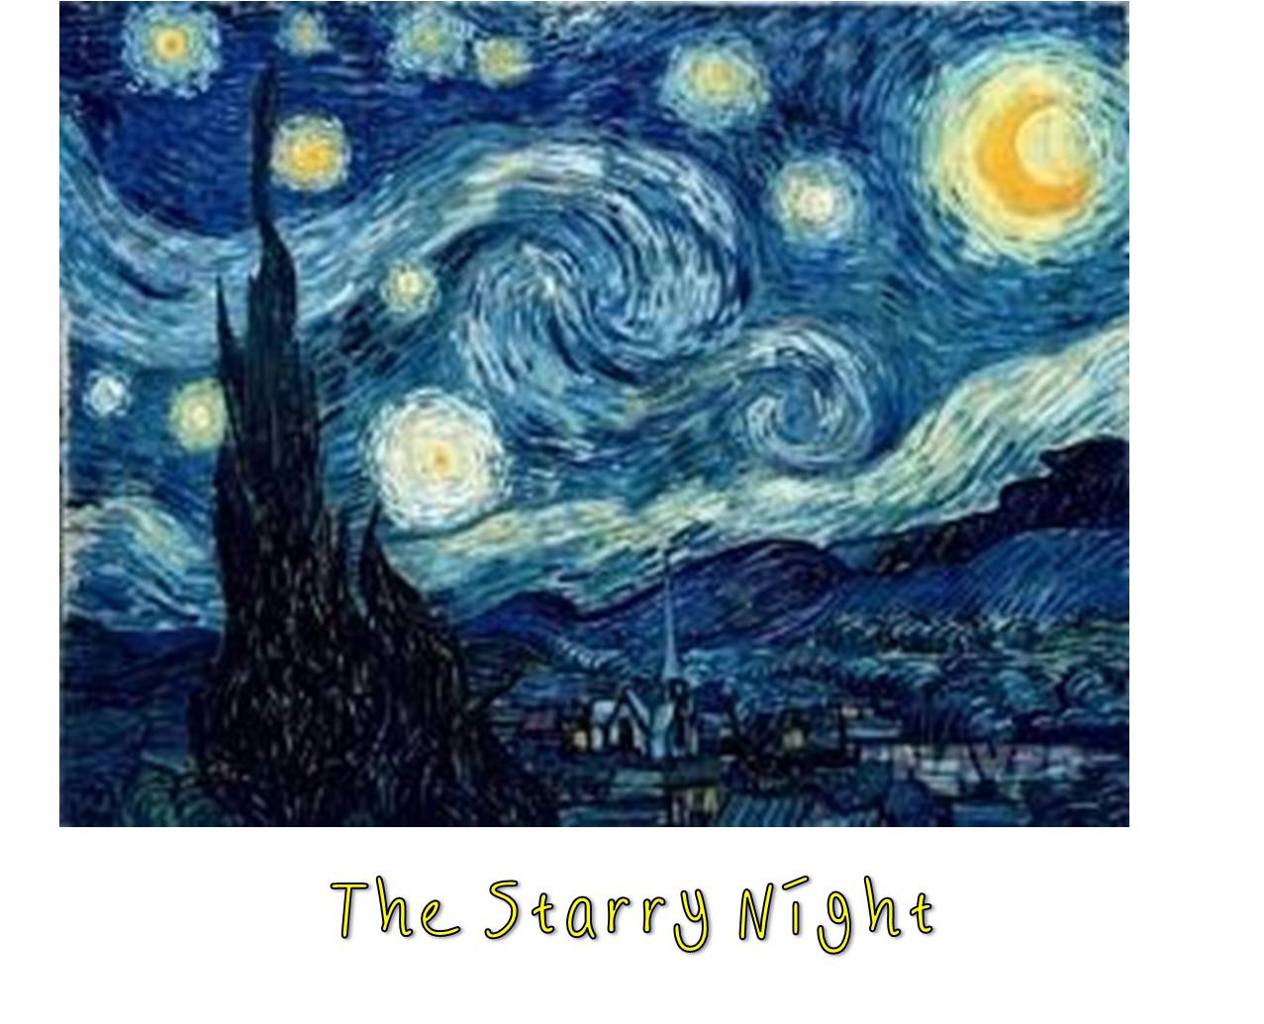
2. Characters picture for describing personality
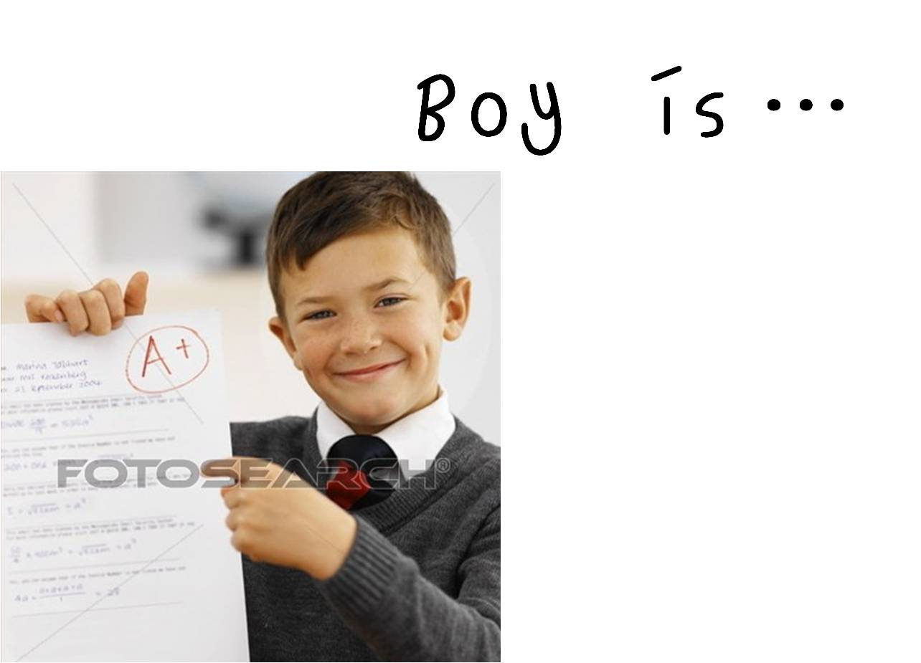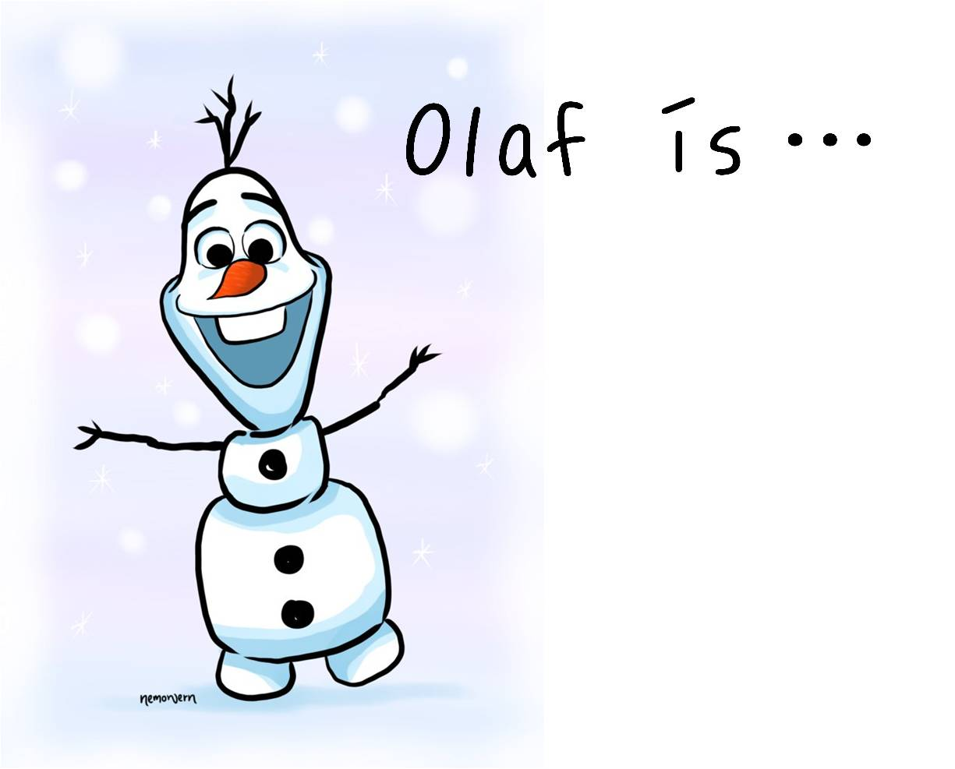

3. Words about describing personality
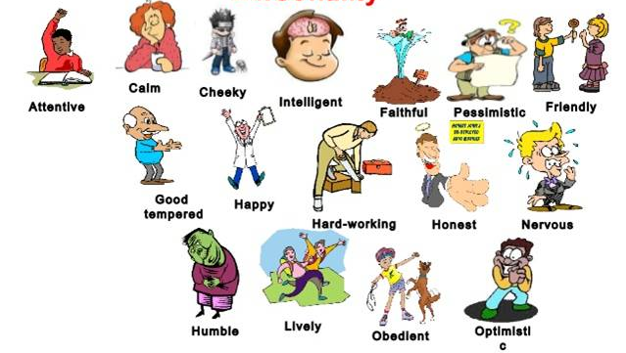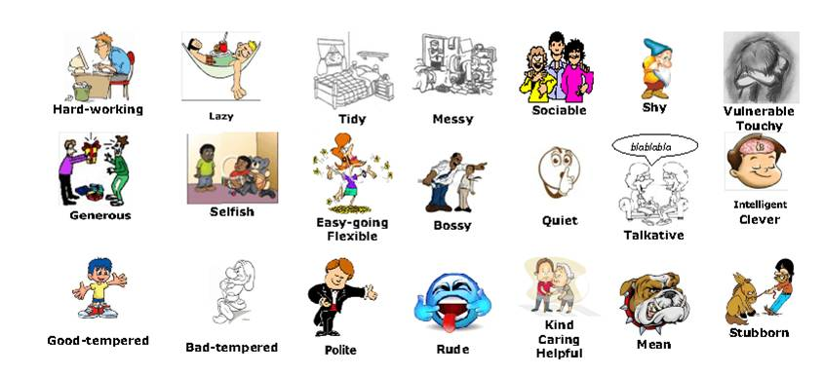
4. Substitution table
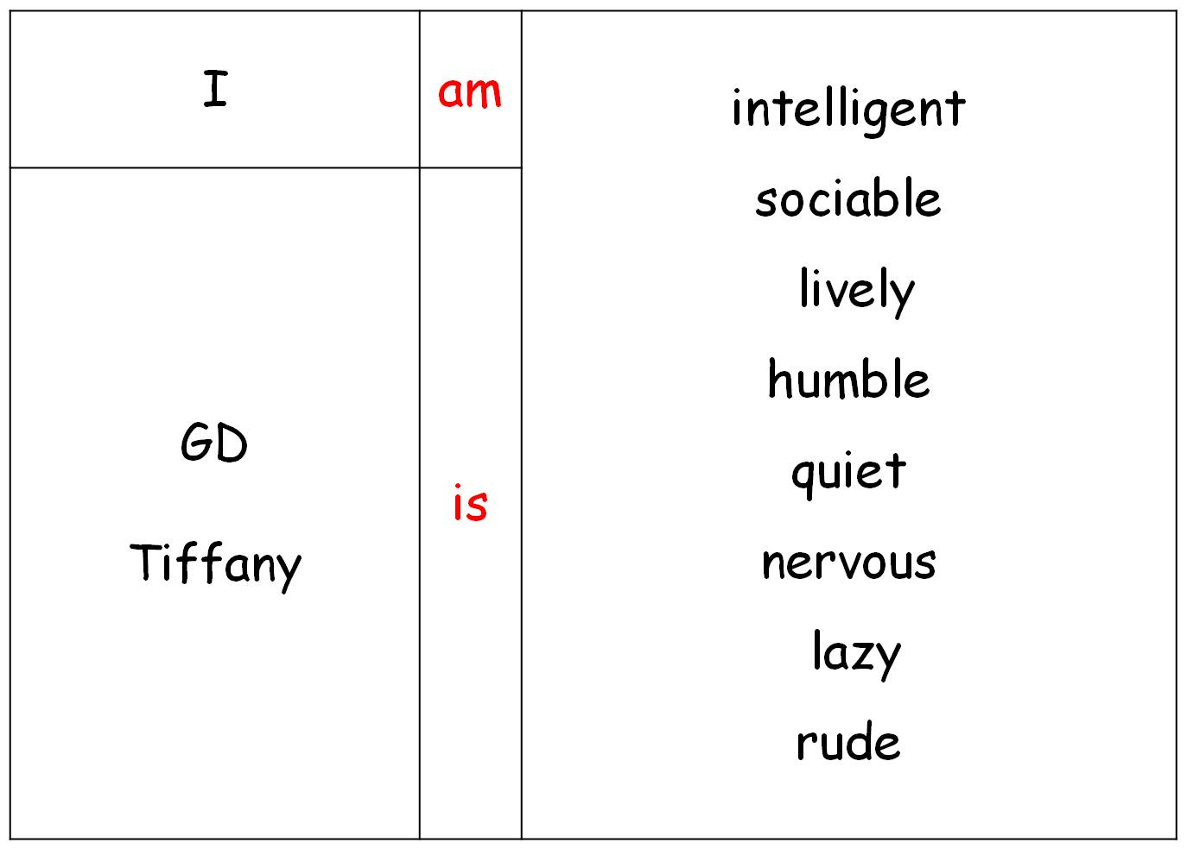

For reference : T make the poster’s background “The starry class”
